 | Pimpri Chinchwad Education Trust’s  Pimpri Chinchwad College of Engineering
ADS Assignment 1

S.Y. B. TECH
Year: 2025-26 Semester: II

Name : Purva Dhobale PRN : 124B1B275
Department : Computer Engineering Division : D
Course : Advanced Data Structures Laboratory Course Code : BCE24PC02

Date : 1 March 2026

Aim :

Consider the Dictionary Implementations which allow for efficient storage and retrieval of key-value pairs using binary search trees. Each node in the tree store (key, value) pair. The dictionary should support the following operations efficiently:
1. Insert word (Handle insertion of duplicate entry)
2. Delete word
3. Search specific word
4. Display dictionary (Traversal)
5. Mirror image of dictionary
6. Create a copy of dictionary
7. Display dictionary level wise

Algorithm

1: Insert a Word (Key–Value Pair)
- Start.
- Create a new node with given word and meaning.
- If root is NULL
→ Make new node as root and stop.
- Set curr = root, parent = NULL.
- Repeat until curr = NULL:
  - Set parent = curr.
  - If word = curr.word
→ Update meaning (handle duplicate) and stop.
  - Else if word < curr.word
→ Move to left child.
  - Else
→ Move to right child.
- Attach new node as:
  - Left child if word < parent.word
  - Right child otherwise.
- Stop.

2: Search a Word
- Start.
- Set curr = root.
- While curr ≠ NULL:
  - If word = curr.word → Display meaning and stop.
  - Else if word < curr.word → Move left.
  - Else → Move right.
- If reached NULL → Word not found.
- Stop.

3: Delete a Word
- Start.
- Locate the node to delete using BST search.
- If node not found → Stop.
- Check cases:
  - Case 1: Node has no child
→ Remove it directly.
  - Case 2: Node has one child
→ Link parent with that child.
  - Case 3: Node has two children
→ Find inorder successor (smallest in right subtree).
→ Copy its data to current node.
→ Delete successor node.
- Stop.

4: Display Dictionary (Inorder Traversal using Linked List)
- Start.
- Set curr = root.
- Use a linked list pointer top = NULL to simulate traversal memory.
- Repeat while (curr ≠ NULL OR top ≠ NULL):
  - Move left while pushing nodes into linked list.
  - Pop last stored node from linked list.
  - Display word and meaning.
  - Move to right child.
- Stop.

5: Create Mirror Image
- Start.
- If tree is empty → Stop.
- Store root in linked list.
- While list is not empty:
  - Take a node.
  - Swap its left and right children.
  - Add children to linked list.
- Stop.

6: Copy Dictionary
- Start.
- If original tree is empty → Stop.
- Insert root into linked list.
- While list not empty:
  - Remove a node.
  - Insert its (word, meaning) into new dictionary.
  - Add its left and right children into list.
- Stop.

7: Level-wise Display
- Start.
- If root is NULL → Stop.
- Create linked list with root node (acts like manual queue).
- While list not empty:
  - Remove front node.
  - Display its word.
  - Insert its left child (if exists).
  - Insert its right child (if exists).
- Stop.

Code :

#include <iostream>
using namespace std;
class Node {
public:
string word, meaning;
Node *left, *right;

Node(string w, string m) {
word = w;
meaning = m;
left = right = NULL;
}
};

class LLNode {
public:
Node* data;
LLNode* next;

LLNode(Node* d) {
data = d;
next = NULL;
}
};

class Dictionary {
Node* root;

public:
Dictionary() {
root = NULL;
}

// Insert Word
void insert(string w, string m) {
Node* newNode = new Node(w, m);

if (root == NULL) {
root = newNode;
cout << "Word inserted.\n";
return;
}

Node *curr = root, *parent = NULL;

while (curr != NULL) {
parent = curr;

if (w == curr->word) {
curr->meaning = m;
delete newNode;
cout << "Duplicate found. Meaning updated.\n";
return;
}
else if (w < curr->word)
curr = curr->left;
else
curr = curr->right;
}

if (w < parent->word)
parent->left = newNode;
else
parent->right = newNode;

cout << "Word inserted.\n";
}

// Search Word
void search(string w) {
Node* curr = root;

while (curr != NULL) {
if (w == curr->word) {
cout << "Found: " << curr->meaning << endl;
return;
}
else if (w < curr->word)
curr = curr->left;
else
curr = curr->right;
}

cout << "Word not found.\n";
}

// Delete Word
void deleteWord(string w) {
Node *curr = root, *parent = NULL;

while (curr && curr->word != w) {
parent = curr;
if (w < curr->word)
curr = curr->left;
else
curr = curr->right;
}

if (!curr) {
cout << "Word not found.\n";
return;
}

// Case 1: 0 or 1 child
if (!curr->left || !curr->right) {
Node* child = curr->left ? curr->left : curr->right;

if (!parent)
root = child;
else if (parent->left == curr)
parent->left = child;
else
parent->right = child;

delete curr;
}
else {
// Case 2: Two children
Node *succParent = curr;
Node *succ = curr->right;

while (succ->left) {
succParent = succ;
succ = succ->left;
}

curr->word = succ->word;
curr->meaning = succ->meaning;

if (succParent->left == succ)
succParent->left = succ->right;
else
succParent->right = succ->right;

delete succ;
}

cout << "Word deleted.\n";
}

// Display Dictionary
void display() {
LLNode* top = NULL;
Node* curr = root;

while (curr || top) {
while (curr) {
LLNode* temp = new LLNode(curr);
temp->next = top;
top = temp;
curr = curr->left;
}

LLNode* temp = top;
top = top->next;

curr = temp->data;
delete temp;

cout << curr->word << " : " << curr->meaning << endl;

curr = curr->right;
}
}

// Mirror Image of Dictionary
void mirror() {
if (!root) return;

LLNode* head = new LLNode(root);

while (head) {
Node* curr = head->data;

Node* t = curr->left;
curr->left = curr->right;
curr->right = t;

if (curr->left) {
LLNode* n = new LLNode(curr->left);
n->next = head;
head = n;
}
if (curr->right) {
LLNode* n = new LLNode(curr->right);
n->next = head;
head = n;
}

LLNode* del = head;
head = head->next;
delete del;
}

cout << "Mirror created.\n";
}

// Copy Dictionary
void copyTo(Dictionary &d2) {
if (!root) return;

LLNode* head = new LLNode(root);

while (head) {
Node* curr = head->data;
d2.insert(curr->word, curr->meaning);

if (curr->left) {
LLNode* n = new LLNode(curr->left);
n->next = head;
head = n;
}
if (curr->right) {
LLNode* n = new LLNode(curr->right);
n->next = head;
head = n;
}

LLNode* del = head;
head = head->next;
delete del;
}

cout << "Dictionary copied.\n";
}

// Level-wise Display
void levelWise() {
if (!root) return;

LLNode *front = new LLNode(root);
LLNode *rear = front;

while (front) {
Node* curr = front->data;
cout << curr->word << " ";

if (curr->left) {
rear->next = new LLNode(curr->left);
rear = rear->next;
}
if (curr->right) {
rear->next = new LLNode(curr->right);
rear = rear->next;
}

LLNode* del = front;
front = front->next;
delete del;
}
cout << endl;
}
};

int main() {
Dictionary dict, copyDict;
int choice;
string word, meaning;

do {
cout << "\n DICTIONARY MENU \n";
cout << "1. Insert Word\n";
cout << "2. Delete Word\n";
cout << "3. Search Word\n";
cout << "4. Display Dictionary\n";
cout << "5. Mirror Dictionary\n";
cout << "6. Create Copy\n";
cout << "7. Level-wise Display\n";
cout << "8. Exit\n";
cout << "Enter choice: ";
cin >> choice;

switch (choice) {
case 1:
cout << "Enter word: ";
cin >> word;
cout << "Enter meaning: ";
cin.ignore();
getline(cin, meaning);
dict.insert(word, meaning);
break;

case 2:
cout << "Enter word to delete: ";
cin >> word;
dict.deleteWord(word);
break;

case 3:
cout << "Enter word to search: ";
cin >> word;
dict.search(word);
break;

case 4:
dict.display();
break;

case 5:
dict.mirror();
break;

case 6:
dict.copyTo(copyDict);
break;

case 7:
dict.levelWise();
break;
}

} while (choice != 8);

return 0;
}

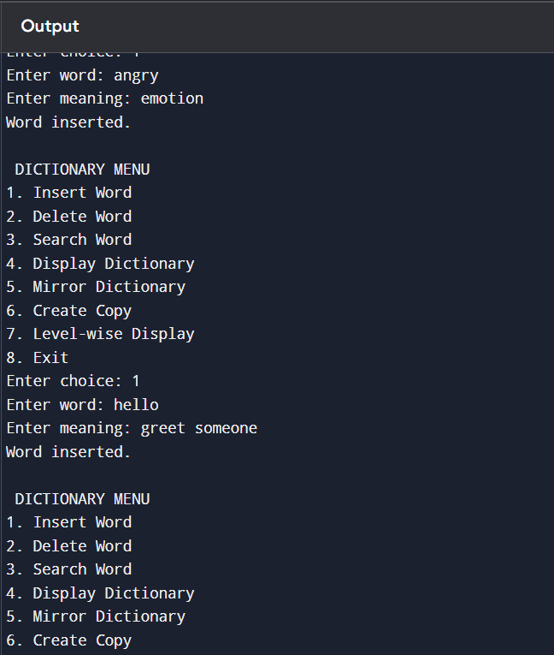
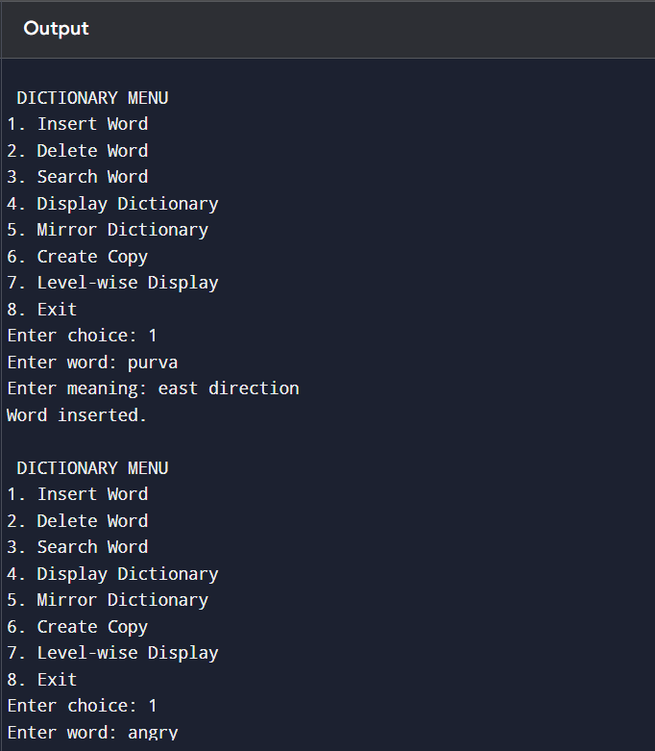
Output :

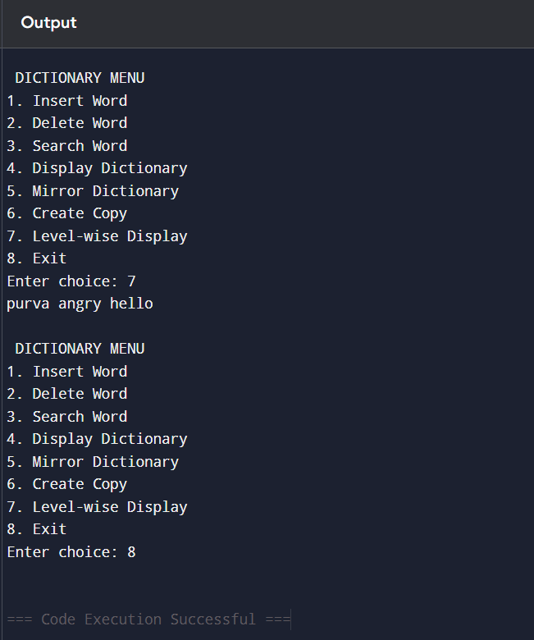
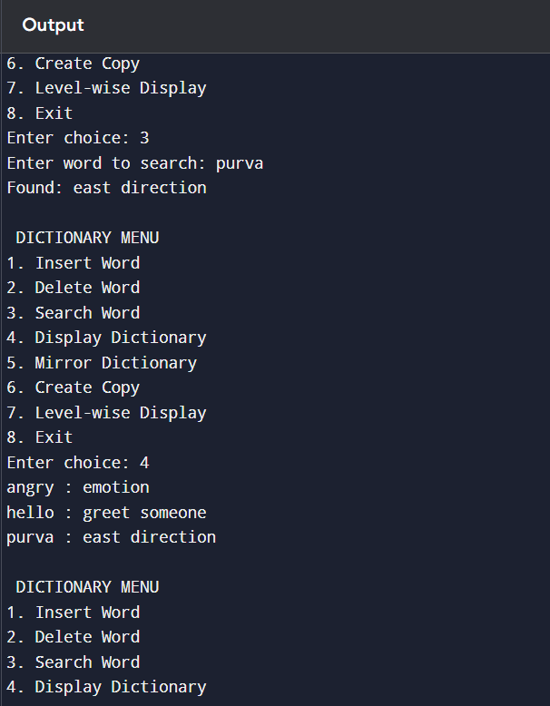

Conclusion :The dictionary was successfully implemented using a Binary Search Tree to store and manage key–value pairs efficiently. All operations were performed iteratively using a linked list as auxiliary support, ensuring efficient storage, retrieval, and traversal without recursion or built-in data structures.

********

