 | Pimpri Chinchwad Education Trust’s  Pimpri Chinchwad College of Engineering
ADS Assignment 8

S.Y. B. TECH
Year: 2025-26 Semester: II

Name : Purva Dhobale PRN : 124B1B275
Department : Computer Engineering Division : D
Course : Advanced Data Structures Laboratory Course Code : BCE24PC02

Date : 10 April 2026

Aim :

Implement the scenario of a file system which maintains directory structure using the Red-Black Tree. Each node in the tree represents a directory, and the tree is balanced to ensure efficient insertion, deletion, and display operations when navigating through the file system.

1. Algorithm: Insert Directory
Algorithm: INSERT(name)
- Create new node z with:
  - dir = name
  - color = RED
- Set:
  - y = NULL (parent)
  - x = root
- Traverse tree to find position:
  - While x != NULL:
    - Set y = x
    - If name < x->dir → move left
    - Else → move right
- Set parent of new node:
  - z->parent = y
- If y == NULL → make z as root
- Else if name < y->dir → insert as left child
- Else → insert as right child
- Call fixInsert(z)

2. Algorithm: Fix Violation
Ensures Red-Black properties are maintained
Algorithm: FIX_INSERT(z)
- While:
  - z is not root AND
  - parent is RED
- Set:
  - parent = z->parent
  - grandparent = parent->parent

Case 1: Parent is LEFT child
- Set uncle = grandparent->right

Case 1A: Uncle is RED
- Recolor:
  - parent → BLACK
  - uncle → BLACK
  - grandparent → RED
- Move z = grandparent

Case 1B: Uncle is BLACK
- If z is right child:
  - Perform Left Rotation on parent
  - Update z = parent
- Recolor:
  - parent → BLACK
  - grandparent → RED
- Perform Right Rotation on grandparent

Case 2: Parent is RIGHT child (mirror case)
- Set uncle = grandparent->left

Case 2A: Uncle is RED
- Same recoloring as above

Case 2B: Uncle is BLACK
- If z is left child:
  - Perform Right Rotation on parent
- Recolor:
  - parent → BLACK
  - grandparent → RED
- Perform Left Rotation on grandparent

- Finally:
  - Set root->color = BLACK

3. Algorithm: Left Rotation
Algorithm: LEFT_ROTATE(x)
- y = x->right
- Move y->left to x->right
- Update parent of y->left
- Link y with parent of x
- Make x left child of y
- Update parent pointers

4. Algorithm: Right Rotation
Algorithm: RIGHT_ROTATE(x)
- y = x->left
- Move y->right to x->left
- Update parent of y->right
- Link y with parent of x
- Make x right child of y
- Update parent pointers

5. Algorithm: Display (Level Order Traversal)
Algorithm: DISPLAY()
- If root is NULL:
  - Print "Tree is empty"
  - STOP
- Create queue
- Insert root into queue
- While queue not empty:
  - Remove front node
  - Print dir and color (R/B)
  - If left child exists → enqueue
  - If right child exists → enqueue
- STOP

6. Algorithm: Main Menu
Algorithm: MAIN()
- Create RBTree object
- Repeat until user chooses Exit:
  - Display menu:
    - Insert Directory
    - Display Directories
    - Exit
  - Input choice
  - If choice = 1:
    - Input directory name
    - Call INSERT
  - If choice = 2:
    - Call DISPLAY
  - If choice = 3:
    - Exit program
  - Else:
    - Print "Invalid choice"

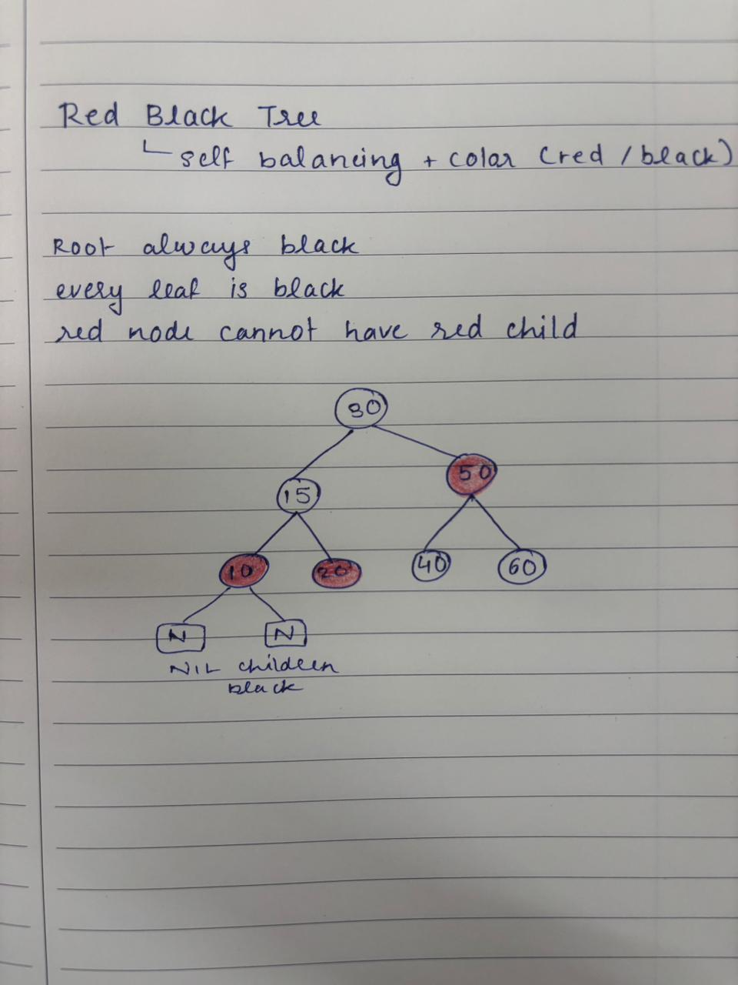

#include <iostream>
using namespace std;

// Node
struct Node {
string dir;
int color; // 0 = RED, 1 = BLACK
Node *left, *right, *parent;

Node(string name) {
dir = name;
color = 0;
left = right = parent = NULL;
}
};

class RBTree {
Node *root;

public:
RBTree() {
root = NULL;
}

// LEFT ROTATION
void rotateLeft(Node *x) {
Node *y = x->right;
if (y == NULL) return;

x->right = y->left;

if (y->left != NULL)
y->left->parent = x;

y->parent = x->parent;

if (x->parent == NULL)
root = y;
else if (x == x->parent->left)
x->parent->left = y;
else
x->parent->right = y;

y->left = x;
x->parent = y;
}

// RIGHT ROTATION
void rotateRight(Node *x) {
Node *y = x->left;
if (y == NULL) return;

x->left = y->right;

if (y->right != NULL)
y->right->parent = x;

y->parent = x->parent;

if (x->parent == NULL)
root = y;
else if (x == x->parent->right)
x->parent->right = y;
else
x->parent->left = y;

y->right = x;
x->parent = y;
}

void fixInsert(Node *z) {
while (z != root && z->parent != NULL && z->parent->color == 0) {
Node *parent = z->parent;
Node *grandparent = parent->parent;

if (grandparent == NULL)
break;

if (parent == grandparent->left) {
Node *uncle = grandparent->right;

if (uncle != NULL && uncle->color == 0) {
parent->color = 1;
uncle->color = 1;
grandparent->color = 0;
z = grandparent;
}
else {
if (z == parent->right) {
z = parent;
rotateLeft(z);
}

parent->color = 1;
grandparent->color = 0;
rotateRight(grandparent);
}
}
else {
Node *uncle = grandparent->left;

if (uncle != NULL && uncle->color == 0) {
parent->color = 1;
uncle->color = 1;
grandparent->color = 0;
z = grandparent;
}
else {
if (z == parent->left) {
z = parent;
rotateRight(z);
}

parent->color = 1;
grandparent->color = 0;
rotateLeft(grandparent);
}
}
}

if (root != NULL)
root->color = 1;
}

// INSERT
void insert(string name) {
Node *z = new Node(name);
Node *y = NULL;
Node *x = root;

while (x != NULL) {
y = x;
if (name < x->dir)
x = x->left;
else
x = x->right;
}

z->parent = y;

if (y == NULL)
root = z;
else if (name < y->dir)
y->left = z;
else
y->right = z;

fixInsert(z);
}

// DISPLAY (LEVEL ORDER)
void display() {
if (root == NULL) {
cout << "Tree is empty\n";
return;
}

Node* queue[100];
int front = 0, rear = 0;

queue[rear++] = root;

while (front < rear) {
Node* temp = queue[front++];

cout << temp->dir << " ("
<< (temp->color == 0 ? "R" : "B") << ") ";

if (temp->left != NULL)
queue[rear++] = temp->left;

if (temp->right != NULL)
queue[rear++] = temp->right;
}

cout << endl;
}
};

int main() {
RBTree fs;
int choice;
string name;

do {
cout << "\n--- FILE SYSTEM MENU ---\n";
cout << "1. Insert Directory\n";
cout << "2. Display Directories\n";
cout << "3. Exit\n";
cout << "Enter choice: ";
cin >> choice;

switch (choice) {
case 1:
cout << "Enter directory name: ";
cin >> name;
fs.insert(name);
cout << "Directory inserted!\n";
break;

case 2:
cout << "Directory Structure:\n";
fs.display();
break;

case 3:
cout << "Exiting...\n";
break;

default:
cout << "Invalid choice!\n";
}

} while (choice != 3);

return 0;
}




