**Laser Lab Auto Solver System Description**

As we presented in class, the auto solver will perform a bread-first search on the grid to find the target, the level in this graph search is the minimum number of extra mirrors needed from the laser source to current node from certain direction. That is to say, each node will keep information of 4 level # (‘up’, ‘down’, ‘left’, ‘right’).

For example, in the picture below, I mark the level numbers in some block to make you better understand it.

The laser source will be level -1.

And the minimum number of turns to get the block in certain direction is marked using small numbers at that direction. We can figure out that we need at least 2 mirrors to get the target.

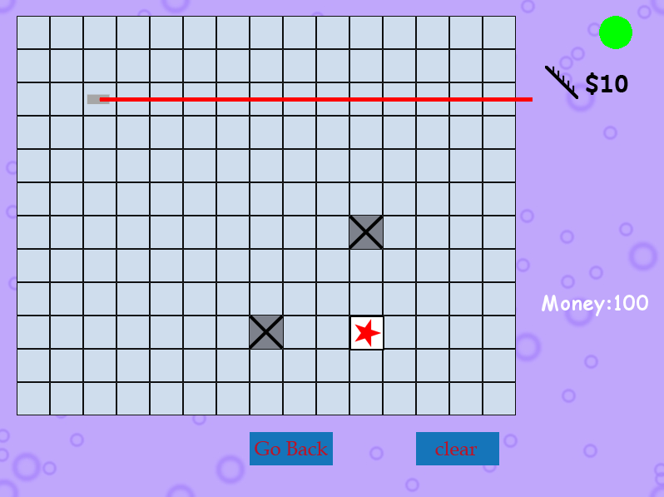

**2**

**1**

**1**

**1**

**1**

**1**

**1**

**2**

**1**

**1**

**1**

**1**

**1**

**1**

**1**

**1**

**2**

**2**

**2**

**2**

**2**

**1**

**1**

**1**

**1**

**1**

**1**

**1**

**1**

**1**

**1**

**0**

**0**

**0**

**0**

**0**

**0**

**0**

**0**

**0**

**0**

**0**

**0**

**0**

**0**

**0**

**0**

**0**

**0**

**0**

**0**

**0**

**0**

**0**

**0**

**0**

**0**

**0**

**-1**

In this case, the user has already put a mirror on the board so the node on the light path will all have level 0 on certain direction. As a result we can get the target using only 1 mirror extra.

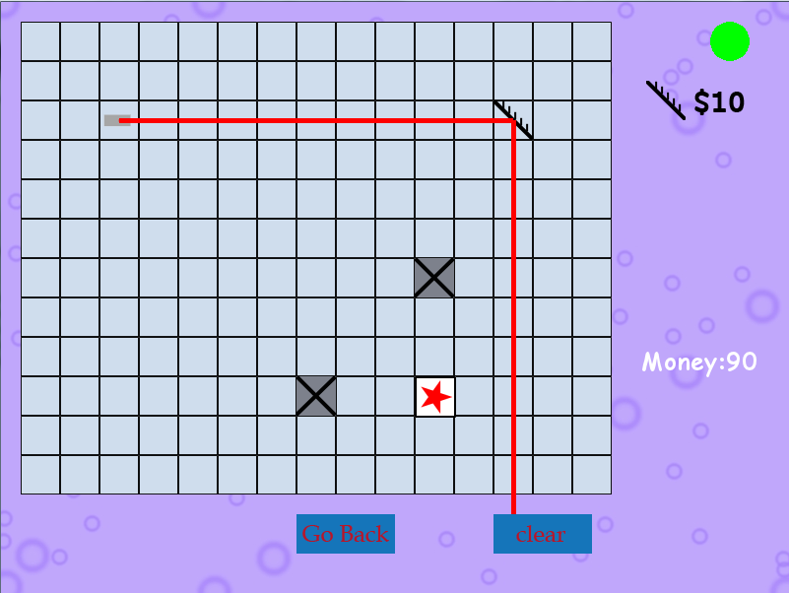

**1**

**1**

**0**

**0**

**0**

**0**

**0**

**0**

**0**

**0**

**0**

**0**

**0**

**0**

**0**

**0**

**0**

**0**

Details about the implementation please refer to the commented code attached.