**I. Creating Application on AppsFlyer.**

1. Add your application

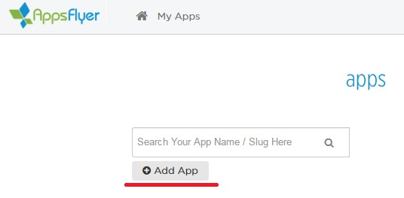

2. Paste your application ID and Dev Key from AppsFlyer to Project Settings -> IOS -> Extra PList Data ->Additional Plist Data:

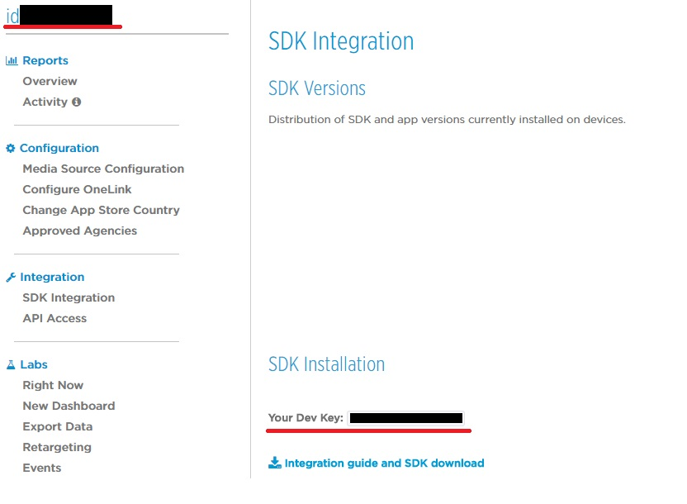

<key>AppsFlyerAppID</key>\n

<string>0000000000</string>\n

<key>AppsFlyerDevKey</key>\n

<string>xxxxxxxxxxxxxxxxxxxxxxxxx</string>\n

**II. Integration.**

1. C++

a) Add AppsFlyer plugin to private dependencyes of your project:

PrivateDependencyModuleNames.*AddRange*(

new string[]

{

...

"AppsFlyer",

...

});

b) Track your events.

FAppsFlyerModule *appsFlyerModule = &FAppsFlyerModule::Get();

if (appsFlyerModule)

{

TArray<FAnalyticsEventAttribute> attributes;

appsFlyerModule->TrackEvent(TEXT(“EventName”), attributes);

}

2. Blueprint

