**I. Creating Application on Chartboost.**

1. Add your application on Chartboost and add your App ID and Signature to Project Settings -> IOS -> Extra PList Data ->Additional Plist Data in UE4:

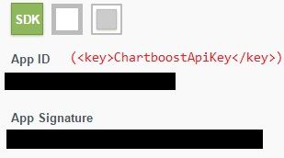

<key>ChartboostApiKey</key>\n

<string>xxxxxxxxxxxxxxxxxxxxxxxx</string>\n

<key>ChartboostSignature</key>\n

<string>xxxxxxxxxxxxxxxxxxxxxxxxxxxxxxxxxxxxxxxx</string>\n

**II. Integration.**

1. C++

a) Add Chartboost plugin to private dependencyes of your project:

PrivateDependencyModuleNames.*AddRange*(

new string[]

{

...

"Chartboost",

...

});

b) Show Ad Rewarded Video on CBLocationMainMenu or Interstitial on CBLocationHomeScreen.

FChartboostModule *chartboostModule = &FChartboostModule::Get();

if (chartboostModule)

{

bool bRewardedVideo = true;

chartboostModule->ShowAd(bRewardedVideo);

}

c) Handle delegates

Add your delegate to OnChartboostAdCompleted:

chartboostModule->GetDelegateHandlerInstance()->OnChartboostAdCompleted

2. Blueprint

a) Show Ad Rewarded Video on CBLocationMainMenu or Interstitial on CBLocationHomeScreen.

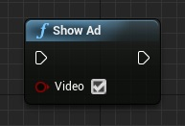

b) Handle delegates

