**I. Creating Application on DeltaDNA.**

1. Add your application on DeltaDNA and paste your data from DeltaDNA to Project Settings -> IOS -> Extra PList Data ->Additional Plist Data in UE4:

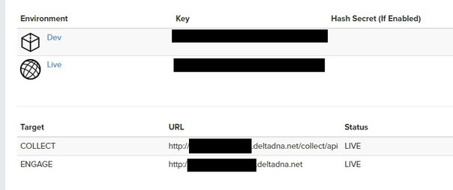

You have to add Dev Api Key or Live Api Key.

<key>DeltaDNAApiKey</key>\n

<string>00000000000000000000000000000000</string>\n

<key>DeltaDNACollectURL</key>\n

<string>http://xxxxxxxxxxxxxxxx.deltadna.net/collect/api</string>\n

<key>DeltaDNAEngageURL</key>\n

<string>http://xxxxxxxxxxxxxxx.deltadna.net</string>\n

<key>NSAppTransportSecurity</key>\n

<dict>\n

<key>NSAllowsArbitraryLoads</key>\n

<true/>\n

</dict>\n

**II. Integration.**

1. C++

a) Add DeltaDNA plugin to private dependencyes of your project:

PrivateDependencyModuleNames.*AddRange*(

new string[]

{

...

"DeltaDNA",

...

});

b) Track your events.

FDeltaDNAModule*deltaDNAModule = &FDeltaDNAModule::Get();

if (deltaDNAModule)

{

TArray<FAnalyticsEventAttribute> attributes;

deltaDNAModule ->TrackEvent(TEXT(“EventName”), attributes);

}

2. Blueprint

