**I. Creating Application on Mixpanel.**

1. Add your application

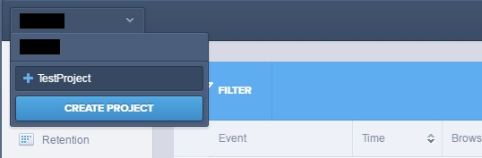

2. Go to Mixpanel project settings and paste your Token from Mixpanel to Project Settings -> IOS -> Extra PList Data ->Additional Plist Data in UE4:

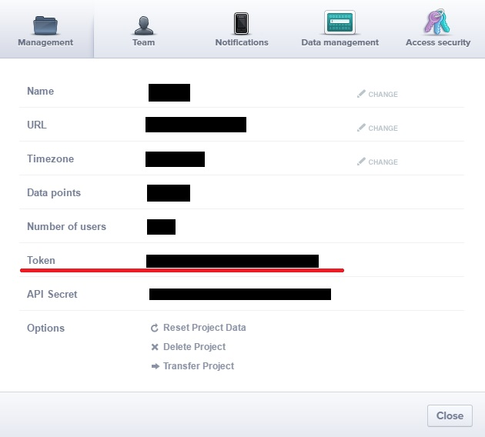

<key>MixpanelApiKey</key>\n

<string>xxxxxxxxxxxxxxxxxxxxxxxxxxxxxxxx</string>\n

**II. Integration.**

1. C++

a) Add Mixpanel plugin to private dependencyes of your project:

PrivateDependencyModuleNames.*AddRange*(

new string[]

{

...

"Mixpanel",

...

});

b) Track your events.

FMixpanelModule *mixpanelModule = &FMixpanelModule::Get();

if (mixpanelModule)

{

TArray<FAnalyticsEventAttribute> attributes;

mixpanelModule->TrackEvent(TEXT(“EventName”), attributes);

}

c) Managing user identity

mixpanelModule->SetUserID(TEXT(“YourUserID”));

d) Storing user profiles

TArray<FAnalyticsEventAttribute> attributes;

TArray<FAnalyticsEventAttribute> incrementableAttributes;

mixpanelModule->StoreUserProfileData(attributes, incrementableAttributes);

e) Tracking revenue

TArray<FAnalyticsEventAttribute> attributes;

mixpanelModule->TrackCharge(99.99, attributes);

2. Blueprint

a) Track your events.

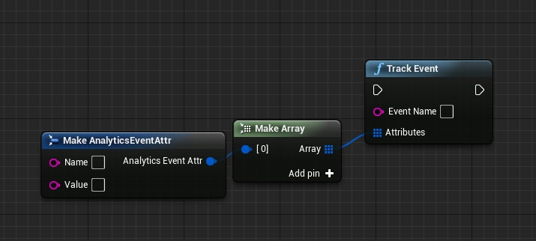

b) Managing user identity

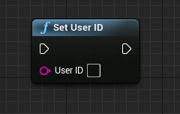

c) Storing user profiles

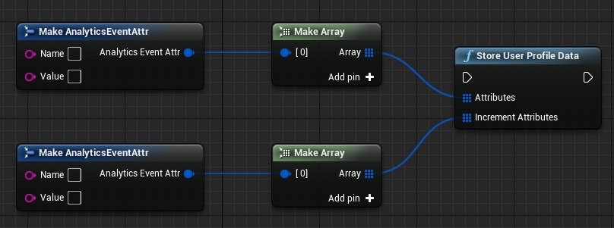

d) Tracking revenue

