**I. Creating Application on VK.**

1. Add your application on VK and add your App ID to Project Settings -> IOS -> Extra PList Data ->Additional Plist Data in UE4:

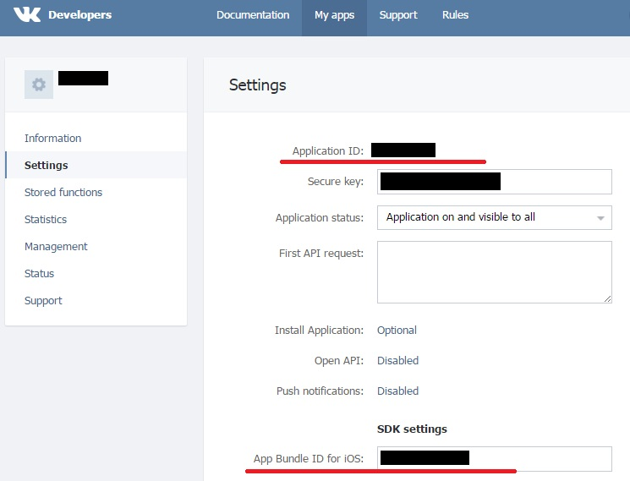

<key>CFBundleURLTypes</key>\n

<array>\n

<dict>\n

<key>CFBundleURLName</key>\n

<string>vk0000000</string>\n

<key>CFBundleURLSchemes</key>\n

<array>\n

<string>vk0000000</string>\n

</array>\n

</dict>\n

</array>\n

<key>VKAppID</key>\n

<string>0000000</string>\n

2. Add your application Bundle ID for IOS to VK project settings.

3. Configure VK in UE4 Project Settings.

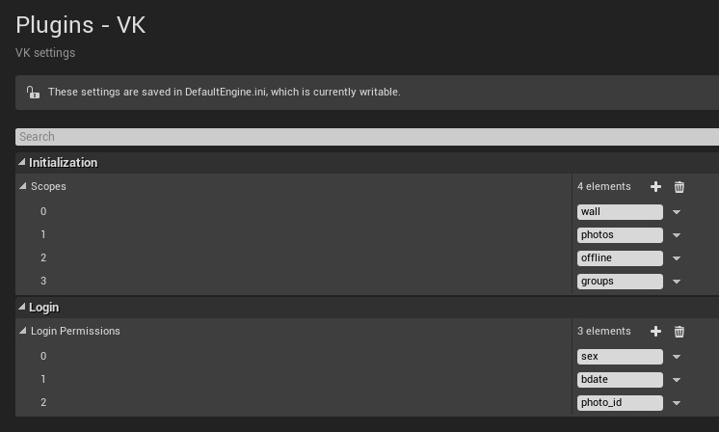

Scopes: https://vk.com/dev/permissions

Login Permissions: <https://vk.com/dev/users.get> see parameter fields

**II. Integration.**

1. C++

a) Add VK plugin to private dependencyes of your project:

PrivateDependencyModuleNames.*AddRange*(

new string[]

{

...

"VK",

...

});

b) Authorization methods:

IVK *vkHelper = &IVK::Get();

if (vkHelper)

{

vkHelper->Login();

...

vkHelper->Logout();

...

if(vkHelper->IsLoggedIn())

{

// User is authorized

}

}

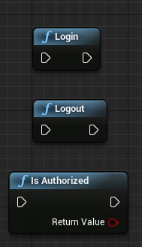

c) Sharing

IVK::ImageInfo imageInfo;

if(bWithImage)

{

// With RGBA image

imageInfo.Data = (uint8*)imageBytesData;

imageInfo.Size.X = imageWidth;

imageInfo.Size.Y = imageHeight;

imageInfo.ChannelsNum = 4; // RGBA  
}

vkHelper->Share(message, imageInfo, userID);

Note: if field userID equals 0, then post will be published on authorized user page.

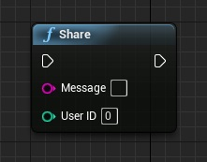

d) Friends

Get friend list:

vkHelper->GetFriendList();



Invite your friend (this method available only for approved on VK apps, read more: https://vk.com/dev/apps.sendRequest):

vkHelper->InviteFriend(userID, message);

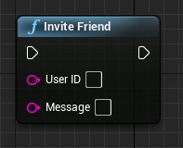

e) Groups

vkHelper->JoinToGroup(groupID);

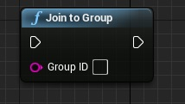

f) Custom requests

You can use custom API requests. Read more on <https://vk.com/dev/methods>.

TMap<FString, FString> params;

params.Add(TEXT(“fields”), TEXT(“*nickname, screen_name, bdate* ”));

vkHelper->CustomRequest(TEXT(“users.get”), params);

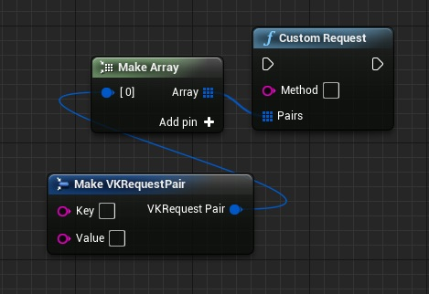

Custom share request (more on <https://vk.com/dev/ios_sdk> API Requests):

TMap<FString, FString> params;

// Add your parameters

vkHelper->PostWithParamters(params);

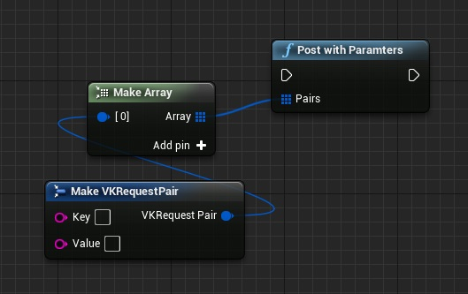

g) Delegates

vkHelper->GetDelegateHandler()->VKOnLoggedIn;

vkHelper->GetDelegateHandler()->VKOnLoginFailed;

vkHelper->GetDelegateHandler()->VKOnShareCompleted;

vkHelper->GetDelegateHandler()->VKOnGotFriends;

vkHelper->GetDelegateHandler()->VKOnFriendWasInvited;

vkHelper->GetDelegateHandler()->VKOnCustomRequestCompleted;

