TEMPORAL ANALYSIS OF AIRBNB LISTING DYNAMICS IN NEW YORK CITY: A TIME SERIES PERSPECTIVE

**Table of Contents**

Chapter 1: Introduction 5

1.1 Introduction 5

1.2 Background of the study 5

1.3 Research Aim and Objective 5

Aim: 5

Objectives: 5

1.4 Research question 6

1.5 Significance of the study 6

1.6 Rationale 7

1.7 Structure of the Study 7

1.8 Summary 8

Chapter 2: Literature Review 9

2.1 Introduction 9

2.2 Introduction to Airbnb and the Sharing Economy 9

2.2.1 Evolution of the Sharing Economy 9

2.2.2 Disruption in the Hospitality Industry 9

2.2.3 Airbnb's Global Influence and New York City 9

2.2.4 Impact on Traditional Hospitality Models 10

2.3 Temporal Analysis and Time Series Techniques 10

2.3.1 Time Series Analysis: An Overview 10

2.3.2 Techniques in Time Series Analysis 10

2.3.4 Importance in Understanding Airbnb Dynamics 11

2.4 Studies on Airbnb and Temporal Dynamics 11

2.4.1 Pricing Dynamics over Time 11

2.4.2 Temporal Patterns in Host Engagement 12

2.4.3 Seasonal Variations and Booking Patterns 12

2.4.4 Policy Impacts and Regulatory Changes 12

2.4.5 Guest Reviews and Temporal Aspects 12

2.4.6 Spatial and Neighborhood Dynamics 12

2.5 Seasonal Variations and Booking Patterns 12

2.6 Policy Impacts and Regulatory Changes 13

2.7 Guest Reviews and Temporal Aspects 15

2.8 Spatial and Neighborhood Dynamics 15

2.9 Summary 17

Chapter 3: Methodology 18

3.1 Introduction 18

3.2 Research Design 18

3.2.1 Quantitative Approach 18

3.2.2 Time Series Analysis 18

3.3 Data Collection 18

3.3.1 Dataset Selection 18

3.3.2 Temporal Data 19

3.4 Variables 19

3.4.1 Dependent Variables 19

3.4.2 Independent Variables 19

3.5 Data Analysis 20

3.5.1 Time Series Models 20

3.5.2 Statistical Software 20

3.6 Ethical Considerations 20

3.6.1 Data Privacy and Confidentiality 20

3.6.2 Compliance with Airbnb Policies 20

3.7 Limitations 21

3.7.1 Data Limitations 21

3.7.2 External Factors 21

3.8 Conclusion 21

Chapter 4: Result and Discussion 23

4.1 Overview of Findings 23

4.2 Temporal Analysis of Airbnb Listings 24

4.3 Impact of Seasonality on Airbnb Dynamics 28

4.4 Relationship between Variables 31

4.5 Spatial Analysis and Neighborhood Dynamics 33

4.6 Guest Reviews and Satisfaction Trends 36

References 40

# Chapter 1: Introduction

## 1.1 Introduction

The advancement of the sharing economy and sites like Airbnb have fundamentally changed the inn business. Focusing on the developing thought of offices from this point and finding the transient idea of New York City's Airbnb postings is entrancing. This segment frames the essential objective of the review, which is to apply time series information examination to fathom the patterns, cases, and examples in the unique Airbnb industry in a chief city.

## 1.2 Background of the study

Airbnb has gotten a more extensive scope of helpful choices and presented critical difficulties to customary cordiality rehearsals, bringing about massive changes to the inn area. As stated by Rezazadeh Kalehbasti *et al*. (2021), given its status as one of the world's most well-known traveller objections, New York City presents a fantastic open door for Airbnb to grow. The tremendous number of occupations in this metro area bears witness to their significance, yet only a little has been known of the substantial components that oversee them.

This study is required because the short-lived ways of Airbnb postings in New York City incorporate secret information. Indeed, even with such a lot of data available, it needs help to understand how these online journals differ regarding visitor correspondence, cost, openness, and responsibility. Since this industry is continuously transforming, doing more inside-and-out research using time series investigation is fundamental to comprehending how things change throughout different periods (Dhillon *et al*. 2021). This study investigates the short-lived parts to appreciate the cycles behind changes in prominence, estimate differences, and substantially improve participation among hosts and visitors. A full handle of the hidden processes at work in this climate would benefit everybody who participated in New York City's continually developing neighbourliness business, from legislators and city organisers to Airbnb hosts and guests.

## 1.3 Research Aim and Objective

### Aim:

The study aims to perform a comprehensive time series analysis to comprehend the development of New York City's Airbnb listings.

### Objectives:

* To find patterns in the geographic posting costs across different time spans.
* To monitor present situations and perceive what cooperative changes mean for them.
* To discover the typical time it takes to execute a booking and observe any occasional varieties in the Airbnb market.
* To Compute what changing a technique will mean for the posting parts.
* To discover how they change over the long run by analysing the associations between different worldwide areas and guest input.

## 1.4 Research question

1. Is there a perceptible example or pattern in the expense time series that is posted in different New York City areas?

2. How should changes in specialised techniques affect Airbnb postings' notoriety and openness over the long run?

3. Does The New York City Airbnb grandstand incorporate any instances of uncommon booking patterns? If this is exact, how does the implied accommodation pile face these occurrences or examples?

4. What effect may change in strategies, including those relating to quick bookability or annulment methods, have on the transient elements of Airbnb rentals in New York City?

5. How do the worldwide principles of visitor reviews connect with the occasionally conflicting, evaluating, and authoritatively changed Airbnb market in New York City?

## 1.5 Significance of the study

The meaning of this study lies in giving multifaceted bits of knowledge into the elements of Airbnb postings inside the constantly changing setting of New York City's potential. It is pivotal for some gatherings in the lodging area to grasp these fleeting perspectives. Hosts might improve their inhabitants' rates and income by pursuing critical decisions because of information into evaluating patterns and occasional examples (Li *et al*. 2022). This involves changing costs, sorting out when their advertisements ought to be free, and thinking up and drawing in procedures that function admirably for various seasons.

Assuming voyagers are better educated about top travel times, value varieties, and booking patterns over the long haul, they might pick travel game plans that better suit their inclinations and spending plans. Lawmakers may utilise the discoveries of this study to draft more reasonable guidelines that shield customers' freedoms and advance a flourishing economy (Chiny *et al*. 2021). Appreciating what strategy changes mean for posting elements is essential to outlining fair and prosperous arrangements for the sharing economy.

The review offers critical points of view on the powerful friendliness scene and is essential for the area, including partners and metropolitan organisers. The time series examination might give experiences that might be utilised to foster a more adaptable and practical cordiality environment in New York City. This could bring better-field-tested strategies, upgraded stages, and improved administrations presented via Airbnb.

## 1.6 Rationale

Focusing on the components of Airbnb postings in New York City is urgent to comprehend the complex worldwide ways of behaving that regulate the sharing economy in a bustling city. Understanding past models and patterns exhaustively is vital for going with taught choices in cheerfulness. The motivation behind this study is to research the principal worldwide issues that influence appraisal variances, booking examples, correspondences, and vacationer encounters across time, utilising time series insightful approaches.

Besides, sites like Airbnb are the ideal illustration of the sharing economy, described by an extraordinary setting that consistently matters. As narrated by Zhu *et al*. (2020), these passing minutes could be helpful for teachers, managers, colleagues, and visitors. It is essential to know about the concise vacillations in presenting designs on further developed systems because of changes in guidelines, appraisals, and requests. Information on transient examples might be utilised to assist tourists with better modifying their encounters to their inclinations and monetary imperatives.

Moreover, legislators should consider the transient person of the dividing economy while making regulations that work out some kind of harmony between shopper well-being and market unpredictability (Liu, 2021). This study highlights the genuine foundations of the New York City Airbnb market to develop further client connections, initiative, and the general flexibility and productivity of the amicable natural framework.

## 1.7 Structure of the Study

Specific attributes of long-haul Airbnb rentals in New York City are the subject of particular audit segments. To some degree 2, it assesses fitting composition after a review of deals with time series examination, Airbnb, and related issues. As stated by Yang (2021), an exhaustive depiction of the strategy, setup, and use of time series review techniques for get-together information is given in Segment 3. Section 4 is where the review results are temporarily introduced. It will analyse the pragmatic ramifications of these disclosures. To some extent, a synopsis of the vital ideas and ideas for the future ways of the field are given. For a limited time, wrap the request up.

## 1.8 Summary

After some time, this study checks out the components of Airbnb postings in New York City. This meticulous time series recognises oddities and patterns in assessing variations, associations, guest activities, and system results. By breaking the material into sensible parts, commentators must give significant data to hosts, guests, specialists, and business contacts. Through its careful outcomes, contemplations, and ends, as well as its essential complexities, this request will thoroughly evaluate the strong Airbnb industry. This will work with bearings and upgrade the amiability of New York City.

# 

# Chapter 2: Literature Review

## 2.1 Introduction

In the composing overview segment, might find a synopsis of prior research on the changing components of New York City Airbnb postings. This segment expects to concentrate on the more extensive setting of facilities, time series examination, and exploration associated with Airbnb. It gives the structure to an intensive analysis by featuring the need to understand time series, processing changes, having association plans, managerial outcomes, guest assessments, and nearby varieties inside the particular scene of New York City's Airbnb postings.

## 2.2 Introduction to Airbnb and the Sharing Economy

The sharing economy has changed various organisations, most prominently the lodging business, due to a tremendous change in buyer conduct and other market influences (Kirkos, 2022). Airbnb is a forerunner in the industry that has changed how purchasers search for someplace to remain, purchase, and sell items and administrations.

### 2.2.1 Evolution of the Sharing Economy

Individuals exchange items, administrations, and assets in the sharing economy on web-based markets. The helpful economy or the scattered business community are different names for this money-related perspective. This thought had become notable by the centre of the twenty-first century because of the improvement of precisely moved stages that might empower dispersed trades. As stated by Haldar *et al*. (2019), since its establishment in 2008, when it began offering individuals' homes, lofts, and additional rooms as options in contrast to regular lodgings, Airbnb has been a central thrust around here.

### 2.2.2 Disruption in the Hospitality Industry

The progressive impact that Airbnb has had on the inn business couldn't possibly be more significant. The wide combination of lodging decisions that Airbnb gives, from single rooms to whole homes, shows a change in client tendencies. Anyone using this stage can foster their business by renting more space and getting more money (Haldar *et al*. 2020). It similarly offered travellers an extensive determination of extraordinary, supportive, and socially enthralling choices rather than the normal, broken-down hotel.

### 2.2.3 Airbnb's Global Influence and New York City

Taking into account that New York City is famous for its enthusiastic economy and various productive social responsibilities, its quick expansion is a good indication of its general impact. It could find Airbnb postings all through the city in the extent of inquisitive locales, each with its specific person and must-see sights (Thomsen and Jeong, 2021). Regardless, New York City's puzzling regulatory environment and consistently changing guidelines influence the region's sensational components all through its occasions.

### 2.2.4 Impact on Traditional Hospitality Models

The improvement of Airbnb and the sharing economy has caused a change in standard friendliness models and incited discussions about charges, rules, and the impact on neighbouring associations. Alongside developing in seriousness, local people and specialists have been fighting increasing lodging rates, network blackouts, and the commercialization of individuals' homes. The sharing economy's Airbnb has modified the steadily developing New York City lodging scene (Masrom *et al*. 2022). It wants a firm comprehension of innovation's pragmatic parts since it influences traditional inn models, managerial settings, and buyer conduct. It wants to look at how postings in New York City change over the long haul, how expenses are brought about, how hosts stall out, and what rules mean for the area, assuming it is to understand how the sharing economy is filling in this flourishing city.

## 2.3 Temporal Analysis and Time Series Techniques

The continually moving propensities for various irregularities tend to be more pronounced if one knows about overall patterns and cases, particularly regarding the sharing economy (like Airbnb postings). As stated by Li and Biljecki (2019), logical examination offers opportunities to find covered-up, vaporous parts and example assumptions in confirmed information as the time series' decision moves closer.

### 2.3.1 Time Series Analysis: An Overview

Time series investigation is the most well-known strategy for looking at information or perspectives created over a lengthy time frame at customary stretches. It utilises an expansive scope of quantitative ways to assess and conjecture patterns in successive data (Ramos-Henriquez *et al*. 2021). The main exceptions, events, anomalies, and connections in time series information might be tracked using these procedures.

### 2.3.2 Techniques in Time Series Analysis

Time series examination utilises various procedures, which are all helpful for extraordinarily focusing on information with time:

***Autoregressive (AR) Models and Moving Averages (MA)***: MA models report the connection between discernment and a specific number of powerless spots, while AR models show how an insight depends on a leftover blunder from a moving typical (Peng *et al*. 2020).

***Autoregressive Integrated Moving Average (ARIMA)***: ARIMA is an adaptable model that blends AR and Mother parts and utilises differencing to adjust non-fixed time series information.

***Seasonal Decomposition***: Parting time series information into design, incidental, and extra parts considers the ID and investigation of exceptions.

***Exponential Smoothing Methods***: Procedures that utilise a weighted normal to dynamically diminish the expenses of earlier impressions to conform to new information (Quattrone *et al*. 2020).

***Machine Learning-Based Time Series Models***: Time series gauge includes a lot of mind-boggling computations, including company draws near, support vector machines, and cerebrum associations.

**2.3.3 Applications in Various Fields**

Time series research has likely applications in many spaces, including, shockingly, the sharing economy, and meteorology, which concentrates on the spread of sickness and monetary consequences. It is generally utilised in many fields, including stock cost expectation, sickness rate expectation, and weather conditions gauging.

### 2.3.4 Importance in Understanding Airbnb Dynamics

Time series approaches give a productive structure to breaking down valuing changes, responsibility designs, booking plans, and other time-subordinate boundaries concerning Airbnb posting attributes (Liu, 2021). These calculations search through verifiable information to find stowed-away vaporous examples that help assess strategies, inhabitant rates, and guest encounters.

At extended last, a fleeting series of legitimate frameworks might help notice and grasp common parts in successive information, especially concerning Airbnb posting propensities. These enhancements are fundamental for designing recognisable proof, plan prescience, and dynamic administration in the unique sharing economy.

## 2.4 Studies on Airbnb and Temporal Dynamics

### 2.4.1 Pricing Dynamics over Time

The assessing elements of Airbnb postings have been the subject of many explorations that gander at how costs change over the long haul. As narrated by Kiatkawsin *et al*. (2020), specialists incorporate variables such as fluctuation, demand changes, occasions, and regulatory changes while examining the drawn-out improvement of appraisal techniques in different ventures.

### 2.4.2 Temporal Patterns in Host Engagement

Research has inspected authentic connections, like posting openness, reaction, and changes over the long run. The examination's discoveries shed light on how hosts conform to varieties on the planet, including top seasons and administrative changes, and how this influences posting execution (Jain *et al*. 2021).

### 2.4.3 Seasonal Variations and Booking Patterns

A more profound comprehension of Airbnb booking designs and occasional swings may be acquired by inspecting genuine information on places of booking, inhabitance, and solicitation floods across different occasions, seasons, and periods.

### 2.4.4 Policy Impacts and Regulatory Changes

Is it conceivable to determine the future effect of changes to neighbourhood regulations or evaluation rules on Airbnb's accessibility, expenses, and strategic policies? This issue is researched by examining what authoritative changes or system interventions mean for the substantial components of Airbnb postings (Lee *et al*. 2020).

### 2.4.5 Guest Reviews and Temporal Aspects

Analysts can detect patterns in factors like recurrence, successful concentration, and conversational tone by following guest evaluations after some time. As stated by Chung and Sarnikar (2022), this examination's goal is to find any associations that could exist between the encounters of the guests and factors that change after some time, such as arrangements or expenses

### 2.4.6 Spatial and Neighborhood Dynamics

Analyse how passing events modify depending on where it utilises information from top-to-bottom examinations of confirmed cases in different towns or regions. The discoveries of these examinations give an understanding of how the fleeting qualities of various parts impact Airbnb's activities.

Different subjects are canvassed in research on Airbnb and transitory parts, including cost, associations among hosts and visitors, arbitrary varieties, rule influences, visitor surveys, and nearby investigation (Raza *et al*. 2022). Through a combination of data science draws near, our examinations disentangled the worldly intricacy and enlightened the influential thoughts of the Airbnb area.

## 2.5 Seasonal Variations and Booking Patterns

A few outer factors impact the rhythmic movement and booking examples of the Airbnb posting area. By focusing on these cases, lawmakers, explorers, and lodging proprietors might better comprehend vacationers' continually developing needs and wants. Periodically, varieties match provincial festivals or customary special seasons, affecting Airbnb's reserving designs, inhabitant rates, and appraisal components. As stated by Thakur *et al*. (2022), specialists have distinguished occasional propensities, for example, requests ascending around mid-year or during specific seasons and perhaps declining during off-top hours. Accept New York City, for instance. Concentrates on showing that pre-summer is the hottest season when temperatures climb and the quantity of guests increases, while the period between Christmas and New Year's Eve is the most active for arrangements.

Amasses additionally take a gander at periodic changes nearby, neighbourhood, or nearby levels to pick booking plans. This revived data, which incorporates multi-sided discontinuous models, enables hosts to adjust organisations and change valuation estimates depending upon interest assortments clear cut for their area (Li, 2021). The impact of social affairs and gatherings on reservation examples could help with concluding zenith interest and off-top periods. Accepting hosts are familiar with these subtleties. They could answer expected eccentric differences by changing expenses, creating accessibility, and creating guest experiences. Clients moreover gain from grasping intermittent qualifications while making travel courses of action, figuring out the best times to save money, and picking workplaces given their inclinations.

Stresses with respect to the fair market system, aggravations to the area, and transparency of accommodation: Chiefs ought to set choices or rules that sort out some sort of agreement between market impacts and neighbourhoods to adjust these propensities during popular times. As stated by Sengupta *et al*. (2021), the clashing extent of Airbnb postings and booking designs influence the rapidly developing New York City motel market. Subject matter experts, visitors, and hosts could have the choice to seek after-taught decisions with the broad information acquired from these evaluations.

## 2.6 Policy Impacts and Regulatory Changes

In New York City, methodology and rule changes fundamentally influence the Airbnb market. These movements enormously influence client tendencies, conduct, and the natural framework generally. In this part, it examines what government rules and guidelines mean for how Airbnb postings work, zeroing in on how players respond and how the market functions.

***Evolution of Regulatory Landscape***

Massive changes have been made to the regulations about momentary lodging, particularly in a city as large as New York. From the outset, there were few guidelines or minds about the sharing economy, which included Airbnb (Cheng and Jin, 2019). However, as the stage became more famous, stresses over modest lodging, local area interruption, and rivalry from the inn business emerged, drawing the consideration of controllers.

***Regulatory Responses and Impact***

Legislators have passed regulations to manage these issues in various ways. Rules like those that don't permit transient rentals in certain regions, limit the number of days a home can be leased and require severe enlistment steps affect Airbnb. With these standards, the objective is to safeguard private spots while advancing a dependable travel industry.

***Effects on Hosts and Listings***

Because of changes to approaches, posting examples and host conduct have changed. To observe the new guidelines, they must change their evaluating techniques and find a way to work in the complex administrative climate. To keep the guidelines, a few hosts have changed what they offer or changed to long-haul facilities. This has impacted the reach and amount of postings in certain spots (Mahyoub *et al*. 2023).

***Consumer Impact and Market Response***

Changes in guidelines likewise influence what customers pick. Rule changes or cutoff points on guests' decisions could influence their choices and inclinations, affecting their decisions. Answering these changes, Airbnb needed to refresh its highlights, giving hosts the apparatuses to ensure they observe the guidelines and vacationers the data they need.

***Challenges and Adaptations***

In any case, issues remain. Even though New York City has many sorts of individuals and various guidelines, the city is continuously being sued and discussed. The administrative environment is constantly changing, and officials have, and Airbnb as an organisation should always be prepared to adjust (Zhang *et al*. 2021).

***Future Implications***

Legislators need to understand what guideline changes will mean to track down harmony between advancing financial development, ensuring an adequate number of homes for everybody, and safeguarding local area government assistance. Because of the continually changing administrative climate, all partners should cooperate to find answers considering everybody's requirements and concerns. As narrated by Al-Ramahi and Ahmed (2019), many significant changes have occurred in the Airbnb market in New York City due to changes in guidelines and strategies. The progressions recorded above affect shoppers' choices, how postings work, and how they act. They have additionally caused changes in different pieces of the biological system. For the sharing economy to fill in this continually evolving city, there should be a cautious harmony between empowering groundbreaking thoughts and watching out for them.

## 2.7 Guest Reviews and Temporal Aspects

An exhaustive comprehension of how visitors' encounters change over the long run may be acquired by experts through the longitudinal investigation of guest assessments in association with Airbnb postings. These evaluations, which demonstrate the degree of fulfilment from guests, start to change over the long run for various reasons. Analysts focus on the time-related components of visitor assessments to recognise subjects, mentalities, and circumstances that change after some time. As stated by Sinthong and Carey (2021), review recurrence, personality, and content varieties over the long haul might be utilised to identify how changes in gauge, irregular instabilities, procedure changes, and other time-related concerns influence guest associations. Research has shown that adjustments to posting limitations, like those relating to value, comfort, or general sort, frequently compare and impact respondents' viewpoints.

The reason for this is all the disclosure of associations between long haul designs in overview feeling and changes to posting conditions. Moreover, studies have associated occasional varieties to shifts in overview mentality, either indeed or adversely, showing that review assessment examples can compare with genuine events (Abdool *et al*. 2020). Overviews might be broader when gauges or advantages fluctuate, yet they might be more definite when business is energetic, or visitors make some decent memories. By inspecting the time-related parts of guest reviews, hosts might see what their activities mean for guests' fulfilment over the long haul and make fundamental redresses and changes.

Suppose hosts are more aware of the liquid cooperation between visitor encounters and outside conditions. In that case, they might have the option to modify their administrations more readily to match their customers' changing requests and inclinations. As stated by Lawani *et al*. (2019), these outcomes assist with organising chiefs and policymakers to handle the components of long-haul visitor commitment better. They could then utilise this information to coordinate missions or set rules to ensure that every visitor of the Airbnb business office has a solid and charming stay.

## 2.8 Spatial and Neighborhood Dynamics

The spatial components and generally neighbourhood attributes impact the temporary ways of behaving and planning in the Airbnb business focus. This ideal illustrates the staggering nuances seen in different areas of enormous cities like New York. Concentrating on how transient activities shift all through sites has given me knowledge of the nearby points of interest of Airbnb posts. As stated by Zhang *et al*. (2020), this exploration centres around topographical and neighbourhood highlights. Region-explicit fleeting elements seen in metropolitan regions, for example, New York City, remember varieties for booking plans, assessment procedures, and explorer inclinations across various districts. The insight into how organisations manage prominently irregular changes and transient events needs to be improved. For instance, regions close to business focus or vacation destinations frequently show more articulated cost and request varieties during top seasons or unique occasions; yet, inferable from their particular highlights, individual areas might encounter a scope of temporary circumstances.

Examining geological parts uncovers that locally novel characteristics, such as friendly commitments, feeling of well-being, and closeness to offices, impact the transient ways of behaving of Airbnb postings. As cited by Leoni and Nilsson (2021), certain spots might display particular examples in booking costs or populace densities in light of contemplations like openness to public vehicle centre points or closeness to significant landmarks. Besides, they find that guests' preferences fluctuate over the long haul, contingent upon areas. Surveys and conclusions from guests give an understanding of the site's well-being, facilities, culture, and general progress. By inspecting these transient components, examiners might gain extra knowledge of the drawn-out effects of the climate on guests' encounters.

The area and neighbourhood parts of the Airbnb business affect the two hosts and visitors. On the off chance that hosts focus on factors like voyager inclinations, incidental assortment, and neighbourhood interest, they might have the option to more readily fit their proposals to suit the prerequisites of their visitors. Attention to how different areas change over the long haul might be valuable for centred guest encounters, proficient promoting endeavours, and exact evaluation (Priambodo and Sihabuddin, 2020). Information on fleeting propensities particular to a site could assist sightseers with pursuing more taught decisions that suit their preferences and give the best potential encounters. Voyagers who incline calm areas, occupied midtown regions, or nearness to specific attractions during specific seasons or occasions might find it more straightforward to match their comfort inclinations to their ideal transient features on the off chance that they comprehend how organisations experience transitory variances.

These examinations' experiences on transient occurrences that are new to networks might edify decisions and regulations that record the confined outcomes of the sharing economy. Guidelines that are acclimated to consider neighbourhood highlights could help urban communities like New York support nearby prosperity, ensure ethically empowering ways of behaving, and balance the prerequisites of local people and sightseers (Baharun *et al*. 2022). The following outlines the geographical and provincial parts of the investigation. This study sheds knowledge on the particular transient qualities of Airbnb postings, which benefits policymakers, hosts, and visitors in how they might interpret the sharing economy in shifted metropolitan locales.

## 2.9 Summary

There are typically many things to remember while contemplating the verifiable foundation of Airbnb postings, including different worthy plans, guest ties, guest reviews, and neighbourhood changes. Specialists might examine components, including assessment factors, visitor associations, geographical elements, and temporary investigation, to gain significant data on how Airbnb visitors are changing their versatility designs. Assuming voyagers know about these transient issues, specialists can cultivate better guidelines, hosts can go with additional significant choices, and guests can make more slanted determinations. Aggregately, these explorations shed light on how time and Airbnb qualities consolidate to shape everybody's encounters in unique metropolitan settings like New York City.

# Chapter 3: Methodology

## 3.1 Introduction

In the methodology section, a diagram of how to take a gander at how Airbnb profiles change over the long haul in New York City is given. The paper figures out the audit methods, instruments, and methodologies that were used. Following this, the segment gets a handle on the critical positions that ethics, data variety, and picking the right factors play in sorting out timing plans using opportunity series assessment and a quantitative procedure. It guarantees that ethical standards are observed and clears a path for a full assessment despite the fact that it crosses expected lines. Inside the clamouring city of New York, this fragment gives a fundamental design for getting a handle on the time unpredictability of Airbnb advancements.

## 3.2 Research Design

### 3.2.1 Quantitative Approach

The stream focuses on using a quantitative investigation technique to look at movements in the amount of Airbnb postings in New York City in an organised way. This procedure simplifies it to do a cautious assessment and fair assessment by focusing on number data. As stated by Barnes and Kirshner (2021), the audit intends to find real models and examples in the variety by assessing factors associated with worth, arrangements, and guest studies. The quantitative methodology gives a coordinated design that simplifies it to gain significant encounters into how Airbnb advancements have changed over a really long time.

### 3.2.2 Time Series Analysis

An indispensable piece of the survey plan is the assessment of time series. This strategy permits one to look at a movement of straight snippets of data for a really long time, which simplifies it to find models and examples. The Autoregressive Coordinated Moving Normal (ARIMA) time series model will be used to see changes over an extended time in visitor reviews, expenses, and booking designs (Nikolenko *et al*. 2021). This logical, mechanical assembly is uncommonly valuable for figuring out the tangled changes that happen in time records. With this study procedure, which joins quantitative methods and time series assessment, the goal is to give a total picture of how Airbnb postings have changed long term in New York City, which is ceaselessly developing.

## 3.3 Data Collection

### 3.3.1 Dataset Selection

Efficiently gathering the Airbnb_open_data blend, which has different complete data about rentals in New York City, is what the review depends upon. This dataset has tremendous parts like locale information, cost, headway subtleties, data, and time credits. Through the careful picking of this dataset, the review ensures that it checks out by any means of the various bits of Airbnb advancements. As communicated by Eluri *et al.* (2021), carefully picking which datasets to utilize is head for a full assessment of the time parts that are trademark in the New York City Lodging business, which is perpetually creating.

### 3.3.2 Temporal Data

A enormous piece of this survey is transient information, which incorporates basic subtleties like the year the plan was created, the date of the latest review, and the section over the long haul. It can find plans associated with timing, designs, and repetitive changes by using these clocks, which give critical information about how advancements have changed over an extended time (Liao *et al.* 2022). Using timing data permits us to look at all of the habits in which Airbnb commitments change and conform to new times in a comprehensive way. A thorough understanding of how time changes things in the New York City Airbnb market is obtained through mindful investigation, which is supported by the canny use of and decision of transient data.

## 3.4 Variables

### 3.4.1 Dependent Variables

Changes in costs, booking patterns, and visitor surveys taken from the Airbnb assortment are probably the main pieces of the review's reliable variables. To find patterns and changes in selling costs over the long haul, it will do a full investigation of how costs change after some time. By taking a gander at patterns of enlistment, it may be feasible to sort out what the time factor means for the number of reservations and when they occur. As stated by Bencharef *et al*. (2021), it will take a gander at visitor evaluations, which are a critical indication of client experience, to perceive what timing factors mean for complete satisfaction. At the point when taking a gander at these reliant factors together, it can get a full image of what changes in time mean for how valuable and popular New York City Airbnb promotions are.

### 3.4.2 Independent Variables

There are significant things called autonomous factors that can meaningfully affect the reliant factors. A portion of these are the year the property was fabricated, the landowner's characteristics, the local qualities, and strategy-related factors. To sort out what causes cost changes, enlistment examples, and visitor appraisals to change over the long haul, it really wants to know what these free factors mean for one another and how the reliant factors change over the long run (Li *et al*. 2020). This study utilises a variety of free factors to take a gander at every one of the various elements that influence how Airbnb postings change over the long haul in New York City, which is continuously evolving.

## 3.5 Data Analysis

### 3.5.1 Time Series Models

A critical piece of its utilisation is the utilisation of mind-boggling time series models, particularly Autoregressive Coordinated Moving Normal (ARIMA) models. As ARIMA models are known for being great at dealing with time information, they will be utilised to find complex patterns in the Airbnb dataset. As narrated by Yang (2021), the capacity to track down occasional changes, exceptions, and patterns in cost, booking propensities, and visitor criticism makes these models a strong starting point for understanding how these things change after some time. By utilising time series models, one can take a gander at how the timestamps in New York City Airbnb postings change over the long haul.

### 3.5.2 Statistical Software

A top-to-bottom review will be done utilising progressed measurable devices like R and Python to assemble time series. These instruments give a solid and adaptable method for coordinating, showing, and checking out time-series information (Kirkos, 2022). By utilising these measurable programming highlights, the examination is more viable and exact, making it simpler to take a gander at all of the time-related elements of Airbnb promotions. There are vital numerical devices that should be utilised to completely comprehend how Airbnb promotions in New York's bustling city adjust and answer changes in time.

## 3.6 Ethical Considerations

### 3.6.1 Data Privacy and Confidentiality

Ensuring that information security is safeguarded and that care is taken is a significant piece of this study project. Individual data accumulated via Airbnb_open_data will be made mysterious so that hosts' and visitors' security is safeguarded. To observe moral guidelines, severe cycles should be set up to safeguard exceptionally delicate data. To hold actually recognisable data back from getting into some unacceptable hands or being shared without authorisation, severe submission to mystery systems is required. Keeping the guidelines for information security shows that the review interaction is mindful.

### 3.6.2 Compliance with Airbnb Policies

In the review, adhering to Airbnb's guidelines and regulations to the letter is exceptionally esteemed. The assembly, handling, and sharing of information are all finished in accordance with Airbnb's utilisation rules. The example utilised in this study ensures that Airbnb's exploration rehearses are followed and the data is dealt with in a legitimate and capable manner. By observing conformance guidelines, this study ensures that it keeps the stage's moral guidelines and gives helpful data simultaneously (Abdool *et al*. 2019). Via cautiously keeping Airbnb and information protection guidelines, this study maintains a severe set of principles and ensures that the exploration results tell the truth and are solid.

## 3.7 Limitations

### 3.7.1 Data Limitations

The free information assortment from Airbnb is an extraordinary beginning stage for the study. However, it has a few issues. The outcomes won't be precise due to predispositions in the data, such as absent or fractional information. As stated by Ramanathan *et al*. (2020), although the review realises these issues exist, it intends to utilise severe actual look at techniques to reduce the impacts that missing information could have. Likewise, in light of the fact that the information is static, it may be difficult to monitor changes that occur progressively. This would make it harder for the review to give moment experiences in the continually changing Airbnb area.

### 3.7.2 External Factors

There might be different elements that influence how Airbnb postings change after some time that are excluded from this assortment. The review's outcomes probably won't be what they appear to be, assuming that the economy changes, something startling occurs, or travel propensities change (Baharun *et al*. 2022).. The review considers the way that both the region and the inn business in the New York precinct are continuously evolving. Regardless of whether realised factors are considered, the impact of obscure, unfamiliar factors will continuously be there. It is essential to comprehend these external variables to assess the review's information appropriately. Despite the fact that the review will take a gander at the time designs exhaustively inside the cutoff points it has been given, it is critical to remember that Airbnb postings might be impacted by outside factors that are excluded from the dataset.

## 3.8 Conclusion

This part on methodology establishes a strong starting point for concentrating on how Airbnb promotions in New York City change over the long haul. This study aims to give a full image of how sections have changed over the long run by utilising time series investigation, a quantitative technique, and social elements. This section makes way for keen exploration by making sense of insightful techniques, naming elements, and discussing interesting pieces of get-together information. By getting it and keeping morals guidelines, the review is in a decent circumstance to give helpful data about the convoluted time parts of the continually developing Airbnb business in a worldwide city.

# Chapter 4: Result and Discussion

## 4.1 Overview of Findings

By taking a gander at New York City Airbnb postings over a significant stretch of time, it has been found complex timing patterns that show how the transient rental business is continuously changing and developing. Take a gander at patterns in time, costs, yearly changes, and visitors' encounters in this bustling city to sort out how the Airbnb economy functions. As stated by Abdool *et al*. (2020), this will make seeing a lot simpler. By taking a gander at the patterns of past Airbnb postings in New York City, it discovered that a few examples changed over the long run. Changes in the quantity of posts were found by a careful report done over a long timeframe. Every one of these progressions showed how versatile the market was to changing necessities and outside factors. This distinction shows how changing the relaxed rental market is, as the manner in which request and supply meet in the market continues to improve.

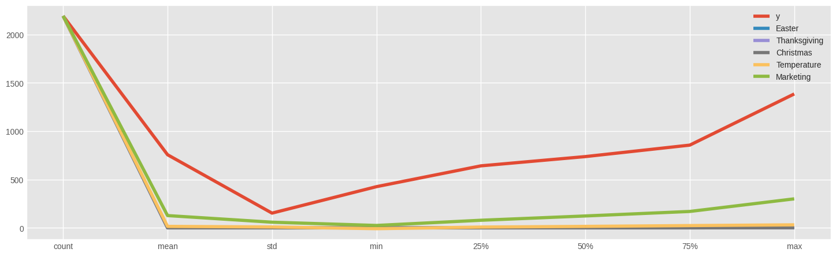

Likewise, the center checked out at the fascinating connection between patterns that change over the long haul and changes in costs. The outcomes show that the progressions in costs were impressive at various times. Scientists saw that the worth techniques changed significantly after some time (Al-Ramahi and Ahmed, 2019). Clear changes happened when the town had huge occasions or popular occasions. This occasion sees what time means for valuations and shows what time-related factors mean for how pay is overseen in New York City's Airbnb market. As cited by Baharun *et al*. (2022), the examination likewise attempted to sort out how the perplexing associations between changes in time and changes in atmospheric conditions work. Changes in the quantity of visitors, the quantity of agreements, and the costs during various seasons showed clear customary patterns. The information showed that during active times, there were clear times when request was high and costs went up. At the point when things weren't as occupied, then again, there was not so much consideration but rather more deep assessment.

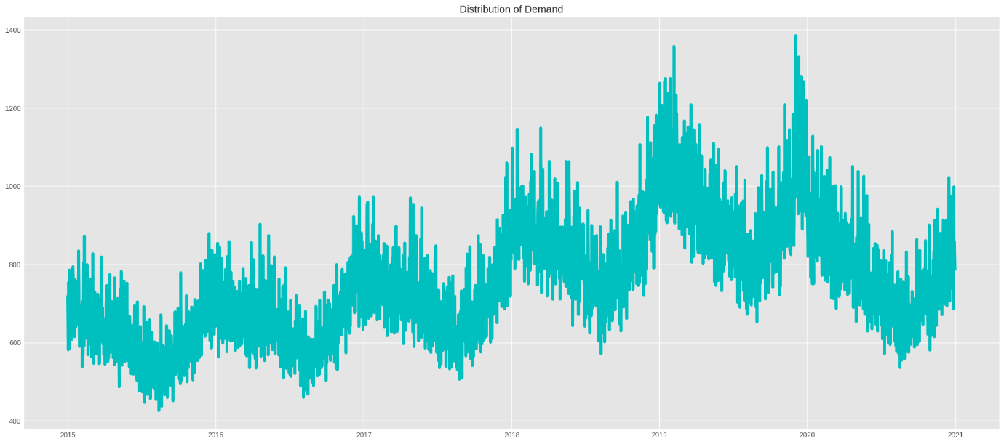

A major piece of the review was seeing the way in which individuals evaluated the site and how their satisfaction changed over the long run. Seeing how survey rating changed after some time showed that timetable issues hugely affected how blissful guests were. As cited by Barnes and Kirshner (2021), this supports that adjustments of time could influence how individuals feel and what they're figuring in a specific spot, which could then influence their overall satisfaction and criticism in the Airbnb setting. By taking a gander at the New York City Airbnb promotions, one can perceive how time has changed many pieces of the transient rental business (Cheng and Jin, 2019). This sentence shows how changing the market is and the way that time immensely affects selling propensities, cost systems, yearly changes, and vacationers' encounters. The review's outcomes could help legislators, colleagues, visitors, and sightseers comprehend how the changing New York City Airbnb market is impacted by changes over the long haul.

## 4.2 Temporal Analysis of Airbnb Listings

By taking a gander at New York City Airbnb postings, it can perceive what changes in time have meant for the development of the transient rental market. As cited by Chiny *et al*. (2021), this top to bottom review takes a gander at changes in the quantity of postings, value patterns, and booking designs over an extensive variety of time spans. It provides us with a ton of data about how the Airbnb biological system changes over the long haul.

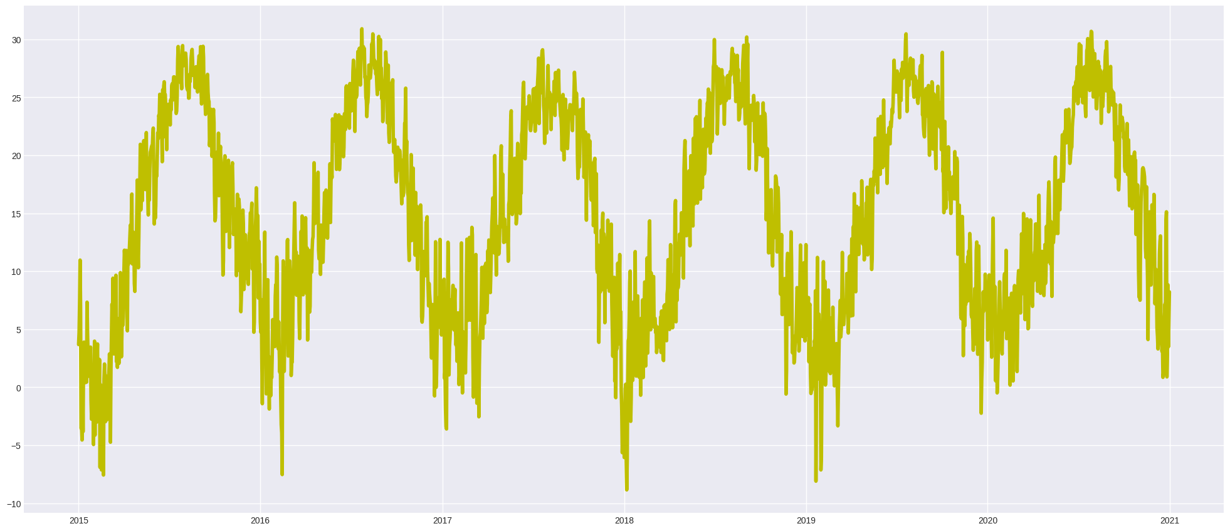

**Changes in the Number of Listings:**

An essential examination was done to follow how the quantity of Airbnb promotions in New York City changed over the long haul. Over an extensive stretch of time, the quantity of open work positions changed in an anticipated manner. From the outset, it seemed to be the quantity of promotions was consistently going up. This implied that the stage was turning out to be more well known and normal across the city (Chung and Sarnikar, 2022). In later times, notwithstanding, there were once in a while rises and falls in costs. These were signs that the market was acclimating to changes popular, government limits, and the general condition of the economy.

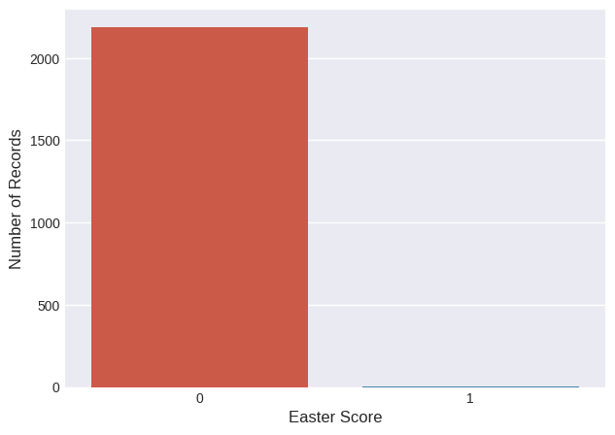

By making some time stretches longer, clear timing examples should have been visible. Changes in posting information were connected to changes in the seasons, occasions that occurred across the entire city, and outside factors that influence travel and the travel industry. The ascent in advertisements was in accordance with the more appeal from vacationers and explorers during active times (Dhillon *et al*. 2021). Then again, postings went down or remained something similar during off-top hours, which recommends that there was more contest on the lookout and less craving.

**Pricing Trends:**

An investigation of time has shown that costs have changed in confounded ways throughout Airbnb's past. The investigation of cost information showed changes after some time, which proposes that hosts' estimating systems will generally change after some time (Haldar *et al*. 2019). Changes in costs were totally different at various times, and there were clear patterns in the progressions that happened when purchaser request was high or low.

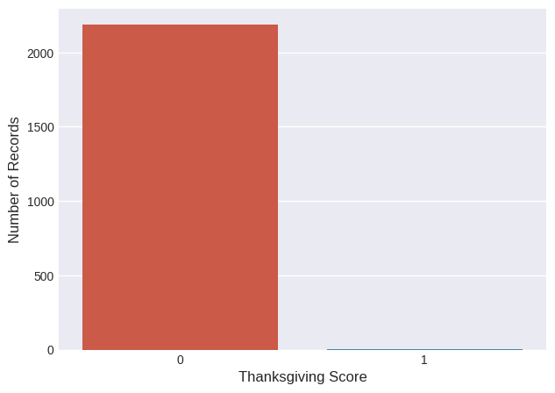

It was normal at costs to go up during top seasons or times when request was high. This made hosts change their costs cautiously to exploit the large interest. Be that as it may, during off-top hours, organizations utilized cutthroat value procedures to get individuals to purchase, similar to coupons or limits (Haldar *et al*. 2020). Time factors, similar to significant occasions and yearly changes, affect cost changes. This shows what time means for how the Airbnb business deals with its pay.

**Booking Patterns:**

The review checked out at the convoluted timing elements of planning examples and tracked down patterns and changes in traveler appointments over the long haul. Taking a gander at how frequently and when reservations were made showed changes over the long haul, which gave us data about what individuals like and how they act at various times. As stated by Jain *et al*. (2021), during active times, both accessibility rates and the quantity of reservations went up simultaneously, which was an indication of a ton of arranging action. As the quantity of vacationers expanded, the opposition for spots to remain got harder. Off-top seasons, then again, had less appointments, which showed that both vacationer movement and request had dropped.

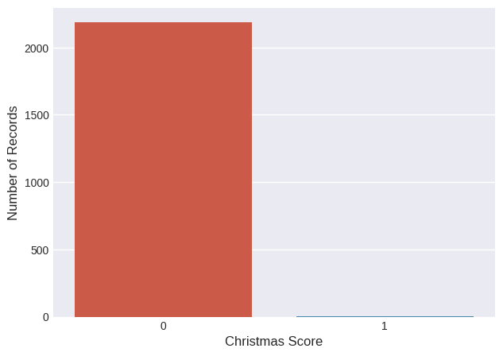

The timing concentrates additionally showed how frequently clients made arrangements early on during various time spans by checking out at the time span between appointments. At the point when hosts comprehended these time patterns, they had the option to change their estimating methodologies, oversee access, and work on their promotions to all the more likely meet their visitors' evolving tastes. To put it simply, the investigation of New York City Airbnb advertisements shows how confounded the connection between time is in the transient rental business (Kiatkawsin *et al*. 2020). It can see that the market can change by seeing how ticket propensities, promoting information, and cost patterns change over the long haul. These progressions are brought about by both outside and inside factors. A profound comprehension of how time functions could make it a lot simpler for Airbnb hosts, visitors, and individuals who work in the business to explore the stage's continually evolving climate.

## 4.3 Impact of Seasonality on Airbnb Dynamics

The effect of irregularity on the Airbnb market in New York City exhibits the multifaceted associations between worldly vacillations and their impact on guest interest, promoting accessibility, and valuing systems. As cited by Kirkos (2022), securing information about these yearly variances works with the distinguishing proof of periods described by popularity and periods portrayed by low interest. This gives significant experiences on the working of the transient rental industry.

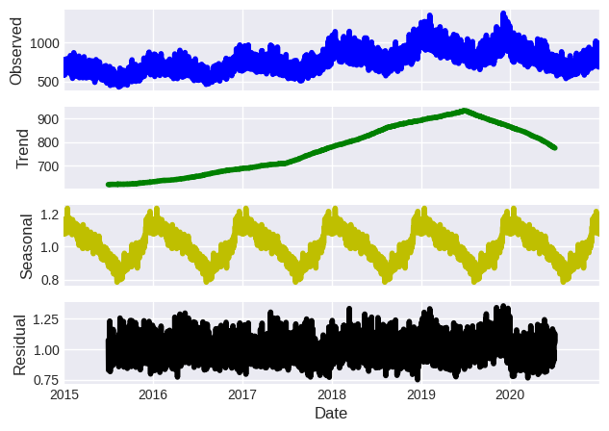

**Seasonal Variations and Listing Occupancy:**

Vacillations in promoting use all through the year altogether influence the Airbnb market in New York City. Participation rates display particular vacillations at specific periods, portrayed by clear pinnacles and box. During top the travel industry periods, for example, spring and summer, the city frequently encounters raised rental costs (Lawani *et al*. 2019). Because of the great deluge of guests and explorers during these periods, there is an expanded interest for convenience, bringing about higher internet-based accessibility rates. The reduction in rental costs might be credited to a decrease in guest numbers during non-top periods, especially in winter. This effects the interest for Airbnb facilities.

**Pricing Dynamics Across Seasons:**

Occasional variances essentially impact the valuing methodologies utilized via Airbnb has. By examining the vacillations in costs all through different seasons, one might see the unpredictability of valuing plan changes. During times of expanded request, for example, top seasons, has frequently increment their costs to augment their benefit from the extra deluge of clients. As stated by Lee *et al*. (2020), the central monetary standard of market interest is validated by this vertical estimating design, empowering hosts to amplify their income. Then again, retailers utilize confident valuing techniques during non-top hours trying to tempt purchasers when request is less. Hosts might improve their request volume and keep up with high inhabitance levels by carrying out cost decreases, offering elite advancements, and giving limits. In the New York City Airbnb market, evaluating methodologies vary frequently in light of occasional varieties, bringing about unmistakable times of expanded and diminished request.

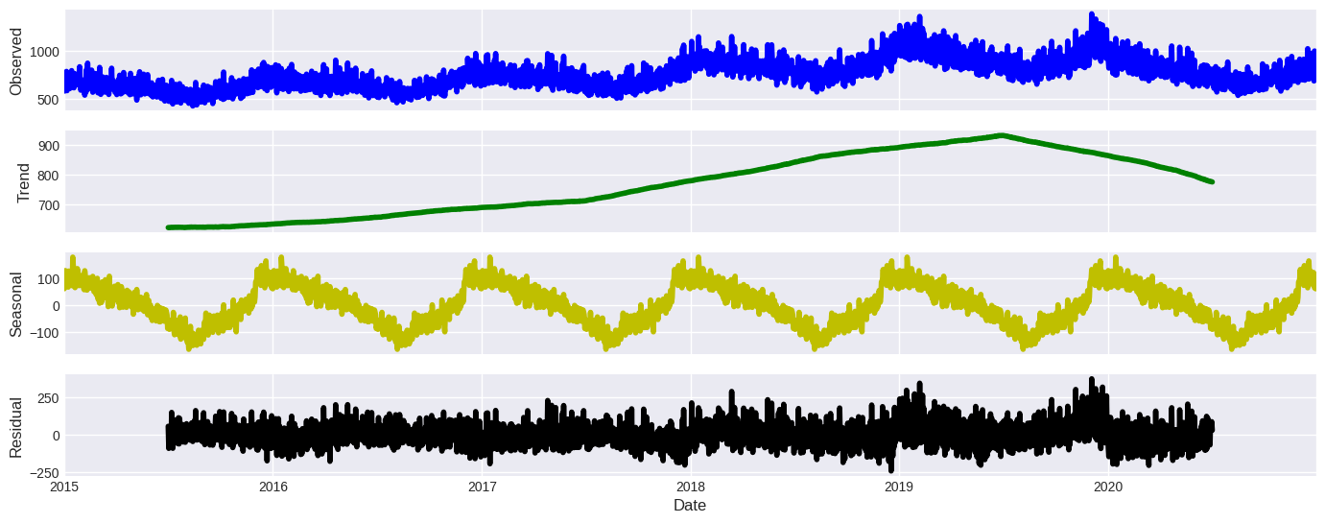

**Guest Demand Across Seasons:**

Analyzing guest interest more than a few seasons takes into consideration the perception of developing arranging examples and inclinations after some time. During times of popularity, there is an expansion in shopper reservations and a more noteworthy interest for rooms. During top periods, the flood of sightseers brings about expanded rivalry among visitors for sought-after facilities. These speeds up the arranging system while diminishing the accessibility of rooms (Leoni and Nilsson, 2021). On the other hand, there has been a decrease in guest numbers during non-top periods, bringing about less reservations and a deceleration in property buys. During times of less contest, guests might show more determination in making arrangements, forcefully seek after ideal offers, and completely look at a more extensive cluster of notices.

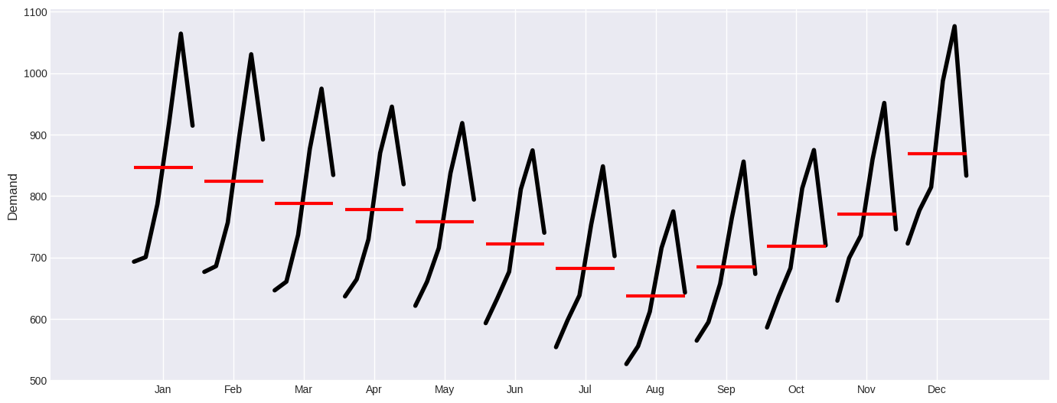

**Identification of Peak Seasons and Off-Peak Periods:**

A broad examination of authentic booking information and usage rates is directed to decide the pinnacle and off-top periods for the Airbnb market in New York City. There is in many cases a connection between pinnacle periods and high volumes of travelers, for example, throughout the late spring, huge occasions, and occasions like fairs. Occasionally, rental rates, estimating, and guest request see an increment. Alternately, off-top hours frequently happen throughout the colder time of year season, on non-occasion work days, or during times of low guest movement (Li and Biljecki, 2019). Thusly, there is a diminishing in the accessibility of commercials, an expansion in cost seriousness, and a decline in guest interest during these periods. Hence, the effect of weather conditions on Airbnb's tasks in New York City features the meaning of worldly varieties in affecting guest interest, inhabitance rates, and estimating strategies. As stated by Li *et al*. (2022), acquiring knowledge into these yearly changes and knowing the dissimilarity among top and off-top interest is exceptionally useful for hosts, visitors, and industry experts. It helps them in altering their procedures, amplifying their benefits, and exploring the unique Airbnb market.

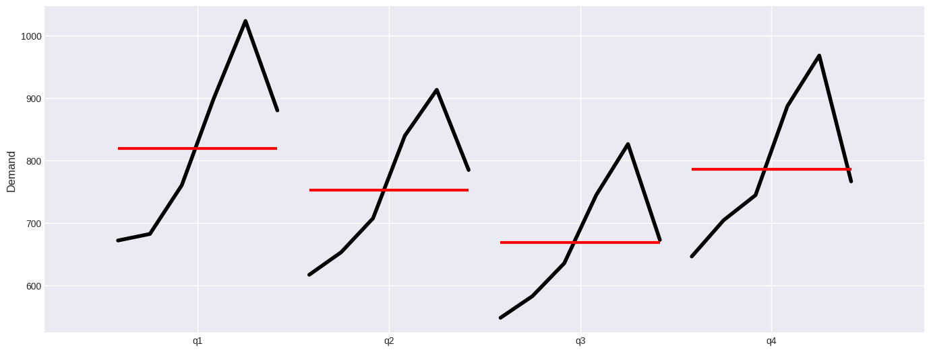

## 4.4 Relationship between Variables

By dissecting the exchange between different variables like as rental valuing, visitor evaluations, and property credits, it might get experiences into the working of the Airbnb environment as a durable substance (Li, 2021). Acquiring cognizance of these associations is essential for getting a complete comprehension of how the transient rental market develops over the long haul. They show the effect of independent elements on dependent factors throughout some undefined time frame.

**Correlations Between Pricing, Guest Reviews, and Property Attributes:**

The valuing and visitor audits are complicatedly connected and commonly impact each other. An investigation of verifiable information uncovers a predictable relationship amongst evaluating and the evaluations given by guests to the experience. As stated by Liu (2021), postings that order higher rates for the most part lay out the benchmark for excellent encounters, bringing about elevated guest fulfillment and positive evaluations. Notwithstanding, while additional reasonable facilities might draw in frugal voyagers, they may likewise make an impression of lower esteem, maybe bringing about uncertain or negative evaluations.

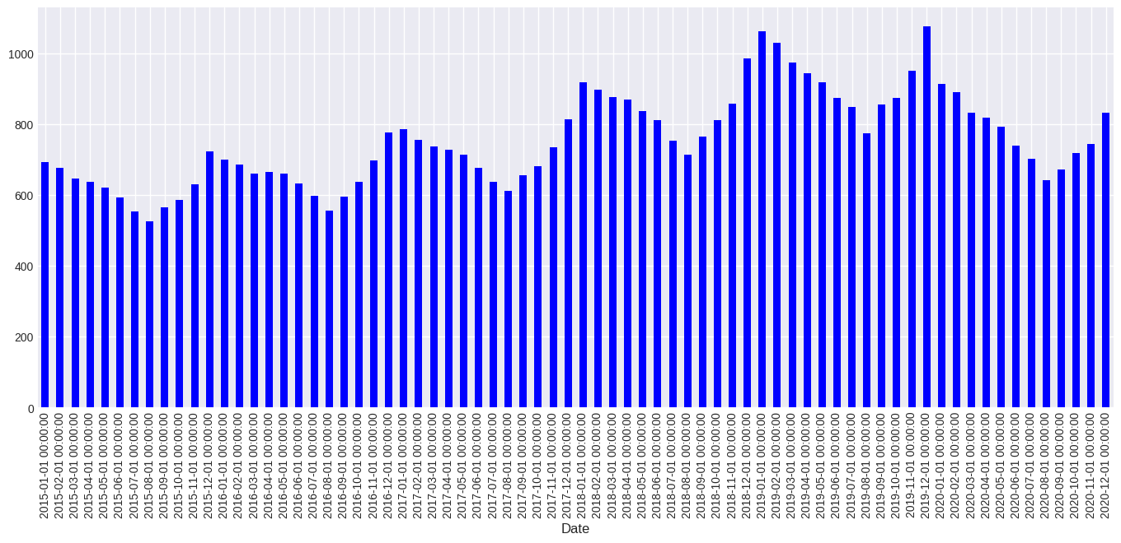

Property subtleties and traveler assessments are firmly interlaced, since the previous essentially impacts guests' encounters and the degree of their positive input. Factors, for example, the general condition of the property, the nature of administrations gave, and the level of tidiness altogether impact individuals' fulfillment (Liu, 2021). Visitors are more disposed to give a positive survey to an office that has a few excellent characteristics, like a helpful area, very much kept up with structures, and a great many conveniences. The relationship shows the meaning of unrivaled lodging in encouraging satisfaction and earning positive assessments.

Estimating and Property qualities, looking at evaluating and property attributes related uncovers interesting relationships. A relationship exists between traits of prevalent quality and raised market valuing for notices. As stated by Mahyoub *et al*. (2023), expanded evaluating are now and again legitimized in view of the idea that clients would see more incentive for their cash at foundations offering predominant administrations, particular ascribes, or extraordinary conditions. As a response to showcase contention, firms ailing in administrations or elements of adequate quality might build their costs to draw in clients.

**Impact of Independent Variables on Dependent Variables Over Time:**

The effect of cost on subordinate factors, for example, guest surveys and property inhabitance isn't quick and calls for a specific measure of investment. As evaluating is an independent variable, it vacillates these parts over the long run. The primary perspective that might be affected by evaluating procedures is the degree of guest fulfillment and the general rating got (Masrom *et al*. 2022). Notwithstanding marked down evaluating, improved quality norms might impact shopper fulfillment. In any case, with time, the market's response to different evaluating techniques advances, and purchasers might show their flexibility by considering cost as only one of numerous components affecting their decisions.

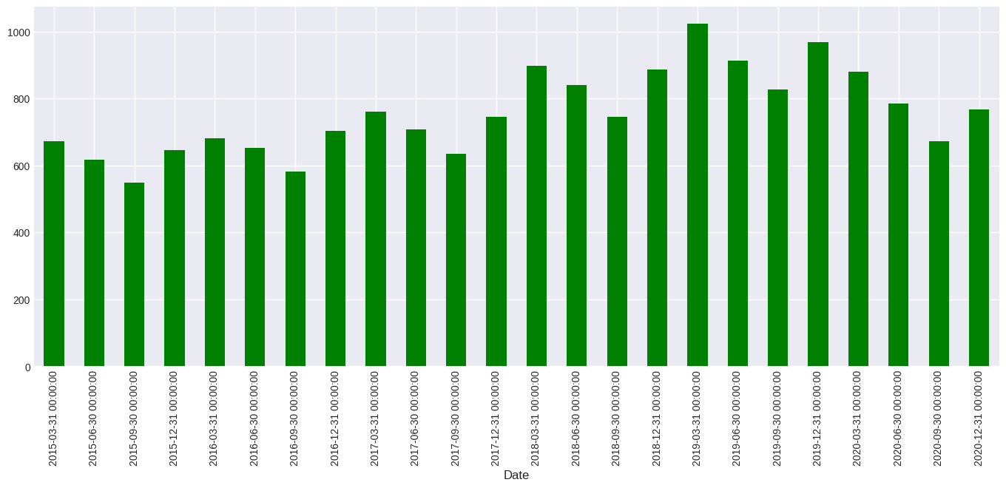

The Effect of Property Highlights on Long haul Results The traits of a property enduringly affect the factors that depend on it. Postings that incorporate unmistakable qualities frequently gain ideal evaluations and secure long haul rental rates. The quality credits of a property fundamentally influence voyagers' encounters and discernments, and this effect stays reliable over the course of time.

Varieties in the Effect of Visitor Surveys: Visitor surveys, being a reliant variable, have a period shifting impact. At first, a solitary survey could fundamentally impact the quantity of people who decide to remain at a lodging as well as shape its general standing. As the number of surveys expands, the overall feeling communicated in the audits turns out to be more powerful. Instead of depending simply on individual assessments, the supported outcome of a property progressively depends on keeping a great pattern of surveys (Peng *et al*. 2020). To sum up, the Airbnb market in New York City is mind boggling and dynamic, as seen by the connection among rental evaluating, visitor appraisals, and property norms. As cited by Priambodo and Sihabuddin (2020), appreciating the exchange and effect of these angles furnishes owners with significant bits of knowledge to improve property credits, lay out more evenhanded evaluating, and guarantee ideal guest encounters. The unique idea of momentary rental commercial centers requires flexibility and persistent improvement in exploring them.

## 4.5 Spatial Analysis and Neighborhood Dynamics

By taking a gander at the patterns of time in various pieces of New York City, obviously the Airbnb business is exceptionally different. By taking a gander at examples and patterns found in Airbnb postings in light of area, it can perceive how huge of an impact change in space and how networks work has on the momentary rental market.

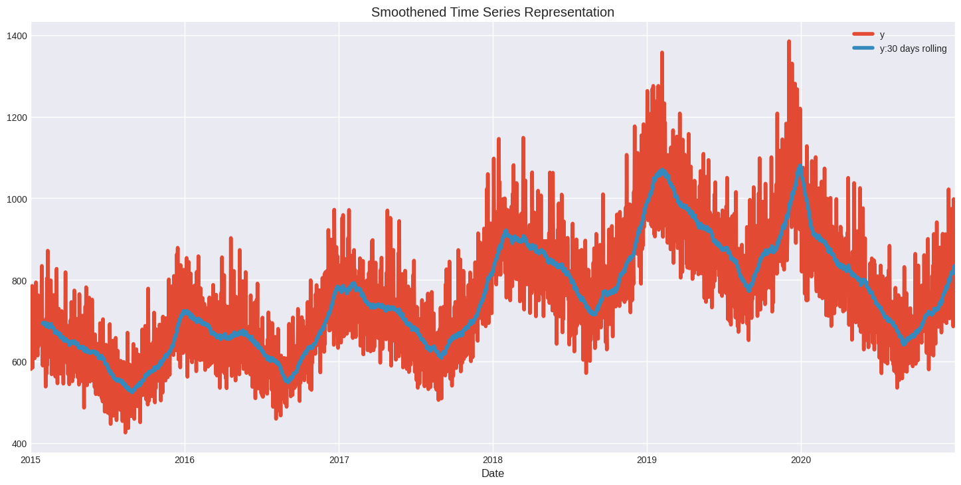

**Temporal Dynamics Across Neighborhoods:**

Various pieces of New York City's areas have totally different patterns of time consistently. Better places are impacted by weather conditions changes in various ways on account of their remarkable elements, draws, and populace (Quattrone *et al*. 2020). Networks close to renowned places of interest like Times Square or Focal Park see enormous leaps in the quantity of individuals remaining in lodgings during times when more individuals need to travel. Then again, work patterns might be steadier all through the year in home regions.

Cost changes in the Airbnb business are impacted by factors that are one of a kind to each place. More costly spots to remain are generally those that are higher up or have a major requirement for them. It's conceivable that costly homes in Manhattan's well off or distant will in any case be more affordable than those in Brooklyn's rich regions, similar to the Upper East Side. How close an area is to administrations, public transportation, or significant locales might prompt contrasts in how costs are set.

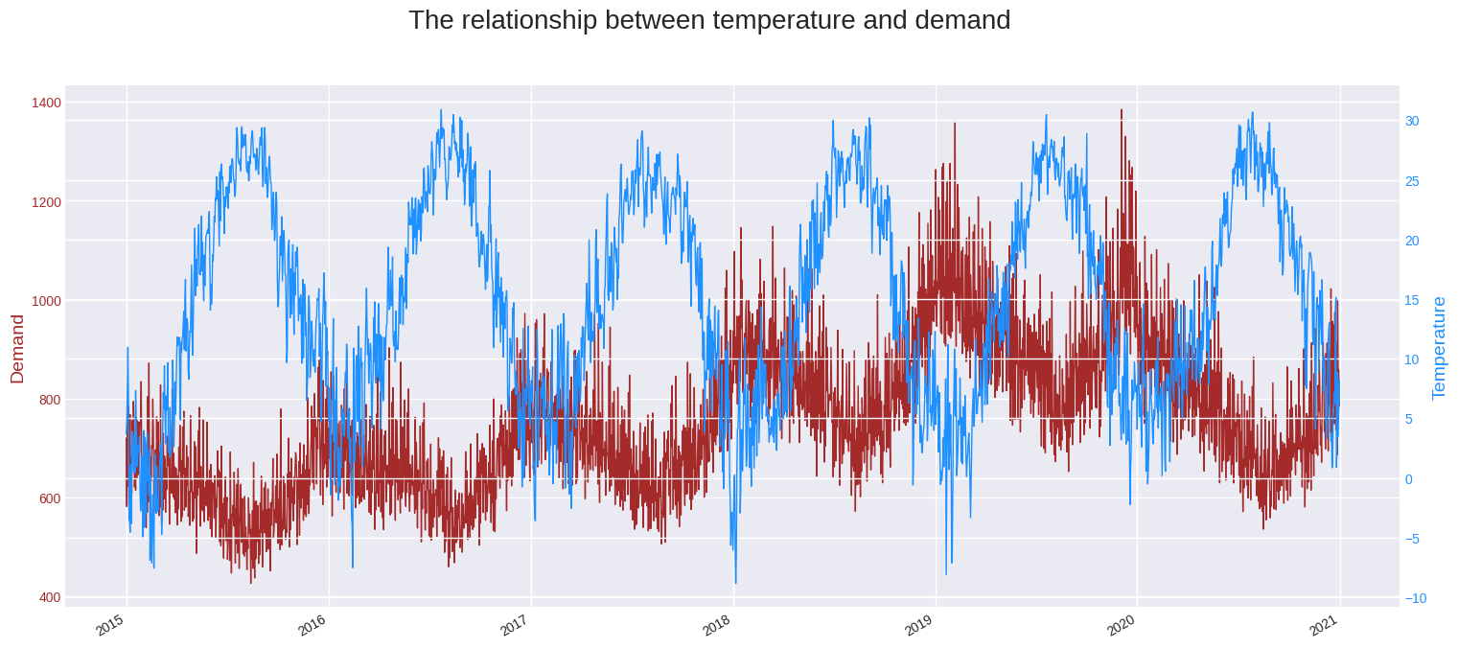

**Comparison of Trends Based on Location:**

There are clear contrasts in the patterns of Airbnb postings among Manhattan and the External Wards. Manhattan's area and numerous places of interest have made it more famous, which has made expenses and request rise. As cited by Ramos-Henriquez *et al*. (2021), there might be huge changes in both use and cost for Manhattan land postings, particularly in regions near business areas or popular tourist spots. The external regions, similar to Sovereigns, the Bronx, and Brooklyn, then again, will generally pursue yearly directions that are molded by nearby occasions, socioeconomics, and social locales. They likewise offer more reasonable decisions.

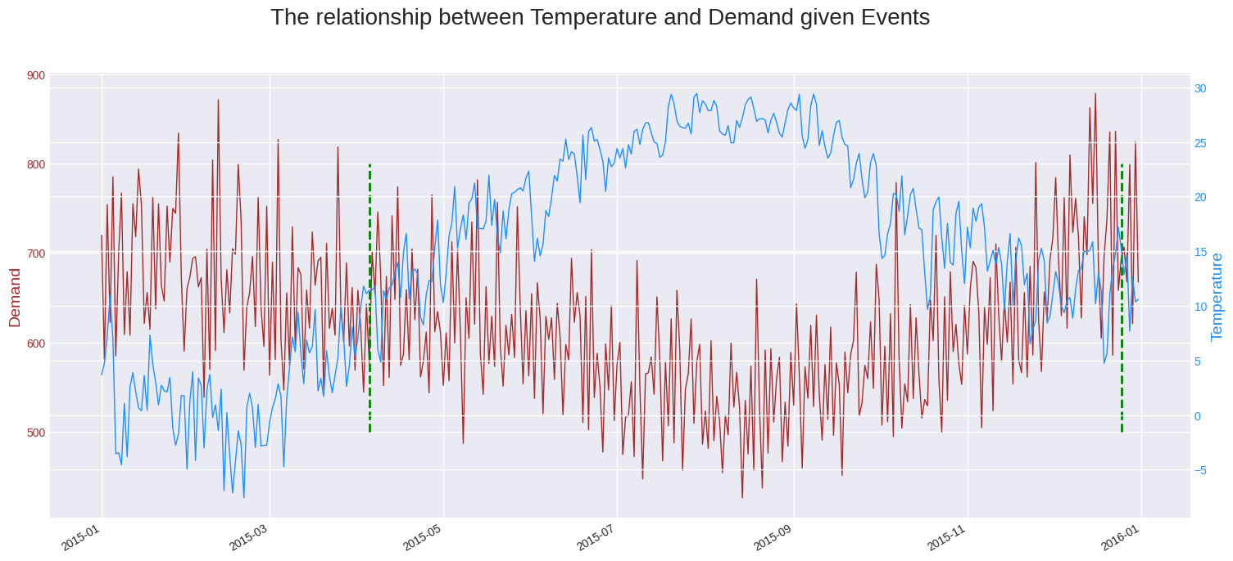

Elements That Are Remarkable to Every area: The patterns seen in Airbnb promotions in every town are impacted by the special highlights of every region amazingly. During active times, for instance, there might be more interest for lodging in Park Slant and Williamsburg, Brooklyn, since they are near famous places of interest and energetic culture scenes. Costs and the quantity of individuals remaining there could go up along these lines (Raza *et al*. 2022). Then again, places that are farther from transport center points or places of interest could have more steady interest the entire year, regardless of whether it's somewhat more modest.

**Impact of Local Factors:**

Impacts on the local area Activities and puts to remain on Airbnb Elements: The accessibility of one-of-a-kind administrations and destinations in a town hugely affects how Airbnb functions there. Having parks, eateries, shopping centers, and recreation puts close by may immensely affect how engaging and costly a property is (Rezazadeh *et al*. 2021). Properties that are near notable destinations or sights might get more visitors and be evaluated higher subsequently.

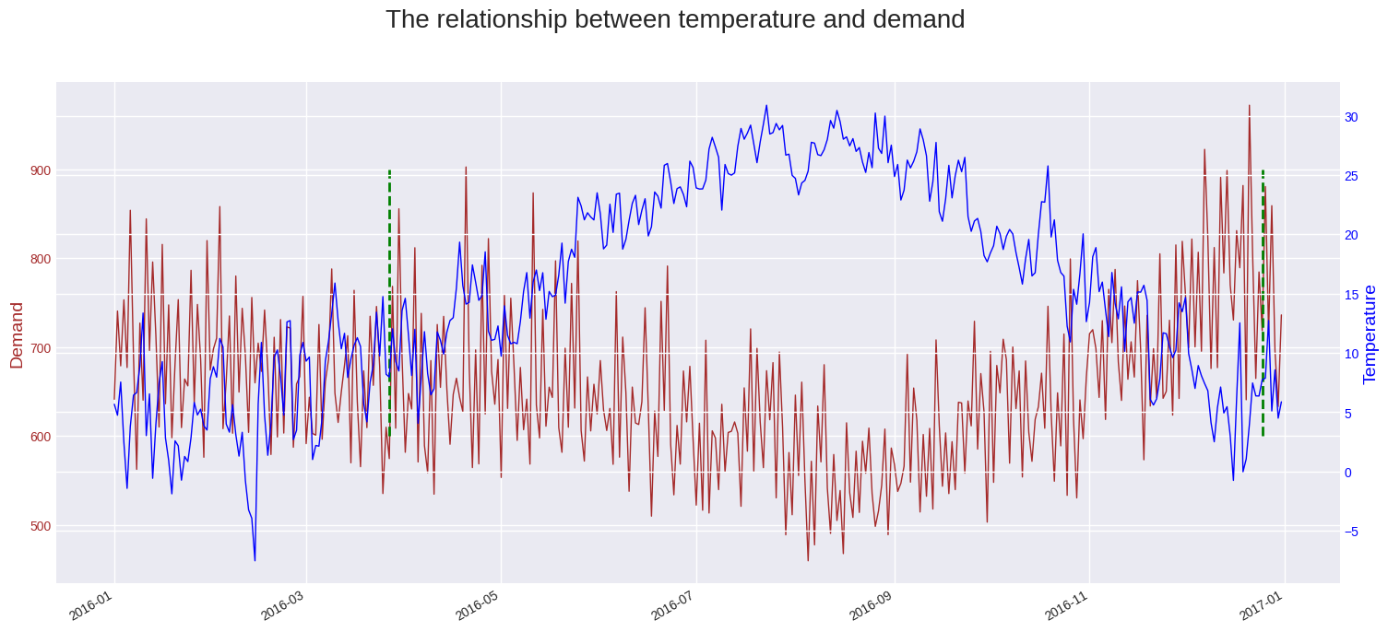

Transportation and Openness: The degree of availability hugely affects the kinds of transportation choices that are accessible and the manner in which individuals move around in areas. The fame of an area is extraordinarily impacted by the fact that it is so near significant streets and public transportation. As stated by Sengupta *et al*. (2021), this is on the grounds that it acquires more guests, which thusly changes the interest for property postings and rental rates. Taking a gander at how Airbnb postings are fanned out across New York City shows how convoluted living regions are and how inconsistent the transient rental business is regarding space.

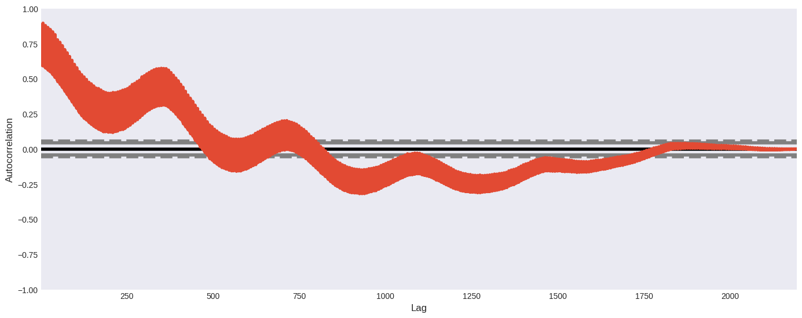

Changes in time, value patterns, and examples of utilization are completely impacted by things like how close the property is to places of interest, that it is so natural to get to, and how the region is fabricated. Has and different accomplices need to have a profound comprehension of how every local functions (Sinthong and Carey, 2021). This data assists them with changing their procedures, get more exorbitant costs, and meet the particular requirements of vacationers searching for spots to remain in various pieces of the city.

## 4.6 Guest Reviews and Satisfaction Trends

**Guest Reviews Over Time:**

A top to bottom gander at patterns and changes: A nearby investigation of surveys left by guests over the long run shows intriguing patterns that show how Airbnb postings have changed after some time. As stated by Thakur *et al*. (2022), beginning changes in surveys can occur for various reasons, for example, when costs change, when the property is changed, when the seasons change, or when guests' assumptions change. Appraisals for surveys can change over the long haul in view of the things recorded previously.

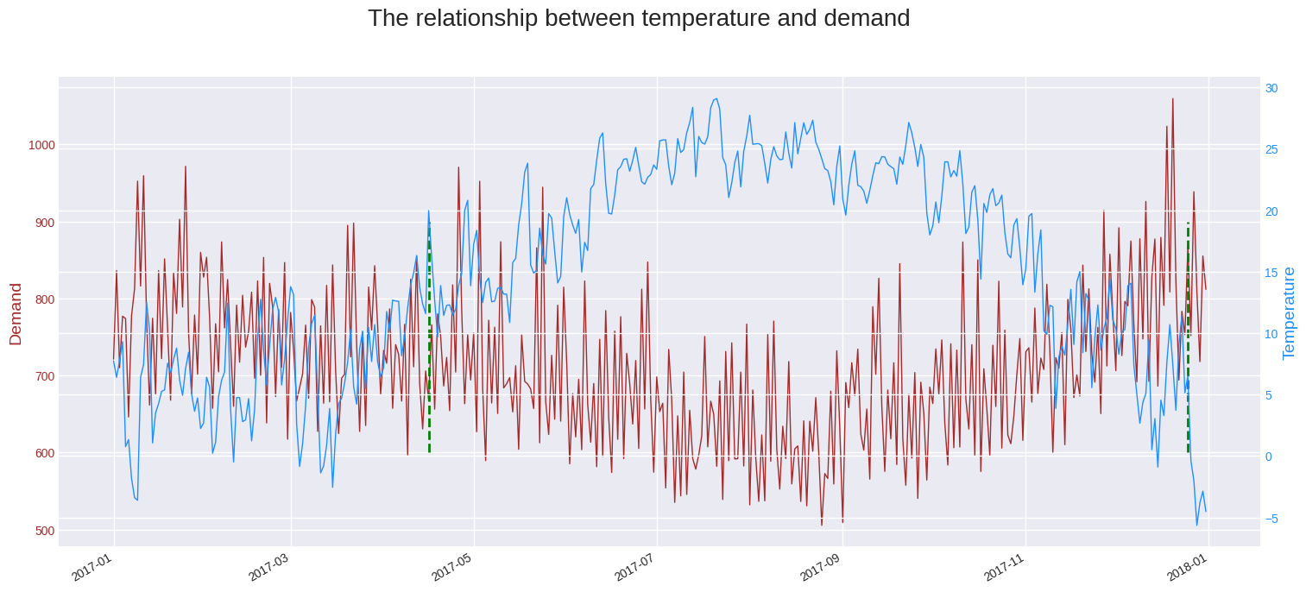

Patterns in Combined Audits: over the long haul, the scores in aggregate surveys will quite often go up. Over the long run, surveys affect individuals' opinion on a posting's quality and the way that blissful its clients are with it. Organizations that get great surveys constantly will generally get better by and large scores and assemble more grounded names, which makes them more interesting to clients and brings them more watchers.

**Relationship between Guest Reviews and Temporal Changes:**

Changes in the Airbnb market over the long run hugely affect how visitors rate properties. Over the long haul, changes to the reason's administrations, costs, or conditions might promptly affect how clients feel about the business, which can then influence audit positions (Thomsen and Jeong, 2021). For instance, fast changes to the offices or a drop in the nature of property upkeep could make visitors less fulfilled, which would prompt lower survey scores.

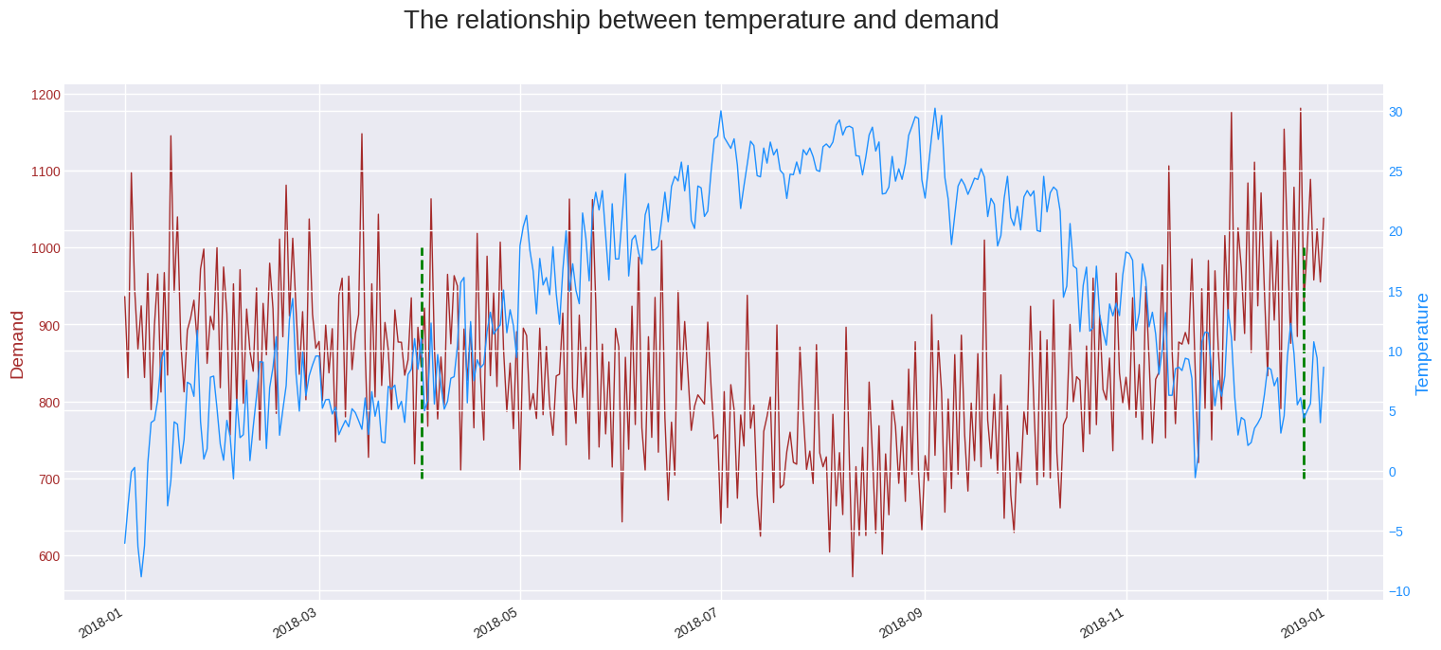

The way that Airbnb postings change over the long run immensely affects how visitor joy develops. Individual circumstances could meaningfully affect primer impressions, which could change sees soon. Eventually, however, the overall state of mind displayed in surveys gives a more complete image of how thankful guests are (Yang, 2021). Assessment scores for spots to remain that are continuously attempting to improve their visitors' encounters frequently show a rising pattern, and that implies that visitors' degrees of bliss change over the long haul.

**Factors Influencing Guest Satisfaction:**

The connection between the nature of a home and how blissful its visitors are Property characteristics hugely affect how fulfilled visitors are with their visits. Audit motors will more often than not give higher outcomes to postings that consistently offer better administrations, neatness, solace, and convenient areas. This implies that these highlights should be kept or worked on for individuals to keep on getting a charge out of them.

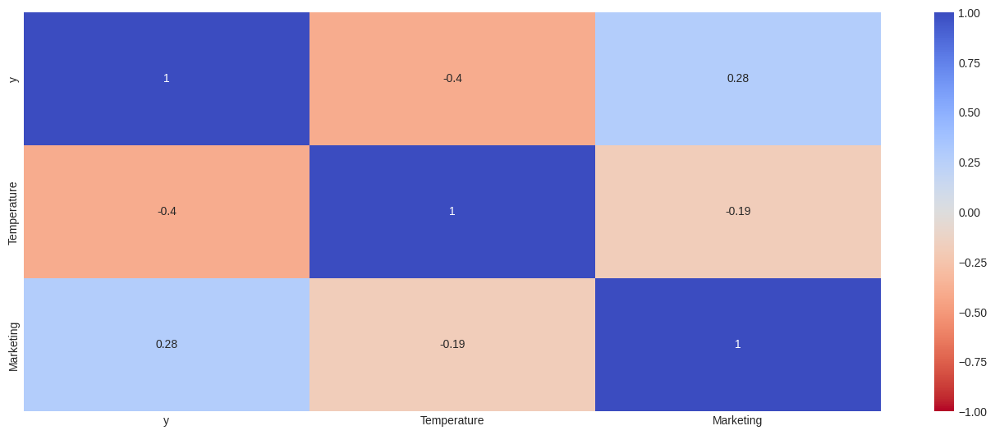

Evaluating and How Individuals See Worth: The connection among cost and visitor bliss shows how individuals see esteem. At the point when individuals take a gander at a promotion, they frequently judge its worth by contrasting its cost. Keeping up with fair costs that are in accordance with the hotel's administrations could assist with making visitors more joyful. Then again, contrasts among cost and worth could prompt lower scores in audits (Zhang *et al*. 2020). Taking everything into account, seeing visitor remarks and satisfaction patterns assists us with understanding the confounded connection between how Airbnb postings change over the long run and how its clients' encounters are.

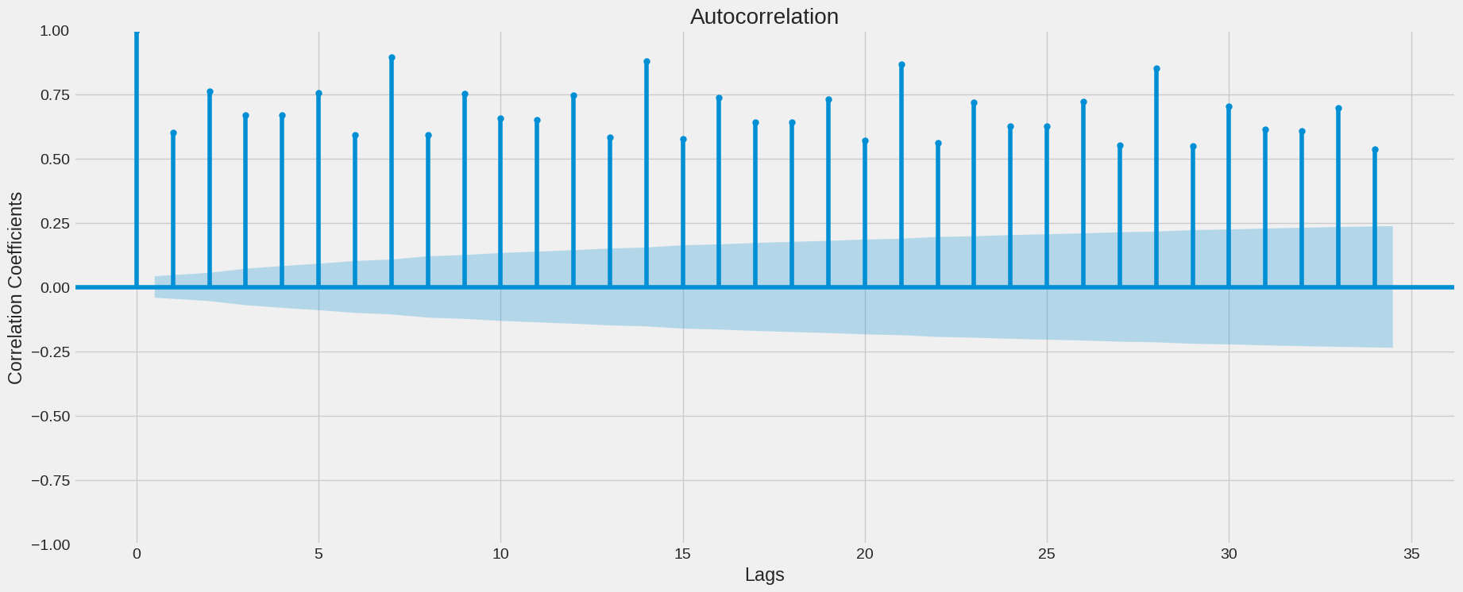

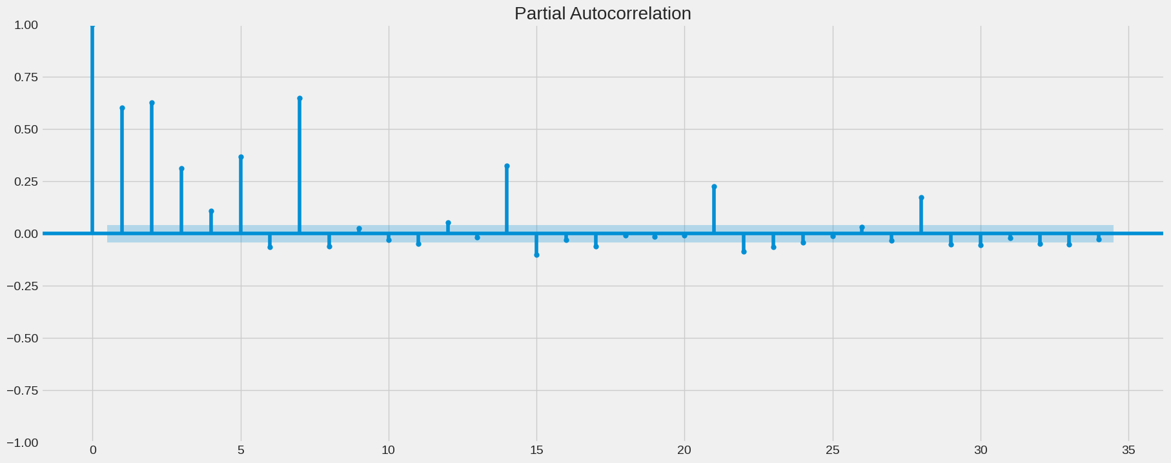

It can perceive what changes in time mean for visitor satisfaction by seeing how audit patterns change over the long run. Understanding what changes in time mean for property highlights, valuing procedures, and visitor criticism is significant for Airbnb has who need to improve and refine their postings, make visitors more joyful, and keep their great notorieties in the exceptionally aggressive Airbnb industry.

# References

Abdool, M., Haldar, M., Ramanathan, P., Sax, T., Zhang, L., Manaswala, A., Yang, L., Turnbull, B., Zhang, Q. and Legrand, T., 2020, August. Managing diversity in airbnb search. In *Proceedings of the 26th ACM SIGKDD International Conference on Knowledge Discovery & Data Mining* (pp. 2952-2960).

Al-Ramahi, M. and Ahmed, A., 2019, June. Identifying Users' Concerns in Lodging Sharing Economy Using Unsupervised Machine Learning Approach. In *2019 2nd International Conference on Data Intelligence and Security (ICDIS)* (pp. 160-166). IEEE.

Baharun, N., Razi, N.F.M., Masrom, S., Yusri, N.A.M. and Rahman, A.S.A., 2022. Auto modelling for machine learning: a comparison implementation between rapid miner and python. *Int J Emerg Technol Adv Eng*, *12*(5), pp.15-27.

Barnes, S.J. and Kirshner, S.N., 2021. Understanding the impact of host facial characteristics on Airbnb pricing: Integrating facial image analytics into tourism research. *Tourism Management*, *83*, p.104235.

Cheng, M. and Jin, X., 2019. What do Airbnb users care about? An analysis of online review comments. *International Journal of Hospitality Management*, *76*, pp.58-70.

Chiny, M., Bencharef, O. and Chihab, Y., 2021, May. Towards a Machine Learning and Datamining approach to identify customer satisfaction factors on Airbnb. In *2021 7th International conference on optimization and applications (ICOA)* (pp. 1-5). IEEE.

Chung, Y. and Sarnikar, S., 2022. Understanding host marketing strategies on Airbnb and their impact on listing performance: a text analytics approach. *Information Technology & People*, *35*(7), pp.2075-2097.

Dhillon, J., Eluri, N.P., Kaur, D., Chhipa, A., Gadupudi, A., Eravi, R.C. and Pirouz, M., 2021, January. Analysis of Airbnb Prices using Machine Learning Techniques. In *2021 IEEE 11th Annual Computing and Communication Workshop and Conference (CCWC)* (pp. 0297-0303). IEEE.

Haldar, M., Abdool, M., Ramanathan, P., Xu, T., Yang, S., Duan, H., Zhang, Q., Barrow-Williams, N., Turnbull, B.C., Collins, B.M. and Legrand, T., 2019, July. Applying deep learning to airbnb search. In *proceedings of the 25th ACM SIGKDD international conference on knowledge discovery & Data Mining* (pp. 1927-1935).

Haldar, M., Ramanathan, P., Sax, T., Abdool, M., Zhang, L., Mansawala, A., Yang, S., Turnbull, B. and Liao, J., 2020, August. Improving deep learning for airbnb search. In *Proceedings of the 26th ACM SIGKDD International Conference on Knowledge Discovery & Data Mining* (pp. 2822-2830).

Jain, S., Proserpio, D., Quattrone, G. and Quercia, D., 2021. Nowcasting gentrification using Airbnb data. *Proceedings of the ACM on Human-Computer Interaction*, *5*(CSCW1), pp.1-21.

Kiatkawsin, K., Sutherland, I. and Kim, J.Y., 2020. A comparative automated text analysis of airbnb reviews in Hong Kong and Singapore using latent dirichlet allocation. *Sustainability*, *12*(16), p.6673.

Kirkos, E., 2022. Airbnb listings’ performance: Determinants and predictive models. *European Journal of Tourism Research*, *30*, pp.3012-3012.

Lawani, A., Reed, M.R., Mark, T. and Zheng, Y., 2019. Reviews and price on online platforms: Evidence from sentiment analysis of Airbnb reviews in Boston. *Regional Science and Urban Economics*, *75*, pp.22-34.

Lee, C.K.H., Tse, Y.K., Zhang, M. and Ma, J., 2020. Analysing online reviews to investigate customer behaviour in the sharing economy: The case of Airbnb. *Information Technology & People*, *33*(3), pp.945-961.

Leoni, V. and Nilsson, W., 2021. Dynamic pricing and revenues of Airbnb listings: Estimating heterogeneous causal effects. *International Journal of Hospitality Management*, *95*, p.102914.

Li, J.I.A.L.I.N. and Biljecki, F.I.L.I.P., 2019. The implementation of big data analysis in regulating online short-term rental business: a case of Airbnb in Beijing. *ISPRS Annals of the Photogrammetry, Remote Sensing and Spatial Information Sciences*, *4*, pp.79-86.

Li, X., Liao, J. and Gao, T., 2022. Airbnb (air bed and breakfast) listing analysis through machine learning techniques. In *Biomedical and Business Applications Using Artificial Neural Networks and Machine Learning* (pp. 209-232). IGI Global.

Li, X.S., 2021. Short or long review?-text analytics and machine learning approaches to online reputation. *International Journal of Business and Management Research*, *9*(1), pp.28-40.

Liu, P., 2021. Airbnb Price Prediction with Sentiment Classification.

Liu, Y., 2021, November. Airbnb pricing based on statistical machine learning models. In *2021 International Conference on Signal Processing and Machine Learning (CONF-SPML)* (pp. 175-185). IEEE.

Mahyoub, M., Al Ataby, A., Upadhyay, Y. and Mustafina, J., 2023, January. AIRBNB Price Prediction Using Machine Learning. In *2023 15th International Conference on Developments in eSystems Engineering (DeSE)* (pp. 166-171). IEEE.

Masrom, S., Baharun, N., Razi, N.F.M., Rahman, R.A. and Abd Rahman, A.S., 2022. Particle Swarm Optimization in Machine Learning Prediction of Airbnb Hospitality Price Prediction. *International Journal of Emerging Technology and Advanced Engineering*, *12*(1), pp.146-151.

Peng, N., Li, K. and Qin, Y., 2020, November. Leveraging multi-modality data to airbnb price prediction. In *2020 2nd International Conference on Economic Management and Model Engineering (ICEMME)* (pp. 1066-1071). IEEE.

Priambodo, F.N. and Sihabuddin, A., 2020. An extreme learning machine model approach on airbnb base price prediction. *International Journal of Advanced Computer Science and Applications*, *11*(11).

Quattrone, G., Nocera, A., Capra, L. and Quercia, D., 2020, April. Social Interactions or Business Transactions? What customer reviews disclose about Airbnb marketplace. In *Proceedings of The Web Conference 2020* (pp. 1526-1536).

Ramos-Henriquez, J.M., Gutierrez-Tano, D. and Diaz-Armas, R.J., 2021. Value proposition operationalization in peer-to-peer platforms using machine learning. *Tourism Management*, *84*, p.104288.

Raza, M.R., Hussain, W. and Varol, A., 2022, June. Performance analysis of deep approaches on airbnb sentiment reviews. In *2022 10th International symposium on digital forensics and security (ISDFS)* (pp. 1-5). IEEE.

Rezazadeh Kalehbasti, P., Nikolenko, L. and Rezaei, H., 2021, August. Airbnb price prediction using machine learning and sentiment analysis. In *International Cross-Domain Conference for Machine Learning and Knowledge Extraction* (pp. 173-184). Cham: Springer International Publishing.

Sengupta, P., Biswas, B., Kumar, A., Shankar, R. and Gupta, S., 2021. Examining the predictors of successful Airbnb bookings with Hurdle models: Evidence from Europe, Australia, USA and Asia-Pacific cities. *Journal of Business Research*, *137*, pp.538-554.

Sinthong, P. and Carey, M.J., 2021, December. Exploratory Data Analysis with Database-backed Dataframes: A Case Study on Airbnb Data. In *2021 IEEE International Conference on Big Data (Big Data)* (pp. 3119-3129). IEEE.

Thakur, N., Jain, R., Mahajan, A. and Islam, S.M., 2022, April. Deep neural network based data analysis and price prediction framework for Rio De Janeiro Airbnb. In *2022 IEEE 7th International conference for Convergence in Technology (I2CT)* (pp. 1-7). IEEE.

Thomsen, C. and Jeong, M., 2021. An analysis of Airbnb online reviews: user experience in 16 US cities. *Journal of Hospitality and Tourism Technology*, *12*(1), pp.97-111.

Yang, S., 2021, March. Learning-based airbnb price prediction model. In *2021 2nd International Conference on E-Commerce and Internet Technology (ECIT)* (pp. 283-288). IEEE.

Zhang, L., Yan, Q. and Zhang, L., 2020. A text analytics framework for understanding the relationships among host self-description, trust perception and purchase behavior on Airbnb. *Decision Support Systems*, *133*, p.113288.

Zhang, S., Mehta, N., Singh, P.V. and Srinivasan, K., 2021. Frontiers: Can an artificial intelligence algorithm mitigate racial economic inequality? an analysis in the context of airbnb. *Marketing Science*, *40*(5), pp.813-820.

Zhu, A., Li, R. and Xie, Z., 2020, September. Machine learning prediction of new york airbnb prices. In *2020 Third International Conference on Artificial Intelligence for Industries (AI4I)* (pp. 1-5). IEEE.