**STUDENT ATTENDANCE PATTERN DETECTOR**

**A PROJECT REPORT**

***Submitted by***

**12324631,12324702,12322441,12405600**

***in partial fulfillment for the award of the degree***

***of***

**BACHELOR OF COMPUTER APPLICATION**



**Lovely Professional University, Punjab**

**16 JUNE 2025**

**BONAFIDE CERTIFICATE**

Certified that this project report **“Student Attendance Pattern Detector Using Set and Stack”** is the bonafide work of team “**T3”** who carried out the project work under my supervision.

**Dr. Shilpa Sharma , Dr. Chirag Sharma ,**

**Dr. Anshu Sharma**

**CLASS MENTOR**

**Gaurav Pushkarma**

**HEAD OF THE DEPARTMENT**

**TABLE OF CONTENTS**

|  |  |  |
| --- | --- | --- |
| **CHAPTER NO.** | **CHAPTER NAME** | **PAGE NO.** |
| **1.** | **Introduction** | **i** |
| **2.** | **Technologies Used** | **ii** |
| **3.** | **Data Structures Used** | **ii** |
| **4.** | **System Design and Flow** | **iv** |
| **5.** | **Java Code Explanation and Screenshots** | **v** |
| 6. | **User Interface (Screenshots)** | .. |
|  | **Fig 1: Student Registration and Attendance Marking** | .. |
|  | **Fig 2: Attendance Report and Export Interface** | … |
| 7. | **Conclusion** | .. |
| 8. | References | .. |

|  |  |  |  |  |
| --- | --- | --- | --- | --- |
|  |  |  | |  |
|  |  |  |  |  |
|  |  |  |  |  |
|  |  | |  |  |
|  |  | | |  |

**1. Introduction**

This project is a Java-based attendance management system designed to automate and simplify the process of tracking student attendance. It supports functions like marking attendance, undoing last entry, generating reports, and exporting data. It’s built to be accurate, easy-to-use, and suitable for educational institutions.

**2. Technologies Used**

- Java (JDK 17 or later)  
- Java Collections Framework  
- File Handling (I/O)  
- GUI: HTML/CSS interface  
- MS Word/Excel for reports

**3. Data Structures Used**

• Stack<Set<String>>:  
Used to store daily attendance. Each day’s attendance is pushed as a Set of IDs.

• HashSet<String>:  
Used to store unique student IDs for a given day (no duplicates).

• HashMap<String, Integer>:  
Used to count how many days each student was present for irregularity detection.

**4. System Design & Flow**

The system works in the following steps:  
1. Students are registered with ID and Name.  
2. On each day, present students are marked and saved in a Stack.  
3. Undo functionality allows removing the last attendance record.  
4. Attendance history can be viewed using the Stack.  
5. Students attending all days are found using Set intersection.  
6. Irregular students are found using HashMap and threshold comparison.  
7. Reports can be saved and exported to files.

Main Class: AttendancePatternDetector

**- Uses Stack<Set<String>> to store daily attendance.  
- recordAttendance(): Takes input for present students and stores in Stack.  
- viewAttendanceHistory(): Shows past attendance from Stack.  
- findConsistentStudents(): Uses Set operations to find students present all days.  
- findIrregularStudents(): Uses HashMap to count presence and compares with threshold.  
- searchStudentAttendance(): Finds days a student was present.  
- saveToFile()/loadFromFile(): For saving and restoring data.  
- undoLastEntry(): Removes last day's attendance.**

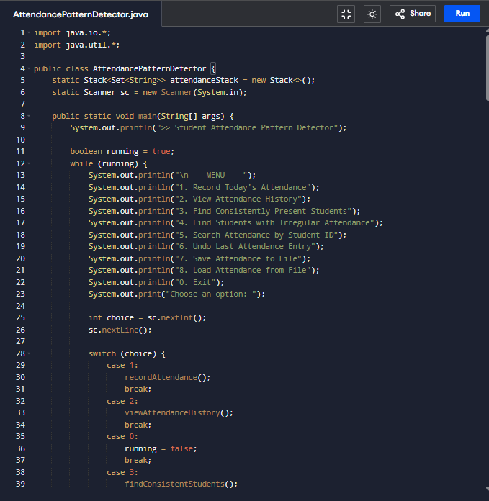

**5. Java Code Explanation & Screenshots**

Main Class: AttendancePatternDetector

- Uses Stack<Set<String>> to store daily attendance.  
- recordAttendance(): Takes input for present students and stores in Stack.  
- viewAttendanceHistory(): Shows past attendance from Stack.  
- findConsistentStudents(): Uses Set operations to find students present all days.  
- findIrregularStudents(): Uses HashMap to count presence and compares with threshold.  
- searchStudentAttendance(): Finds days a student was present.  
- saveToFile()/loadFromFile(): For saving and restoring data.  
- undoLastEntry(): Removes last day's attendance.

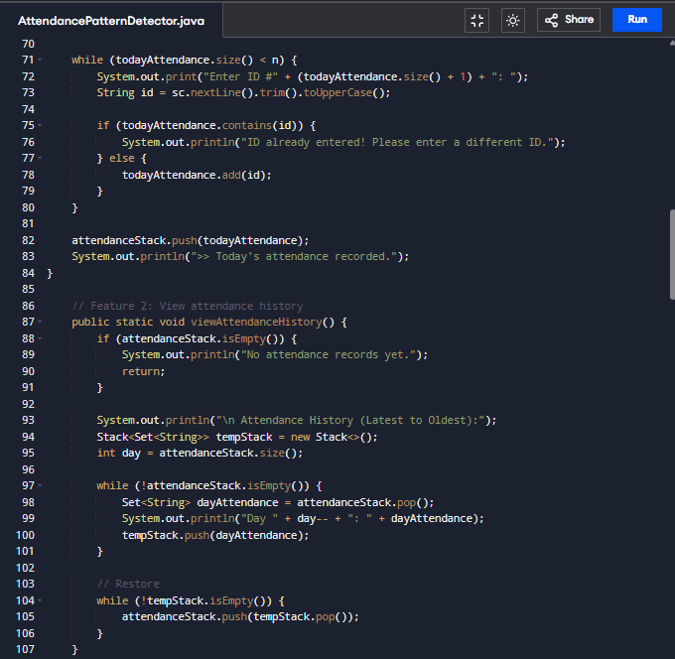

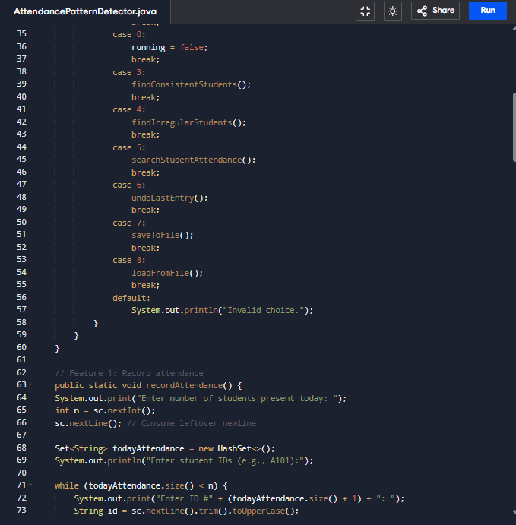

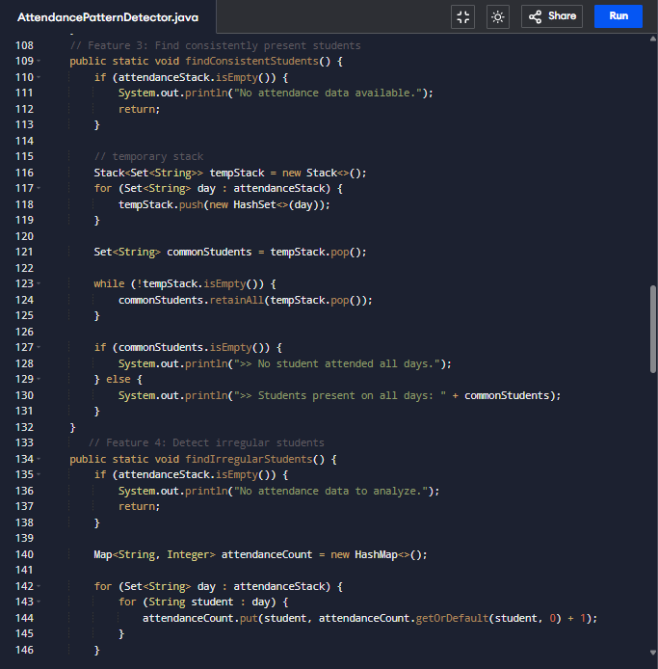

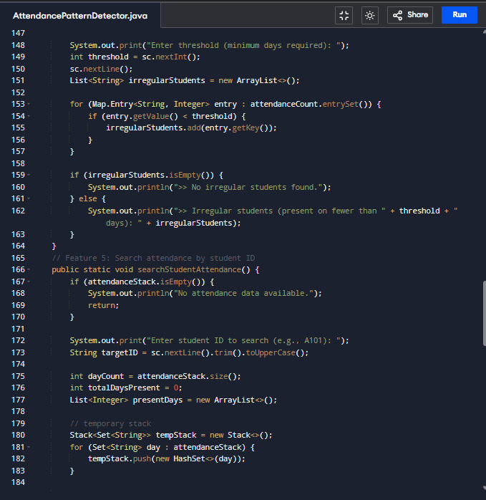

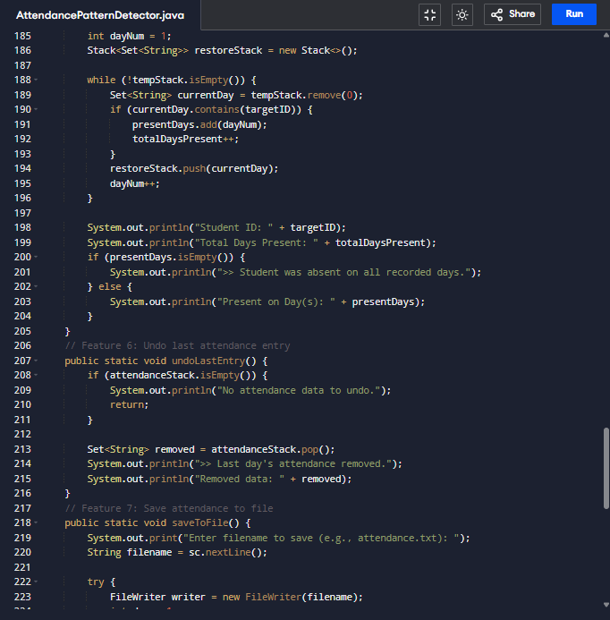

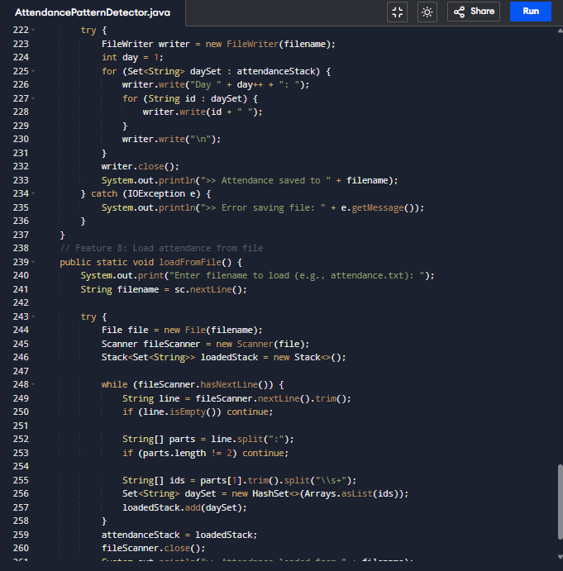

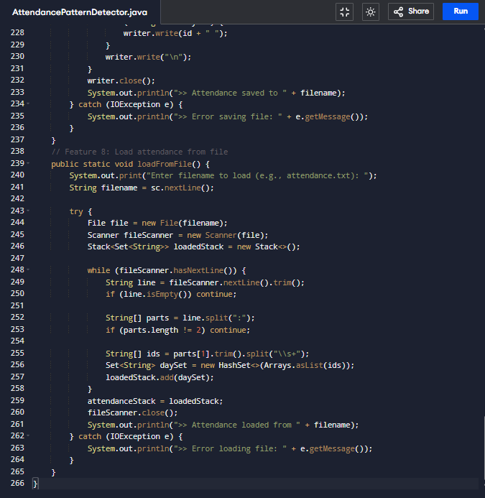

Fig 1: Student Registration and Attendance Marking

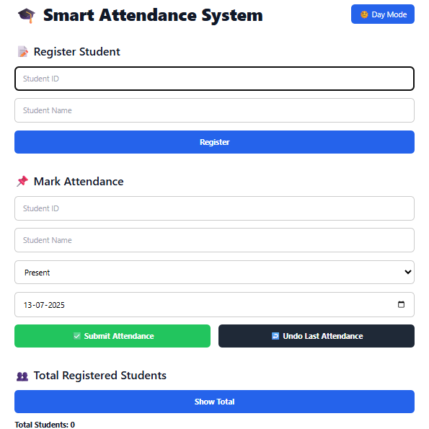

# 6. User Interface (Screenshots)

Below are the screenshots of the front-end interface used for interacting with the system.

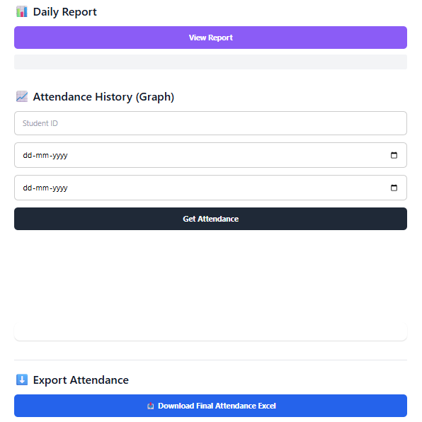

Fig 2: Attendance Report and Export Interface

**7. Conclusion**

The Smart Attendance Management System effectively simplifies daily attendance tracking using Java’s built-in data structures. It provides essential features like undo, search, report export, and irregular student detection. The system is scalable and easy to maintain, suitable for use in schools, colleges, and other institutions.

**8. References**

1. Java Documentation - https://docs.oracle.com/javase/8/docs/api/  
2. GeeksforGeeks - Java Collections Framework  
3. Oracle Java Tutorials - https://docs.oracle.com/javase/tutorial/  
4. StackOverflow Discussions  
5. Java Code by: Student Project Submission