Setup sonar cloud server

**Step1: Setup Sonar cloud and generate a authentication token**

[**https://sonarcloud.io/login**](https://sonarcloud.io/login)

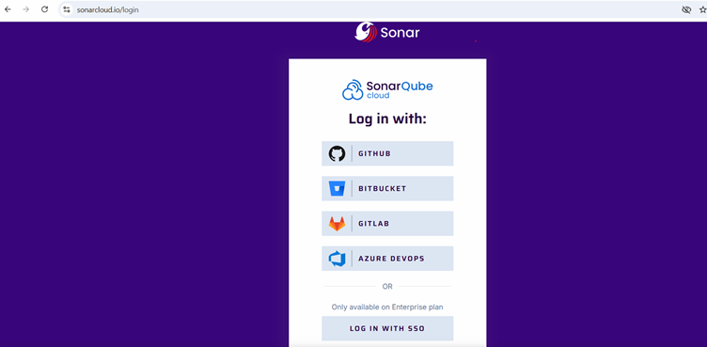

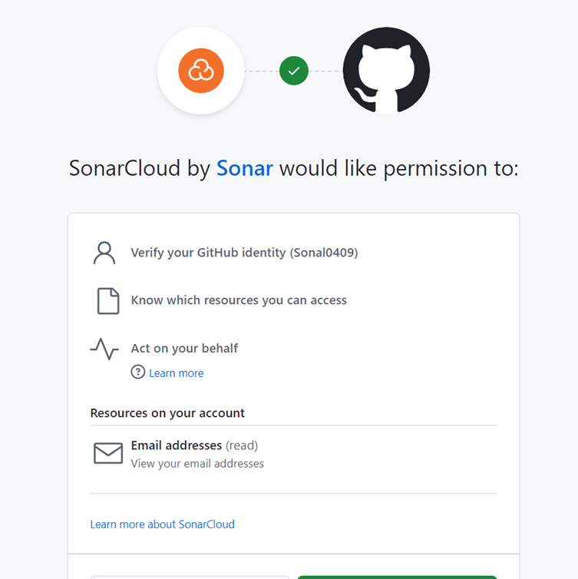

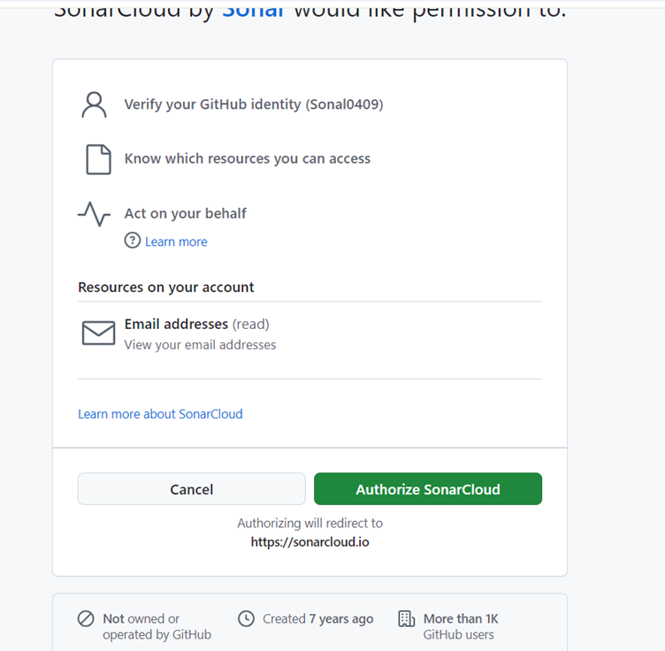

**Se;ect Orgranizations**

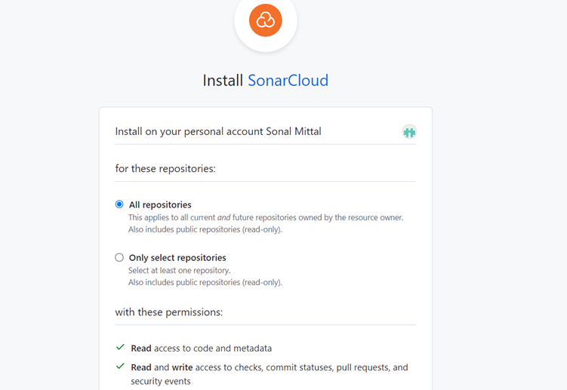

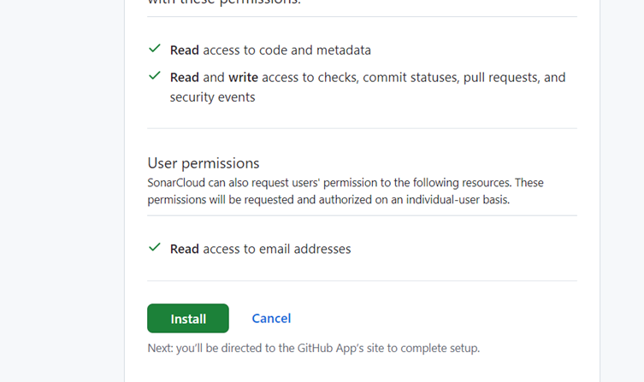

**You will be on sonarQube cloud dashboard.**

Setup an organization and a project on the SonarQube server

**Click on user account on right side à click on account –click on Security and generate token**

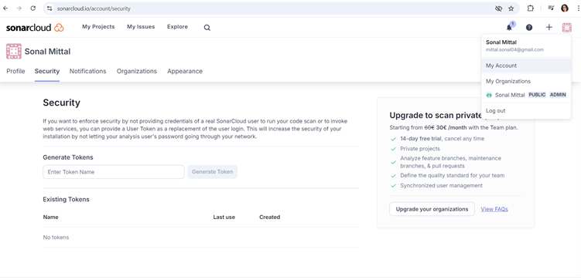

**Give a name to token and click on generate token**

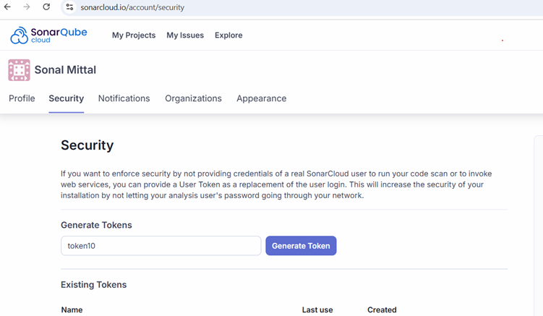

**Step 2: Create an organization in sonar cloud**

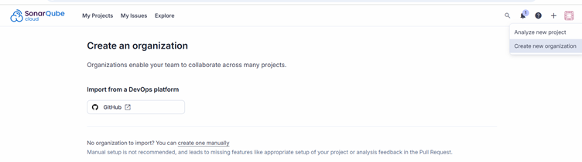

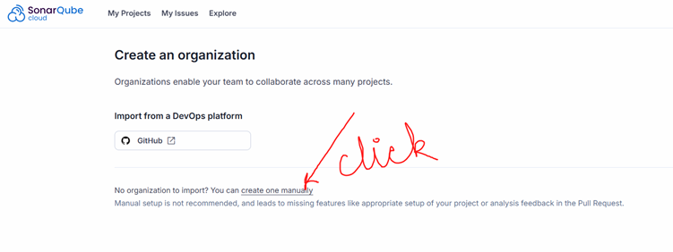

**Give a unique org name**

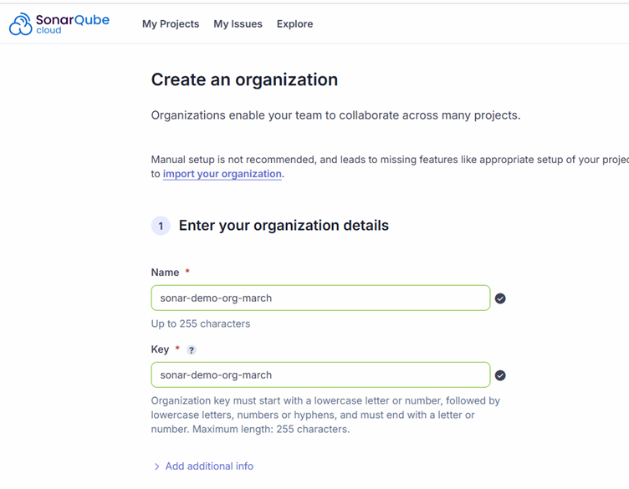

**Select the free plan**

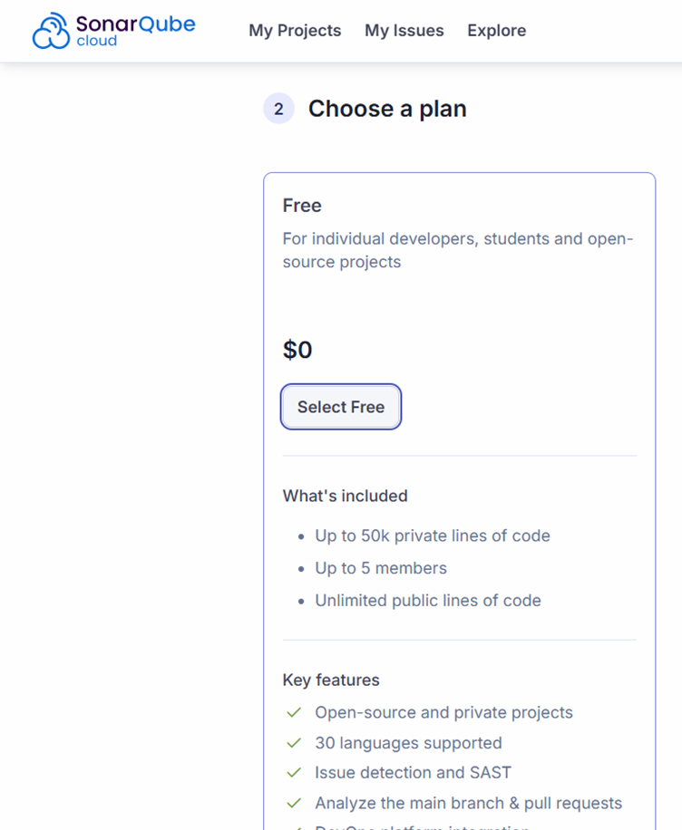

**Scroll down and click on create organization**

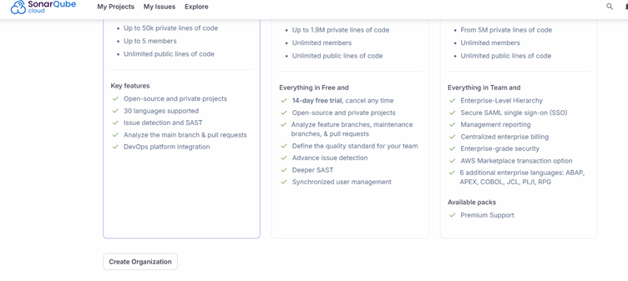

**Step 3: Create a project in the organization**

**Click on analyze project button and enter below details**

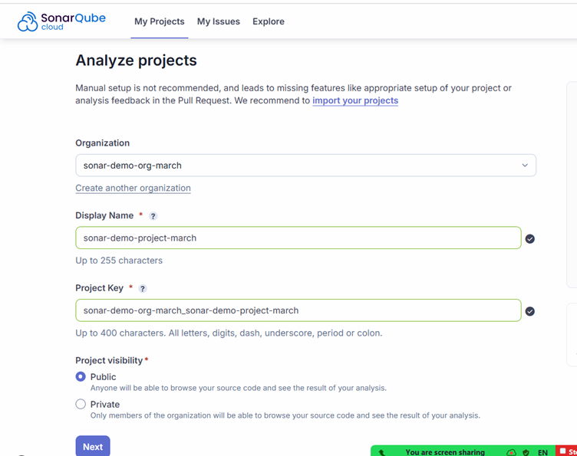

**Press next and select previous version**

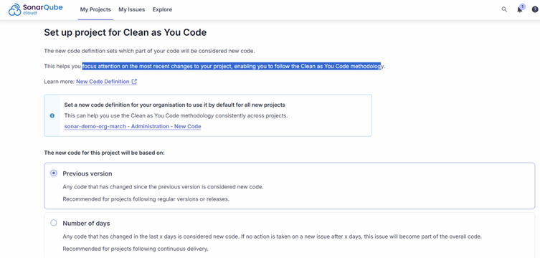

**Click on create project**

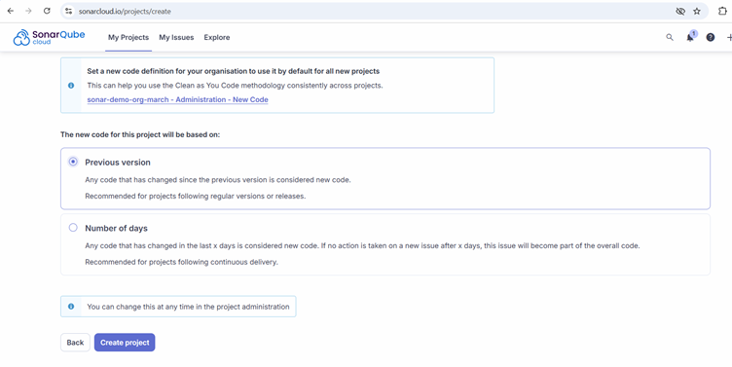

SonarQube + Jenkins

**Go to Jenkins server and Create a credentials to store the sonar token**

**Go to manage Jenkins à go to credentials à click on global -> click on Add crednetials -> add below details à click on create button**

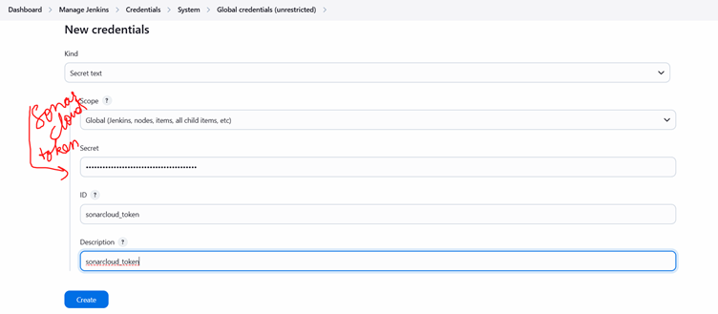

**Download the sonar cloud scanner plugin**

**Go to manage Jenkins à go to Plugins à available plugins à search for** [**SonarQube Scanner**](https://plugins.jenkins.io/sonar) **à select it and click on install**

**After installation**

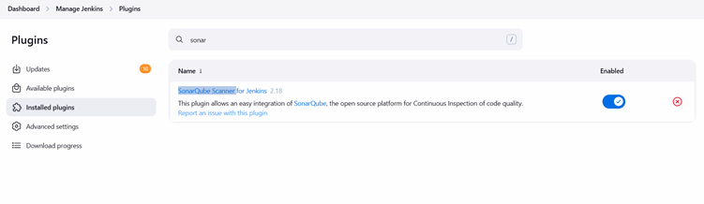

**Step 6: Tell jenkins where is our sonar server**

**Manage Jenkins à System -> scroll down and  search for SonarQube servers -> enter below details and save**

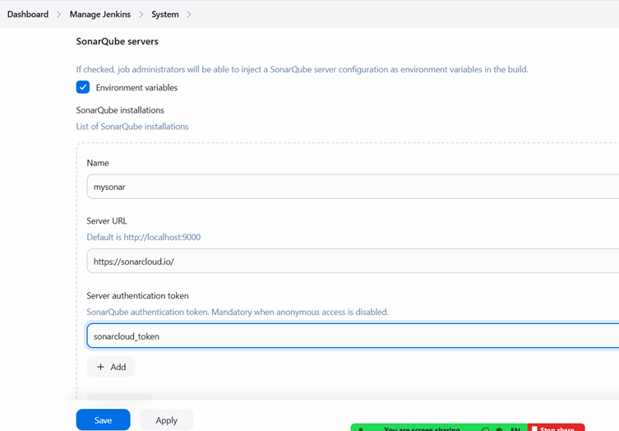

**Step 7: Setup Sonar tool on Jenkins**

**Manage Jenkins à tools à scroll down to SonarQube Scanner installations -> click on Add SonarQube scanner -> add below details as same. -> save the page**

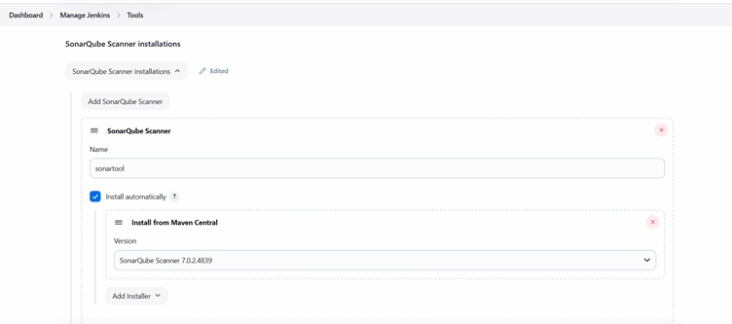

**Save this page**

SonarQube pipeline

**pipeline{**

**agent any**

**tools{**

**maven 'mymaven'**

**}**

**stages{**

**stage('checkout Code')**

**{**

**steps{**

**git 'https://github.com/demo1orgtoday/SonarQubeCoverageJava.git'**

**}**

**}**

**stage('Build Code')**

**{**

**steps{**

**sh 'mvn package'**

**}**

**}**

**stage('SonarScan'){**

**environment{**

**scannerHome = tool 'sonartool'**

**}**

**steps{**

**withSonarQubeEnv('mysonar'){**

**sh '''${scannerHome}/bin/sonar-scanner \**

**-Dsonar.projectKey=sonar-demo-org-march_sonar-demo-project-march \**

**-Dsonar.java.binaries=target/classes \**

**-Dsonar.organization=sonar-demo-org-march**

**'''**

**}**

**}**

**}**

**}**

**}**