Student Tracker Test Document
To begin testing for this project, it will be broken down into different sections. The different sections are:
- Account Registration
  - Teacher
  - Student
  - Admin
- Account Login
- For each role, testing for the particular page it pertains to, so for teachers the record page, for students the time page, and for admins, the admin page.
  - Also testing for no access for the page that a particular role does not have access to
- Testing for each roles functionalities (student clock in, teacher time checking, etc.)

Account Registration:
Teacher:
To test for the teacher, simply making a teacher account is sufficient.
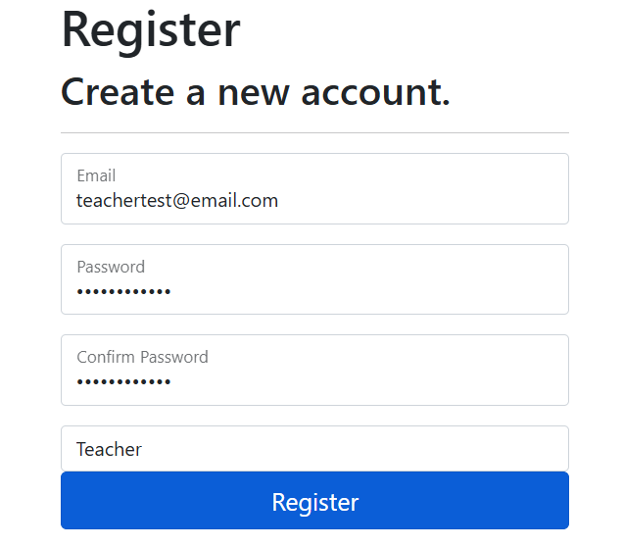
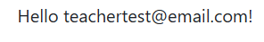
Works!
Student:
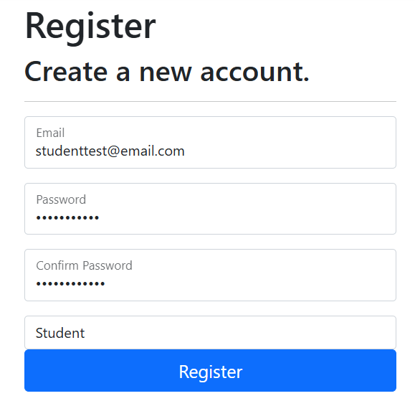
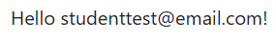
Admin:
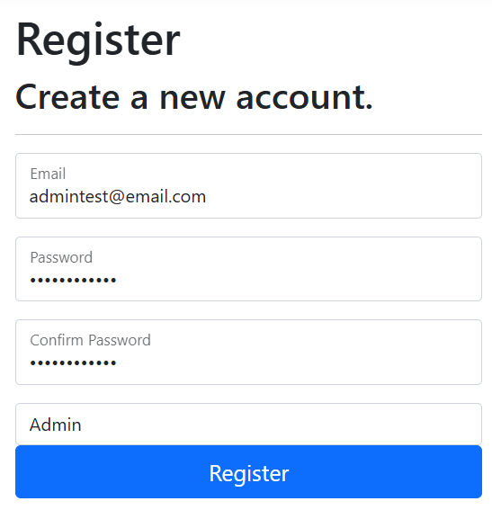
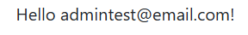
For each of these, simply making an account and seeing if it displays the correct account name is sufficient testing. Testing for each roles function comes later.
Account Login After Creation Testing:
For this section, after making the accounts, to test login functionality simply attempting to login with the account should be sufficient.
Teacher Login:
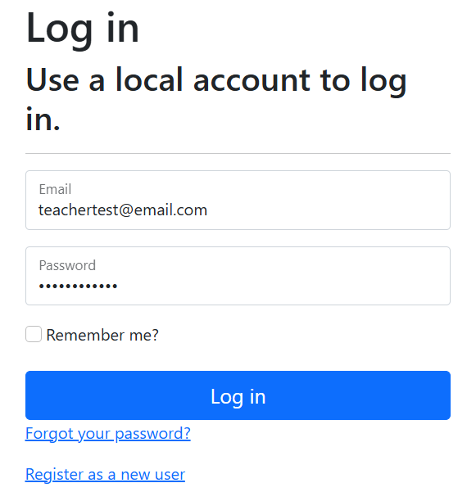
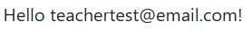

Student:
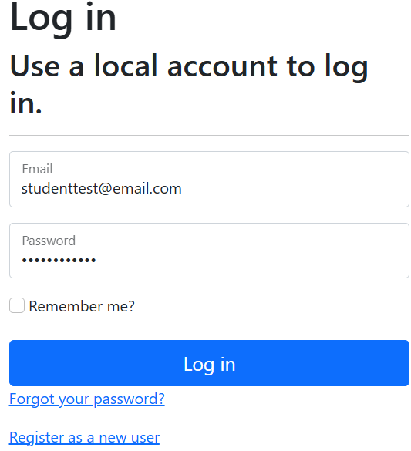
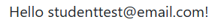
Admin:
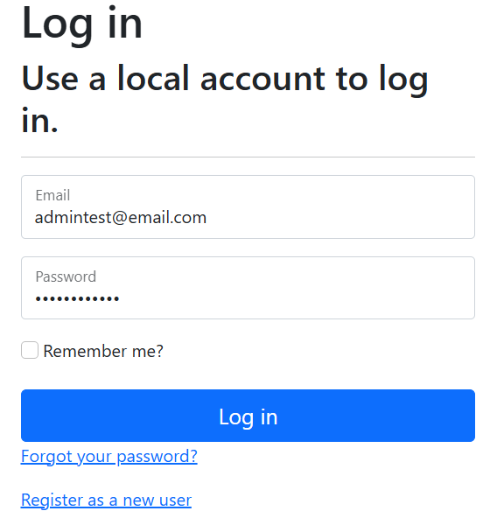
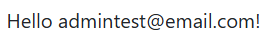

For the displaying of the account name in the navbar, this is the code. As you can see, it successfully pulls the identity of the account upon creation.

Role page access testing:
For this one, we are starting with the student in order to have displayable functionality for the other roles.
Student:
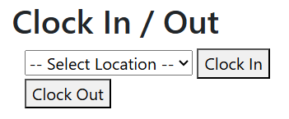
When clicking on the Time page, if you are logged into the student role you now have access to it. This confirms the role access works (for students at least).
Teacher:
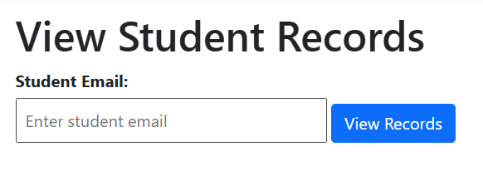
The teacher does have access to the students page that is used in order to view student time records.

Testing Page Blocking For Roles:
Student:
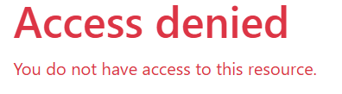
When attempting to access the Admin or Students page as a student, the application successfully blocks access to said page.
Teacher:
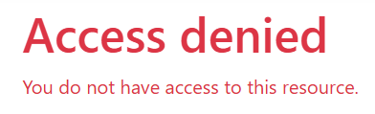
Just like the student, the teacher does not have access to the admin page, and it also does not have access to the time page. This confirms that the access for the teacher role works.
Admin:
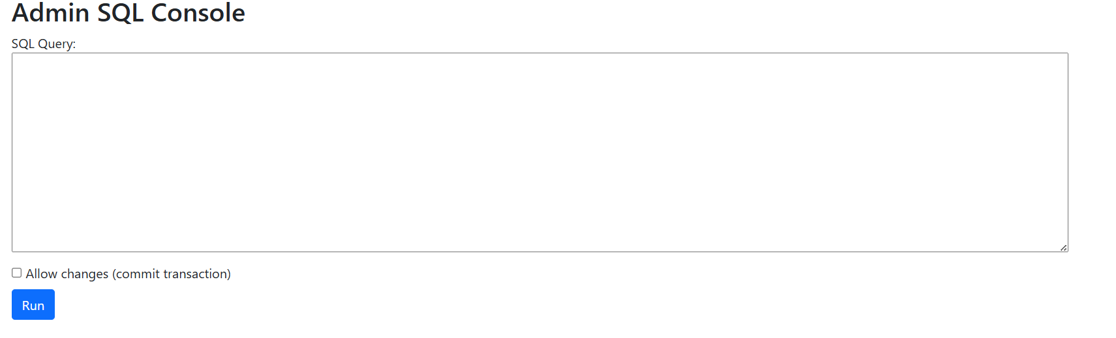
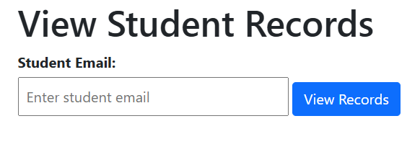
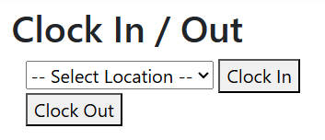
The admin should have access to all pages of the application, and these screenshots showcase that the admin does indeed have access to all pages.

Testing for Role Functionality:
To test for this section, we must attempt to use the functionality provided by the role. So for students, attempting to clock in and see if it does push data to the database. For teachers, seeing if it can pull student records from the database.
Student:
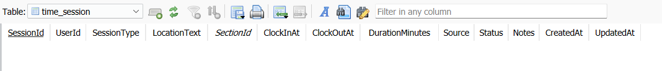
To begin with, the time_session table (which holds student clock records) is empty.
After clocking in with the surgery location, the html page successfully reloads and allows you to clock out. It also pushes to the database (note that this is after clockout was clicked as well, so clockedoutat is not null):
Teacher:
For the teacher student record viewing page, after clocking in/out as the student, that students records were pulled to test if it works:
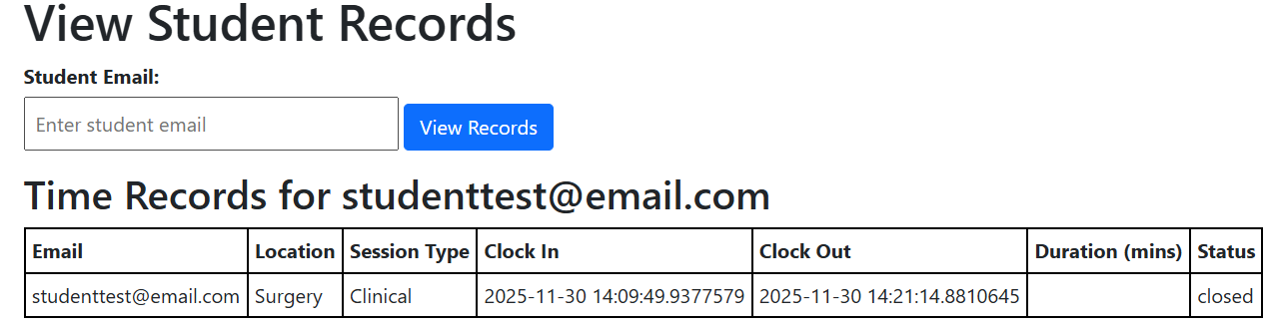
Note that duration clocked in in minutes is not populated. For this we would probably need to do a trigger for inserting into clock out, but time ran out.

Admin:
For the purpose of testing the admin page (Which contains a box to type a sql query), we will just be entering an update statement, specifically to change the email in the ‘notes’ column, for the test time record.
Here is before the update:
Here is after running the update statement:
