Wesley Ruede
11.05.19 (v1)

A complete overhaul, interpretation, and implementation of a project that was sent to me today by Nick Grahm. I revived 3 files:

GameDisplay.xlsm
GameMaster.xlsm
gong.wav

After digging into the source files I was able to uncover some images and some source code which may serve as some sort of reminder as to my plan of action:

Rem Attribute VBA_ModuleType=VBADocumentModule
Option VBASupport 1

Private Sub CommandButton1_Click()
Application.Run "GameDisplay.xlsm!starttimer"
CommandButton1.Visible = False
CommandButton2.Visible = True
CommandButton3.Visible = False
End Sub

Private Sub CommandButton2_Click()
Application.Run "GameDisplay.xlsm!stoptimer"
CommandButton1.Visible = True
CommandButton2.Visible = False
CommandButton3.Visible = True
End Sub

Private Sub CommandButton3_Click()
Application.Run "GameDisplay.xlsm!resettimer"
CommandButton1.Visible = True
CommandButton2.Visible = False
CommandButton3.Visible = False
End Sub

Private Sub CommandButton4_Click()
sendhint
Application.Run "GameDisplay.xlsm!sendhint"
End Sub

Private Sub CommandButton5_Click()
If Sheet1.Range("C24").Value = "" Then
WindowsMediaPlayer1.URL = ""
ElseIf WindowsMediaPlayer1.playState = "1" Then
CommandButton5.Caption = "Pause Background Music"
WindowsMediaPlayer1.URL = Sheet1.Range("B25")
WindowsMediaPlayer1.Controls.Play
ElseIf WindowsMediaPlayer1.playState = "0" Then
CommandButton5.Caption = "Pause Background Music"
WindowsMediaPlayer1.URL = Sheet1.Range("B25")
WindowsMediaPlayer1.Controls.Play
ElseIf WindowsMediaPlayer1.playState = "3" Then
CommandButton5.Caption = "Play Background Music"
WindowsMediaPlayer1.Controls.pause
ElseIf WindowsMediaPlayer1.playState = "2" Then
CommandButton5.Caption = "Pause Background Music"
WindowsMediaPlayer1.Controls.Play
ElseIf WindowsMediaPlayer1.playState = "10" Then
If Sheet1.Range("B25") = "" Then
WindowsMediaPlayer1.Controls.stop
Else
CommandButton5.Caption = "Pause Background Music"
WindowsMediaPlayer1.URL = Sheet1.Range("B25")
WindowsMediaPlayer1.Controls.Play
End If
End If
End Sub

Private Sub CommandButton6_Click()
Sheet1.Range("K23").Value = False
CommandButton5.Caption = "Play Background Music"
WindowsMediaPlayer1.Controls.stop
End Sub

Private Sub CommandButton7_Click()
Sheet1.Range("B25").Value = ""
CommandButton5.Caption = "Play Background Music"
WindowsMediaPlayer1.Controls.stop
Dim fd As Office.FileDialog
Set fd = Application.FileDialog(msoFileDialogFilePicker)
With fd
.AllowMultiSelect = False
.Title = "Please select a .WAV file"
.Filters.Clear
.Filters.Add "Excel 2003", "*.wav"
.Filters.Add "All Files", "*.*"
If .Show = True Then
Sheet1.Range("B25") = .SelectedItems(1)
End If
End With
End Sub

Private Sub CommandButton8_Click()
CommandButton8.Caption = WindowsMediaPlayer1.playState
End Sub

Private Sub CommandButton9_Click()
Dim fd As Office.FileDialog
Set fd = Application.FileDialog(msoFileDialogFilePicker)
With fd
.AllowMultiSelect = False
.Title = "Please select a .WAV file"
.Filters.Clear
.Filters.Add "Excel 2003", "*.wav"
.Filters.Add "All Files", "*.*"
If .Show = True Then
Sheet1.Range("I11") = .SelectedItems(1)
End If
End With
End Sub

Private Sub WindowsMediaPlayer1_PlayStateChange(ByVal NewState As Long)
If Sheet1.Range("K23").Value = True Then
WindowsMediaPlayer1.Controls.Play
ElseIf WindowsMediaPlayer1.playState = "8" Then
WindowsMediaPlayer1.URL = ""
CommandButton5.Caption = "Play Background Music"
Sheet1.Range("B25").Value = ""
Else
End If
End Sub

Private Sub CommandButton10_Click()
Dim fd As Office.FileDialog
Set fd = Application.FileDialog(msoFileDialogFilePicker)
With fd
.AllowMultiSelect = False
.Title = "Please select a .WAV file"
.Filters.Clear
.Filters.Add "Excel 2003", "*.wav"
.Filters.Add "All Files", "*.*"
If .Show = True Then
Sheet1.Range("B13") = .SelectedItems(1)
End If
End With
End Sub
Private Sub Workbook_Open()
Application.DisplayFormulaBar = False
End Sub

I can only reach the conclusion that this is some form of visual basic code that is used as an interaction method via some sort of macros that are also found embedded into the files. There are some image files which will need to be extracted as well as design.

The clock has been handled right out of the gate. It took me two iterations to find the correct method of handling this issue however how simple or complicated the implementation is.

I have succeeded in extracting some image data from the file:

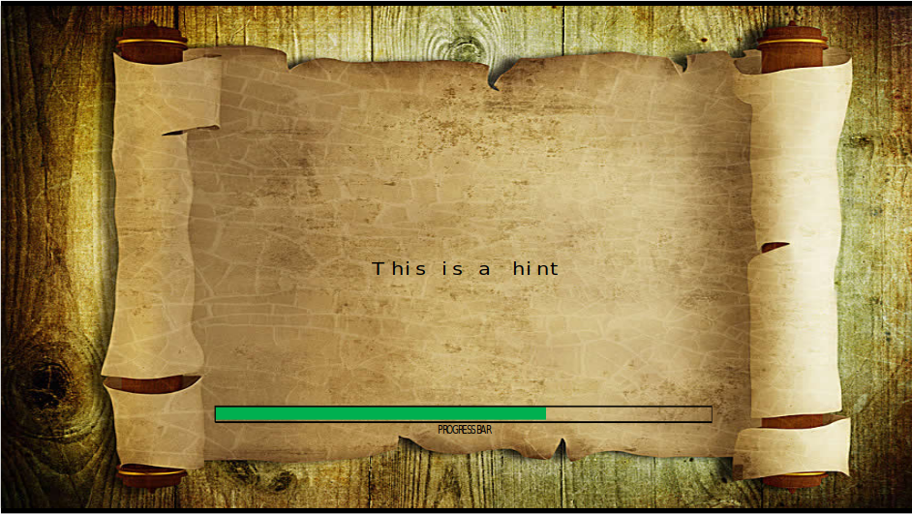

There is also a table in relation to the time frame and some arbitrary data points

I’m not sure how useful this chart will be in the long run though it may be some key indicator as to his intent with the time frame and count down.

The final topic to cover is the entire layout. There are a few more sections of the app which I will need to hook together in the coming days. Here is the initial design:

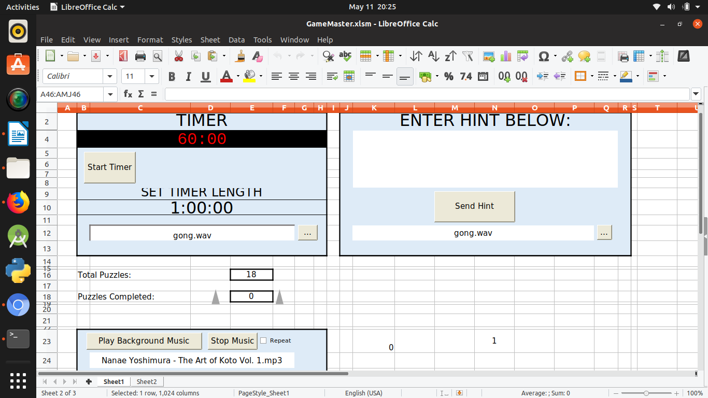

12.05.19 (v2)

Today I have found that it will be necessary to access the files in order to be able to use the image that was discovered. To make use of the image I will need to use tkinter in order to access the directory via the file manager. As it stands, unless I can I find a more effective mode I may need to use a second file.

The needed resources as it stands are:
- openDir(tk).py
- timerGui(tk).py
- gameDisplay.jpg

I’ll need to import the image as a background to the timer and locate the timer at the top or bottom most section of the display window.

I have succeeded in defining a class with a timer and gui with tkinter. It is functional however it is not full functional yet as I will need to import the the file and be able to have the timer countdown display in the gui. Here is the newTimer.py class:

import tkinter as tk
import time
import subprocess

class Application(tk.Frame):
def __init__(self,master=None):
super().__init__(master)
self.master = master
self.pack()
self.create_widgets()

def timer(self):
timeleft = int(Entry.get(x))
while timeleft > 0:
count = print(timeleft)
time.sleep(1)
timeleft = self.timeleft
timeleft = timeleft - 1
subprocess.Popen(['start','gong.wav'], shell = True)

def create_widgets(self):
self.timeleft = tk.Button(self)
self.timeleft["text"] = self.timeleft
self.timeleft.pack(side="top")

self.quit = tk.Button(self, text="QUIT", fg="red",
command=self.master.destroy)
self.quit.pack(side="bottom")

root = tk.Tk()
app = Application(master=root)
app.mainloop()

As it stands I will still need to get the input working as there is is no functional input method.

