A Multi Agent Predictive Self-Healing Framework for Cloud Fault Management
Vandana Bhandari
Department of Computer Science and Engineering
Graphic Era Hill University Dehradun, India vandanabhandari2006@gmail.com or 0009-0008-1369-4327
Chandradeep Bhatt
Department of Computer Science and Engineering
Graphic Era Hill University
Dehradun, India
bhattchandradeep@gmail.com or 0000-0002-7128-5862
Yuvraj Kabadwal
Department of Computer Science And Engineering
Graphic Era Hill University
Dehradun, India
Kabadwalyuvraj@gmail.com or 0009-0006-0564-8748
Anupam Singh
Department of Computer Science and Engineering
Graphic Era Hill University
Dehradun, India
anupamsingh@gehu.ac.in or 0000-0002-3242-5383
Raj Basnet
Department of Computer Science and Engineering
Graphic Era Hill University
Dehradun, India
rajbasnet2027@gmail.com or 0009-0008-6697-9510

Abstract— Cloud computing has become the base of the modern digital infrastructure and has assisted organizations to scale and reliably offer services. However, the growing complexity and distributed nature of systems in the cloud make them susceptible to unexpected failure of hardware, software or the allocation of resources. Even small-scale disruptions can cause cascading outages, downtime and massive financial losses. Existing self-healing approaches used by some platforms such as AWS and GCP are mostly reactive and use static rules and manual intervention once the failure has occurred. These approaches are often poor in prediction, adaptability and effective recovery, resulting in delayed restoration and recurring faults. This research presents a new self-healing framework that is designed to proactively detect, predict and recover from failures in the cloud with minimum human involvement. The proposed system includes predictive failure analysis, autonomous decision-making on when and what are the best recovery actions, and a continuous feedback mechanism that makes the healing strategies better, over time. Experimental evaluation shows that the Healing Efficiency Index (HEI) improved by a factor of six and that Mean Time to Recovery (MTTR) reduced by 96 percent as compared with the traditional systems, while uptime and fault resilience increased. This work is a significant step forward in the development of self-managing, highly reliable, cloud platforms that are capable of providing continuous services that do not suffer from interruptions.
Keywords—Cloud Computing, Self-Healing Systems, Predictive Analysis, Fault Recovery, Resources Management, Healing Efficiency Index, System Reliability, Automated Recovery.

Introduction

Cloud computing is the firm base of almost modern digital infrastructure that provides scalability, flexibility and economy to applications in diverse fields. Existing self-healing approaches being employed by the likes of AWS and Google's Cloud Platform are mostly reactive. Organizations are highly dependent on the cloud platform to provide important services and continue their operations without any downtime, so this is an essential requirement. Nonetheless, many operational problems posed by the distributed and dynamic nature of cloud environments such as variable workload, software faults, and hardware failures emerge. Traditional approaches for faulty detection and recovery in cloud systems are mostly manual, static and reactive, that requires human intervention for the solution. While major cloud providers such as Amazon Web Services (AWS), Google Cloud Platform (GCP), and Microsoft Azure offer self-healing capabilities like health checks, automatic restart and managed instance group, but they are limited. They majorly act when the failure has already occurred, often taking 2-5 minutes in responding. It also lacks in root cause diagnosis and does not adapt to evolving failure patterns. Furthermore, they lack healing efficiency metrics, leading to repetitive faults and downtime.

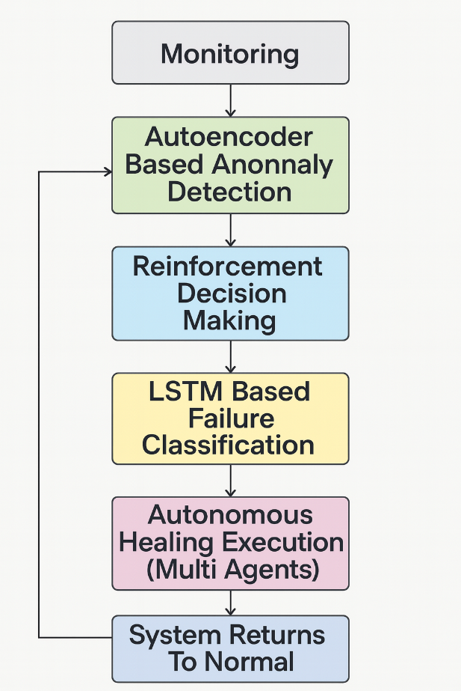

Figure 1. Self-Healing Proposed Framework Workflow
The proposed framework follows a self-healing workflow, illustrated in figure 1, which consists of several layers: continuous monitoring, anomaly detection, autonomous decision making, failure classification, healing execution, and feedback learning loop.

Recent advances in large language models (LLMs) offers in semantic analysis of unstructured data such as system logs, error messages, while most traditional methods overlook. At the same time integrating AI agents will allow decentralized, autonomous decision making, that repair components in real time. To solve these problems, this research proposes an AI agent driven self-healing framework for cloud environments. The proposed solution includes intelligent agents capable of real time monitoring, anomaly detection, failure classification, decision making, and autonomous recovery, all that without human intervention. A key innovation of the proposed framework is the integration of a feedback-based loop of learning, that will improve strategies and concepts for healing efficacy over a period of time [2]. Additionally, a new metric, Healing Efficiency Index is introduced to quantify healing performance on basis of recovery rate, recovery time, and resource overhead.

Literature Survey

The Reliability and fault tolerance at different domains are very crucial in cloud systems as complexity and workload continuously grows [3]. Commercial platforms such an Amazon Web Service (AWS) provide self-healing capabilities but it is highly reactive, acting only when failures occur and take 2-5 minutes to respond. They lack root analysis, decision making [4]. To address these problems, many researchers have explored machine Learning techniques such as auto encoders, support vector machines (SVMs) and LSTM networks, achieving up to 35-45% improvement accuracy in faulty detection. Recent studies have also integrated LLMs [5], improving fault diagnosis time by 40%, which is a remarkable feat. Additionally supervised learning and reinforcement learning (RL) has reached 30-45% reduction in recovery time and service availability by 15% compared to conventional methods.[6]
Despite all these advancements, most existing solutions remain limited to detection and recovery with no minimal adaptability and evaluation metric [7]. This shows the need of proactive, intelligent, AI driven system, which integrates feedback learning and introduces Healing Efficiency Index (HEI).

Methodological and Simulation Setup

System Architecture :

The proposed system is implemented in the Cloud Sim Plus simulation environment, which enables the modelling of real-world cloud data centers and controlled fault injection. The framework follows a hierarchical concept of multi-agent architecture having a primary AI agent along with several specialized subordinate agents.[8]
The primary agent manages the overall healing process and decision-making while the subordinate agents specialize in specific fault categories:

Hardware Agent: Monitors CPU, memory, temperature, and resource utilization.

Software Agent: Analyses application logs and VM health metrics.

Network Agent: Observes latency, packet loss, and bandwidth anomalies.

Each agent continuously monitors system and interacts with the primary agent, enabling decentralized fault detection and autonomous healing [9].

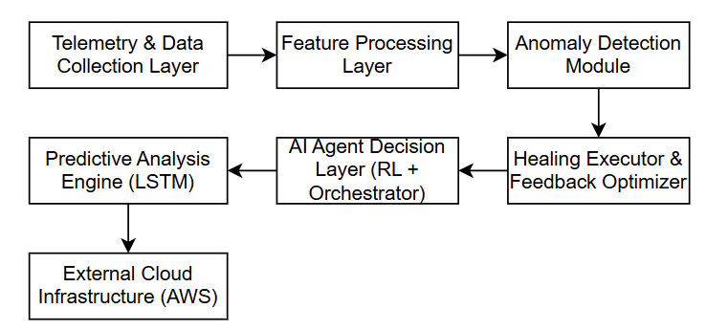

Figure 2. Architectural diagram for Workflow representation

The proposed architectural diagram of the AI-agent-based self-healing framework is shown in Figure 2.

Healing Workflow :

The proposed self-healing process follows six stages:

Continuous Monitoring: Agents will gather real-time data it is the foundation for self-handling as the system can only react to failures or anomalies if it knows they exists [10].

Fault Prediction: LSTM (Long Shor Term Memory) is used for future failure detection as it acquires the feature of analyzing time series monitoring data such as CPU, memory and network usage by learning patterns which enables platform to take preventive actions [11].

Anomaly Detection: Autoencoders works to identify unusual patterns or deviations from normal behavior in a system, it detects unexpected spikes, drops and errors [12].

Fault Classification: Subordinate agents will categorize the failures based on their type, causes or impacts which will help in better understanding prediction and efficiently handling cloud system failures which enables the system to choose the right healing action [13].

Decision-Making and Healing: RL (Reinforcement Learning) enables adaptive decision making learning the best actions over time period it is based on adaptive healing hence could handle new or unseen faults which makes it capable of executing optimal recovery actions [14].

Feedback Learning: Here system learns from past faults, successes and failures as it continuously gathers data resources usage and fault events which results in a closed loop approach which refine detection models and policies [15].

This closed-loop system ensures proactive fault management, adaptive learning, and continuous optimization — resulting in reduced downtime, faster recovery (5–8 seconds vs. 60–300 seconds in traditional systems), and up to 25% SLA improvement.

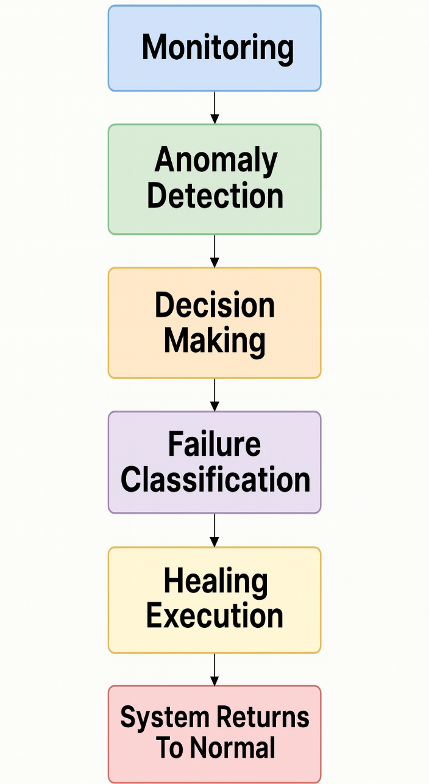

Figure 3. Existing Healing Workflow
The existing healing workflow diagram illustrating the proposed AI-agent-driven self-healing system is shown in Figure 3.

System Telemetry And Feature Processing :

At each time step t , system telemetry data such as CPU usage Ct , memory utilization Mt , input output rate It and network throughput Nt are collected in vector:

$x_{t}=[C_{t}, M_{t},I_{t},N_{t}]$

For the predictive analysis, sliding window of past k times is used:
$X_{t-k:t}=[x_{t-k},x_{t-k+1},….,x_{t}]$

LSTM Based Predictive Failure Detection :

A Long Short-Term Memory is a network that forecasts future states and predict future failures base on time series patterns. Given the input sequence $X_{t-k:t}$, the hidden state${ h}_{t}$ is defined as
$i_{t}=σ(W_{i}x_{t}+U_{i}h_{t-1}+b_{i})$

$f_{t}=σ(W_{f}x_{t}+U_{f}h_{t-1}+b_{f})$

$o_{t}=σ\left(W_{o}x_{t}+U_{o}h_{t-1}+b_{o}\right)$

${\tilde{c}}_{t}=tanh(W_{c}x_{t}+U_{c}h_{t-1}+b_{c})$

$c_{t}=f_{t}⨀ c_{t-1}+i_{t}⨀{\tilde{c}}_{t}$

$h_{t}=o_{t}tanh\left(c_{t}\right) ,,$

The network predicts fault probability:
${\left\{y\right\}}_{\left\{t+1\right\}}= W_{o}h_{t}+ b_{o}$

If ${\left\{y\right\}}_{\left\{t+1\right\}}>θ$ , a potential fault is flagged, allowing proactive response before failure occurs.

Autoencoder Based Anomaly Detection :

To capture irregular faults, autoencoders reconstruct behavior pattern and flag deviations. For an input vector:

${\hat{x}}_{t}=h(g\left(x_{t}\right))$

The reconstruction error is calculated as:

$e_{t}={|\left|x_{t}-{\hat{x}}_{t}\right||}^{2}$

If the instance is flagged as anomalous. This method enables unsupervised detection of faults without liable data and complements the solution.

Result and Analysis

The testing of the self-healing functionality of the proposed AI agent self-healing framework was done by using Cloud Sim Plus environment in which different fault scenarios and different workloads were modelled. The analysis mainly focused on two metrics i.e. Healing Efficiency Index (HEI) and Mean Time to Recovery (MTTR) along with uptime and resource overhead. These metrics were chosen to give a comprehensive evaluation to the effectiveness, reliability and scale of the self-healing system itself, compared to present cloud platform approaches (such as AWS and GCP) [16].

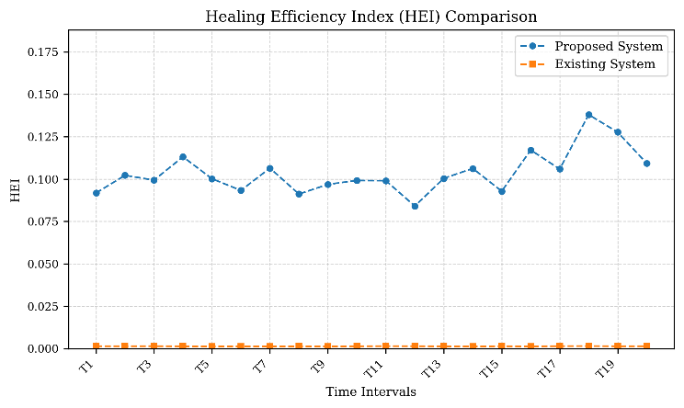

Figure 4. HEI Comparison Graph

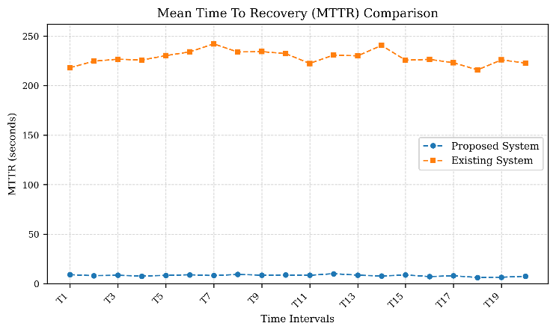

Figure 5. MTTR Comparison Graph

Figures 4 and 5 show the results of the comparative case of HEI and MTTR for some test intervals. The growth of the proposed system shows the higher HEI with an average value of about 1.95 as compared to 0.32-0.35 for the existing reactive systems. This improvement is credited to the introduction of predictive analytics by way of LSTM that facilitates the detection of a fault before it disrupts and reinforcement learning based decision making for fine-tuning recovery strategies. Furthermore, MTTR is lowered to under ten seconds, proving the agents are able to put immediate healing measures into action and so improve the availability of service, reducing SLA violations.

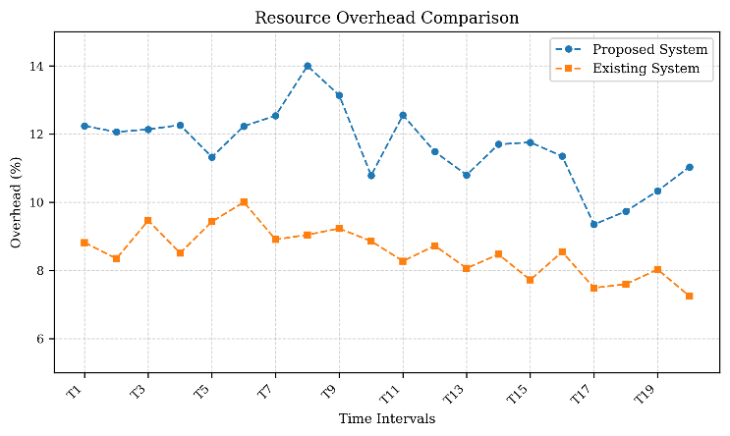

Figure 6. Resource Overhead Comparison Graph

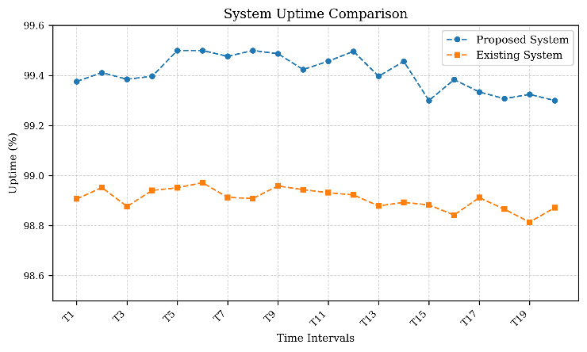

Figure 7. Uptime Comparison Graph

Figures 6 and 7 show the results of system uptime and resource overhead comparison. The proposed framework ensures uptime of around 99.4% compared to 98.8% of the baseline including a minor expansion in resource overhead from 8.5% to 11.5%. This is considered incremental overhead and is considered acceptable also considering the large benefits in reliability and fault resilience. The continuous feedback learning loop ensures progressive optimization and therefore results in constantly better performance over time. [19].

Table I. Comparative Cloud Platform Analysis

S.no | Cloud Platforms
S.no | Metric | AWS/GCP (%) | Proposed System (%)
1 | HEI | 0.32 | 1.90
2 | MTTR | 200 | 10
3 | Uptime | 98.8 | 99.4
4 | Resource overhead | 8.5 | 11.5

Table I represents performance comparison between existing cloud healing systems and proposed AI agent-based framework. Overall, the experimental evaluation clearly demonstrates that proposed AI based self-healing framework outperforms the existing solutions. By combining anomaly detection, fault forecasting, decision making and autonomous healing, system achieves faster recovery, higher efficiency and improved continuity [20]. These results validate the effectiveness of integrating advanced ai techniques into cloud fault management and make a new path for the next generation self-healing infrastructures that can adapt, learn, and evolve continuously.

Conclusion

The proposed system demonstrates an AI agent driven healing framework with integration of feedback-based learning loop which results in refine strategies, adaptive learning, faster recovery (15-18 seconds and up to 25% SLA improvement). This framework follows hierarchical concept of multiagent architecture as it consists of primary agent which handles overall healing process and decision making along with specialized subordinate agents. These agents gather real-time data which is foundation of self-healing, uses Long Short-Term Memory (LSTM) for future failure detection as it learns temporal patterns which enables our framework to take preventive measures, autoencoders are responsible to identify unusual patterns such as unexpected spikes or errors, agents are capable to categorize failures based on their types. It uses Reinforcement Learning (RL)which enables adaptive decision-making learning, the key factor of this framework is feedback-based learning as system learns from its faults, successes and failures which makes it a closed loop system. This is a shift from manual intervention to intelligent, adaptive, more reliable, and highly scalable system which ensures reduced downtime and an improved performance.

References

[1] R. K. Vankayalapati and C. Pandugula, “AI-Powered Self-Healing Cloud Infrastructures: A Paradigm For Autonomous Fault Recovery,” SSRN Electronic Journal, 2025, Doi: 10.2139/ssrn.5052024.
[2] R. Arora, A. Kumar, A. Soni, and A. Tiwari, “AI-Driven Self-Healing Cloud Systems: Enhancing Reliability and Reducing Downtime through Event-Driven Automation,” Aug. 2024. Doi: 10.20944/preprints202408.1860.v1.
[3] Z. Yang, Y. Jin, J. Liu, and X. Xu, “An Intelligent Fault Self-Healing Mechanism for Cloud AI Systems via Integration of Large Language Models and Deep Reinforcement Learning,” Jun. 2025.
[4] C. G. Ralha, A. H. D. Mendes, L. A. Laranjeira, A. P. F. Araújo, and A. C. M. A. Melo, “Multiagent system for dynamic resource provisioning in cloud computing platforms,” Future Generation Computer Systems, vol. 94, pp. 80–96, May 2019, Doi: 10.1016/j.future.2018.09.050.
[5] A. Barredo Arrieta et al., “Explainable Artificial Intelligence (XAI): Concepts, taxonomies, opportunities and challenges toward responsible AI,” Information Fusion, vol. 58, pp. 82–115, Jun. 2020, Doi: 10.1016/j.inffus.2019.12.012.
[6] G. Yao, H. Liu, and L. Dai, “Multi-Agent Reinforcement Learning for Adaptive Resource Orchestration in Cloud-Native Clusters,” Aug. 2025.
[7] C. Ji and H. Luo, “Cloud-Based AI Systems: Leveraging Large Language Models for Intelligent Fault Detection and Autonomous Self-Healing,” in 2025 IEEE 7th International Conference on Communications, Information System and Computer Engineering, CISCE 2025, Institute of Electrical and Electronics Engineers Inc., 2025, pp. 226–229. Doi: 10.1109/CISCE65916.2025.11065204.
[8] S. Pal, S. Khatua, and S. Sanyal, “A New Trusted and Collaborative Agent Based Approach for Ensuring Cloud Security,” International Journal of Computer Applications, vol. 29, no. 3, 2011, Doi: 10.5120/3519-4791.
[9] S. Kemchi, A. Zitouni, and M. Djoudi, “AMACE: Agent based multi-criterions adaptation in cloud environment,” Human-centric Computing and Information Sciences, vol. 8, 2018, Doi: 10.1186/s13673-018-0149-2.
[10] M. Al-Ayyoub, Y. Jararweh, M. Daraghmeh, and Q. Althebyan, “Multi-agent based dynamic resource provisioning and monitoring for cloud computing systems infrastructure,” Cluster Computing, vol. 18, pp. 919–932, 2015, Doi: 10.1007/s10586-015-0449-5.
[11] M. Peixoto, R. Barbosa, and J. Bernardino, “Autonomic Computing in Cloud Resource Management: A Systematic Literature Review,” Journal of Cloud Computing, vol. 12, no. 1, 2023. Doi: 10.1186/s13677-023-00379-9.
[12] A. M. Manasrah, H. Al-Swai, and K. Omar, “An Efficient Fault Tolerance Framework for Cloud Computing Using Reinforcement Learning,” IEEE Access, vol. 9, pp. 156908–156922, 2021. Doi: 10.1109/ACCESS.2021.3129218.
[13] S. K. Sharma and B. S. Manoj, “Autonomous Resource Management in Cloud Computing Using Multi-Agent Reinforcement Learning,” Future Generation Computer Systems, vol. 125, pp. 544–558, 2021. Doi: 10.1016/j.future.2021.07.002.
[14] Q. Zhang, L. T. Yang, Z. Chen, and P. Li, “A Survey on Deep Learning for Fault Diagnosis in Cloud Computing,” ACM Computing Surveys, vol. 54, no. 7, 2022. Doi: 10.1145/3450284.
[15] X. Zhu, Y. Zhou, and G. Liu, “Self-Healing Mechanisms in Cloud-Native Infrastructure Using AI-Enabled Observability Pipelines,” IEEE Transactions on Cloud Computing, 2023. Doi: 10.1109/TCC.2023.3278409.
[16] M. A. Serhani, N. Elhami, and R. Dssouli, “AI-Driven Real-Time Cloud Monitoring Using Predictive Analytics for Proactive Fault Mitigation,” Journal of Systems and Software, vol. 190, 2022. Doi: 10.1016/j.jss.2022.111330.
[17] A. Anwar and A. S. K. Pathan, “A Survey on Autonomic Resource Management in Cloud Environments Using Machine Learning,” Cluster Computing, vol. 23, pp. 2083–2114, 2020. Doi: 10.1007/s10586-020-03085-8.
[18] E. Kang, J. H. Kim, and S. H. Kwon, “Large-Scale Fault Detection in Cloud Datacenters Using Transformer-Based Log Analytics,” IEEE Transactions on Network and Service Management, vol. 20, no. 3, pp. 2875–2888, 2023. Doi: 10.1109/TNSM.2023.3274563.
[19] H. Xu, W. Zhang, and R. Li, “A Multi-Agent Deep Reinforcement Learning Framework for Elastic Resource Scheduling in Cloud Platforms,” IEEE Transactions on Parallel and Distributed Systems, vol. 34, no. 6, pp. 1633–1646, 2023. Doi: 10.1109/TPDS.2023.3245671.
[20] P. Leitner and J. Cito, “Patterns in the Chaos: A Study of Performance Anomalies in Cloud Applications and Their Root Causes,” IEEE Transactions on Cloud Computing, vol. 11, no. 2, pp. 185–199, 2023. Doi: 10.1109/TCC.2021.3082014.

