**CCTV/Video Footage Analysis Tool**

Faculty Mentor - Dr.S.Kalpana

Student Mentor – Thejeswini V

[thejatheja0213@gmail.com](mailto:thejatheja0213@gmail.com)

Student Support Mentor – S L Chandru

[chandruselvarsu@gmial.com](mailto:chandruselvarsu@gmial.com)

**Department of Artificial Intelligence &Data Science ,**

**KGiSL INSTITUTE OF TECHNOLOGY,COIMBATORE**

**Praveenkumar1, Swathini2, sanjay3, venkatramana4 and Tamizharasu5**

**email:** [**1praveenkumar23aib05@kgkite.ac.in**](mailto:1praveenkumar23aib05@kgkite.ac.in)

[**2swathini23aib46@kgkite.ac.in**](mailto:2swathini23aib46@kgkite.ac.in)

[**3sanjay23aib23@kgkite.ac.in**](mailto:3sanjay23aib23@kgkite.ac.in)

[**4venkatramana23aib56@kgkite.ac.in**](mailto:4venkatramana23aib56@kgkite.ac.in)

[**5tamizharasu23aib48@kgkite.ac.in**](mailto:5tamizharasu23aib48@kgkite.ac.in)

**Department of Artificial Intelligence &Data Science ,**

**KGiSL INSTITUTE OF TECHNOLOGY,COIMBATORE**

***Abstract***

***A CCTV/Video Footage Analysis Tool is a software system designed to efficiently process and interpret surveillance video data.The tool provides intuitive user interfaces and customizable functionalities, empowering users to extract actionable insights from vast amounts of footage efficiently o automatically detect, track, and classify objects and events within video streams. Key features include real-time monitoring, anomaly detection, facial recognition, and behavior analysis. By automating tedious tasks and providing valuable insights, the CCTV/Video Footage Analysis Tool empowers security personnel to swiftly identify threats, investigate incidents, and take proactive measures, ultimately improving safety and security in diverse environments. the CCTV/Video Footage Analysis Tool provides intuitive user interfaces for viewing and managing video data, with options for customizable alerts and notifications based on predefined criteria.T his tool represents a significant advancement in video surveillance technology, enhancing security measures and facilitating proactive risk management strategies. This includes identifying individuals, vehicles, and other relevant entities, as well as recognizing specific actions or anomalies. The tool can analyze footage from various sources, including closed-circuit television (CCTV) cameras, body cameras, and drones, providing comprehensive coverage across diverse surveillance environments***

***Keywords:***

***Object detection and tracking,real-time alert,image Classification ,colour detection***

# INTRODUCTION

The CCTV/Video Footage Analysis Tool is specialized software designed to enhance the quality of video recordings obtained from Closed-Circuit Television (CCTV) systems and Digital Video Recorders (DVRs). It focuses on improving visibility and clarity, especially in situations with low resolution or inadequate lighting conditions. Using advanced techniques in image processing and machine learning, the tool can extract valuable information from the footage, such as identifying vehicle number plates and categorizing vehicles based on various characteristics. Its main aim is to make recorded footage more understandable and accessible, aiding in the identification of critical details and objects. This tool is particularly beneficial for surveillance and investigative purposes, enabling users to efficiently derive actionable insights from recordings that may otherwise be challenging or compromised.

# OBJECTIVES

Footage Enhancement: Enhance the quality of CCTV/DVR stored footage to improve visibility and clarity, enabling better analysis and interpretation of the video content.

Number Plate Recognition: Implement robust Optical Character Recognition (OCR) algorithms to accurately extract vehicle number plates from the enhanced footage, facilitating identification and tracking.

Vehicle Classification: Utilize machine learning algorithms to classify vehicles captured in the footage based on attributes such as color, model, and type, enabling automated analysis and categorization.

User Interface: Develop an intuitive and user-friendly interface that allows users to easily interact with the tool, import footage, adjust settings, and view analysis results in a comprehensible manner.

# FEATURES

* **Footage Enhancement**: Apply advanced image processing techniques, including noise reduction, contrast enhancement, and sharpening, to enhance the quality of CCTV/DVR stored footage.
* **Number Plate Recognition**: Utilize OCR algorithms, such as Tesseract or custom-trained models, to accurately recognize and extract vehicle number plates from the enhanced footage.
* **Vehicle Classification**: Train machine learning models, such as convolutional neural networks (CNNs), using labeled datasets to classify vehicles based on attributes like color, model, and type.
* **User Interface**: Develop a graphical user interface (GUI) using modern frameworks like PyQt or Tkinter, providing users with an intuitive platform to interact with the tool and access its functionalities seamlessly

# ARCHITECTURE

The architecture of the CCTV/Video Footage Analysis Tool comprises several interconnected modules, each responsible for specific tasks:

Input Module: Imports CCTV/DVR stored footage into the system for analysis, supporting various video formats and sources.

Footage Enhancement Module: Applies image processing techniques to enhance the quality of the input footage, including noise reduction, contrast adjustment, and edge enhancement.

Number Plate Recognition Module: Implements OCR algorithms to identify and extract vehicle number plates from the enhanced footage, incorporating preprocessing steps like edge detection and character segmentation.

Vehicle Classification Module: Utilizes machine learning algorithms, such as CNNs, to classify vehicles captured in the footage based on attributes like color, model, and type, requiring labeled datasets for training and validation.

User Interface Module: Provides a user-friendly GUI for interacting with the tool, enabling users to import footage, adjust enhancement settings, and visualize analysis results effectively

# IMPLEMENTATION DETAILS

Footage Enhancement: Implement image processing algorithms using libraries like OpenCV in Python, leveraging techniques such as histogram equalization, gamma correction, and adaptive filtering to enhance video quality.

+

Number Plate Recognition: Utilize OCR libraries such as Tesseract or implement custom-trained models using deep learning frameworks like TensorFlow or PyTorch, incorporating preprocessing techniques like morphological operations and contour detection.

Vehicle Classification: Train CNN models using labeled datasets of vehicle images, preprocess data by resizing, normalization, and data augmentation, and implement classification algorithms using deep learning frameworks.

User Interface: Develop a GUI using frameworks like PyQt or Tkinter in Python, designing an intuitive interface with options for importing footage, adjusting enhancement settings, and displaying analysis results in real-time.

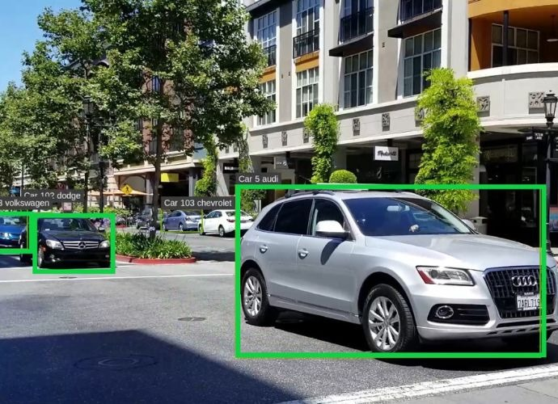

Fig.1. recognition of vehicles

# CONCLUSIONS

The CCTV/Video Footage Analysis Tool represents a comprehensive solution for enhancing the quality of DVR stored footage, extracting valuable information such as vehicle number plates, and classifying vehicles based on various attributes. By integrating advanced image processing and machine learning techniques, the tool offers enhanced capabilities for surveillance, security, and forensic analysis, empowering users to make informed decisions based on the insights derived from the analyzed video content.

# REFERENCES

1. Xizhe Zhang, Siddartha Khastgir, Justin-Kiyoshi Tiele, Kazuhito Takenaka, Tasuku Hayakawa, Paul Jennings, "ODD and Behavior Based Scenario Generation for Automated Driving Systems", *IEEE Access*, vol.12, pp.10652-10663, 2024.

1. Edward Schwalb, Patrick Irvine, Xizhe Zhang, Siddartha Khastgir, Paul Jennings, "A Two-Level Abstraction ODD Definition Language: Part II", *2021 IEEE International Conference on Systems, Man, and Cybernetics (SMC)*, pp.1669-1676, 2021.

1. Xizhe Zhang, Siddartha Khastgir, Hamid Asgari, Paul Jennings, "Test Framework for Automatic Test Case Generation and Execution Aimed at Developing Trustworthy AVs from Both Verifiability and Certifiability Aspects", *2021 IEEE International Intelligent Transportation Systems Conference (ITSC)*, pp.312-319, 2021.