**Udacity Project II Analysis**

**Introduction**

The dataset used in this project was combined from a CSV document provided by WeRateDogs

through Udacity, JSON text document provided by Udacity and a TSV, which was gotten from a

Udacity on Udacity website.

**Data Analysis**

After combining the datasets, it was trimmed down to 1906 rows and twelve columns and the

analysis is carried out to asnwer the following questions;

* What is the top source, users tweeted from?
* The top 10 most popular dog breed in the tweets
* Top rated dog based on retweets
* Top rated dog based on favorite count
* The winner of the contest, which is top rated based on dog rating and retweet count and favorite count

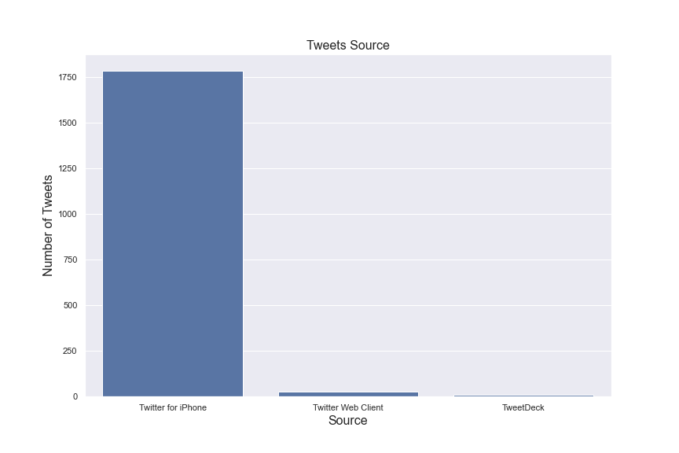

The top source used by users is the Iphone as you can see from the plot above.

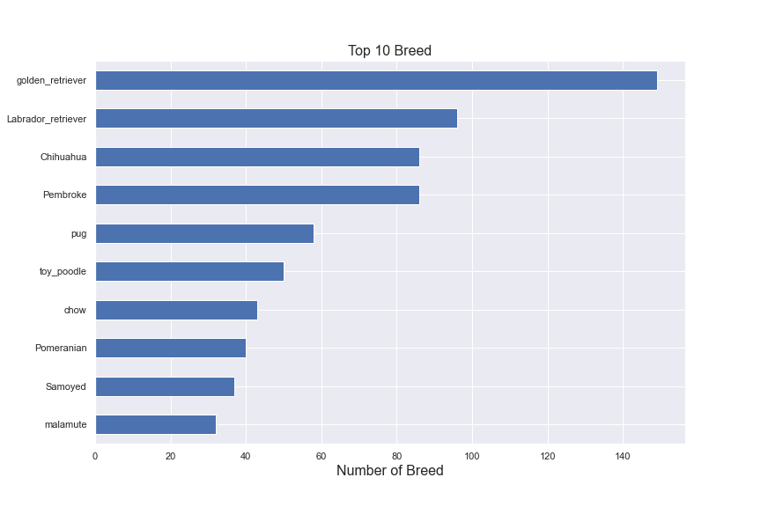

This plot showed the top ten breed in the dataset, the top dog breed is Golden Retriever, followed by Labrador Retriever, after which the Chihuahua comes third in the ranking.



This is the dog image that with the highest retweets. This is also the dog with the highest rating, retweet count and favorite counts. It is our top rated dog from the tweet.

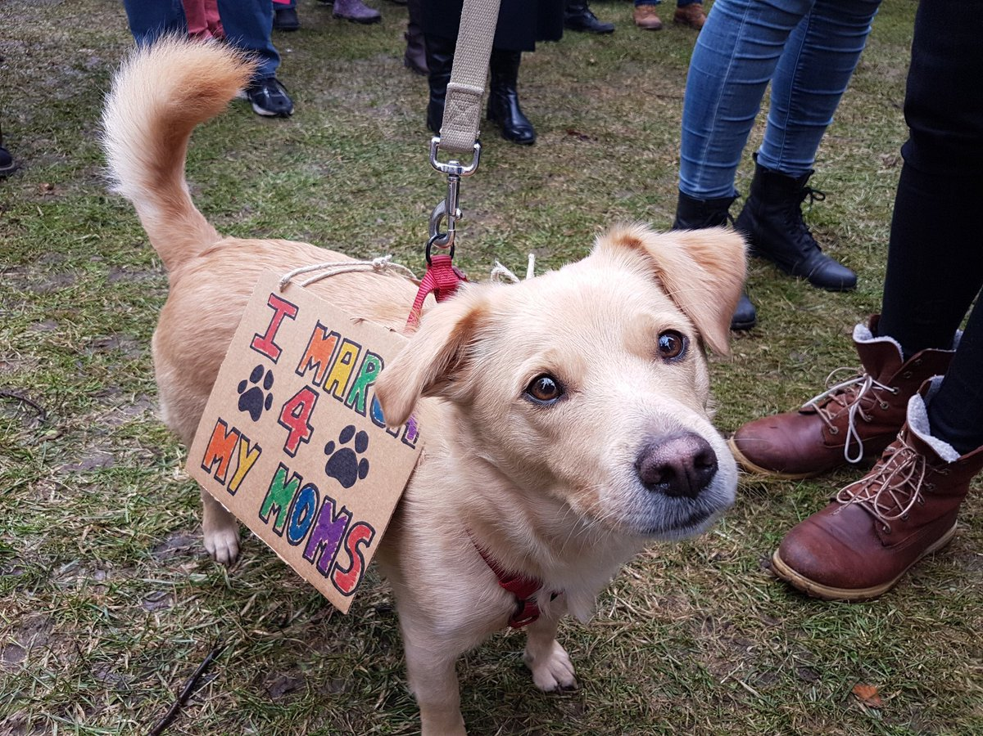

This is the dog image that with the highest favorite counts