Supplementary
PyHEARTS Output Variables Reference (per-cycle CSV)
The table lists each column emitted by *_pyhearts.csv, with a plain-language description and how it is computed in the toolbox. Threshold and species-specific values: ProcessCycleConfig. HRV metrics are listed in the separate table below.
Feature Name | Description | Calculation
cycle_index | Cycle number (0-based) within the record | Index assigned during epoching; increments per retained R–R cycle
cycle_trend | Estimated linear trend slope within the cycle | Slope from line through first and last samples after baseline subtraction (linergress)
r_squared | Goodness-of-fit (R2) of Gaussian model | Squared Pearson correlation between detrended cycle and fitted sum of Gaussians
rmse | Root mean square error of fit | RMSE between detrended cycle and fitted waveform
P_global_center_idx | P wave center (absolute sample index) | xs_samples[center_idx] after center refinement
P_global_le_idx | P wave left edge (absolute sample index) | xs_samples[le_idx] where signal crosses fraction threshold (std-guided
P_global_ri_idx | P wave right edge (absolute sample index) | xs_samples[ri_idx] where signal crosses fraction threshold (std-guided)
P_center_ms | P wave center time (ms) | (global_center_idx/fs)×1000
P_le_ms | P wave left-edge time (ms) | (global_le_idx/fs)×1000
P_ri_ms | P wave right-edge time (ms) | (global_ri_idx/fs)×1000
P_center_idx | P wave center (relative index) | Rounded fitted center refined to local extremum within ±10 samples (or ±½FWHM for seeded)
P_le_idx | P wave left edge (relative index) | Search left from P center until signal ≤ baseline + 0.30 × (P_center − baseline); enforce min duration (≥20 ms human, ≥2 ms mouse)
P_ri_idx | P wave right edge (relative index) | Search right from P center until signal ≤ baseline + 0.30 × (P_center − baseline); enforce min duration (≥20 ms human, ≥2 ms mouse)
P_gauss_center | P wave Gaussian center (samples) | Fitted μ from curve_fit
P_gauss_height | P wave Gaussian amplitude (mV) | Fitted peak height on detrended signal
P_gauss_stdev_samples | P wave Gaussian σ (samples) | Fitted σ; initialized from FWHM/2.3548, min 0.5 samples
P_gauss_stdev_ms | P wave Gaussian σ (ms) | σ(samples)×(1000/fs)
P_gauss_fwhm_samples | P wave Gaussian FWHM (samples) | 2√(2 ln 2)·σ
P_gauss_fwhm_ms | P wave Gaussian FWHM (ms) | FWHM(samples)×(1000/fs)
P_fwhm_le_idx | P FWHM-based left edge (cycle-relative samples) | gauss_center - (gauss_fwhm_samples/2)
P_fwhm_ri_idx | P FWHM-based right edge (cycle-relative samples) | gauss_center + (gauss_fwhm_samples/2)
P_fwhm_le_ms | P FWHM-based left edge time (ms) | (fwhm_le_idx / sampling_rate) * 1000
P_fwhm_ri_ms | P FWHM-based right edge time (ms) | (fwhm_ri_idx / sampling_rate) * 1000
P_fwhm_global_le_idx | P FWHM-based left edge (absolute sample index) | xs_samples[int(round(fwhm_le_idx))]
P_fwhm_global_ri_idx | P FWHM-based right edge (absolute sample index) | xs_samples[int(round(fwhm_ri_idx))]
P_center_voltage | P wave amplitude at center (mV) | Detrended signal value at center_idx
P_le_voltage | P wave amplitude at left edge (mV) | Detrended signal at le_idx
P_ri_voltage | P wave amplitude at right edge (mV) | Detrended signal at ri_idx
P_duration_ms | P wave duration (ms) | (ri_idx − le_idx) × (1000/fs); must exceed species minimum
P_rise_ms | P wave rise time (ms) | (center_idx − le_idx) × (1000/fs)
P_decay_ms | P wave decay time (ms) | (ri_idx − center_idx) × (1000/fs)
P_rdsm | P wave rise–decay symmetry | (center_idx − le_idx)/(ri_idx − le_idx)
P_sharpness | P wave sharpness (normalized) | 95th percentile of |dV/dt| between P_le_idx and P_ri_idx, normalized by (P_center_voltage − baseline)
P_max_upslope_mv_per_s | P maximum upslope (mV/s) | max(diff(signal[le_idx:center_idx]) / dt)
P_max_downslope_mv_per_s | P maximum downslope (mV/s) | min(diff(signal[center_idx:ri_idx]) / dt)
P_slope_asymmetry | P slope asymmetry (unitless) | abs(max_upslope) / abs(max_downslope)
P_voltage_integral_uv_ms | P wave voltage integral (µV·ms) | Trapz integral of detrended mV over [le_idx, ri_idx] ×1e6
Q_global_center_idx | Q wave center (absolute sample index) | xs_samples[center_idx] after center refinement
Q_global_le_idx | Q wave left edge (absolute sample index) | xs_samples[le_idx] where signal crosses fraction threshold (std-guided)
Q_global_ri_idx | Q wave right edge (absolute sample index) | xs_samples[ri_idx] where signal crosses fraction threshold (std-guided)
Q_center_ms | Q wave center time (ms) | (global_center_idx/fs)×1000
Q_le_ms | Q wave left-edge time (ms) | (global_le_idx/fs)×1000
Q_ri_ms | Q wave right-edge time (ms) | (global_ri_idx/fs)×1000
Q_center_idx | Q wave center (relative index) | Rounded fitted center refined to local extremum within ±10 samples (or ±½FWHM for seeded)
Q_le_idx | Q wave left edge (relative index) | Search left from Q center until signal ≥ baseline + 0.30 × (Q_center − baseline) (Q negative), subject to minimum duration
Q_ri_idx | Q wave right edge (relative index) | Search right from Q center until signal ≥ baseline + 0.30 × (Q_center − baseline) (Q negative), subject to minimum duration
Q_gauss_center | Q wave Gaussian center (samples) | Fitted μ from curve_fit
Q_gauss_height | Q wave Gaussian amplitude (mV) | Fitted peak height on detrended signal
Q_gauss_stdev_samples | Q wave Gaussian σ (samples) | Fitted σ; initialized from FWHM/2.3548, min 0.5 samples
Q_gauss_stdev_ms | Q wave Gaussian σ (ms) | σ(samples)×(1000/fs)
Q_gauss_fwhm_samples | Q wave Gaussian FWHM (samples. | 2√(2 ln 2)·σ
Q_gauss_fwhm_ms | Q wave Gaussian FWHM (ms) | FWHM(samples)×(1000/fs)
Q_fwhm_le_idx | Q FWHM-based left edge (cycle-relative samples) | gauss_center - (gauss_fwhm_samples/2)
Q_fwhm_ri_idx | Q FWHM-based right edge (cycle-relative samples) | gauss_center + (gauss_fwhm_samples/2)
Q_fwhm_le_ms | Q FWHM-based left edge time (ms) | (fwhm_le_idx / sampling_rate) * 1000
Q_fwhm_ri_ms | Q FWHM-based right edge time (ms) | (fwhm_ri_idx / sampling_rate) * 1000
Q_fwhm_global_le_idx | Q FWHM-based left edge (absolute sample index) | xs_samples[int(round(fwhm_le_idx))]
Q_fwhm_global_ri_idx | Q FWHM-based right edge (absolute sample index) | xs_samples[int(round(fwhm_ri_idx))]
Q_center_voltage | Q wave amplitude at center (mV) | Detrended signal value at center_idx
Q_le_voltage | Q wave amplitude at left edge (mV) | Detrended signal at le_idx
Q_ri_voltage | Q wave amplitude at right edge (mV) | Detrended signal at ri_idx
Q_duration_ms | Q wave duration (ms) | (ri_idx − le_idx) × (1000/fs); must exceed species minimum
Q_rise_ms | Q wave rise time (ms) | (center_idx − le_idx) × (1000/fs)
Q_decay_ms | Q wave decay time (ms) | (ri_idx − center_idx) × (1000/fs)
Q_rdsm | Q wave rise–decay symmetry | (center_idx − le_idx)/(ri_idx − le_idx)
Q_sharpness | Q wave sharpness (normalized) | 95th percentile of |dV/dt| between Q_le_idx and Q_ri_idx, normalized by (Q_center_voltage − baseline).
Q_max_upslope_mv_per_s | Q maximum upslope (mV/s) | max(diff(signal[le_idx:center_idx]) / dt)
Q_max_downslope_mv_per_s | Q maximum downslope (mV/s) | min(diff(signal[center_idx:ri_idx]) / dt)
Q_slope_asymmetry | Q slope asymmetry (unitless) | abs(max_upslope) / abs(max_downslope)
Q_voltage_integral_uv_ms | Q wave voltage integral (µV·ms) | Trapz integral of detrended mV over [le_idx, ri_idx] ×1e6
R_global_center_idx | R peak center (absolute sample index) | xs_samples[center_idx] after center refinement
R_global_le_idx | R peak left edge (absolute sample index) | xs_samples[le_idx] where signal crosses fraction threshold (std-guided)
R_global_ri_idx | R peak right edge (absolute sample index) | xs_samples[ri_idx] where signal crosses fraction threshold (std-guided)
R_center_ms | R peak center time (ms) | (global_center_idx/fs)×1000
R_le_ms | R peak left-edge time (ms) | (global_le_idx/fs)×1000
R_ri_ms | R peak right-edge time (ms) | (global_ri_idx/fs)×1000
R_center_idx | R peak center (relative index) | Rounded fitted center refined to local extremum within ±10 samples (or ±½FWHM for seeded)
R_le_idx | R peak left edge (relative index) | Search left from R center until signal ≤ baseline + 0.30 × (R_center − baseline) (R positive), subject to minimum duration
R_ri_idx | R peak right edge (relative index) | Search right from R center until signal ≤ baseline + 0.30 × (R_center − baseline) (R positive), subject to minimum duration
R_gauss_center | R peak Gaussian center (samples) | Fitted μ from curve_fit
R_gauss_height | R peak Gaussian amplitude (mV) | Fitted peak height on detrended signal
R_gauss_stdev_samples | R peak Gaussian σ (samples) | Fitted σ; initialized from FWHM/2.3548, min 0.5 samples
R_gauss_stdev_ms | R peak Gaussian σ (ms) | σ(samples)×(1000/fs)
R_gauss_fwhm_samples | R peak Gaussian FWHM (samples) | 2√(2 ln 2)·σ
R_gauss_fwhm_ms | R peak Gaussian FWHM (ms) | FWHM(samples)×(1000/fs)
R_fwhm_le_idx | R FWHM-based left edge (cycle-relative samples) | gauss_center - (gauss_fwhm_samples/2)
R_fwhm_ri_idx | R FWHM-based right edge (cycle-relative samples) | gauss_center + (gauss_fwhm_samples/2)
R_fwhm_le_ms | R FWHM-based left edge time (ms) | (fwhm_le_idx / sampling_rate) * 1000
R_fwhm_ri_ms | R FWHM-based right edge time (ms) | (fwhm_ri_idx / sampling_rate) * 1000
R_fwhm_global_le_idx | R FWHM-based left edge (absolute sample index) | xs_samples[int(round(fwhm_le_idx))]
R_fwhm_global_ri_idx | R FWHM-based right edge (absolute sample index) | xs_samples[int(round(fwhm_ri_idx))]
R_center_voltage | R peak amplitude at center (mV) | Detrended signal value at center_idx
R_le_voltage | R peak amplitude at left edge (mV) | Detrended signal at le_idx
R_ri_voltage | R peak amplitude at right edge (mV) | Detrended signal at ri_idx
R_duration_ms | R peak duration (ms) | (ri_idx − le_idx) × (1000/fs); must exceed species minimum
R_rise_ms | R peak rise time (ms) | (center_idx − le_idx) × (1000/fs)
R_decay_ms | R peak decay time (ms) | (ri_idx − center_idx) × (1000/fs)
R_rdsm | R peak rise–decay symmetry | (center_idx − le_idx)/(ri_idx − le_idx)
R_sharpness | R peak sharpness (normalized) | 5th percentile of |dV/dt| between R_le_idx and R_ri_idx, normalized by (R_center_voltage − baseline)
R_max_upslope_mv_per_s | R maximum upslope (mV/s) | max(diff(signal[le_idx:center_idx]) / dt)
R_max_downslope_mv_per_s | R maximum downslope (mV/s) | min(diff(signal[center_idx:ri_idx]) / dt)
R_slope_asymmetry | R slope asymmetry (unitless) | abs(max_upslope) / abs(max_downslope)
R_voltage_integral_uv_ms | R peak voltage integral (µV·ms) | Trapz integral of detrended mV over [le_idx, ri_idx] ×1e6
S_global_center_idx | S wave center (absolute sample index) | xs_samples[center_idx] after center refinement
S_global_le_idx | S wave left edge (absolute sample index) | xs_samples[le_idx] where signal crosses fraction threshold (std-guided)
S_global_ri_idx | S wave right edge (absolute sample index) | xs_samples[ri_idx] where signal crosses fraction threshold (std-guided)
S_center_ms | S wave center time (ms) | (global_center_idx/fs)×1000
S_le_ms | S wave left-edge time (ms) | (global_le_idx/fs)×1000
S_ri_ms | S wave right-edge time (ms) | (global_ri_idx/fs)×1000
S_center_idx | S wave center (relative index) | Rounded fitted center refined to local extremum within ±10 samples (or ±½FWHM for seeded)
S_le_idx | S wave left edge (relative index) | Search left from S center until signal ≥ baseline + 0.30 × (S_center − baseline) (S negative), subject to minimum duration
S_ri_idx | S wave right edge (relative index) | Search right from S center until signal ≥ baseline + 0.30 × (S_center − baseline) (S negative), subject to minimum duration
S_gauss_center | S wave Gaussian center (samples) | Fitted μ from curve_fit
S_gauss_height | S wave Gaussian amplitude (mV) | Fitted peak height on detrended signal
S_gauss_stdev_samples | S wave Gaussian σ (samples) | Fitted σ; initialized from FWHM/2.3548, min 0.5 samples
S_gauss_stdev_ms | S wave Gaussian σ (ms) | σ(samples)×(1000/fs)
S_gauss_fwhm_samples | S wave Gaussian FWHM (samples) | 2√(2 ln 2)·σ
S_gauss_fwhm_ms | S wave Gaussian FWHM (ms) | FWHM(samples)×(1000/fs)
S_fwhm_le_idx | S FWHM-based left edge (cycle-relative samples) | gauss_center - (gauss_fwhm_samples/2)
S_fwhm_ri_idx | S FWHM-based right edge (cycle-relative samples) | gauss_center + (gauss_fwhm_samples/2)
S_fwhm_le_ms | S FWHM-based left edge time (ms) | (fwhm_le_idx / sampling_rate) * 1000
S_fwhm_ri_ms | S FWHM-based right edge time (ms) | (fwhm_ri_idx / sampling_rate) * 1000
S_fwhm_global_le_idx | S FWHM-based left edge (absolute sample index) | xs_samples[int(round(fwhm_le_idx))]
S_fwhm_global_ri_idx | S FWHM-based right edge (absolute sample index) | xs_samples[int(round(fwhm_ri_idx))]
S_center_voltage | S wave amplitude at center (mV) | Detrended signal value at center_idx
S_le_voltage | S wave amplitude at left edge (mV) | Detrended signal at le_idx
S_ri_voltage | S wave amplitude at right edge (mV) | Detrended signal at ri_idx
S_duration_ms | S wave duration (ms) | (ri_idx − le_idx) × (1000/fs); must exceed species minimum
S_rise_ms | S wave rise time (ms) | (center_idx − le_idx) × (1000/fs)
S_decay_ms | S wave decay time (ms) | (ri_idx − center_idx) × (1000/fs)
S_rdsm | S wave rise–decay symmetry | (center_idx − le_idx)/(ri_idx − le_idx)
S_sharpness | S wave sharpness (normalized) | 95th percentile of |dV/dt| between S_le_idx and S_ri_idx, normalized by (baseline − S_center_voltage)
S_max_upslope_mv_per_s | S maximum upslope (mV/s) | max(diff(signal[le_idx:center_idx]) / dt)
S_max_downslope_mv_per_s | S maximum downslope (mV/s) | min(diff(signal[center_idx:ri_idx]) / dt)
S_slope_asymmetry | S slope asymmetry (unitless) | abs(max_upslope) / abs(max_downslope)
S_voltage_integral_uv_ms | S wave voltage integral (µV·ms) | Trapz integral of detrended mV over [le_idx, ri_idx] ×1e6
T_global_center_idx | T wave center (absolute sample index) | xs_samples[center_idx] after center refinement
T_global_le_idx | T wave left edge (absolute sample index) | xs_samples[le_idx] where signal crosses fraction threshold (std-guided)
T_global_ri_idx | T wave right edge (absolute sample index) | xs_samples[ri_idx] where signal crosses fraction threshold (std-guided)
T_center_ms | T wave center time (ms) | (global_center_idx/fs)×1000
T_le_ms | T wave left-edge time (ms) | (global_le_idx/fs)×1000
T_ri_ms | T wave right-edge time (ms) | (global_ri_idx/fs)×1000
T_center_idx | T wave center (relative index) | Rounded fitted center refined to local extremum within ±10 samples (or ±½FWHM for seeded)
T_le_idx | T wave left edge (relative index) | Search left from T center until signal ≤ baseline + 0.30 × (T_center − baseline) (T positive), subject to minimum duration
T_ri_idx | T wave right edge (relative index) | Search right from T center until signal ≤ baseline + 0.30 × (T_center − baseline) (T positive), subject to minimum duration
T_gauss_center | T wave Gaussian center (samples) | Fitted μ from curve_fit
T_gauss_height | T wave Gaussian amplitude (mV). | Fitted peak height on detrended signal.
T_gauss_stdev_samples | T wave Gaussian σ (samples). | Fitted σ; initialized from FWHM/2.3548, min 0.5 samples.
T_gauss_stdev_ms | T wave Gaussian σ (ms). | σ(samples)×(1000/fs).
T_gauss_fwhm_samples | T wave Gaussian FWHM (samples). | 2√(2 ln 2)·σ.
T_gauss_fwhm_ms | T wave Gaussian FWHM (ms). | FWHM(samples)×(1000/fs).
T_fwhm_le_idx | T FWHM-based left edge (cycle-relative samples) | gauss_center - (gauss_fwhm_samples/2)
T_fwhm_ri_idx | T FWHM-based right edge (cycle-relative samples) | gauss_center + (gauss_fwhm_samples/2)
T_fwhm_le_ms | T FWHM-based left edge time (ms) | (fwhm_le_idx / sampling_rate) * 1000
T_fwhm_ri_ms | T FWHM-based right edge time (ms) | (fwhm_ri_idx / sampling_rate) * 1000
T_fwhm_global_le_idx | T FWHM-based left edge (absolute sample index) | xs_samples[int(round(fwhm_le_idx))]
T_fwhm_global_ri_idx | T FWHM-based right edge (absolute sample index) | xs_samples[int(round(fwhm_ri_idx))]
T_center_voltage | T wave amplitude at center (mV) | Detrended signal value at center_idx
T_le_voltage | T wave amplitude at left edge (mV) | Detrended signal at le_idx
T_ri_voltage | T wave amplitude at right edge (mV) | Detrended signal at ri_idx
T_duration_ms | T wave duration (ms) | (ri_idx − le_idx) × (1000/fs); must exceed species minimum
T_rise_ms | T wave rise time (ms) | (center_idx − le_idx) × (1000/fs)
T_decay_ms | T wave decay time (ms) | (ri_idx − center_idx) × (1000/fs)
T_rdsm | T wave rise–decay symmetry | (center_idx − le_idx)/(ri_idx − le_idx)
T_sharpness | T wave sharpness (normalized) | 95th percentile of |dV/dt| between T_le_idx and T_ri_idx, normalized by (T_center_voltage − baseline)
T_max_upslope_mv_per_s | T maximum upslope (mV/s) | max(diff(signal[le_idx:center_idx]) / dt)
T_max_downslope_mv_per_s | T maximum downslope (mV/s) | min(diff(signal[center_idx:ri_idx]) / dt)
T_slope_asymmetry | T slope asymmetry (unitless) | abs(max_upslope) / abs(max_downslope)
T_voltage_integral_uv_ms | T wave voltage integral (µV·ms) | Trapz integral of detrended mV over [le_idx, ri_idx] ×1e6
PR_interval_ms | PR interval duration (ms) | T_ms(Q_le) − T_ms(P_le); imputed if edges missing; gated to physiologic limits
PR_segment_ms | PR segment duration (ms) | T_ms(Q_le) − T_ms(P_ri)
QRS_interval_ms | QRS duration (ms) | T_ms(S_ri) − T_ms(Q_le)
ST_segment_ms | ST segment duration (ms) | T_ms(T_le) − T_ms(S_ri)
ST_interval_ms | ST interval duration (ms) | T_ms(T_ri) − T_ms(S_ri)
QT_interval_ms | QT interval duration (ms) | T_ms(T_ri) − T_ms(Q_le)
PP_interval_ms | PP interval between successive P centers (ms) | Δsamples(P_global_center) × (1000/fs); gated to pp_bounds_ms (defaults to rr_bounds_ms)
RR_interval_ms | RR interval between successive R centers (ms) | Δsamples(R_global_center) × (1000/fs); gated to rr_bounds_ms
QTc_Bazett_ms | QTc (Bazett) (ms) | QT_interval_ms / sqrt(RR_interval_ms/1000)
QTc_Fridericia_ms | QTc (Fridericia) (ms) | QT_interval_ms / (RR_interval_ms/1000)^(1/3)
QTc_Framingham_ms | QTc (Framingham) (ms) | QT_interval_ms + 0.154*(1000 - RR_interval_ms)
ST_elevation_mv | ST elevation at J+60ms (mV) | Voltage at S_ri_idx + 60ms (clipped to ST end)
ST_slope_mv_per_s | ST slope (mV/s) | Linear regression slope over ST segment (S end → T start)
ST_deviation_mv | ST deviation from baseline (mV) | ST_elevation_mv - baseline (median PR segment or fallback)
R_minus_S_voltage_diff_signed | Signed voltage difference R − S | Difference of Gaussian peak amplitudes: amp(A) − amp(B) from fitted detrended signal
R_minus_P_voltage_diff_signed | Signed voltage difference R − P | Difference of Gaussian peak amplitudes: amp(A) − amp(B) from fitted detrended signal
T_minus_R_voltage_diff_signed | Signed voltage difference T − R | Difference of Gaussian peak amplitudes: amp(A) − amp(B) from fitted detrended signal
PyHEARTS HRV Metrics Reference (per-recording)
These metrics are computed from the RR interval series and saved separately via save_hrv_metrics().
Feature Name | Description | Calculation
average_heart_rate | Mean heart rate (bpm) | Compute RR→HR (60/(RR_ms/1000)) then mean; requires ≥60 RR intervals
sdnn | SD of NN (RR) intervals (ms) | std(RR_intervals_ms, ddof=1)
rmssd | Root mean square of successive RR differences (ms) | sqrt(mean(diff(RR_ms)^2))
nn50 | Count of successive RR diffs > 50 ms | sum(abs(diff(RR_ms)) > 50)
pnn50 | Percent of successive RR diffs > 50 ms (%) | 100 * nn50 / (N-1)
sd1 | Poincaré short-term HRV (ms) | rmssd / sqrt(2)
sd2 | Poincaré long-term HRV (ms) | sqrt(2*sdnn^2 - sd1^2)

Supplementary Table 1.
Comprehensive list of PyHEARTS features, including feature name, description and method of calculation.

Dataset | Stability | Rank | Display_name | Effect | p (raw) | p-adj (Bonferroni) | Significance
AA | most_stable | 1 | ST int | 0.00E+00 | 4.99E-26 | 3.05E-24 | p < 0.001
 |  | 2 | RS_diff | 0.00E+00 | 6.87E-22 | 4.19E-20 | p < 0.001
 |  | 3 | P height | 0.00E+00 | 8.87E-19 | 5.41E-17 | p < 0.001
 |  | 4 | Q center volt | 0.00E+00 | 1.75E-16 | 1.07E-14 | p < 0.001
 |  | 5 | P right volt | 0.00E+00 | 4.76E-16 | 2.90E-14 | p < 0.001
 | least_stable | 1 | RR int | 8.30E+00 | 1.19E-13 | 7.27E-12 | p < 0.001
 |  | 2 | T dur | 2.20E+00 | 7.65E-45 | 4.67E-43 | p < 0.001
 |  | 3 | T center | 1.86E+00 | 3.65E-42 | 2.23E-40 | p < 0.001
 |  | 4 | T decay | 1.10E+00 | 2.57E-40 | 1.57E-38 | p < 0.001
 |  | 5 | T rise | 1.00E+00 | 3.44E-41 | 2.10E-39 | p < 0.001
MGH | most_stable | 1 | P left volt | 0.00E+00 | 4.67E-10 | 2.85E-08 | p < 0.001
 |  | 2 | P right volt | 0.00E+00 | 5.38E-10 | 3.28E-08 | p < 0.001
 |  | 3 | P rise | 0.00E+00 | 1.89E-09 | 1.15E-07 | p < 0.001
 |  | 4 | P decay | 0.00E+00 | 2.18E-09 | 1.33E-07 | p < 0.001
 |  | 5 | T rise | 0.00E+00 | 2.40E-08 | 1.46E-06 | p < 0.001
 | least_stable | 1 | R dur | -1.11E+00 | 2.74E-07 | 1.67E-05 | p < 0.001
 |  | 2 | Q rise | -8.33E-01 | 8.75E-08 | 5.34E-06 | p < 0.001
 |  | 3 | R rise | -8.33E-01 | 5.22E-10 | 3.18E-08 | p < 0.001
 |  | 4 | R decay | -6.45E-01 | 1.46E-06 | 8.91E-05 | p < 0.001
 |  | 5 | S center | 1.36E-01 | 0.000336 | 0.020507 | p < 0.05

Supplementary Table 2. Within Session Drift Analysi.
Top five most stable and least stable ECG features within session, ranked by absolute effect size of early–late differences. Results are shown separately for the healthy aging (AA; n = 895 recordings) and clinical (MGH; n = 183 recordings) datasets. For each feature, sample size (n), paired test (Wilcoxon signed-rank or paired t-test), median effect (late – early), raw p-value, adjusted p-value (Bonferroni), and significance level are reported.

Age bin (years) | Dataset A | Dataset B | U statistic | p (raw) | q (FDR)
15–20 | AA | PTB-XL | 16866.5 | 4.95×10⁻²⁷ | 1.11×10⁻²⁵
15–20 | SPH | AA | 24233.5 | 6.90×10⁻¹⁸ | 7.76×10⁻¹⁷
20–25 | SPH | AA | 89210 | 1.51×10⁻⁴⁶ | 6.78×10⁻⁴⁵
20–25 | AA | PTB-XL | 5495.5 | 6.18×10⁻²⁰ | 9.28×10⁻¹⁹
25–30 | SPH | AA | 91476 | 1.57×10⁻¹¹ | 1.18×10⁻¹⁰
25–30 | AA | PTB-XL | 2785.5 | 1.53×10⁻⁹ | 8.60×10⁻⁹
25–30 | SPH | PTB-XL | 55607 | 1.06×10⁻² | 2.27×10⁻²
35–40 | SPH | PTB-XL | 175922 | 3.44×10⁻⁴ | 8.14×10⁻⁴
35–40 | SPH | AA | 36524 | 1.99×10⁻² | 3.90×10⁻²
40–45 | SPH | AA | 19159.5 | 1.03×10⁻¹⁰ | 6.59×10⁻¹⁰
40–45 | AA | PTB-XL | 7516.5 | 6.95×10⁻⁷ | 2.09×10⁻⁶
40–45 | SPH | PTB-XL | 153011.5 | 1.41×10⁻² | 2.88×10⁻²
45–50 | SPH | AA | 20676 | 3.66×10⁻¹³ | 3.30×10⁻¹²
45–50 | AA | PTB-XL | 10088 | 6.66×10⁻⁹ | 3.33×10⁻⁸
50–55 | SPH | AA | 7353 | 5.32×10⁻⁵ | 1.50×10⁻⁴
50–55 | AA | PTB-XL | 3566 | 1.46×10⁻⁴ | 3.71×10⁻⁴
55–60 | SPH | AA | 7252 | 4.20×10⁻⁷ | 1.58×10⁻⁶
55–60 | AA | PTB-XL | 4335.5 | 5.87×10⁻⁷ | 1.89×10⁻⁶
55–60 | AA | MGH | 300 | 1.48×10⁻⁴ | 3.71×10⁻⁴
60–65 | AA | PTB-XL | 3990.5 | 1.59×10⁻⁸ | 7.15×10⁻⁸

Supplementary Table 3. Pairwise comparisons of mean absolute error (MAE) across datasets within 5-year age bins.
Tests were performed using Mann–Whitney U tests, with false discovery rate (FDR) correction applied across all bins and pairs (Benjamini–Hochberg). Only significant results (q ≤ 0.05) are shown.

Category | Object Parameter  (ProcessCycleConfig) | Default Value
Human data | Epoch correlation threshold | 0.80
 | Epoch variance threshold | 5.0 × global variance
 | Baseline detrending window | 200 ms
 | RR interval bounds | 300–1800 ms
 | Shape window caps (ms) | P = 160, Q = 60, R = 80, S = 60, T = 200
 | Minimum component duration | 20 ms
Mouse data | Baseline detrending window | 100 ms
 | RR interval bounds | 80–250 ms
 | Shape window caps (ms) | P = 35, Q = 12, R = 18, S = 12, T = 60
 | Minimum component duration | 2 ms
Common settings | Curve fitting bounds | ±20% around initial guess (bound_factor = 0.20)
 | Fitting iteration limit | maxfev = 2500
 | Wavelet context | Daubechies-6 (db6), detail level = 3, multiplier k = 1.75, peak height threshold = 1.2σ
 | Dynamic QRS context offset | linearly scaled 1–60 ms
 | Threshold for width crossings | threshold_fraction = 0.30
 | Default voltage differences | R–S, R–P, T–R (signed)

Supplementary Table 4. Species-specific configuration settings
Two configuration presets, for_human() and for_mouse(), automatically apply these values. Users may override any field at runtime. The full resolved configuration, including all overrides and version tag (v1-human or v1-mouse), is saved with each output to ensure full reproducibility.

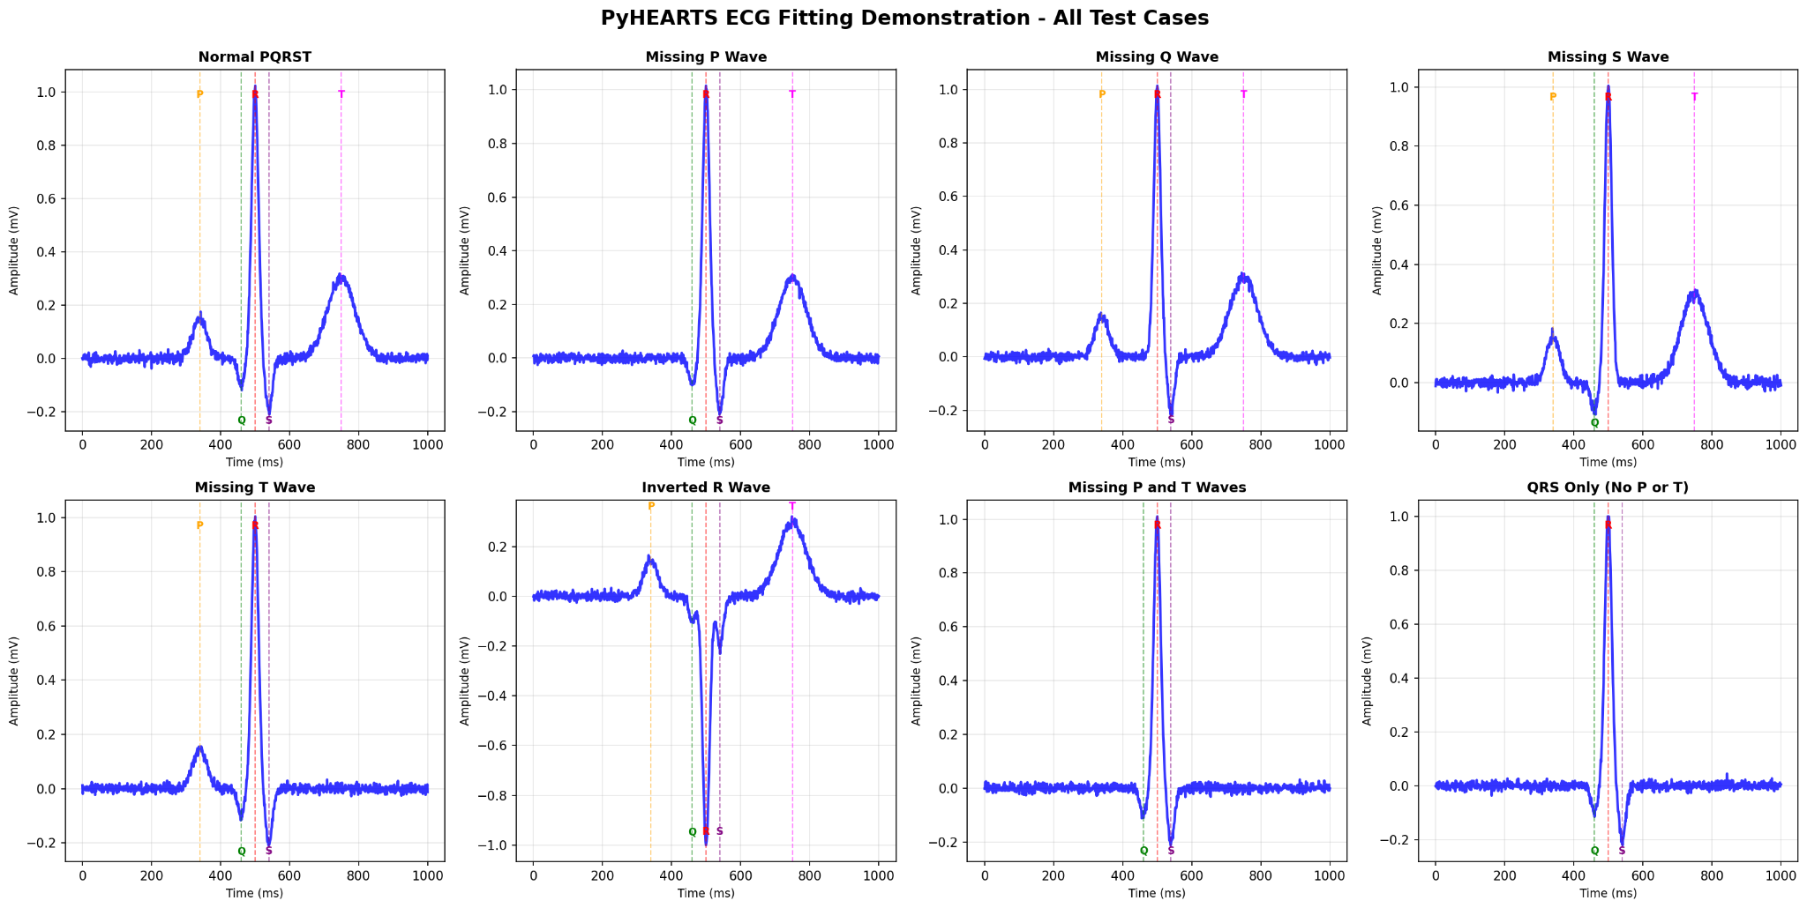
Supplementary Figure 1. PyHEARTS ECG fitting performance across diverse waveform morphologies.

Representative single-beat ECG segments (blue) and fitted P–QRS–T model (red) are shown for eight scenarios: normal PQRST, missing P wave, missing Q wave, missing S wave, missing T wave, inverted R wave, missing P and T waves, and QRS-only (no P or T). Vertical dashed lines mark the detected/fitted fiducial locations for P, Q, R, S and T components (labels at the corresponding markers), illustrating robust handling of absent components and polarity inversion while maintaining accurate localization of the QRS complex.
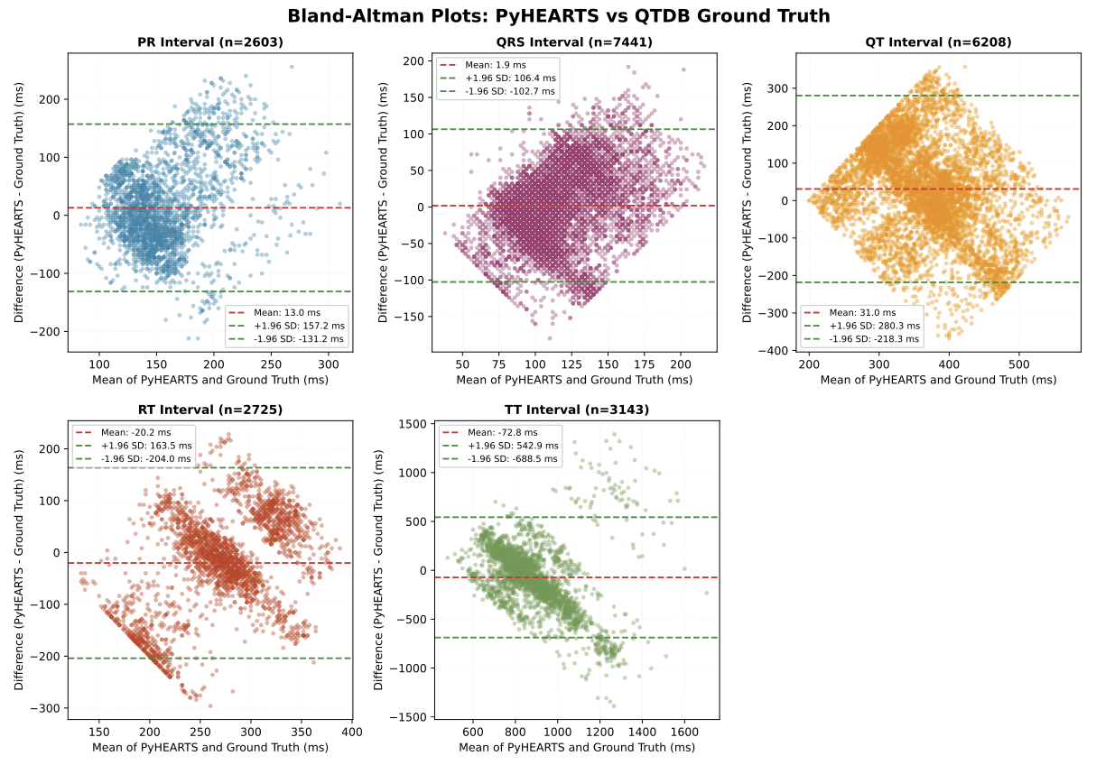
Supplementary Figure 2. Bland-Altman plots comparing PyHEARTS interval measurements against QTDB ground truth annotations.

Agreement between PyHEARTS and manual annotations for PR (n=2,603), QRS (n=7,441), QT (n=6,208), RT (n=2,725), and TT (n=3,143) intervals across 103 subjects. Each plot shows the difference (PyHEARTS − Ground Truth) versus the mean of the two methods, with mean bias (dashed red line) and 95% limits of agreement (dashed green lines, mean ± 1.96 SD). Data from the PhysioNet QT Database (QTDB).

