PyMOL – Basics – The GUI

**Molecular Visualisation**

PyMOL Intuitive interface Python compatible

Chimera Great for larger structures Advanced visualisations

VMD Great for trajectory analysis

QuteMol Simple stylised visuals

**Pymol Version**

Pymol 2.x Python 3 ‘Incentive’ version (university licence)

Pymol 1.x Python 2 Open Source version

.pse files will not open between version

.pml and .py scripts contain python will not run between versions

Available for Windows / Mac / Linux

**Resources**

<https://pymolwiki.org/index.php/Main_Page>

<https://www.uml.edu/docs/PyMOL%20Quick%20Reference%20Guide_tcm18-230352.pdf>

**What is a pdb?**

<https://www.rcsb.org/>

Lets have a look at a PDB file

What is a .cif file? And is this important?

**Navigating the GUI**

*But first we need a structure*

fetch 2chb

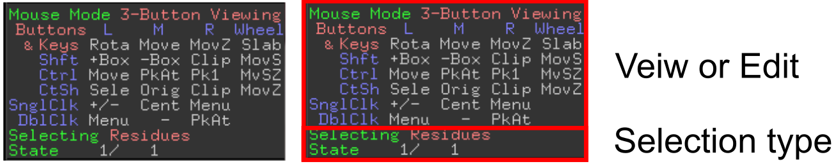

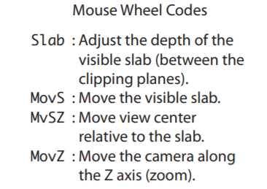 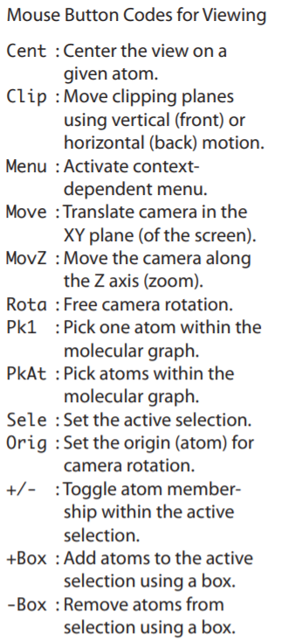 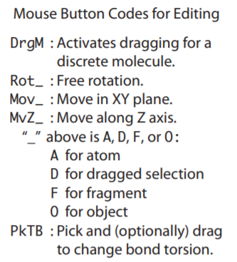

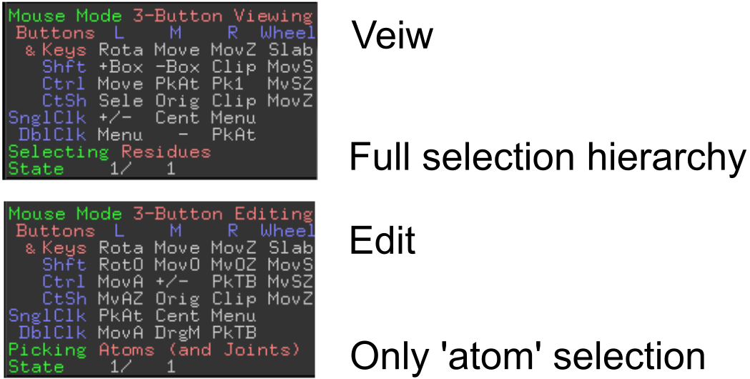

**Objects and Selection**

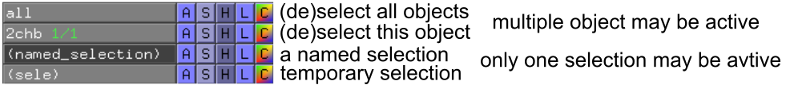

** [A] Action  [S] Show 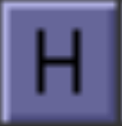 [H] Hide  [L] Label 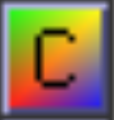 [C] Colour**

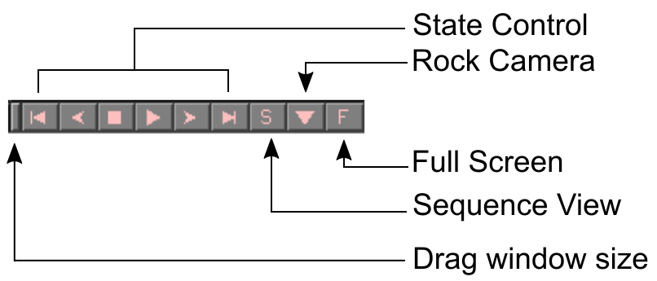

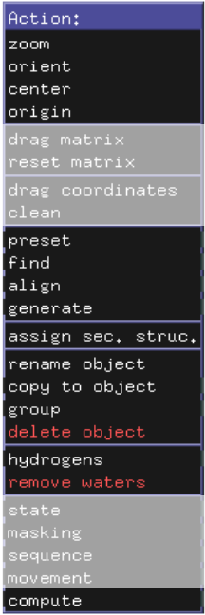

**Show state control**

fetch 1j8k



as sticks

remove hydrogen

*Find hydrogen bonds*

*Look at presets*

split_states 1j8k

delete 1j8k

join_states 1j8k, 1j8k_*

split_states 1j8k

delete 1j8k

*align all to one*

**Show alignment**

fetch 1qoh

*select chains – take two, extract, align*

rein

fetch 1qoh, type=pdb1

1qoh  > align > to molecule > 2chb

align 1qoh, 2chb

cealign 1qoh, 2chb

super 1qoh, 2chb

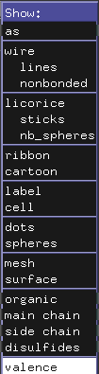

Show – **Add** to the current representation

As – **replace** the current representation

Tip! You can type this also!

as cartoon

show sticks

select polymer - selects protein/nucleic acid

select polymer.protein

select organic - selects ligand

select inorganic - selects ions

select solvent - selects water

select ! polymer - selects **not** protein/nucleic acid

select ! organic - selects **not** ligand

select ! inorganic - selects **not** ions

select ! solvent - selects **not** water

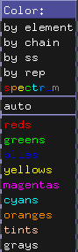

By element – first line keeps current C color

By chain – allows chainbows per chain

By ss – colours by secondary structure

Although limited options, you can try

color firebrick, ss H

color forest, ss S

color density, ss L

command options

util.cbc cbc = color by chain

util.cnc cnc = color not carbon

util.chainbows

***therefore!***

rein

fetch 2chb, async=0

remove solvent

remove inorganic

as cartoon

show sticks, organic

util.cbc

color black, organic

util.cnc

bg_color white

orient

