ETF Screening Report

ETF Researcher

May 1, 2021

## Preparation

### Import ETF List

## # A tibble: 6 x 9  
## Symbol ETF_name Asset_class Total_assets YTD_Price_Change Daily_Volume  
## <chr> <chr> <chr> <dbl> <chr> <dbl>  
## 1 BLOK Amplify Transfo~ Equity 340. 0.792 156134  
## 2 BLCN Reality Shares ~ Equity 183. 0.5593 70842  
## 3 LEGR First Trust Ind~ Equity 53.5 0.1673 7405  
## 4 GFIN Goldman Sachs F~ Equity 50.4 0.1394 7153  
## 5 KOIN Innovation Shar~ Equity 19.4 0.3047 9558  
## 6 QQQ Invesco QQQ Equity 149662 0.4664 37415434  
## # ... with 3 more variables: Close_price <dbl>, Day_Change <dbl>, Label <chr>

### Clean Up the Table

* What types of ETFs according to sectors / industries

##   
## Consumer Discretionary Consumer Staples Energy   
## 13 3 11   
## Equity Financials Healthcare   
## 20 8 12   
## Industrials Materials Real Estate   
## 8 12 12   
## Technology Telecom Utilities   
## 32 1 6

### Select ETFs with Total Assets >= $50 Million

* How many ETFs have total assets higher than 100 million USD

## [1] 137

## Get ETFS Data from Yahoo Finance

* Define a function to obtain data and candleChart

## Artificial Intelligence (AI) ETFs

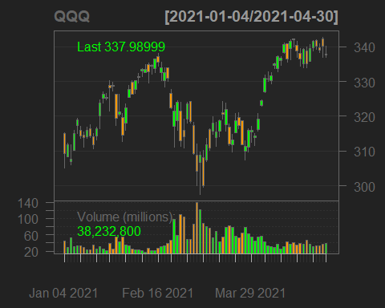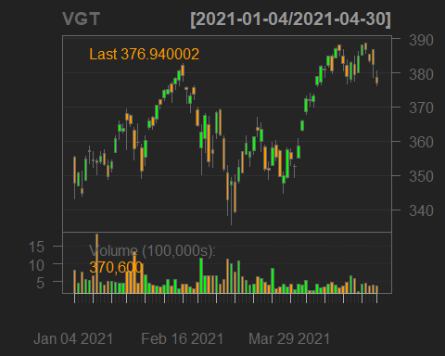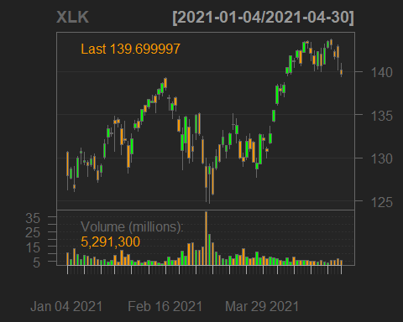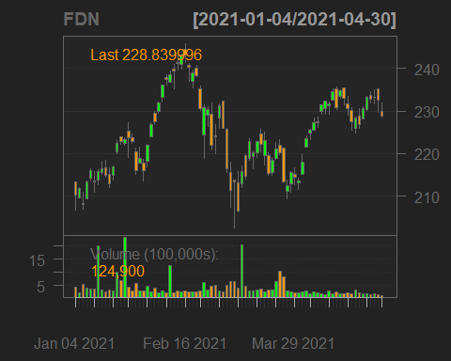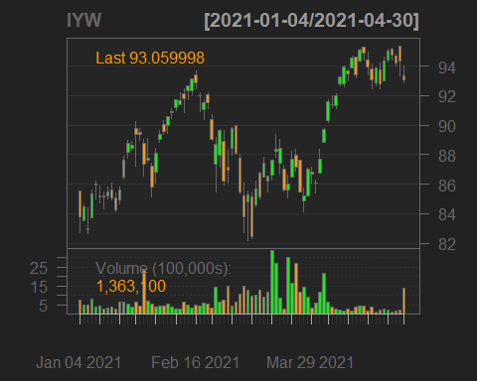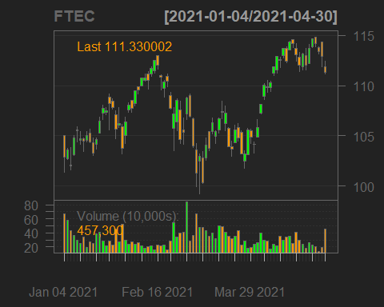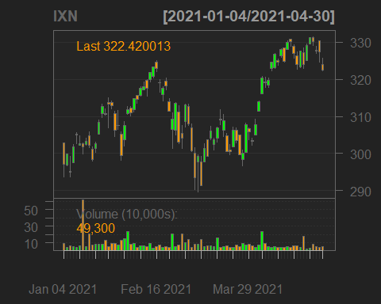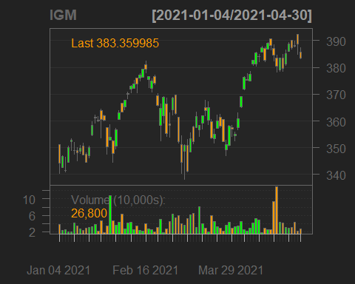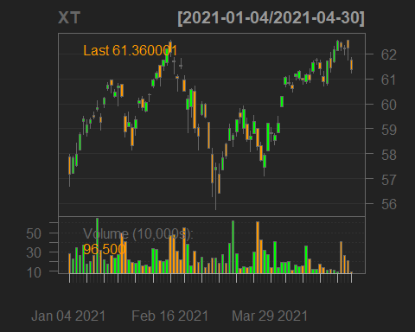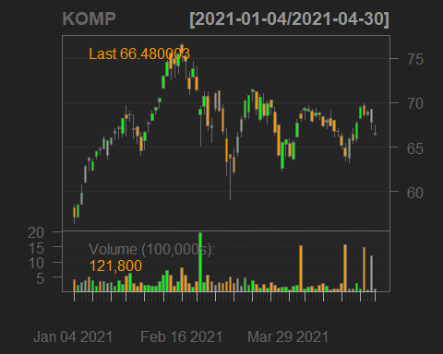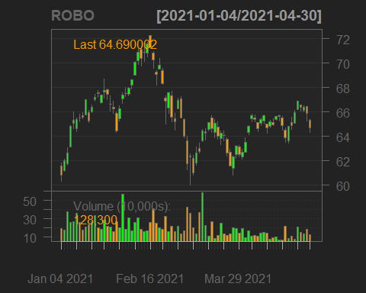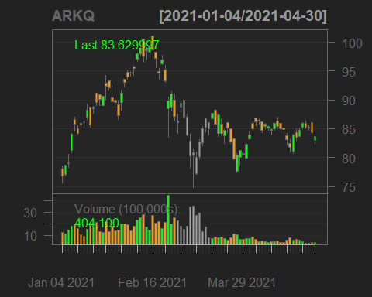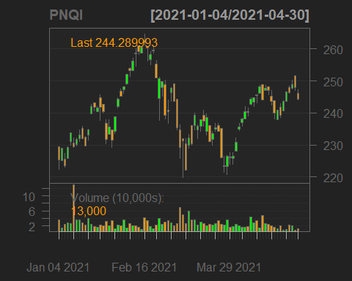

## Symbol sd ret  
## 1 QQQ 0.014 0.073  
## 2 VGT 0.015 0.061  
## 3 XLK 0.015 0.069  
## 4 FDN 0.017 0.073  
## 5 IYW 0.016 0.088  
## 6 FTEC 0.015 0.060  
## 7 IXN 0.015 0.065  
## 8 IGM 0.015 0.092  
## 9 XT 0.011 0.060  
## 10 KOMP 0.025 0.142  
## 11 ROBO 0.015 0.050  
## 12 ARKQ 0.023 0.071  
## 13 PNQI 0.018 0.065

## Software and Cyber Security

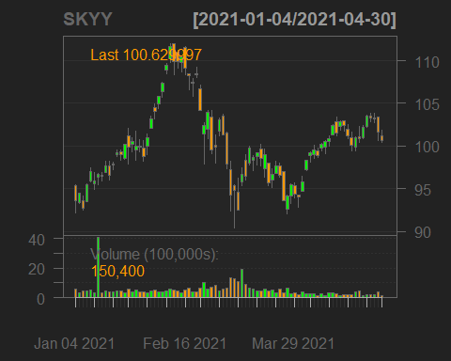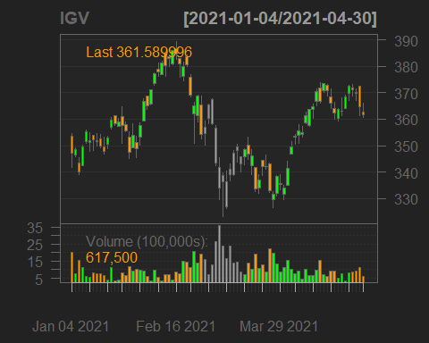

## Symbol sd ret  
## 1 SKYY 0.017 0.055  
## 2 IGV 0.017 0.023

## Semiconductor

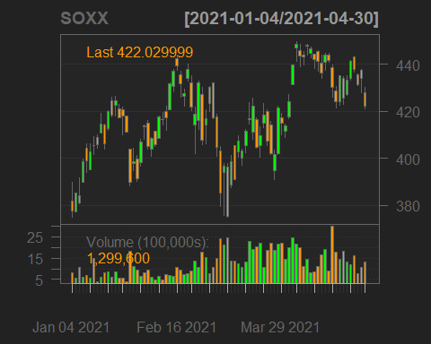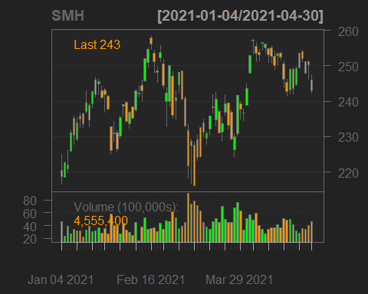

## Symbol sd ret  
## 1 SOXX 0.025 0.106  
## 2 SMH 0.025 0.102

## Oil and Gas (OilGas)

## Natural Resources (NaturalResource)

## MLP (MLP)

## Medical Device (MedicalDevice)

## Media (Media)

## Battery

## Internet

## Internet Security (InternetSecurity)

## Infrastructure

## Home

## Health Care

## Gold Mining (GoldMine)

## Finanical Service (FinService)

## Consumer

## Clean Energy (CleanEnergy)

## Utilities

## Telecom

## Technology

## Real Estate

## Materials

## Industrials

## Healthcare General(HealthcareG)

## Financials

## Staples

## Consumer Discretionary (ConsumerD)

## Biotechnology

## Banks

## Airlines

## Aerospace and Defence (Aerospace)

## Solar

## Silver

## Retail

## Transportation

## Water

## Game