Multilingual Chatbot – Documentation

1.Overview
This multilingual chatbot application provides intelligent, real-time conversational assistance in Tamil, English, Hindi, and German. The application supports text and voice input/output, document/image uploads with OCR and PDF extraction, and live translation.
2.Features
- Multilingual Input & Output (Tamil, English, Hindi, German)
- Voice Input via Microphone
- Text-to-Speech Output
- File Upload Support (PDF, Image, Text)
- OCR for Image Text Extraction
- Real-time Translation using Google Translator
- Claude 3 Sonnet Integration via OpenRouter

3.Technologies used
- Python 3.x
- PyQt5 for GUI
- gTTS for TTS
- SpeechRecognition for STT
- Tesseract OCR (Tamil/Multilingual)
- PyMuPDF (fitz) for PDF text extraction
- Google Translate (deep_translator)
- Claude 3 via OpenRouter API

4.Installation Guide
1.Install Python 3.x and pip
2. Clone the project folder
3. Install dependencies using pip:
pip install -r requirements.txt
Install Python Libraries:
pip install pyqt5 openai deep-translator gtts speechrecognition pillow pytesseract PyMuPDF

Install Tesseract OCR:
- Download from: https://github.com/tesseract-ocr/tesseract
- Install to: C:\Program Files\Tesseract-OCR\
- Add this path to your environment variable or set in code:
- pytesseract.pytesseract.tesseract_cmd = r"C:\Program Files\Tesseract-OCR\tesseract.exe"

4. Install Tesseract OCR and add its path to your system environment variables.
5. Run the application:
python main.py
5.Folder Structure: 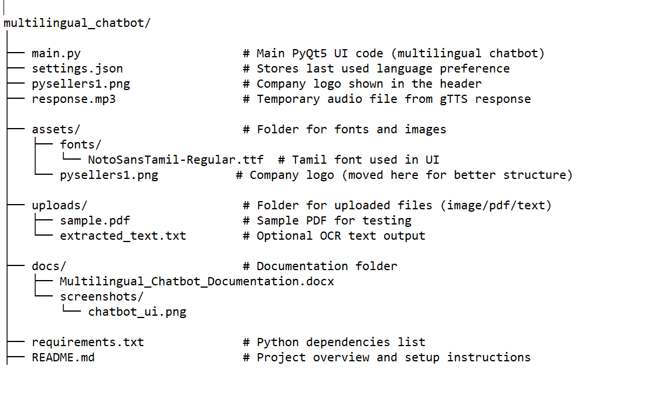
6.How to run: python main.py
7.code walkthrough
- main.py contains the full chatbot application UI using PyQt5.
- TamilChatbot class: Defines the full GUI and logic.
- class: For UI updates across threads.
- handle_file_upload(): Handles text/image/pdf inputs with OCR/PyMuPDF.
- voice_handler(): Uses microphone to get speech input.
- get_answer(): Gets Claude response and translates.
- translate_answer(): Translates output to selected language.
- speak_answer(): Converts response to speech using gTTS.
- update_ui_language(): Dynamically updates button/label translations.
8.I/O & O/P Screenshots
1.First we use the dropdown to select the input language
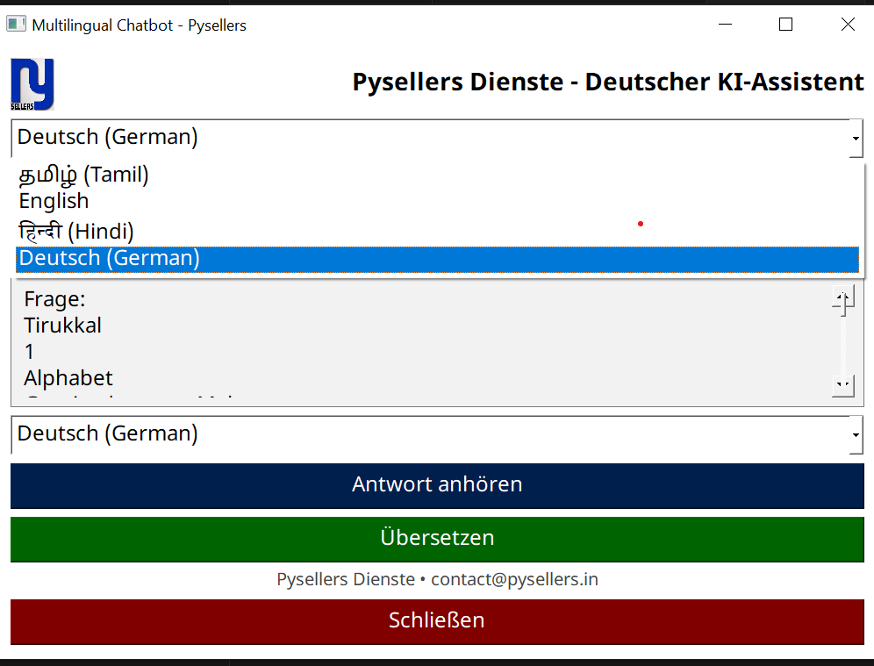

2. You can either upload a file (Text, PDF, PNG, JPEG, JPG, or image) or enter text manually in the input box. Alternatively, you can click the microphone button to speak your question.

3. The chatbot will display the response in the output box. You can preview uploaded files (images or PDFs) in the output area before text extraction, ensuring that your upload was successful.

4. You can then translate the chatbot's response into your preferred language by selecting a language from the dropdown and clicking the Translate button.

5. You can also listen to the response using the Speak button.
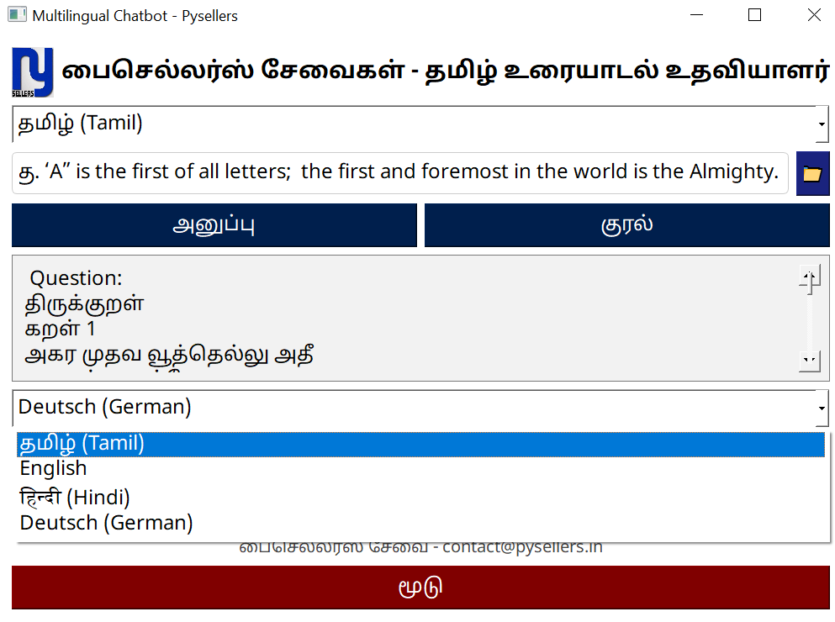

6.close button is used to close the chatbot

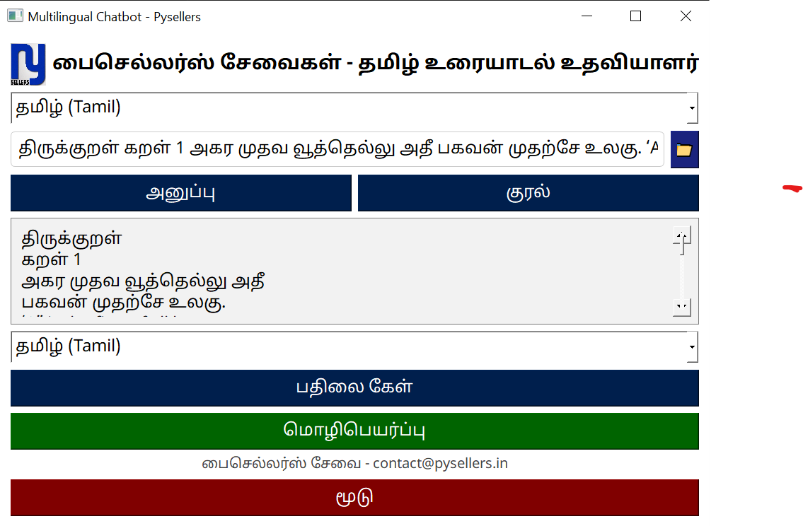

9.Best practices
- Use QThreads for long tasks if scaling
- Handle exceptions gracefully (TTS/STT/Claude errors)
- Avoid blocking main thread
- Translate only after full Claude response.
10.Future enhancement
- Save chat history per language
- Add offline mode with local models
- Add support for more languages (French, Arabic)
- Theme and layout customization
11.Support
For any issues, please contact: contact@pysellers.in

