**📦 Physical device shots**

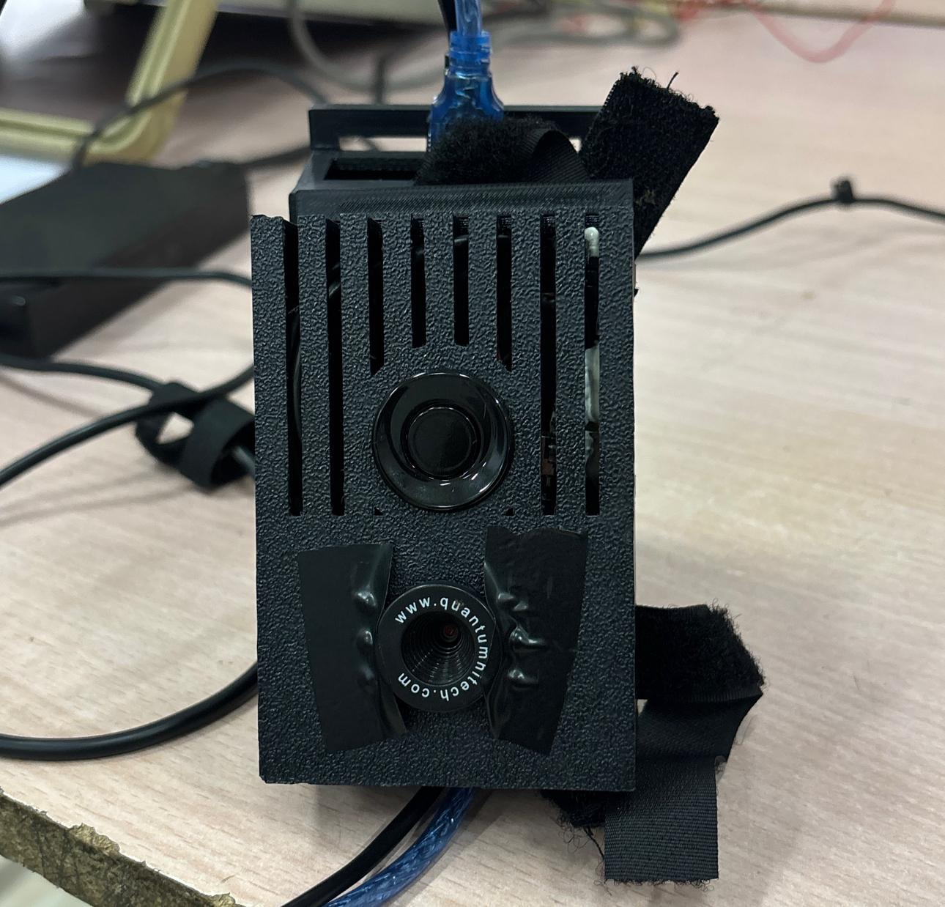

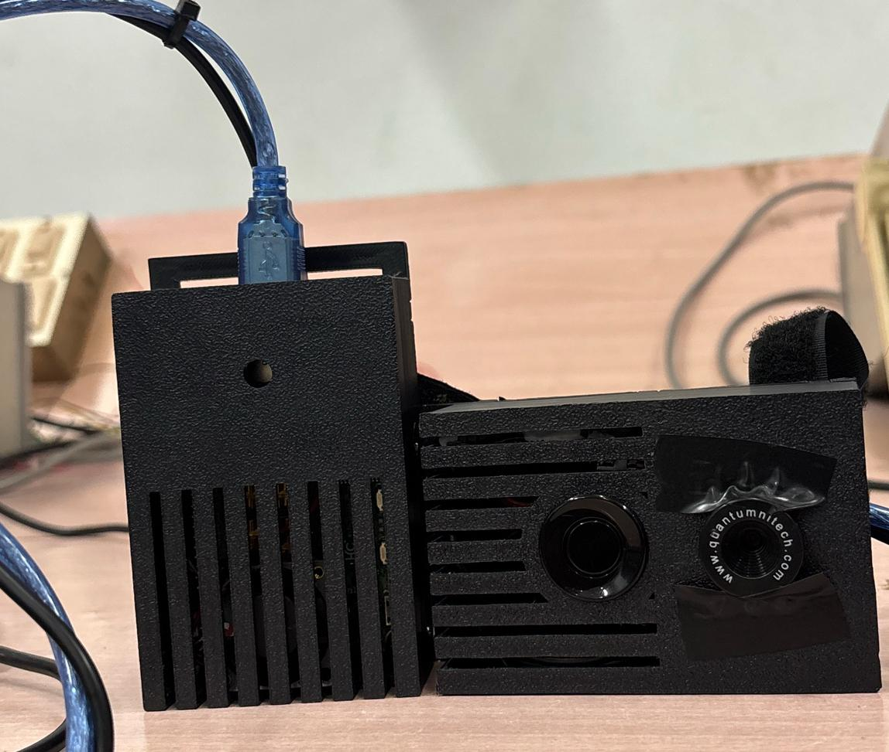

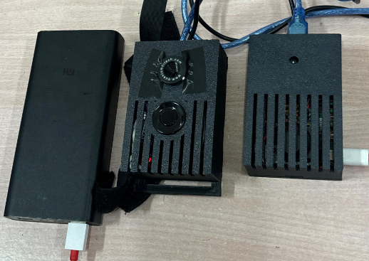

_________________________________________________________________________________________

**🟥 Bounded region text detection examples**

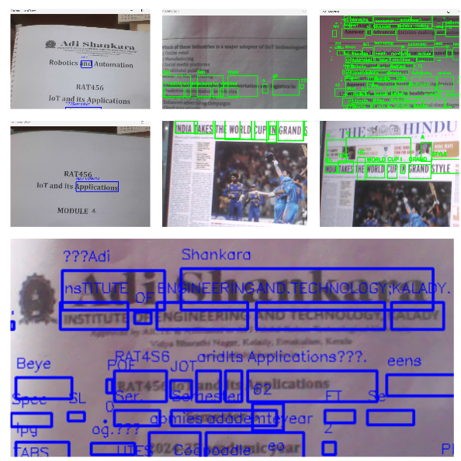

**📸 Terminal logs & OCR output**

**OBSTACLE DETECTION**

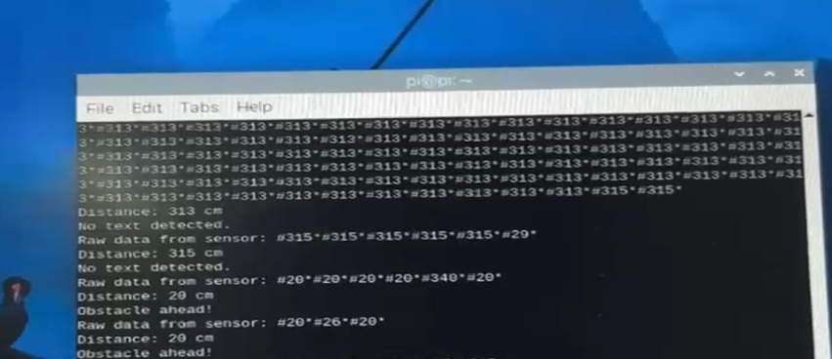

**EXTRACTED TEXT**

