*PySilSub*: A Python toolbox for performing the method of silent substitution with multiprimary stimulation devices.

Joel T. Martin1, Geoff Boynton2, Daniel Baker1 and Alex Wade1, Manuel Spitschan3,4,

1Department of Psychology, The University of York, York, United Kingdom, YO10 5DD

2Department of Psychology, University of Washington, 119A Guthrie Hall Box 351525, Seattle, WA 98195-1525

3Max Planck Institute for Biological Cybernetics, Tübingen, Germany

4TUM Department of Sport and Health Sciences (TUM SG), Technical University of Munich, Munich, Germany

Author Note

Address: Joel T. Martin, Department of Psychology, The University of York, York, United Kingdom, YO10 5DD

Phone: +44 (0)1904 323190

Email: [joel.martin@](mailto:joel.martin@)york.ac.uk

The research was supported by funding from the Biotechnology and Biological Sciences Research Council (BBSRC: BB/V007580/1), the Engineering and Physical Sciences Research Council (EPSRC: EP/S021507/1), the Welcome Trust (204686/Z/16/Z) and John Fell OUP Research Fund, University of Oxford (0005460).

Abstract

Silent substitution is a technique for stimulating individual classes of photoreceptors on the retina whilst maintaining a constant level of activation in others.

Keywords: silent substitution, melanopsin, instrumentation, pupillary light reflex, software, open source

*PySilSub:* A Python toolbox for performing the method of silent substitution with multiprimary stimulation devices.

A normal human retina contains several types of photosensetive cell (for review, see Grünert & Martin, 2020). Enabling colour vision at mesopic and photopic light levels are the short-, medium-, and long-wavelength-light-sensetive cone photoreceptors. Cone cells are packed densley into the fovea and distributed sparsely elsewhere in the retina. For scotopic (twilight) vision we have rod photoreceptors. Though not present at the fovea, rods are most numerous of the photoreceptor cells and are otherwise widely distributed in retina. Finally, discovered in human retinae only at the turn of the millenium—intrinsically photosensetive retinal ganglion cells (ipRGCs) expressing the photopigment melanopsin in their axons and soma (Provencio et al., 2000). ipRGCs do not contribute to vision in the same way as rods and cones but they play important roles in ‘non-visual’ functions, such as circadian photoentraiment and pupil control, via direct projections to the suprachiasmatic nucleus of the hypothalamus and the olivery pretectal nucleus of the midbrain (Gamlin et al., 2007; Ruby et al., 2002).

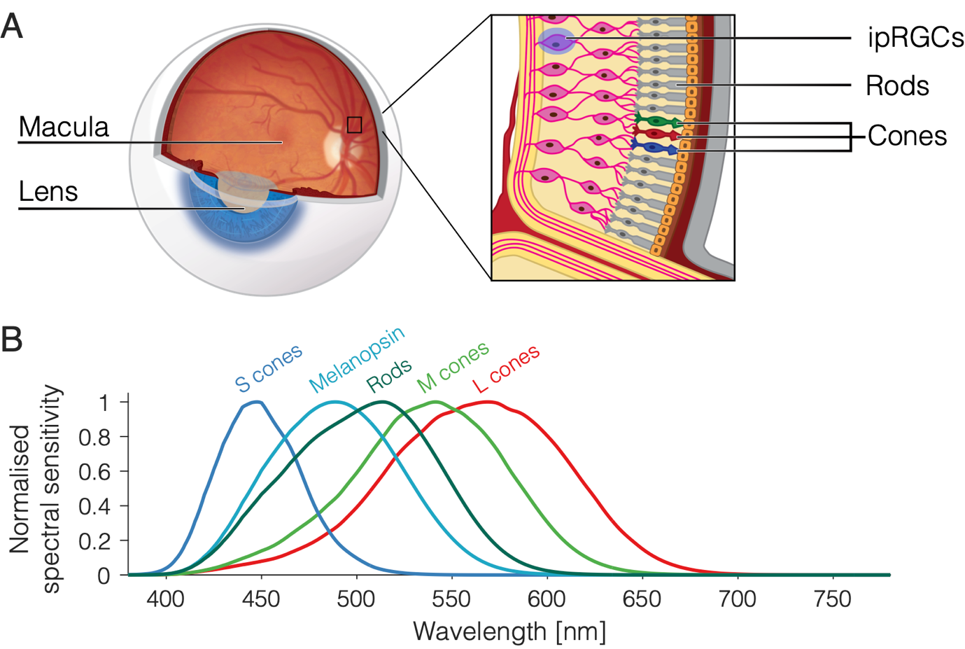

Figure 1. (A) Photoreceptors of the retina and (B) their spectral sensitivities.

As illustrated in Figure 1, the photoreceptors have different spectral sensetivities. The curve for each type of photoreceptor essentially describes the probability of its capturing a photon at a given wavelength. Therefore S-cones are about 10 times more likely than L-cones to capture photons at 450 nm, and the liklihood of L- and M-cones capturing at 550 nm is about the same. Because the spectral sensetivities of the photoreceptors overlap, it should be clear that most lights in the visible spectrum will stimulate all types of photoreceptor, albeit to varying degrees. However, it is possible to prepare light stimuli that selectively target photoreceptor classes via the method of silent substitution.

Silent substitution is an elegant technique that involves using pairs of lights to selectively stimulate one class of retinal photoreceptor whilst maintaining a constant level of activation in the others. This is possible owing to Rushton’s (1972) principle of univariance, which states that the output of a photoreceptor is one-dimensional and depends upon quantum catch, not upon what quanta are caught. In other words, different light spectra will have an identical effect on a photoreceptor providing they lead to the same number of photons being absorbed. The prinicple of univariance and its relevance to silent substitution is covered in greater detail by Estévez and Spekreijse (1982) along with other details regarding the early history of the method. In vision science, silent substitution has contributed to our understanding of human colour vision mechanisms (Horiguchi et al., 2013) and it has enabled researchers to examine how targeted photoreceptor stimulation affects physiological responses such as melatonin suppression (Allen et al., 2018), the electroretinogram (Maguire et al., 2017), and the pupillary light reflex (Spitschan et al., 2014). Its potential as a diagnostic tool for retinal disease has also garnered attention in recent years (Kuze et al., 2017; Wise et al., 2021).

Among the challenges to silent substitution are inhomogeneities of the retina (most notably the presence of the macular pigment at the fovea, whose light absorbing properties effectively shift the spectral sensetivity of underlying photoreceptors), individual variation in photoreceptor spectral sensetivities, rod intrusion, and uncertainty of the stimulation device (Spitschan & Woelders, 2018). But, from a practical standpoint, arguably the greatest challange of silent substitution is in finding the settings for a multiprimary stimulation device to produce lights that selectively stimulate the photoreceptor(s) of interest. The Silent Substitution Toolbox (Spitschan et al., 2015) can help with this, but it requires the user to be familiar with, and possess a lisence for, MATLAB. Here we present *PySilSub*, an alternative silent substitution software written in Python which features generic object-oriented support for multiprimary stimulation devices, predicitive methods, visual conveniences, example datasets, an intuitive user-friendly interface with thorough documentation, and solutions to stimulus design based on linear algebra and constrained numerical optimisation. In this manuscript we review describe our toolbox and demonstrate its use.

**Method**

**Stimulation devices**

To stimulate one class of retinal photoreceptor without changing the activation in others—which is to perform the method of silent substitution—requires a multiprimary stimulation device with at least as many primaries as there are photoreceptors in the retina. This generally means that 5 primaries are needed, although 4 primaries may suffice when working in the photopic range as rods become saturated and incapable of signaling above 300 cd/m2 (Adelson, 1982; Aguilar & Stiles, 1954; but see Kremers et al., 2009; Shapiro, 2002). The primaries should be independently addressable, additive, and ideally stable over time with a linear input-output function. Peak wavelength and bandwidth of the primaries are key considerations that will ultimately define the gamut and available contrast (Evéquoz et al., 2021), and the light source will also need to be integrated into an optical setup for stimulus delivery—usually either a Ganzfeld (e.g., Martin et al., 2021) or Maxwellian (e.g., Cao et al., 2015).

Conus and Geiser (2020) reviewed stimulation devices from a range of silent substitution studies and found that in most cases the device had 4 or 5 primaries and was built from scratch using LEDs, optical bench components, and microprocessors, such as Arduino, for pulse width modulation control of intensity. Only a few devices were commercially bought. Whatever the device and setup, one must first calibrate the device from the perspective of an observer and create a forward model that can predict spectral output for any combination of settings. Typically, this involves sampling each of the primaries at a range of intensities with an external spectrometer and using interpolation methods (e.g., Martin et al., 2021).

The first notable feature of our software is a *StimulationDevice* class that takes a set of spectral calibration measurements and turns them into a predictive model. The required format is a CSV file where the first row describes the wavelength sampling (e.g., 380, 381, … 780) and every other row is a spectral measurement. Also required in the CSV file are the column headers Primary and Setting, with corresponding values to identify the spectra. For a perfectly linear device, it would suffice to measure each channel at maximum and minimum but as devices tend not to be linear it is prudent to obtain measurements across the input range. If sampling with an OceanOptics (﻿Ocean Insight Inc., Oxford, UK) or JETI ﻿(JETI Technische Instrumente, GmbH, Jena, Germany) spectrometer, one may benefit from the interfaces in python packages such as *LuxPy* (Smet, 2020), *PyPlr* (Martin et al., 2021; Martin & Spitschan, 2021) or *Seabreeze* (Poehlmann, 2019).

Once the device is calibrated, the easiest way to

Table 1. Calibration file format. Minimal example is shown for a hypothetical 5-primary device with 8-bit channel resolutions and perfect linearity. Each primary, marked with an ordinal index starting at zero, has a spectral measurement for the maximum (256) and minimum (0) setting, where the minimum setting should reflect the ambient spectral power distribution (i.e., when all channels are off). As devices tend not to be linear, the file should ideally include spectral samples for a range of settings. If this device was not linear, sampling from 0-256 in steps of 8 or 16 would be sensible.

|  |  |  |  |  |  |  |
| --- | --- | --- | --- | --- | --- | --- |
| Primary | Setting | 380 | 381 | … | 779 | 780 |
| 0 | 0 | *Spectral measurements -->* | | | | |
| 0 | 256 |
| 1 | 0 |
| 1 | 256 |
| 2 | 0 |
| 2 | 256 |
| 3 | 0 |
| 3 | 256 |
| 4 | 0 |
| 4 | 256 |

**Silent substitution problems**

**Making stimuli**

Silent substitution stimuli typically take the form of pulses or temporal modulations of photoreceptor-specific contrast presented against a background spectrum to which an observer has adapted. The background spectrum serves to maintain a set pattern of photoreceptor activations and the modulation spectrum increases activation of the targeted photoreceptor(s) without altering activation of the others.

***Numerical optimization.***

Silent substitution can be approached as a constrained numerical optimization problem of the form:

Where are the optimization variables (the device settings) whose lower and upper bounds, and , are between 0 and 1 to ensure that the solution is within the gamut of the device, is the objective function that aims to maximise contrast of the target photoreceptor(s), and is a function that calculates contrast for the silenced photoreceptor(s), where and should be zero. In all cases, is a vector containing the weights for the LED settings.

***Linear algebra.***

***Binocular silent substitution.***

**Discussion**

**Summary**

**Acknowledgements**

**Open Practices Statement**

References

Adelson, E. H. (1982). Saturation and Adaptation. *Vision Research*, *22*, 1299–1312.

Aguilar, M., & Stiles, W. S. (1954). Saturation of the rod mechanism of the retina at high levels of stimulation. *Optica Acta: International Journal of Optics*, *1*(1), 59–65. https://doi.org/10.1080/713818657

Allen, A. E., Hazelhoff, E. M., Martial, F. P., Cajochen, C., & Lucas, R. J. (2018). Exploiting metamerism to regulate the impact of a visual display on alertness and melatonin suppression independent of visual appearance. *Sleep*, *41*(8), 1–7. https://doi.org/10.1093/sleep/zsy100

Cao, D., Nicandro, N., & Barrionuevo, P. A. (2015). A five-primary photostimulator suitable for studying intrinsically photosensitive retinal ganglion cell functions in humans. *Journal of Vision*, *15*(1), 1–13. https://doi.org/10.1167/15.1.27

Conus, V., & Geiser, M. (2020). A review of silent substitution devices for melanopsin stimulation in humans. *Photonics*, *7*(4), 1–10. https://doi.org/10.3390/photonics7040121

Estévez, O., & Spekreijse, H. (1982). The “ Silent Substitution ” method in research. *Vision Research*, *22*(6), 681–691. https://doi.org/10.1016/0042-6989(82)90104-3

Evéquoz, G., Truffer, F., & Geiser, M. (2021). Maximum possible contrast level for silent substitution: a theoretical model applied to melanopsin stimulation. *Journal of the Optical Society of America A*, *38*(9), 1312. https://doi.org/10.1364/josaa.420373

Grünert, U., & Martin, P. R. (2020). Cell types and cell circuits in human and non-human primate retina. *Progress in Retinal and Eye Research*, *78*(November 2019), 100844. https://doi.org/10.1016/j.preteyeres.2020.100844

Horiguchi, H., Winawer, J., Dougherty, R. F., & Wandell, B. A. (2013). Human trichromacy revisited. *Proceedings of the National Academy of Sciences of the United States of America*, *110*(3). https://doi.org/10.1073/pnas.1214240110

Kremers, J., Czop, D., & Link, B. (2009). Rod and S-cone driven ERG signals at high retinal illuminances. *Documenta Ophthalmologica*, *118*(3), 205–216. https://doi.org/10.1007/s10633-008-9159-0

Kuze, M., Morita, T., Fukuda, Y., Kondo, M., Tsubota, K., & Ayaki, M. (2017). Electrophysiological responses from intrinsically photosensitive retinal ganglion cells are diminished in glaucoma patients. *Journal of Optometry*, *10*(4), 226–232. https://doi.org/10.1016/j.optom.2016.07.004

Maguire, J., Parry, N. R. A., Kremers, J., Murray, I. J., & McKeefry, D. (2017). The morphology of human rod ERGs obtained by silent substitution stimulation. *Documenta Ophthalmologica*, *134*(1), 11–24. https://doi.org/10.1007/s10633-017-9571-4

Martin, J. T., Pinto, J., Bulte, D., & Spitschan, M. (2021). PyPlr: A versatile, integrated system of hardware and software for researching the human pupillary light reflex. *Behavior Research Methods*, *0123456789*. https://doi.org/10.3758/s13428-021-01759-3

Martin, J. T., & Spitschan, M. (2021). *PyPlr (v1.0.0) [computer software]*. https://doi.org/https://doi.org/10.5281/zenodo.1234

Poehlmann, A. (2019). *Seabreeze (v1.3.0) [computer software]*. https://github.com/ap--/python-seabreeze/releases/tag/v1.3.0

Provencio, I., Rodriguez, I. R., Jiang, G., Hayes, W. P., Moreira, E. F., & Rollag, M. D. (2000). A novel human opsin in the inner retina. *Journal of Neuroscience*, *20*(2), 600–605. https://doi.org/10.1523/jneurosci.20-02-00600.2000

Rushton, W. A. H. (1972). Pigments and signals in colour vision. *The Journal of Physiology*, *220*(3), 1–31. https://doi.org/10.1113/jphysiol.1972.sp009719

Shapiro, A. G. (2002). Cone-specific mediation of rod sensitivity in trichromatic observers. *Investigative Ophthalmology and Visual Science*, *43*(3), 898–905.

Smet, K. A. G. (2020). Tutorial: The LuxPy Python Toolbox for Lighting and Color Science. *LEUKOS - Journal of Illuminating Engineering Society of North America*, *16*(3), 179–201. https://doi.org/10.1080/15502724.2018.1518717

Spitschan, M., Aguirre, G. K., & Brainard, D. H. (2015). Selective stimulation of penumbral cones reveals perception in the shadow of retinal blood vessels. *PLoS ONE*, *10*(4), 1–22. https://doi.org/10.1371/journal.pone.0124328

Spitschan, M., Jain, S., Brainard, D. H., & Aguirre, G. K. (2014). Opponent melanopsin and S-cone signals in the human pupillary light response. *Proceedings of the National Academy of Sciences of the United States of America*, *111*(43), 15568–15572. https://doi.org/10.1073/pnas.1400942111

Spitschan, M., & Woelders, T. (2018). The method of silent substitution for examining melanopsin contributions to pupil control. *Frontiers in Neurology*, *9*(NOV). https://doi.org/10.3389/fneur.2018.00941

Wise, E. N., Foster, M. L., Kremers, J., & Mowat, F. M. (2021). A modified silent substitution electroretinography protocol to separate photoreceptor subclass function in lightly sedated dogs. *Veterinary Ophthalmology*, *24*(1), 103–107. https://doi.org/10.1111/vop.12847