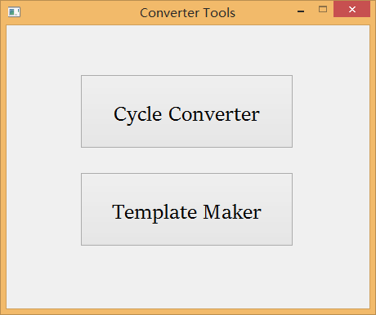

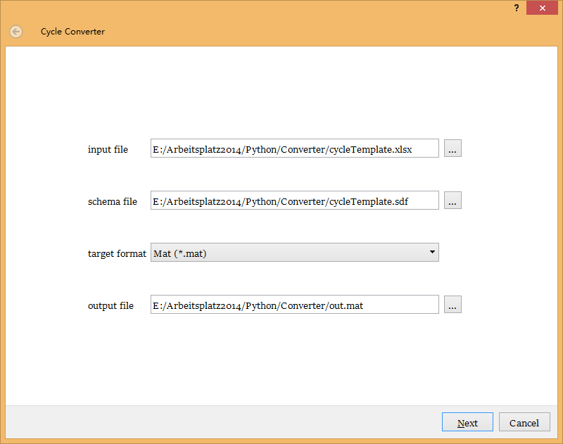

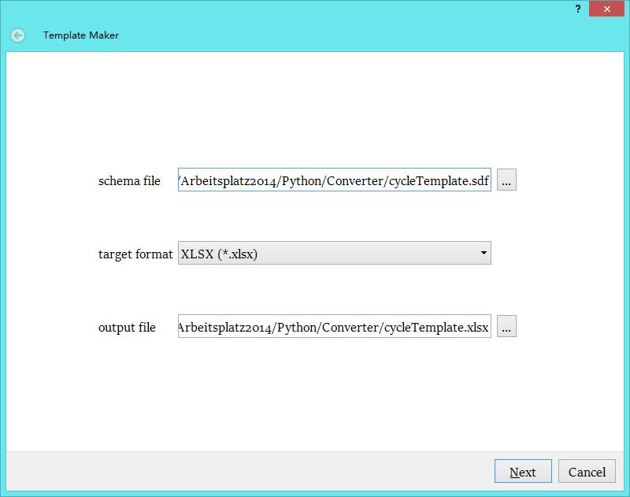

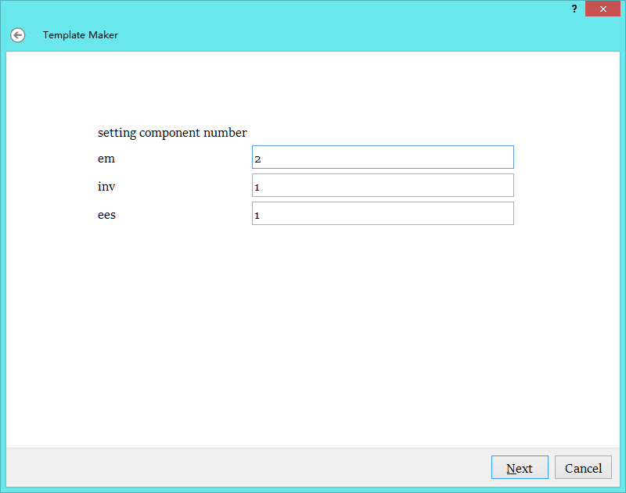

ERROR MESSAGE:

Syntax:

ees1 soc naming error must be an underscore symbol between the component name (prefix) and the variable name

ees1rci naming error must be an underscore symbol between the component name (prefix) and the variable name

inv[1] number missing number not correct in component name

ees1_current data length error data length not equals to time, time length = 13, data length = 14

Semantic:

ees1 component structure error component structure not equals to schema: [u'ees1 soc', u'ees1_current', u'ees1_lossPower', u'ees1_voltage', u'ees1rci'], schema [u'ees1_current', u'ees1_lossPower', u'ees1_rci', u'ees1_soc', u'ees1_voltage']

inv2 component name not found component name not found, but a similar component to validate

time comment not validated Zeitachse der Zyklendaten, schema:

inv2_switchingFrequency unit not validated Hz, schema:

ees1_voltage comment not validated Ausgangsspannung des Hochvoltspeichers (Anschlussklemmen des Hochvoltspeichers)äöüßÄÜÖ, schema:Ausgangsspannung des Hochvoltspeichers (Anschlussklemmen des Hochvoltspeichers)

ees1 soc schema not found

ees1rci schema not found