**Storytelling: Uncovering Insights from Global Superstore Data**

* **The Global Superstore dataset provides a comprehensive look at sales, profit, and customer behavior across various regions and product categories. Through data exploration and visualization, we can uncover meaningful insights that highlight the store's performance and identify areas for improvement. This narrative will guide you through the key findings, supported by visualizations.**

1. **Sales and Profit Over Time**

The time series analysis reveals the trends in sales and profit over the years. We observe seasonal spikes, likely corresponding to major shopping events and holidays. However, certain months show unexpected dips, indicating potential areas for targeted marketing efforts.  
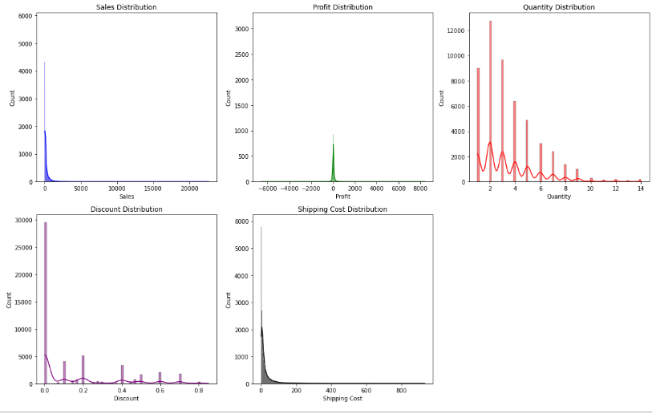

1. **Top Products by Sales and Profit**

Identifying the top-performing products is crucial for inventory management and marketing strategies. This analysis highlights the top 10 products in terms of sales and profit. This information helps in prioritizing stock for high-demand items and promoting products that generate the most profit.

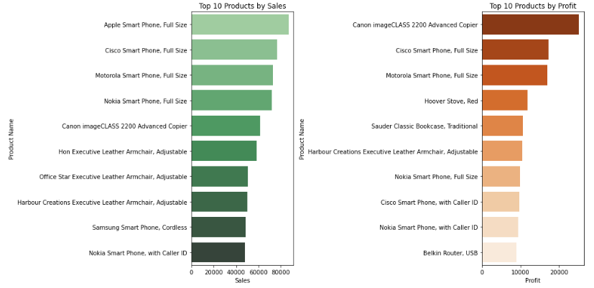

1. **Customer Segment Analysis**

The analysis of sales and profit by customer segment shows that the Consumer segment generates the most sales, while the Corporate segment yields higher profit margins. This insight can guide promotional campaigns and customer relationship management.

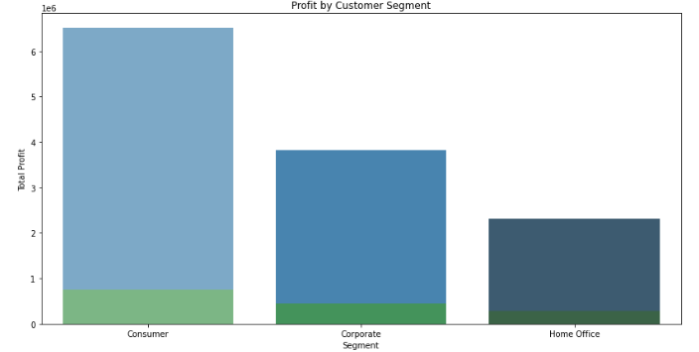

1. **Geographical Analysis**

The analysis shows that certain regions outperform others, suggesting potential markets for expansion and regions that may require additional marketing support.

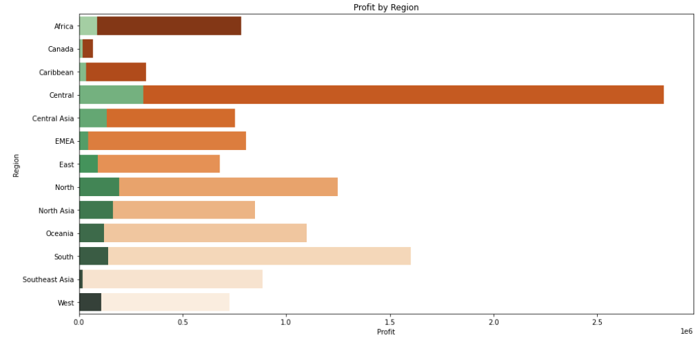

1. **Correlation Matrix**

A strong correlation between discount and profit suggests that higher discounts may negatively impact profit margins. Understanding these relationships will aid in making data-driven decisions.

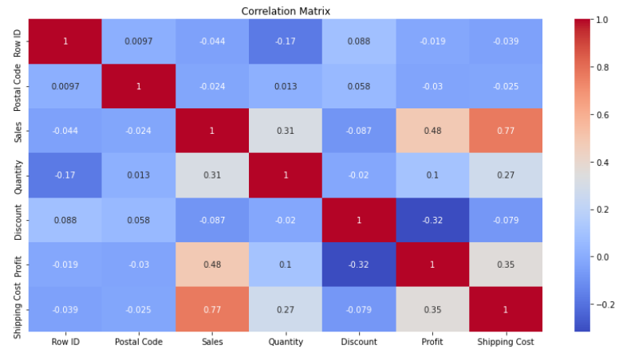

* **CONCLUSION**  
  By leveraging these insights, Global Superstore can optimize its operations, enhance customer satisfaction, and drive overall growth.

**Thanks & Regards  
PARAS YADAV**