My Expense Tracker

1.When the application opens it it will display a expense limit and expense period if it is already saved. User might change the limit by clicking the change button. If they are not saved then it will allow the user to enter the value and peri od.

Here expense limit of $50.00 is set for a period of a day and no expenses were entered earlier on that day .

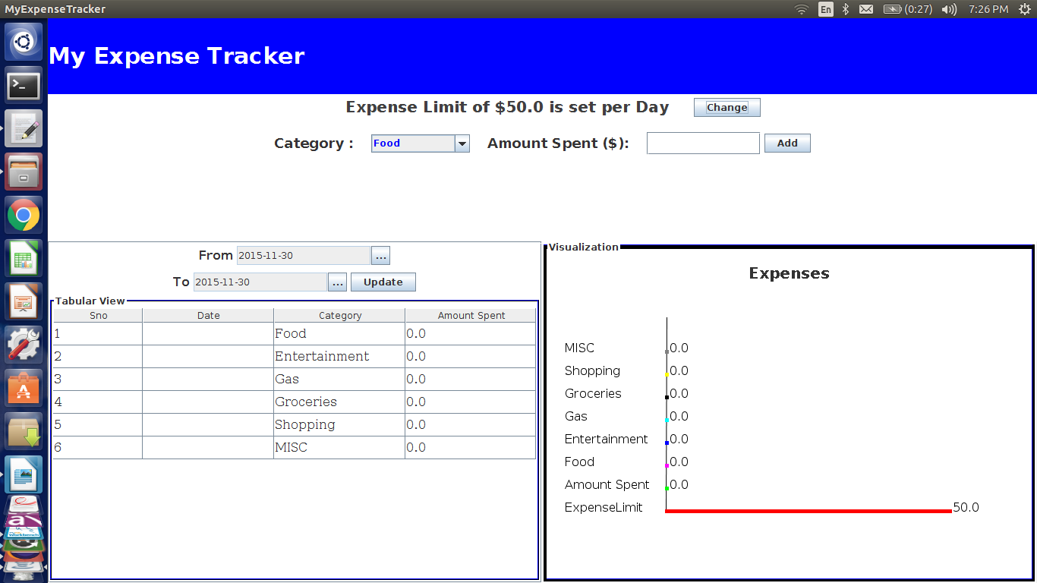

2.User has to enter for the limit value and select from the drop down for the period. User input is validated. If anything other than a number (int or double) is entered it displays a message saying to enter the valid amount. Once you enter the correct format it will store the values.
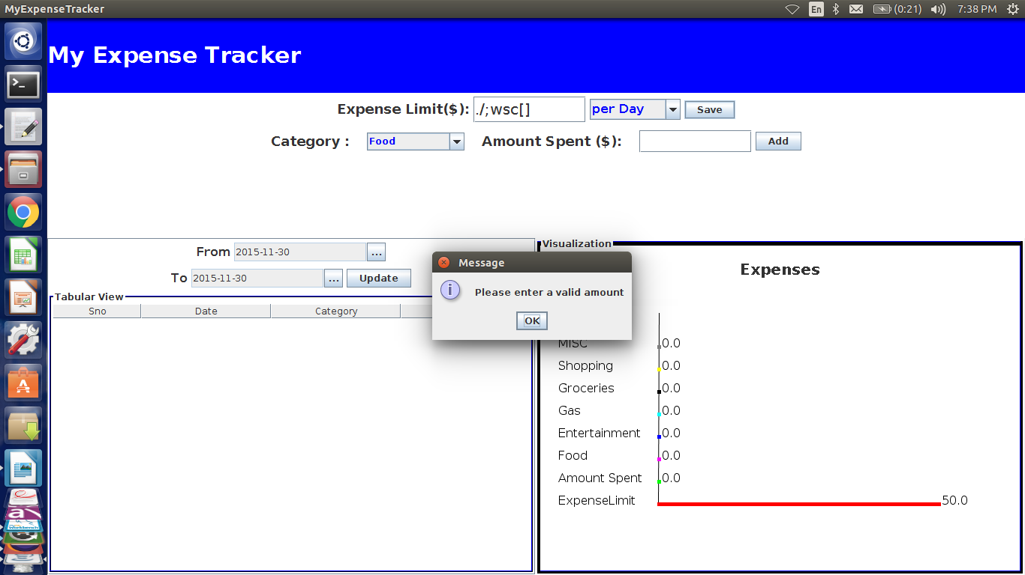

3.Once the limit is set user can enter the expenses under each of the selected category. Validation is
done here as well for the user input. As the user enters the expenses,they will be stored in the database
and both the table view and the display view will be updated.

When the user selects the category and enters the expense and clicks on add both the views will be updated.
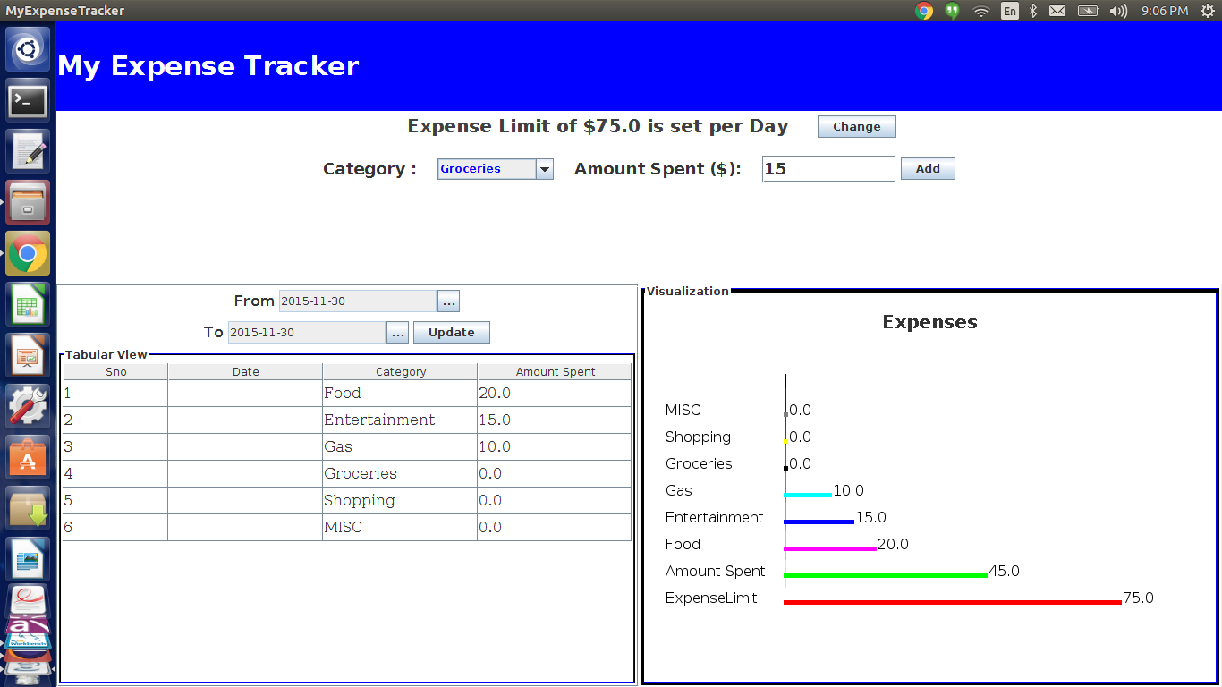

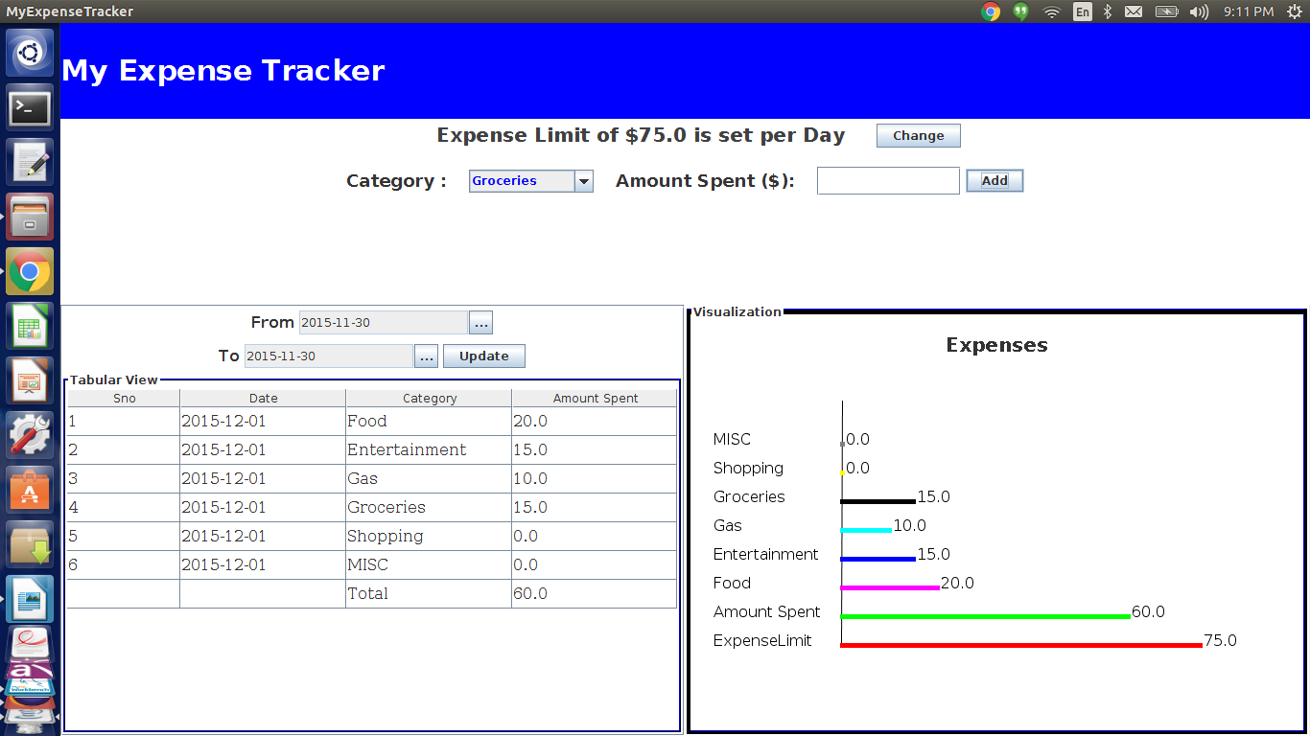

4.While entering if the user exceeds the set limit within the limit period,the user is alerted by displaying the amount that he has exceeded.

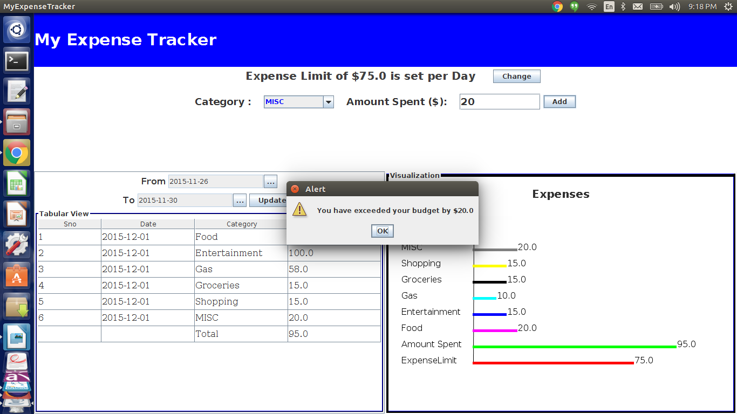
5. User can also query for expense history by selecting from and to dates and clicking update.
Table view will be updated with the expense history where as the display view will just show the
currently entered expenses.
Following screen shot displays expenses entered from November 26th of 2015 to November 30th of 2015.
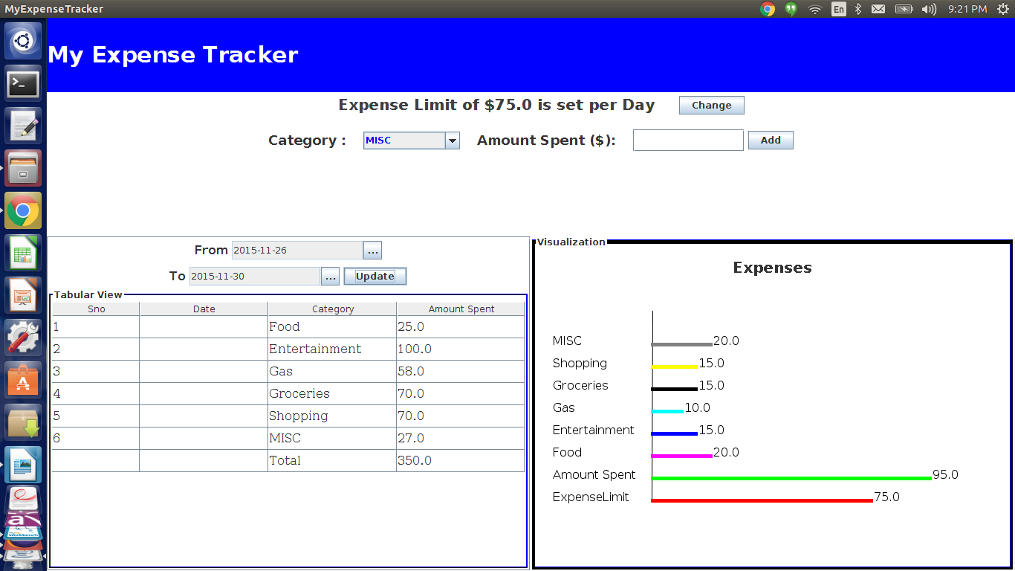

6.If the user comes back to enter more expenses then when the application opens,both the views will
have the already added expenses in the current limit period and whatever expenses the user enters
will also be reflected.

