**Исходный текст программы**

#include <stdio.h>

#include <stdlib.h>

#include <string.h>

typedef struct {

char Name[30];

char TELE[30];

char DATE[30];

} noteInterface;

void sort(noteInterface *BLOCKNOTE, int n);

int isValidMonth(char *s);

int main() {

const char *fileName = "index.csv";

int i;

int n = 9;

int count = 0;

char userInput[50];

char month[3];

noteInterface BLOCKNOTE[9];

FILE *file = fopen(fileName, "r");

if (file != NULL) {

for (i = 0; i < 9; i++) {

if (fscanf(file, "%29[^,],%29[^,],%29[^,\n]\n", BLOCKNOTE[i].Name, BLOCKNOTE[i].TELE, BLOCKNOTE[i].DATE) != 3) {

n = i;

i = 9;

}

}

fclose(file);

sort(BLOCKNOTE, n);

printf("All users, sorted by name:\n");

printf("| %-3s | %-30s | %-30s | %-30s |\n", "No", "Name", "Phone Number", "Date of Birth");

printf("----------------------------------------------------------------------------------------------------------\n");

for (i = 0; i < n; i++) {

printf("| %-3d | %-30s | %-30s | %-30s |\n", i + 1, BLOCKNOTE[i].Name, BLOCKNOTE[i].TELE, BLOCKNOTE[i].DATE);

}

printf("\nEnter the month number (01, 02, ..., 11, 12) to see users born this month: ");

scanf("%s", userInput);

if (isValidMonth(userInput)) {

for (i = 0; i < n; i++) {

strncpy(month, BLOCKNOTE[i].DATE + 5, 2);

month[2] = '\0';

if (strcmp(month, userInput) == 0) {

count++;

printf("| %-3d | %-30s | %-30s | %-30s |\n", i + 1, BLOCKNOTE[i].Name, BLOCKNOTE[i].TELE, BLOCKNOTE[i].DATE);

}

}

if (count == 0) {

printf("It seems that none of the users were born in this month");

}

} else {

printf("invalid month number\n");

}

} else {

perror("failed to open file");

}

return 0;

}

void sort(noteInterface *BLOCKNOTE, int n) {

noteInterface tmp;

int i, j;

for(i = 0; i < n; i++) {

tmp = BLOCKNOTE[i];

for (j = i - 1; (j >= 0) && (BLOCKNOTE[j].Name[0] > tmp.Name[0]); j--) {

BLOCKNOTE[j+1] = BLOCKNOTE[j];

}

BLOCKNOTE[j+1] = tmp;

}

}

int isValidMonth(char *s) {

return ((strlen(s) == 2) &&

(s[0] == '1' && '0' <= s[1] && s[1] <= '2') ||

(s[0] == '0' && '1' <= s[1] && s[1] <= '9'));

}

**Контрольные примеры**

**Пример 1:**

Исходный файл (10 строк):

Ann M.,88005553535,2005.06.05

Bob S.,88005553536,1990.03.15

Alice L.,88005553537,1985.11.20

John D.,88005553538,1978.09.02

Emily P.,88005553539,2002.12.10

Michael R.,88005553540,1995.07.25

Sarah H.,88005553541,1982.04.30

David C.,88005553542,1976.08.18

Olivia K.,88005553543,2001.01.28

James M.,88005553544,1993.06.08

Результат работы программы:

All users, sorted by name:

| No | Name | Phone Number | Date of Birth |

----------------------------------------------------------------------------------------------------------

| 1 | Alice L. | 88005553537 | 1985.11.20 |

| 2 | Ann M. | 88005553535 | 2005.06.05 |

| 3 | Bob S. | 88005553536 | 1990.03.15 |

| 4 | David C. | 88005553542 | 1976.08.18 |

| 5 | Emily P. | 88005553539 | 2002.12.10 |

| 6 | John D. | 88005553538 | 1978.09.02 |

| 7 | Michael R. | 88005553540 | 1995.07.25 |

| 8 | Olivia K. | 88005553543 | 2001.01.28 |

| 9 | Sarah H. | 88005553541 | 1982.04.30 |

Enter the month number (01, 02, ..., 11, 12) to see users born this month: 06

| 2 | Ann M. | 88005553535 | 2005.06.05 |

**Пример 2:**

Исходный файл:

Ann M.,88005553535,2005.06.05

Bob S.,88005553536,1990.03.15

Alice L.,88005553537,1985.11.20

Результат работы программы:

All users, sorted by name:

| No | Name | Phone Number | Date of Birth |

----------------------------------------------------------------------------------------------------------

| 1 | Alice L. | 88005553537 | 1985.11.20 |

| 2 | Ann M. | 88005553535 | 2005.06.05 |

| 3 | Bob S. | 88005553536 | 1990.03.15 |

Enter the month number (01, 02, ..., 11, 12) to see users born this month: 02

It seems that none of the users were born in this month

**Пример 3:**

Исходный файл:

Ann M.,88005553535,2005.06.05

Результат работы программы:

All users, sorted by name:

| No | Name | Phone Number | Date of Birth |

----------------------------------------------------------------------------------------------------------

| 1 | Ann M. | 88005553535 | 2005.06.05 |

Enter the month number (01, 02, ..., 11, 12) to see users born this month: 13

invalid month number

**Примеры выполнения программы**

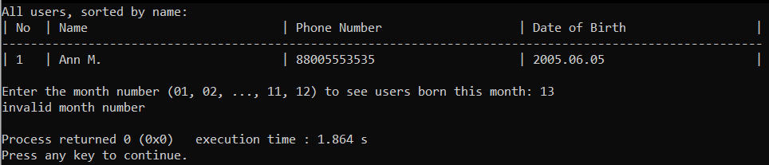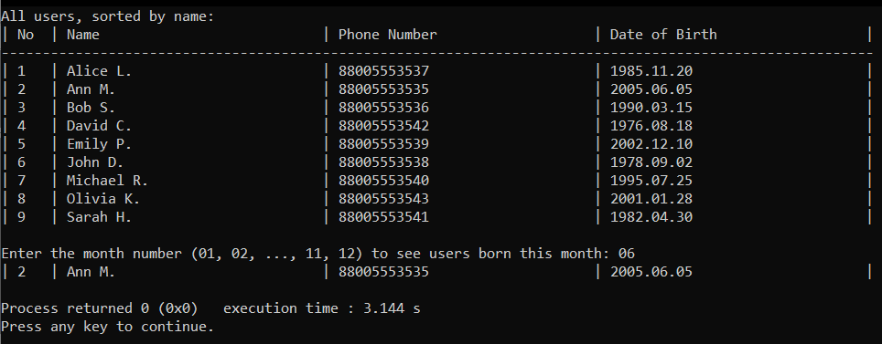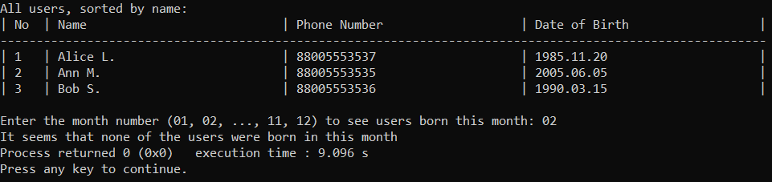

**Выводы.**

Были получены практические навыки работы со структурами и массивами структур в Си.