**Исходный текст программы**

#include <stdio.h>

#include <stdlib.h>

#include <string.h>

#define MAXLEN 256

#define OPTION_1 "Print all profession"

#define OPTION_2 "Select profession and reverse list"

#define OPTION_3 "List carousel"

typedef struct professionStruct {

int id;

char name[MAXLEN];

struct professionStruct* next;

} Profession;

typedef struct professionHeadStruct {

Profession* first;

Profession* last;

int count;

} ProfessionHead;

void appOption(ProfessionHead* pHead, int option);

void appGUI(ProfessionHead* pHead);

void reverseListGUI(ProfessionHead* pHead);

void listCarouselGUI(ProfessionHead* pHead);

ProfessionHead* makeProfessionHead();

Profession* makeProfessionNode(char name[MAXLEN]);

void pushBackProfessionNode(ProfessionHead* head, Profession* profession);

void freeProfessionList(ProfessionHead* head);

void readProfessions(char* filename, ProfessionHead* head);

void pushFrontProfessionNode(ProfessionHead* head, Profession* profession);

ProfessionHead* makeReversedListWithNoID(ProfessionHead* head, int id);

Profession* findProfessionById(ProfessionHead* head, int id);

void trim(char str[MAXLEN]);

void clearStdin();

void printMenu();

void printProfessionHeader();

void printAllProfessions(ProfessionHead* head);

void printOptionHeader(const char* optionDescription);

void pressEnterToContinue();

void clearConsole();

void trimForDisplay(char *output, const char *input, int maxLength);

void printProfession(Profession *profession);

void printShortLine();

void printListSize(ProfessionHead *pHead);

int main() {

ProfessionHead* pHead = NULL;

pHead = makeProfessionHead();

if (pHead != NULL) {

appGUI(pHead);

freeProfessionList(pHead);

} else {

perror("Memory allocation failed");

}

return 0;

}

void appGUI(ProfessionHead* pHead) {

int option;

readProfessions("professions.csv", pHead);

do {

clearConsole();

printMenu();

scanf("%d", &option);

clearStdin();

if (option != 0) {

appOption(pHead, option);

} else {

clearConsole();

}

} while (option != 0);

}

void appOption(ProfessionHead* professionHead, int option) {

clearConsole();

switch (option) {

case 1:

printOptionHeader(OPTION_1);

printAllProfessions(professionHead);

break;

case 2:

printOptionHeader(OPTION_2);

reverseListGUI(professionHead);

break;

case 3:

listCarouselGUI(professionHead);

break;

default:

clearConsole();

printf("\nFailed: invalid option\n");

break;

}

pressEnterToContinue();

}

void reverseListGUI(ProfessionHead* pHead) {

ProfessionHead* newPhead = NULL;

Profession* profession = NULL;

int id, option;

if (pHead->first != NULL) {

printAllProfessions(pHead);

printf("\nSelect the ID (after this a new list will be created that will contain all the elements of the original list\n");

printf("except the element whose ID you specify. The order of the elements will be inverse in this list)\n\n");

printf("ID: ");

scanf("%d", &id);

clearStdin();

profession = findProfessionById(pHead, id);

if (profession == NULL) {

printf("\nFailed: there is no profession with id %d\n", id);

} else {

printf("\nProfession with id %d:\n", id);

printProfessionHeader();

printProfession(profession);

printShortLine();

newPhead = makeReversedListWithNoID(pHead, id);

if (newPhead != NULL) {

printf("\nReversed list:\n");

printAllProfessions(newPhead);

option = 2;

printf("Do you want to make sure that this list is circular?\n");

printf("1. Yes\n");

printf("2. No\n");

printf("Option: ");

scanf("%d", &option);

clearStdin();

if (option == 1) {

listCarouselGUI(newPhead);

}

freeProfessionList(newPhead);

} else {

printf("\nFailed: memory allocation failed\n");

}

}

} else {

printf("There are no profession in the list\n");

}

}

void listCarouselGUI(ProfessionHead* pHead) {

Profession* temp;

int option;

if (pHead->first != NULL) {

temp = pHead->first;

do {

clearConsole();

printf("This program uses circular linked lists! You can verify this by using the \"carousel\" to endlessly scroll the list\n\n");

option = 0;

printProfessionHeader();

printProfession(temp);

printShortLine();

printf("\nPress ENTER to see the next profession\n");

printf("Press 0 to exit\n");

option = getchar();

if (option == '\n') {

temp = temp->next;

} else {

clearStdin();

}

} while (option != '0');

} else {

printf("\nThere are no professions in the list\n");

}

}

ProfessionHead* makeProfessionHead() {

ProfessionHead* head = NULL;

head = (ProfessionHead*)malloc(sizeof(ProfessionHead));

if (head != NULL) {

head->count = 0;

head->first = NULL;

head->last = NULL;

} else {

perror("Memory allocation failed");

}

return head;

}

Profession* makeProfessionNode(char name[MAXLEN]) {

Profession* profession = NULL;

profession = (Profession*)malloc(sizeof(Profession));

if (profession != NULL) {

profession->id = 0;

strcpy(profession->name, name);

profession->next = NULL;

}

return profession;

}

void pushBackProfessionNode(ProfessionHead* head, Profession* profession) {

head->count++;

if (head->first == NULL) {

head->first = profession;

head->last = profession;

profession->id = 1;

} else {

profession->id = head->last->id + 1;

head->last->next = profession;

head->last = profession;

}

profession->next = head->first;

}

void freeProfessionList(ProfessionHead* head) {

Profession *temp1, *temp2;

int i;

temp1 = head->first;

for (i = 0; i < head->count; i++) {

temp2 = temp1->next;

free(temp1);

temp1 = temp2;

}

free(head);

}

void readProfessions(char* filename, ProfessionHead* head) {

FILE* file;

Profession* profession;

int n, count, i;

char temp[MAXLEN] = {0};

profession = NULL;

n = count = 0;

file = fopen(filename, "r");

if (file != NULL) {

while ((fgets(temp, MAXLEN, file)) != NULL) n++;

rewind(file);

for (i = 0; i < n; i++) {

fgets(temp, MAXLEN, file);

trim(temp);

profession = makeProfessionNode(temp);

if (profession != NULL) {

pushBackProfessionNode(head, profession);

count++;

}

}

fclose(file);

} else {

perror("Failed to open file");

}

if (count != n) {

perror("Failed to read from file");

freeProfessionList(head);

}

}

void pushFrontProfessionNode(ProfessionHead* pHead, Profession* profession) {

Profession* temp;

int i, id;

pHead->count++;

if (pHead->first == NULL) {

pHead->first = profession;

pHead->last = profession;

profession->id = 1;

} else {

profession->next = pHead->first;

pHead->first = profession;

id = 1;

temp = pHead->first;

for (i = 0; i < pHead->count; i++, id++) {

temp->id = id;

temp = temp->next;

}

}

}

ProfessionHead* makeReversedListWithNoID(ProfessionHead* pHead, int id) {

ProfessionHead* newPHead = NULL;

Profession* temp = pHead->first;

Profession* newProfession;

int i, errorFlag;

newPHead = makeProfessionHead();

if (newPHead != NULL && temp != NULL) {

errorFlag = 0;

for (i = 0; i < pHead->count && !errorFlag; i++) {

if (temp->id != id) {

newProfession = makeProfessionNode(temp->name);

if (newProfession != NULL) {

pushFrontProfessionNode(newPHead, newProfession);

} else {

errorFlag = 1;

}

}

temp = temp->next;

}

if (!errorFlag) {

newPHead->last->next = newPHead->first;

}

}

return newPHead;

}

Profession* findProfessionById(ProfessionHead* head, int id) {

Profession* temp = NULL;

int i, isFound = 0;

if (id > 0 && id <= head->count) {

temp = head->first;

for (i = 0; i < head->count && !isFound; i++) {

if (temp->id == id) {

isFound = 1;

} else {

temp = temp->next;

}

}

if (!isFound) {

temp = NULL;

}

}

return temp;

}

void trim(char str[MAXLEN]) {

int i, flag = 0;

str[MAXLEN - 1] = '\0';

for (i = 0; str[i] != '\0' && !flag; i++) {

if (str[i] == '\n' || str[i] == '\r') {

str[i] = '\0';

flag = 1;

}

}

}

void clearStdin() {

int c;

while ((c = getchar()) != '\n' && c != EOF) { }

}

void printMenu() {

printShortLine();

printf("| Choose an option |\n");

printf("|--------------------------------------------------|\n");

printf("| 0. Exit |\n");

printf("| 1. Print all professions |\n");

printf("| 2. Select profession and reverse list |\n");

printf("| 3. List carousel |\n");

printShortLine();

printf("Option: ");

}

void printProfessionHeader() {

printShortLine();

printf("| ID | Name |\n");

printf("|----|---------------------------------------------|\n");

}

void printAllProfessions(ProfessionHead* head) {

Profession *q;

int i;

printListSize(head);

printProfessionHeader();

q = head->first;

for (i = 0; i < head->count; i++) {

printProfession(q);

q = q->next;

}

printShortLine();

}

void printProfession(Profession *profession) {

char trimmedProfessionName[32];

trimForDisplay(trimmedProfessionName, profession->name, 31);

printf("| %-2d | %-43s |\n", profession->id, trimmedProfessionName);

}

void printShortLine() {

printf("====================================================\n");

}

void printOptionHeader(const char* optionDescription) {

printShortLine();

printf("| Option: %-40s |\n", optionDescription);

printShortLine();

printf("\n");

}

void pressEnterToContinue() {

printf("\nPress ENTER to continue ");

clearStdin();

clearConsole();

}

void clearConsole() {

#if defined(_WIN32) || defined(_WIN64)

system("cls");

#else

system("clear");

#endif

}

void trimForDisplay(char *output, const char *input, int maxLength) {

if (strlen(input) > maxLength) {

strncpy(output, input, maxLength - 3);

output[maxLength - 3] = '\0';

strcat(output, "...");

} else {

strcpy(output, input);

}

}

void printListSize(ProfessionHead *pHead) {

printShortLine();

printf("| List size: %-37d |\n", pHead->count);

printShortLine();

printf("\n");

}

**Контрольные примеры**

**Пример 1:**

==================================================== | Choose an option | |--------------------------------------------------| | 0. Exit | | 1. Print all professions | | 2. Select profession and reverse list | | 3. List carousel | ==================================================== Option: 2

==================================================== | Option: Select profession and reverse list | ==================================================== ==================================================== | List size: 8 | ==================================================== ==================================================== | ID | Name | |----|---------------------------------------------| | 1 | pilot | | 2 | engineer | | 3 | teacher | | 4 | driver | | 5 | dentist | | 6 | actor | | 7 | writer | | 8 | musician | ==================================================== Select the ID (after this a new list will be created that will contain all the elements of the original list except the element whose ID you specify. The order of the elements will be inverse in this list) ID: 4 Profession with id 4: ==================================================== | ID | Name | |----|---------------------------------------------| | 4 | driver | ==================================================== Reversed list: ==================================================== | List size: 7 | ==================================================== ==================================================== | ID | Name | |----|---------------------------------------------| | 1 | musician | | 2 | writer | | 3 | actor | | 4 | dentist | | 5 | teacher | | 6 | engineer | | 7 | pilot | ====================================================

**Пример 2:**

==================================================== | Option: Select profession and reverse list | ==================================================== ==================================================== | List size: 8 | ==================================================== ==================================================== | ID | Name | |----|---------------------------------------------| | 1 | pilot | | 2 | engineer | | 3 | teacher | | 4 | driver | | 5 | dentist | | 6 | actor | | 7 | writer | | 8 | musician | ==================================================== Select the ID (after this a new list will be created that will contain all the elements of the original list except the element whose ID you specify. The order of the elements will be inverse in this list) ID: 10 Failed: there is no profession with id 10 Press ENTER to continue

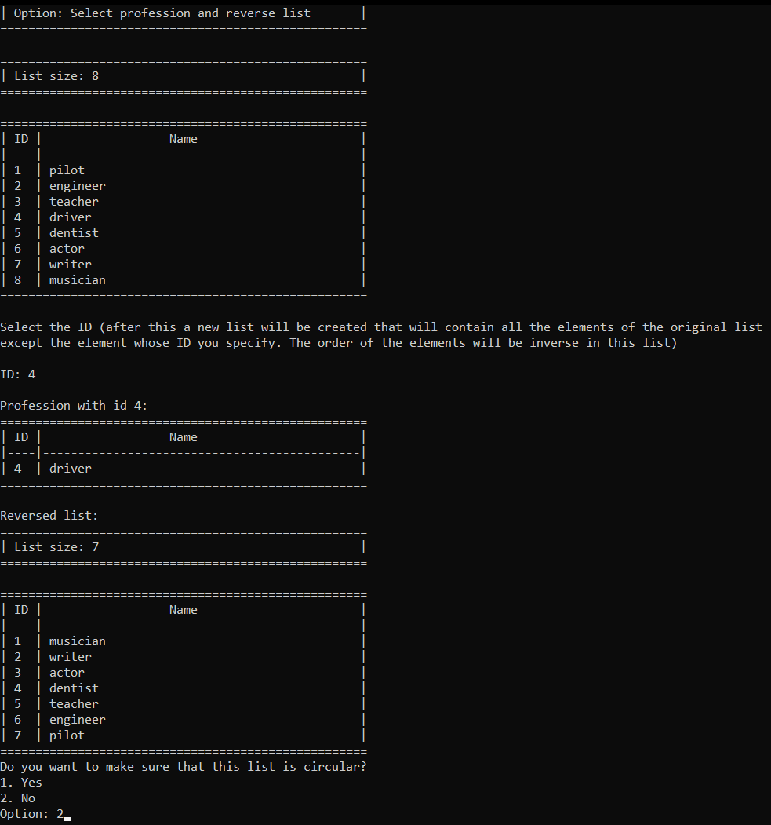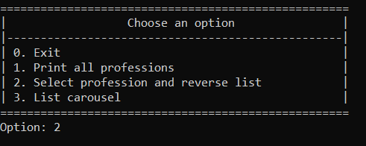**Примеры выполнения программы**

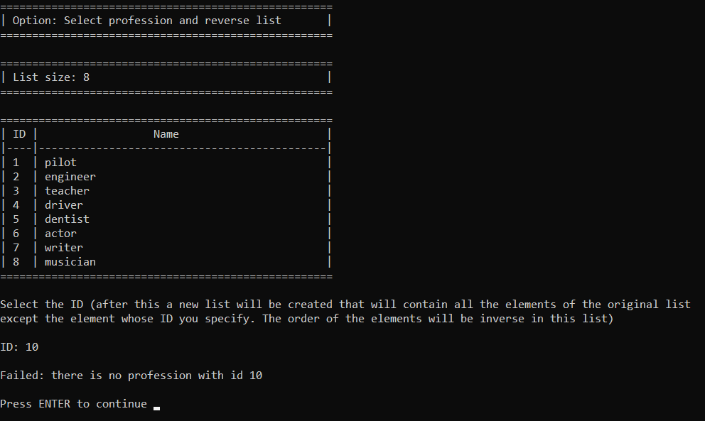

**Выводы.**

В результате выполнения работы были получены практические навыки работы с кольцевыми односвязными списками в языке С.