**Исходный текст программы**

#include <stdio.h>

#include <stdlib.h>

typedef struct {

unsigned char oct1;

unsigned char oct2;

unsigned char oct3;

unsigned char oct4;

} IPv4Address;

void convertBtoC(IPv4Address* addrB);

void convertCtoB(IPv4Address* addrC);

void printIPv4Address(IPv4Address* addr);

void printIPv4AddressBinary(IPv4Address* addr);

void printBinary(int n);

void inputIpv4(IPv4Address* addr, char ipClass);

void clearConsole();

void pressEnterToContinue();

void clearStdin();

int main() {

IPv4Address addr;

clearConsole();

inputIpv4(&addr, 'B');

printf("Original Class B address: ");

printIPv4Address(&addr);

printIPv4AddressBinary(&addr);

convertBtoC(&addr);

printf("Converted to Class C: ");

printIPv4Address(&addr);

printIPv4AddressBinary(&addr);

pressEnterToContinue();

inputIpv4(&addr, 'C');

printf("\nOriginal Class C address: ");

printIPv4Address(&addr);

printIPv4AddressBinary(&addr);

convertCtoB(&addr);

printf("Converted to Class B: ");

printIPv4Address(&addr);

printIPv4AddressBinary(&addr);

pressEnterToContinue();

return 0;

}

void inputIpv4(IPv4Address* addr, char ipClass) {

int oct1 = 0, oct2 = 0, oct3 = 0, oct4 = 0;

int condition;

do {

printf("Enter class %c ipv4 address: ", ipClass);

scanf("%d.%d.%d.%d", &oct1, &oct2, &oct3, &oct4);

clearStdin();

if (ipClass == 'B') {

condition = (128 <= oct1 && oct1 < 192) && (0 <= oct2 && oct2 < 256) && (0 <= oct3 && oct3 < 256) && (0 <= oct4 && oct4 < 256);

} else {

condition = (192 <= oct1 && oct1 < 224) && (0 <= oct2 && oct2 < 256) && (0 <= oct3 && oct3 < 256) && (0 <= oct4 && oct4 < 256);

}

if (condition) {

addr->oct1 = (unsigned char)oct1;

addr->oct2 = (unsigned char)oct2;

addr->oct3 = (unsigned char)oct3;

addr->oct4 = (unsigned char)oct4;

} else {

printf("Invalid class %c ipv4 address!\n", ipClass);

}

} while (!condition);

}

void clearConsole() {

#if defined(_WIN32) || defined(_WIN64)

system("cls");

#else

system("clear");

#endif

}

void convertBtoC(IPv4Address* addrB) {

/* 0x1F = 0001 1111 i.e. 31 ; we need to make 1st three bits = 0 and save other bits */

/* 0xC0 = 1100 0000 i.e. 192 ; we need to make 1st two bits = 1 and save other bits */

addrB->oct1 = (addrB->oct1 & 0x1F) | 0xC0;

}

void convertCtoB(IPv4Address* addrC) {

/* 0x3F = 0011 1111 i.e. 63 ; we need to make 1st two bits = 0 and save other bits */

/* 0x80 = 1000 0000 i.e. 128 ; we need to make 1st bit = 1 and save other bits */

addrC->oct1 = (addrC->oct1 & 0x3F) | 0x80;

}

void printIPv4Address(IPv4Address* addr) {

printf("%d.%d.%d.%d\n", addr->oct1, addr->oct2, addr->oct3, addr->oct4);

}

void clearStdin() {

int c;

while ((c = getchar()) != '\n' && c != EOF) { }

}

void pressEnterToContinue() {

printf("\nPress ENTER to continue ");

clearStdin();

clearConsole();

}

void printIPv4AddressBinary(IPv4Address* addr) {

printf("Address in binary: ");

printBinary(addr->oct1);

printf(".");

printBinary(addr->oct2);

printf(".");

printBinary(addr->oct3);

printf(".");

printBinary(addr->oct4);

printf("\n");

}

void printBinary(int n) {

int i;

for (i = 7; i >= 0; i--) {

printf("%d", (n >> i) & 1);

}

}

**Контрольные примеры**

**Пример 1:**

Enter class B ipv4 address: 145.120.8.0

Original Class B address: 145.120.8.0

Address in binary: 10010001.01111000.00001000.00000000

Converted to Class C: 209.120.8.0

Address in binary: 11010001.01111000.00001000.00000000

Enter class C ipv4 address: 220.168.1.1

Original Class C address: 220.168.1.1

Address in binary: 11011100.10101000.00000001.00000001

Converted to Class B: 156.168.1.1

Address in binary: 10011100.10101000.00000001.00000001

**Пример 2:**

Enter class B ipv4 address: 0.0.0.0.0

Invalid class B ipv4 address!

Enter class B ipv4 address: 128.-2.2500.0

Invalid class B ipv4 address!

Enter class B ipv4 address: 192.0.0.0

Invalid class B ipv4 address!

Enter class B ipv4 address: 128.168.1.1

Original Class B address: 128.168.1.1

Address in binary: 10000000.10101000.00000001.00000001

Converted to Class C: 192.168.1.1

Address in binary: 11000000.10101000.00000001.00000001

Enter class C ipv4 address: 128.0.0.0

Invalid class C ipv4 address!

Enter class C ipv4 address: 192.168.1.1

Original Class C address: 192.168.1.1

Address in binary: 11000000.10101000.00000001.00000001

Converted to Class B: 128.168.1.1

Address in binary: 10000000.10101000.00000001.00000001

**Примеры выполнения программы**

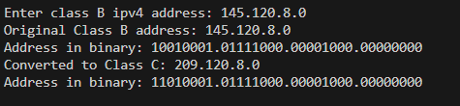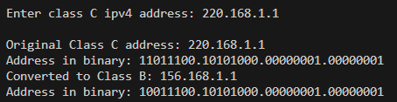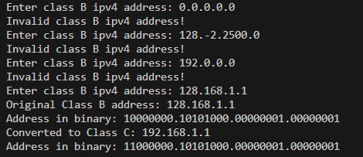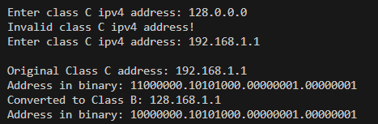

**Выводы.**

B результате выполнения работы изучены методы работы с битовыми полями структур; получены практические навыки при программировании на языке С.