Senior process exicutive2015 -2018

Intermediate

Soumya

Paidakula

Senior Process

Executive

I'm Soumya Paidakula, 3D Modeling

Specialist with 3 years’ experience. I'm

Specialist in handling and managing day-

To-day team operation with considerable

experience to read trends

Experience

Skill

Contact

Education

2017 -2021

Sree Chaitanya Institute Of Technological Sciences

•

Bachelor of Technology(CIVIL)

2015 -2017

Bharathi Junior College

•

Intermediate

2014 -2015

2021 - Present

Senior process executive,   
Cognizant

•

Ensuring high-quality outputs and timely delivery. Collaborate with cross-functional teams, and provide creative solutions to meet client requirements

**MS-EXCEL**

**Auto-CAD**

**SketchUp & SketchUp PRO**

**C-LANGUAGE**

**JAVA**

•

+91-8008174669

•

Paidakulasowmya1234@gmail.com

•

Karimnagar

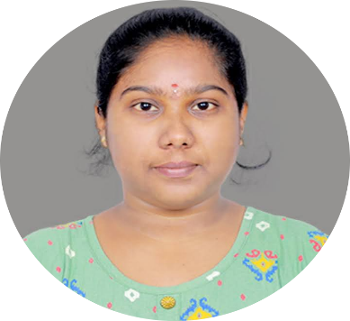

•

Secondary School Education(SSC)

Vasant Valley Concept School

•