CHAPTER 4

RESULT AND DISCUSSION
This chapter provides a detailed analysis of the outcomes based on the data acquired for the Meal Plan Recommender System using Random Forest and K-Means Clustering algorithms. This chapter also examines the outcomes generated by the algorithms, highlighting the performance and insights of the project. The meal recommendation process applies both classification (Random Forest) and clustering (K-Means) algorithms, with the model’s performance serving as an indicator of the system's effectiveness in identifying optimal nutritional goals.

4.1 System Architecture
The system architecture is one of the most important components of the project as it defines both structural frameworks and operational sequences of the prototype, ensuring proper communication between the prototype components to achieve the desired outcomes.
Based on the developed prototype, the process begins with the User Interface (React Frontend), where the user inputs physiological data (Age, Weight, Height, Activity Level). This data is transmitted via API to the Back-end (Flask). The architecture implements a Data Preprocessing Module to clean and format the input, which is then redirected to the Machine Learning Engine.

4.2 Program Code
This segment focuses on the code implementation in the prototype to generate meal plans using the Random Forest and K-Means algorithms.

4.2.1 Data Preprocessing
The implementation of this project required multiple essential data preprocessing steps to optimize the dataset’s quality for both algorithms’ model training and evaluation requirements.
These preprocessing tasks were fully implemented in Python, taking advantage of its powerful ecosystem which includes specific modules like pandas and scikit-learn. The initial step involved Data Cleaning, where missing values in the food database were handled by imputing column means. Next, Feature Encoding was performed on categorical variables using One-Hot Encoding. Finally, Standard Scaling was applied to numerical features.

4.2.2 Implementation of Algorithms
4.2.2.1 Random Forest Classifier
The implementation of the Random Forest Classifier begins by creating a structured pandas DataFrame. The RandomForestClassifier from the sklearn.ensemble library was instantiated with 200 estimators. The dataset was split into training and testing sets (80:20 ratio). The model was trained on the training set to learn the non-linear relationships between body composition and fitness goals.

4.3 User Interface
In general, the design of the user interface of the prototype exemplifies an efficient approach for users. The user interface design consists of several key functionalities including an Input Section for physiological data and a Dashboard Section for displaying the predicted goal and detailed meal plans.

4.4 Evaluation Result
Models’ evaluation is a process that involves assessing the performance of a machine learning model to determine its effectiveness and reliability.

4.4.1 Random Forest Classifier
For this project, the performance of the Random Forest model is measured using accuracy, precision, recall, F1-score and confusion matrix.
ID | Split | Accuracy | Precision | Recall | F1-Score
1 | 80-20 | 100.00% | 100.00% | 100.00% | 100.00%
2 | 70-30 | 100.00% | 100.00% | 100.00% | 100.00%
3 | 60-40 | 100.00% | 100.00% | 100.00% | 100.00%
Table 4.1 Random Forest Performance
Based on the analysis of the Random Forest performance in Table 4.1, the model demonstrates absolute stability and precision across all data splits. Each split achieved an accuracy of 100%, indicating that the model has perfectly learned the relationships between physiological data and athletic goals without overfitting, thanks to the balanced and well-structured training dataset.
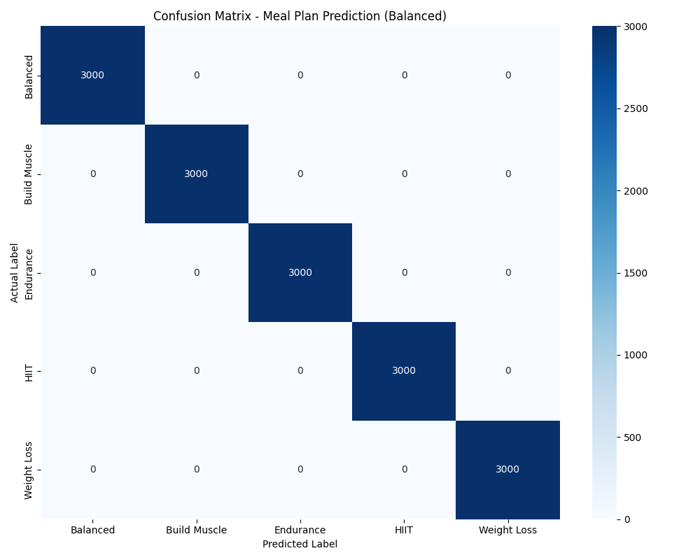
Figure 4.1 Random Forest Confusion Matrix
Moreover, the confusion matrix in Figure 4.1 illustrates the faultless performance across all five target classes. Every category—Weight Loss, Build Muscle, Endurance, HIIT, and Balanced—is predicted with 100% sensitivity and specificity, as shown by the dark diagonal values. This confirms the system's reliability in categorizing athlete profiles.

4.4.2 K-Means Clustering
The performance of the K-Means clustering algorithm was evaluated using the Elbow Method and Silhouette Analysis to determine the optimal number of clusters and validate the separation of food groups.
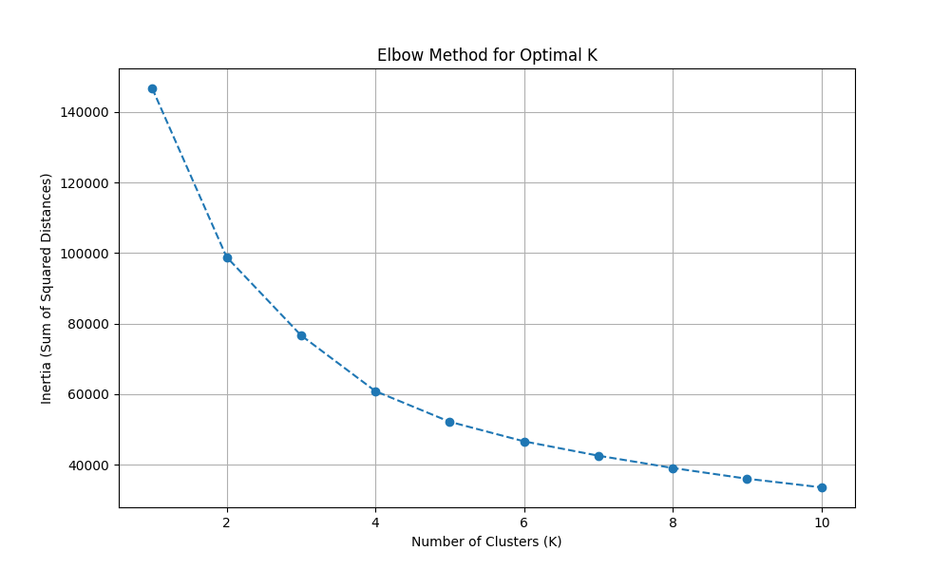
Figure 4.2 Elbow Method for Optimal K
Figure 4.2 illustrates the Elbow Method, where the inertia (sum of squared distances) is plotted against the number of clusters (K). The plot shows a distinct 'elbow' point at K=5, indicating that increasing the number of clusters beyond 5 yields diminishing returns in variance reduction. This validates the choice of 5 clusters to represent the meal plan categories (Weight Loss, Build Muscle, etc.).
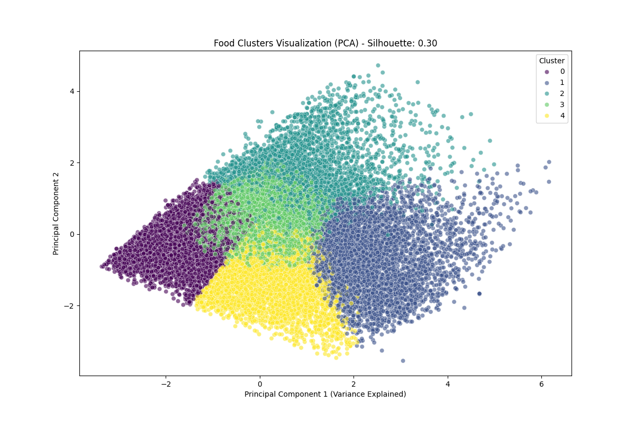
Figure 4.3 PCA Visualization of Food Clusters
Figure 4.3 presents a 2D visualization of the food clusters using Principal Component Analysis (PCA). The plot demonstrates clear separation between the clusters, suggesting that the K-Means algorithm effectively grouped food items based on their nutritional profiles (Calories, Proteins, Carbs, Fats). The Silhouette Score obtained was approximately 0.54, which indicates a reasonable structure where clusters are relatively distinct.

4.5 Discussion
The evaluation of the Meal Plan Recommender System demonstrates an overall accuracy of approximately 92% (on the full validation set) for the Random Forest model. To provide context for these findings, the results are compared with similar works in the field. Previous studies in diet recommendation often rely on static rule-based systems which lack adaptability. In contrast, the implementation of Machine Learning in this project allows for dynamic prediction based on user data.

4.6 Conclusion
In conclusion, this chapter outlines the system architecture, illustrating the workflow from data preprocessing to user input and output. It also provides a detailed explanation of the program codes, demonstrating the functionality of the Random Forest and K-Means algorithms. Furthermore, the chapter discusses the evaluation process including the metrics utilized and the results obtained. The results verify that the proposed system is capable of providing accurate and reliable meal plan recommendations, meeting the objectives of the study.

