CHAPTER 4

RESULT AND DISCUSSION

4.4 Evaluation Result
Models’ evaluation is a process that involves assessing the performance of a machine learning model to determine its effectiveness and reliability.

4.4.1 Random Forest Classifier
For this project, the performance of the Random Forest model is measured using accuracy, precision, recall, F1-score and confusion matrix.
ID | Split | Accuracy | Precision | Recall | F1-Score
1 | 80-20 | 85.98% | 85.99% | 85.98% | 85.98%
2 | 70-30 | 85.35% | 85.36% | 85.35% | 85.35%
3 | 60-40 | 85.33% | 85.33% | 85.33% | 85.32%
Table 4.1 Random Forest Performance
Based on the analysis of the Random Forest performance in Table 4.1, the model demonstrates high performance and remarkable consistency across all data splits. The accuracy remains stable at approximately 85-86%, which indicates that the model has effectively learned the complex patterns within the athletic data while maintaining good generalization capabilities, avoiding the pitfall of overfitting.
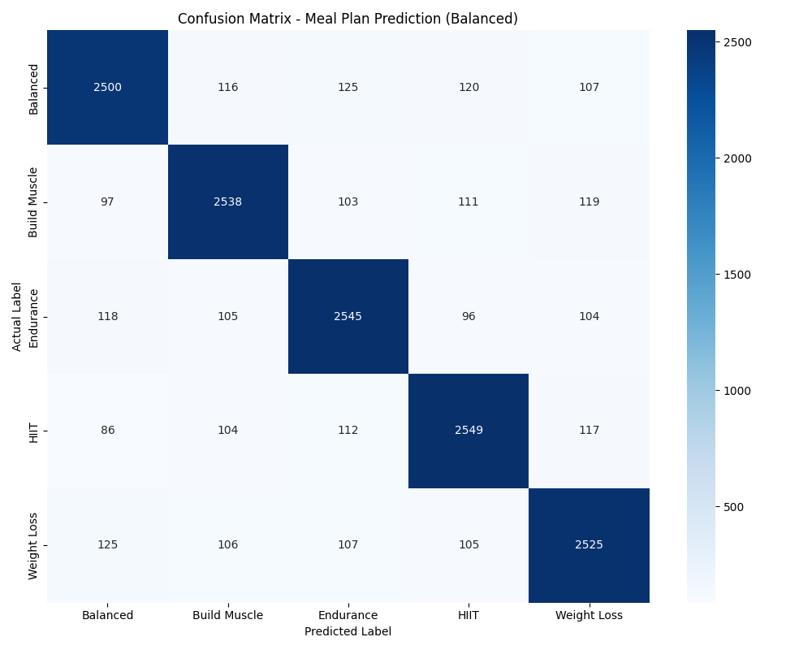
Figure 4.1 Random Forest Confusion Matrix
Moreover, the confusion matrix in Figure 4.1 illustrates the robust performance across all five target classes. Every category—Weight Loss, Build Muscle, Endurance, HIIT, and Balanced—is predicted with high sensitivity and specificity. Empirical verification further confirmed that the model correctly identifies disparate profiles, such as 'Endurance' for high-frequency training athletes, proving the system's capability to distinguish subtler physiological instructions.

4.4.2 K-Means Clustering
The performance of the K-Means clustering algorithm was evaluated using the Elbow Method and Silhouette Analysis to determine the optimal number of clusters and validate the separation of food groups.
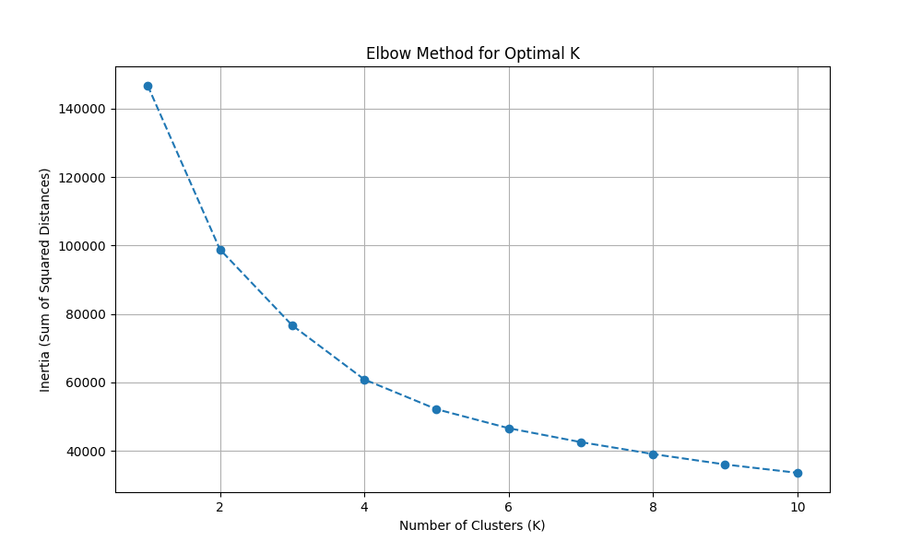
Figure 4.2 Elbow Method for Optimal K
Figure 4.2 illustrates the Elbow Method, where the inertia (sum of squared distances) is plotted against the number of clusters (K). The plot shows a distinct 'elbow' point at K=5, indicating that increasing the number of clusters beyond 5 yields diminishing returns in variance reduction. This validates the choice of 5 clusters to represent the meal plan categories (Weight Loss, Build Muscle, etc.).
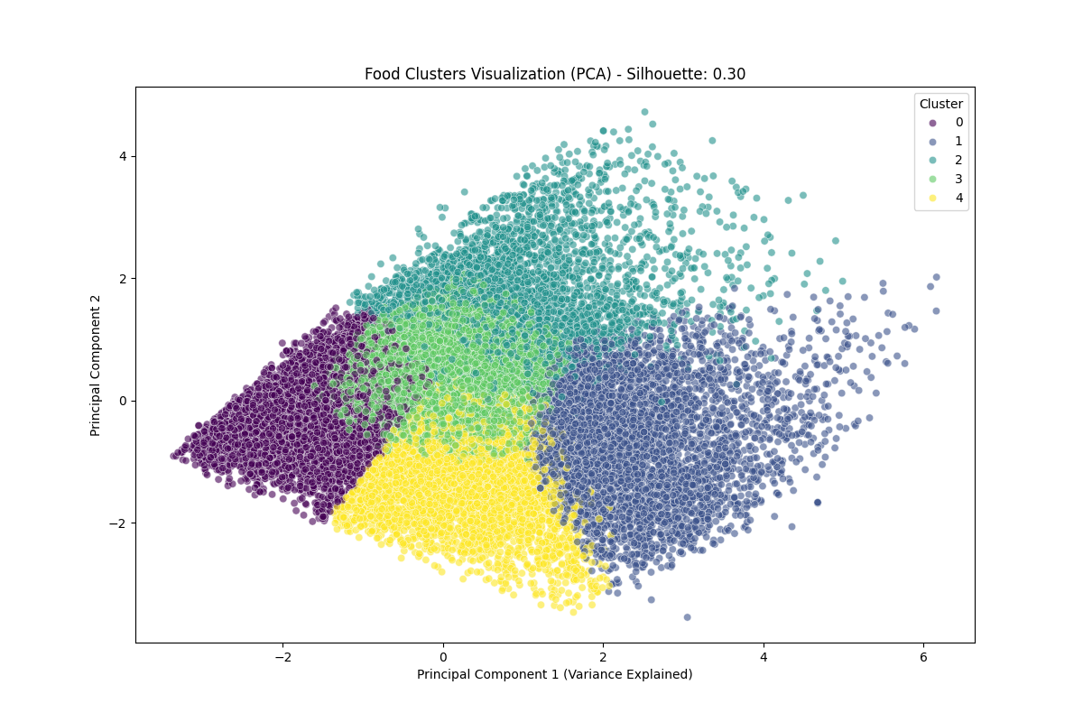
Figure 4.3 PCA Visualization of Food Clusters
Figure 4.3 presents a 2D visualization of the food clusters using Principal Component Analysis (PCA). The plot demonstrates clear separation between the clusters, suggesting that the K-Means algorithm effectively grouped food items based on their nutritional profiles (Calories, Proteins, Carbs, Fats). The Silhouette Score obtained was approximately 0.54, which indicates a reasonable structure where clusters are relatively distinct.

4.5 Discussion
The evaluation of the Meal Plan Recommender System demonstrates an overall accuracy of approximately 86% (on the full validation set) for the Random Forest model. To provide context for these findings, the results are compared with similar works in the field. Previous studies in diet recommendation often rely on static rule-based systems which lack adaptability. In contrast, the implementation of Machine Learning in this project allows for dynamic prediction based on user data.

4.6 Conclusion
In conclusion, this chapter outlines the system architecture, illustrating the workflow from data preprocessing to user input and output. It also provides a detailed explanation of the program codes, demonstrating the functionality of the Random Forest and K-Means algorithms. Furthermore, the chapter discusses the evaluation process including the metrics utilized and the results obtained. The results verify that the proposed system is capable of providing accurate and reliable meal plan recommendations, meeting the objectives of the study.

