#### 0 **Four BST Rotation**

* L, R , LR, RL
* With all rotations, BST properties remain preserved
* Each rotation has constant time complexity
* We know that tree imbalance can be caused by a stick and by an elbow. We fix sticks in previous lecture, and in this part we learn to fix elbow by transforming the elbow into a stick.
* Goal : create a tree with height difference as small as possible
* Then we will have AVL Trees aka balanced BST

#### **AVL Tree consideration**

* Four rotations
  + Simple rotations: stick
  + Complex rotations: elbow
* Maintain height of tree
* Detect imbalance of tree

**Rotations**

* **Theorem 1: If an insertion occurred in subtrees t3 or t4, and an imbalance was detected at t, then a LEFT rotation about t restores the balance of the tree. We gauge this by noting the balance factor of t→right is 1.**

1. We identified the lowest point 2. Let h(TL)=k. Since we inserted at **t3** or **t4** and

of imbalance, which means b=2. balance at **t** is 2, h(TR)=k+2. 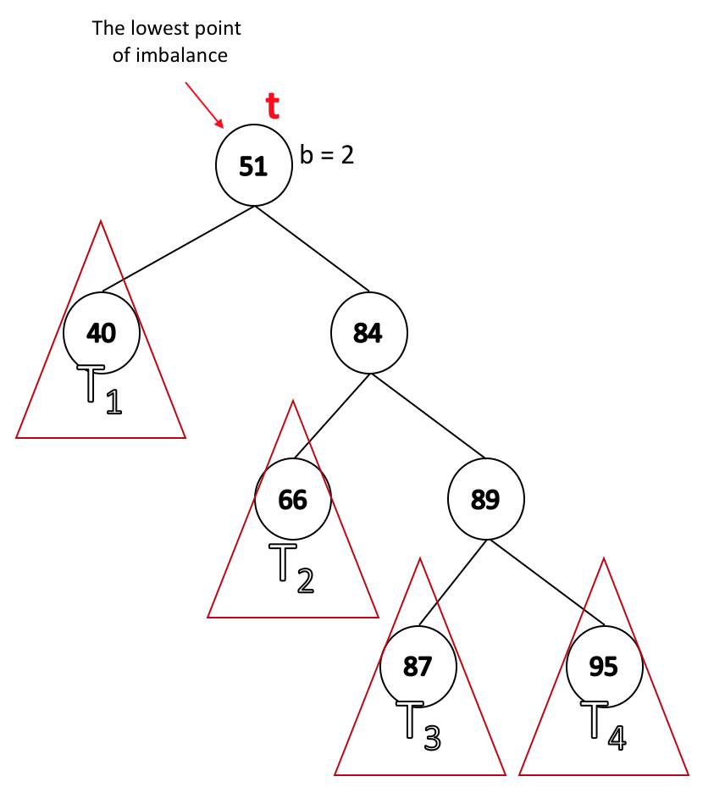

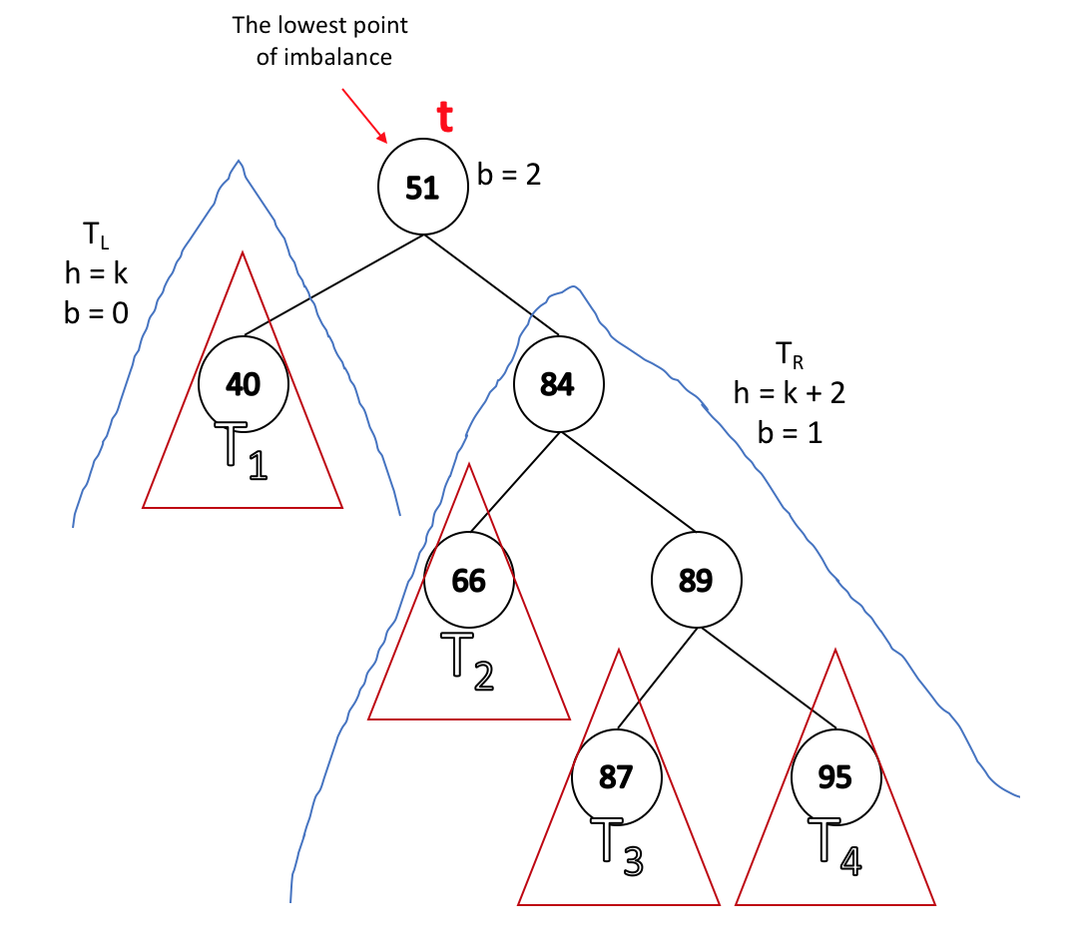

**3. If b(t→right) = 2, then we would have detected it as the lowest point of imbalance. Therefore, b(t→right) < 2. If b(t→right) = -1, it would mean that the tree is leaning to the left, but we said we are inserting to the right. Therefore, b(t→right) > -1. Since we have b(t) = 2, we know that b(t→right) cannot be 0 because it is not balanced. Therefore, b(t→right) = 1.**

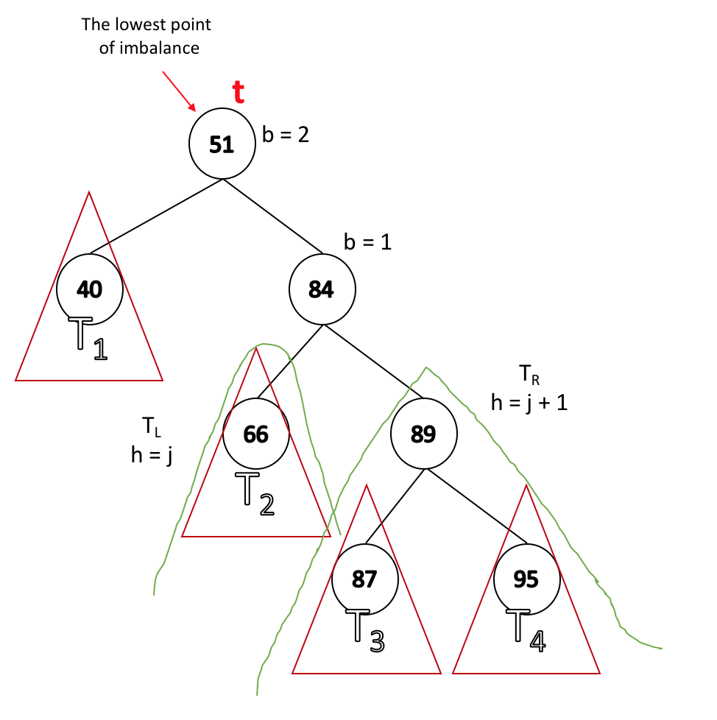

* **Theorem 2: If an insertion occurred in subtrees t2 or t3, and an imbalance was detected at t, then a RIGHT-LEFT rotation about t restores the balance of the tree.**
  + **We gauge this by noting the balance factor of t→right is -1.**

1. We identified the lowest point 2. Let h(TL)=k. Since we inserted at **t2** or **t3** and

of imbalance, which means b=2. balance at **t** is 2, h(TR)=k+2.

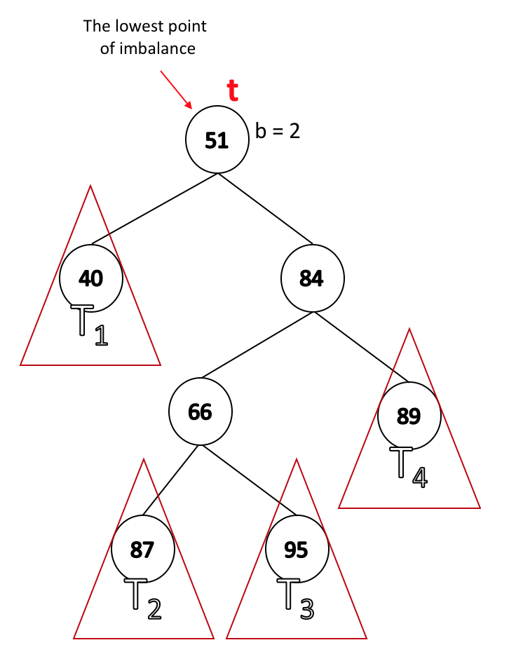 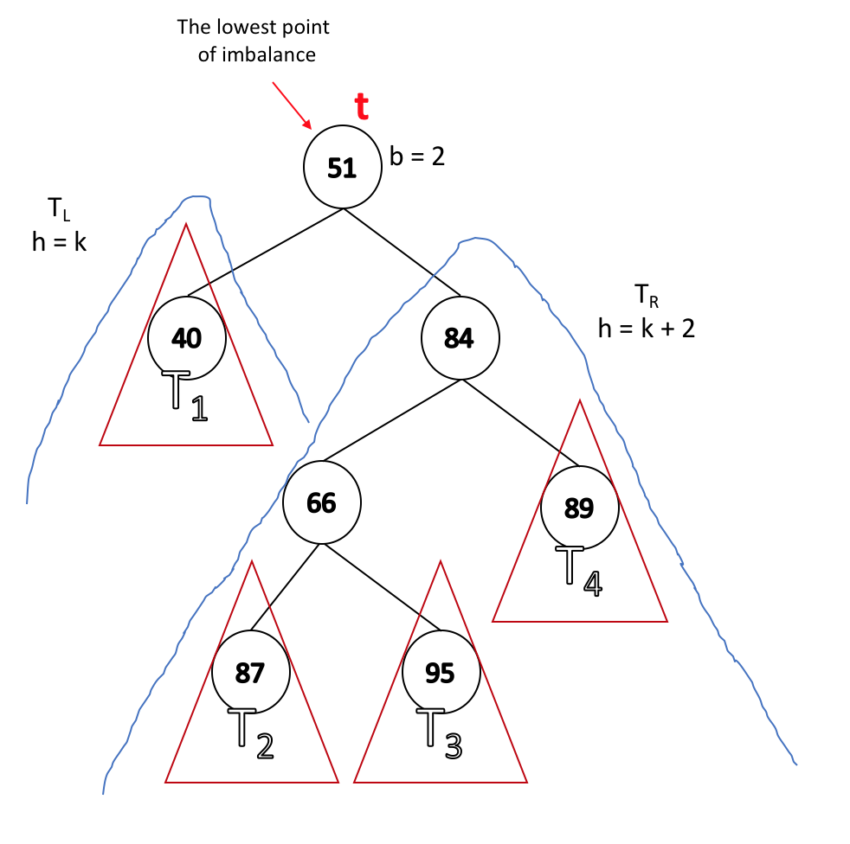

**3. Similarly to the third step in Theorem 1, the balance of t→left cannot be 2 because t→left is not the lowest point of imbalance. Furthermore, t→left cannot be 1 because the insertion is done on the left side of the t→left. Therefore, the only value that shows imbalance is b(t→left) = -1.**

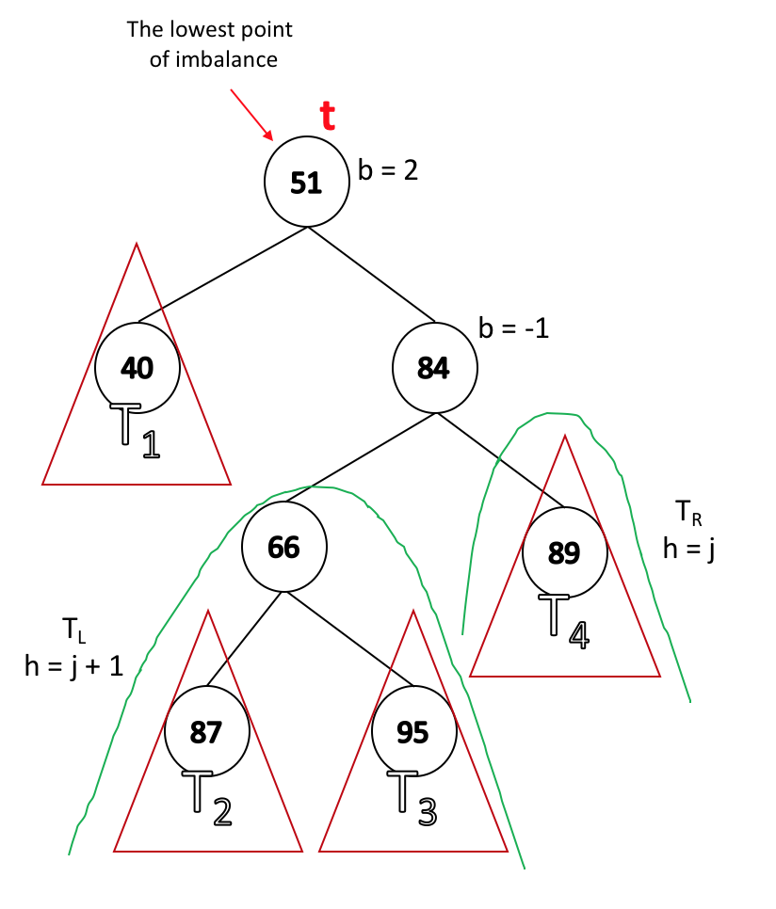

* Both of these theorems involve two steps:
  + Identify the point of imbalance.
  + Apply rules to determine what kind of rotation to use.
* The two theorems we introduced offer solutions for only two rotations, but we learned that there are four rotations. Luckily, the other two rotations (R and LR) are just mirrors of the L and RL.
  + In fact, if we know one rotation we know all four: For example, if we know L, then R is a mirror of L; RL and LR are just combinations of L and R.

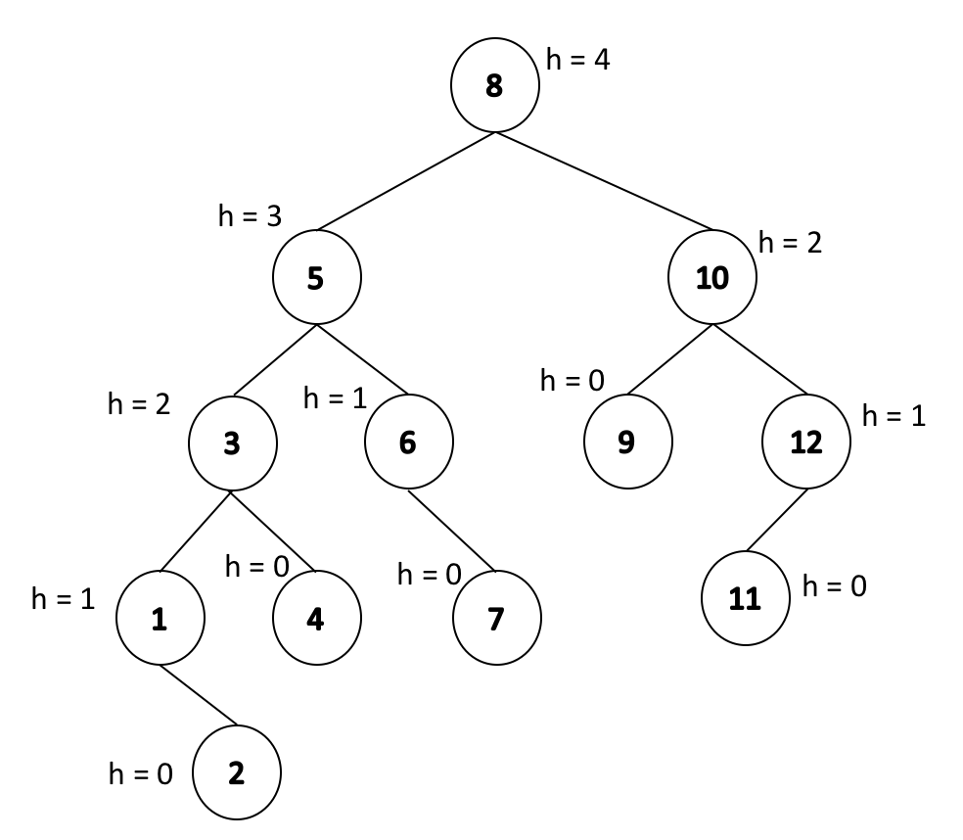

**Insertion of AVL**

* How do we maintain the tree height?
* Use BST insert
* As we recurse back:
  + Check for imbalance.
  + Correct it (do rotations).
  + Update height.

|  |  |
| --- | --- |
| **AVLTree.cpp** | |
| 1  2  3  4  5  6  7  8  9  10  11  12  13  14  15  16  17 | AVLTree<T>::_insert(const T & x, treeNode<T> * & t )  Base case: if t == NULL then insert;  Case 1: x < t→key // we are going to the left subtree  _insert(x, t→left) // recursive call on the left subtree  if balance == -2 // detecting imbalance point  if leftBalance == -1 then rotate to the right ;  else rotate left-right;  Case 2: x > t→key // we are going to the right subtree  _insert(x, t→right) // recursive call on the right subtree  if balance == 2 // detecting imbalance point  if rightBalance == 1 then rotate to the left;  else rotate right-left;    update height;  } |