#### **Graph Vocabulary**

* size of the **vertices**  |V| = n
* size= m
* **Incident edges**: all edges t hat connected to that node.

Example: incident edges to 4 are (4,1), (4,2), (4,3), (4,5), (4,6), and (4,7).

* **Degree**: the num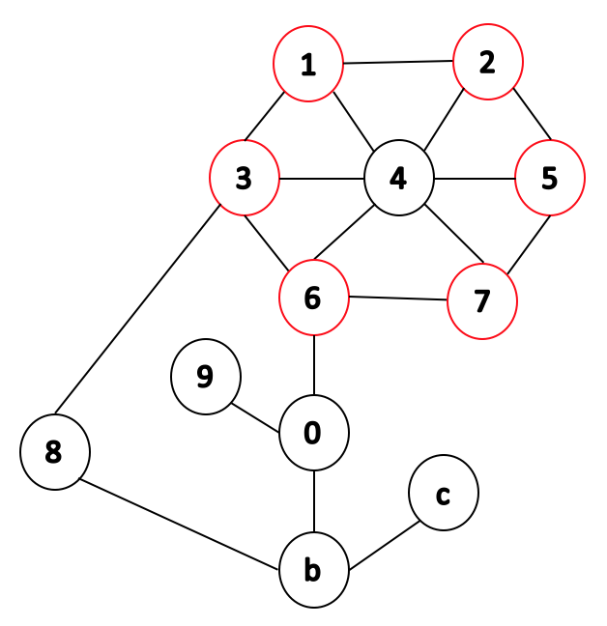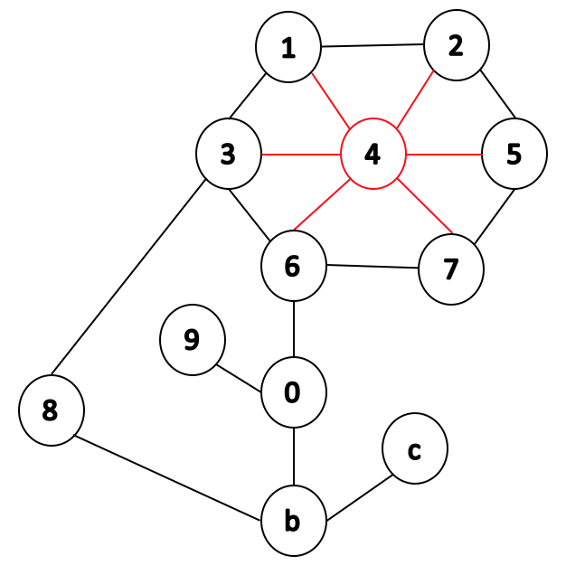
* **Path**: a sequence of vertices connected by edges.

Example: a path from 1 to b in

cludes visiting nodes 4, 6, and 0.

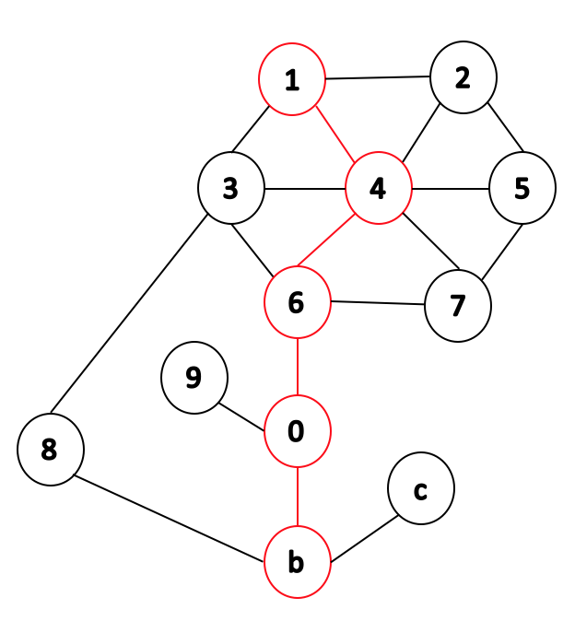

* **Cycle**: a path with common beginning and end.

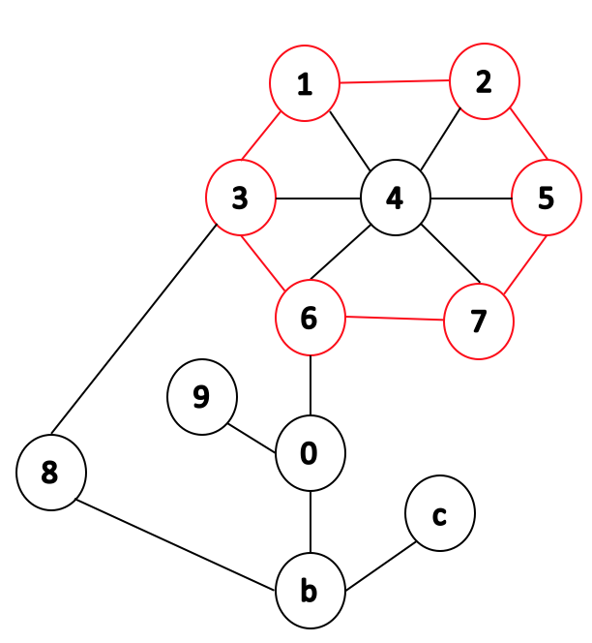

* **Simple graph**: a graph with no self-loop edges and no multi-edges.

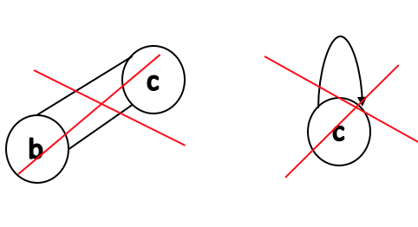

* **Subgraph**: any subset of vertices such that every edge in the subgraph implies that both vertices that are incident to that edge are part of that graph.

Example: vertices {1, 2, 3, 4, 5, 6, 7} and edges {(4,1), (4,2), (4,3), (4,5), (4,6), (4,7), (1,2), (2,5), (5,7), (7,6), (6,3), (3,1)} construct a subgraph. Edges that are cut by the red line, (6,0) and (3,8), are not part of the subgraph.

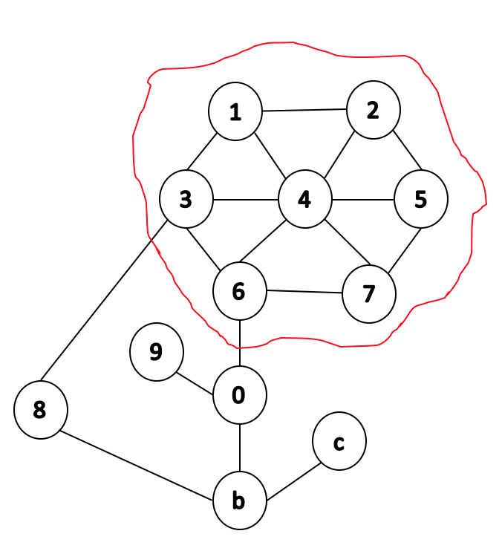

Based on above terms we will see:

* **Complete subgraph**: every two distinct vertices are adjacent.
* **Connected subgraph**: there is a path between every two vertices in the graph.
* **Connected component**: a connected subgraph where none of the vertices are connected to the rest of the graph.
* **Acyclic subgraphs**: a subgraph with no cycles.
* **Spanning trees**: a connected acyclic subgraph with minimal edge weight.
* **Minimal number of edges**:
  + Non-connected graph → m = 0

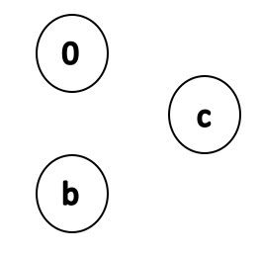

* + Connected graph → m = n - 1

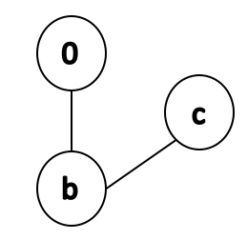

* **Maximal number of edges**:
  + If the graph is not simple, number of edges: infinite.
  + If the graph is simple:

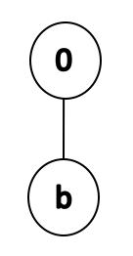 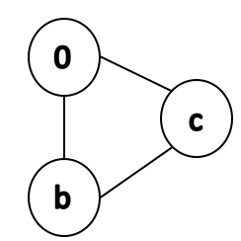 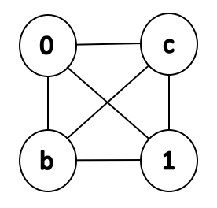 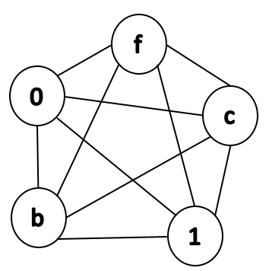 …..

|  |  |
| --- | --- |
| n | m |
| 1 | 0 |
| 2 | 1 |
| 3 | 3 |
| 4 | 6 |
| 5 | 10 |
| ... | ... |
| n | $\sum_{k=1}^{n-1}{}k=$ ${O (n}^{2})$ |

* Sum of all degrees of all vertices → 2 * m
* **Theorem**: Every minimally connected graph has G=(V, E) has |V| - 1 edges.
  + **Lemma 1**: Every connected subgraph of G is minimally connected
    - We continue by assuming this lemma is true (proof is left for exercises)
* **Proof** 
  + Consider an arbitrary minimally connected graph G=(E, V).
  + **Base case**: |V| = 1, by definition a minimally connected graph consisting of 1 vertex has 0 edges. By the theorem the number of edges should be |V| - 1 = (1 - 1) = 0.
  + **Inductive hypothesis**: For any *j* < |V|, any minimally connected graph of *j* vertices has (*j* - 1) edges.
  + **1. Suppose |V| > 1:** 
    - Choose any vertex *u* and let *d* denote the degree of *u*.
  + Choose vertex w in the graph below.

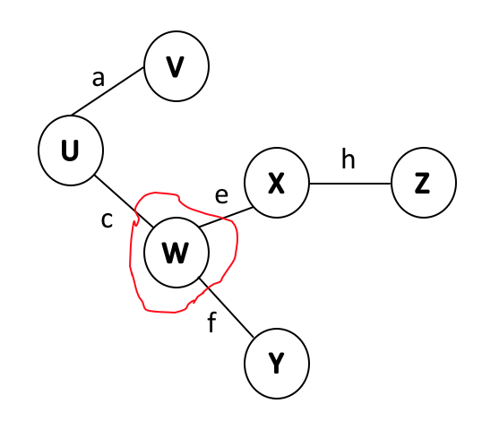

* + - **2. Partition**: remove the incident edges of u, partitioning the graph into (*d* + 1) components → $C_{0}$ = ($V_{0}, E_{0}$), …, $C_{d}$ = ($V_{d}, E_{d}$).
  + We choose vertex w, removed edges *c*, *e*, and *f*; and now we have 4 components → deg(*w*) + 1 = 3 + 1 = 4.

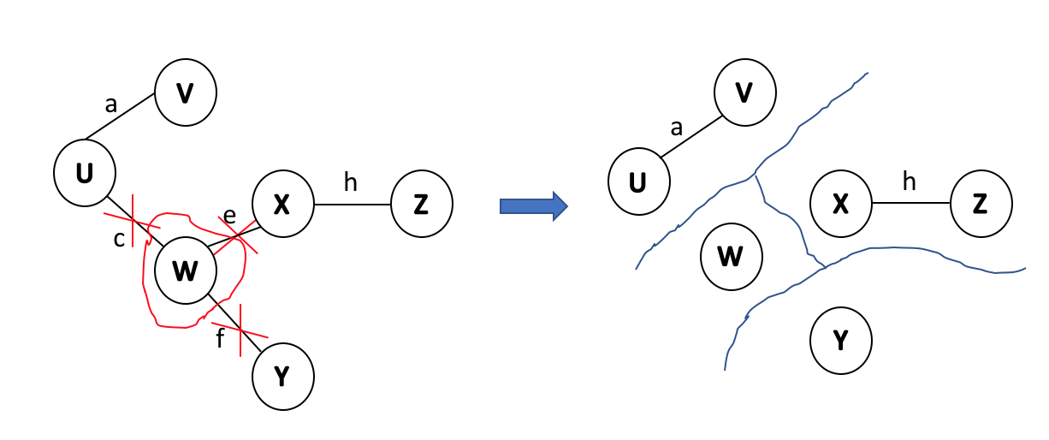

* + By Lemma 1 every component $C_{k}$ is a minimally connected subgraph of G.
  + By our inductive hypothesis: ${|E}_{k}| = |V|-1$.
  + **3. Count edges**: $d +\sum_{k=1}^{d}{}$ $E_{k}=d + \sum_{k=1}^{d}{}|V_{k}| = n -1$. QED

### **Graph ADT**

* + **Data**: all vertices, all edges, and structure to maintain relations between vertices and edges.
  + **Functions**:
    - insert vertex/edge
    - remove vertex/edge
    - find incident edges
    - check if two vertices are adjacent
    - find origin/destination.

#### **Graph implementation 1 :: Edge List**

* **Vertex collection**: Use hash table (find/remove/insert will be O(1)).
* **Edge collections**: Use a linked list (hash table is not good because we have many collisions (no random distribution, violates SUHA) )
* **Running time**
  + **Insert vertex** → we are using hash table where insert takes O(1) time.
  + **Remove vertex** → removing from hash table takes O(1), but we need to remove incident edges which means we need to loop over edges list. We have m edges so it will take O(m)
  + **areAdjacent** → again, we need to loop over the edge list which takes O(m) time.
  + **InsertEdge** → add edge to edge list by adding to the front so it takes O(1)
  + **incidentEdges** → O(m).
  + The running times seem linear, however, we know that the relationship between number of nodes and the number of edges can be $n^{2}$; which means O(m) could in fact be O($n^{2}$)