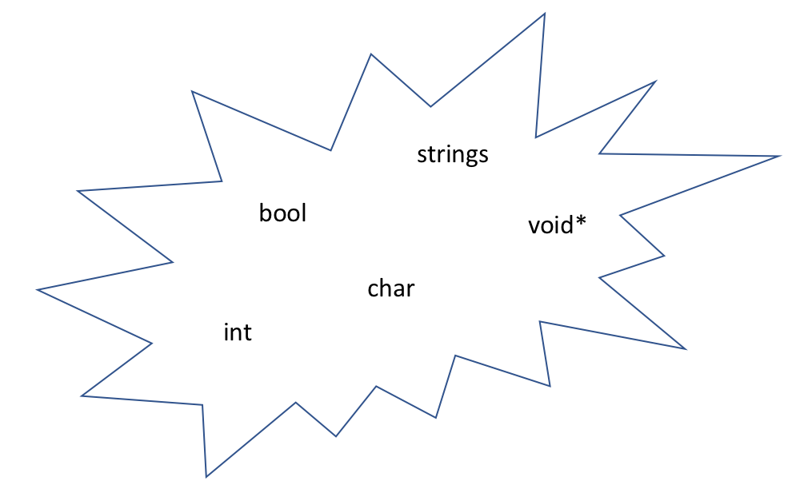

### **The Priority Queue/Heap**

* ADT:
  + insert
  + remove
  + isEmpty
* Store ordered data
* Operator “<” must be implemented
* Whenever remove is called, the data structure pops out an element with a predetermined property (for example, the smallest element)
  + Just like a Stack/Queue, we cannot tell the structure what it removes
  + Unlike Stack/Queue, the Priority Queue always remove an element with a certain priority (for example, the smallest element)

#### **Implementations**

* Possible (bad) implementations of the above ADT and their running times:

|  |  |  |  |
| --- | --- | --- | --- |
| Runtime | insert | removeMin | Total time |
| s | O(1)* | O(n) | O(n) |
| Unsorted List | O(1) | O(n) | O(n) |
| Sorted Array | O(n) | O(1) | O(n) |
| Sorted List | O(n) | O(1) | O(n) |

Further, HashTable is not ordered so not useful. Only thing left is, the **Tree**!

**Tree structure implementation: the (min)Heap**

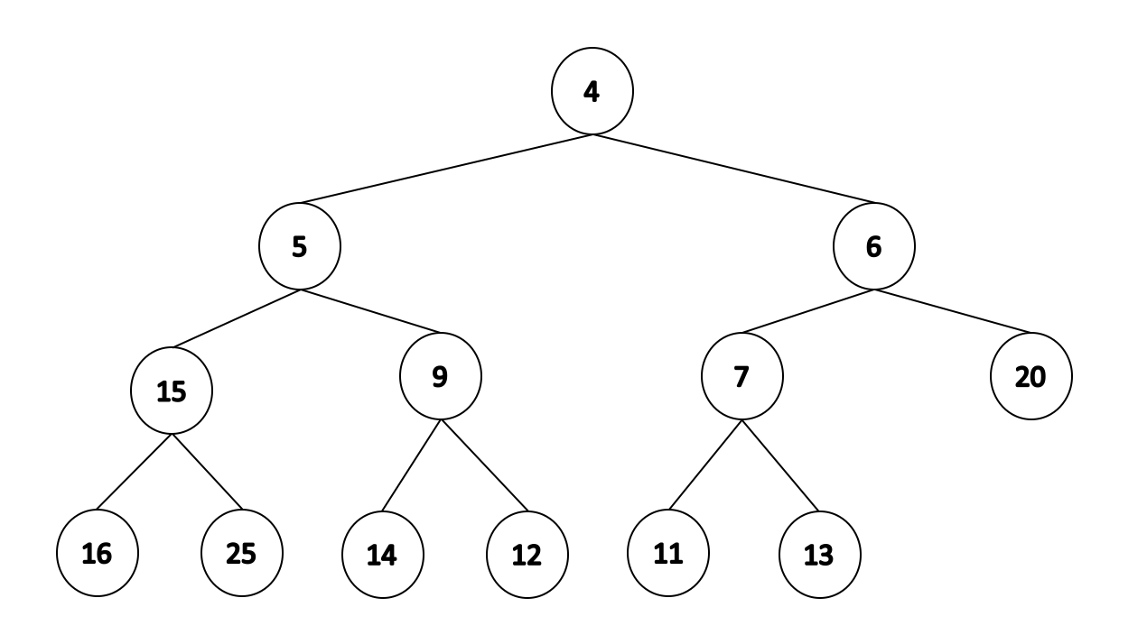

* + A binary, complete tree with the smallest element on the root
  + Children are larger than their parent
  + **Definition of a minHeap:**

A complete binary tree is a minHeap if

* + - **T = {}**, or
    - **T = {r, TL, TR}**, where **TL, TR** are minHeaps and **r** is greater than their root
* We map the tree into a simpler data structure : **minHeap**.
  + We will map level order tree traversal to an array or vector.
    - We will use trees just for representation.

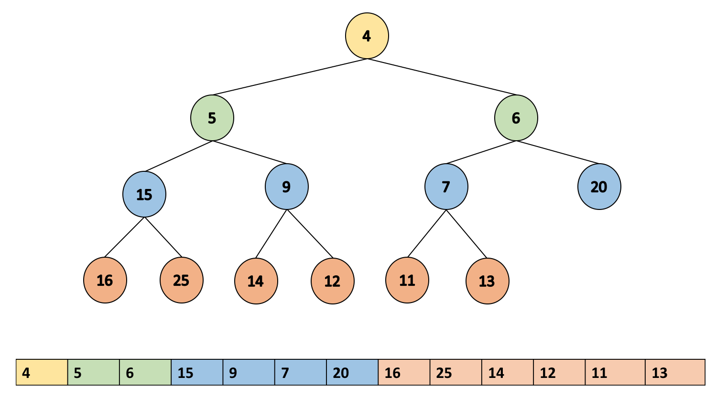

* + In this case we traverse the array in the following way:
    - Left child is at index: 2 * i + 1
    - Right child is at index: 2 * i + 2
    - Parent is at index: (i - 1) / 2
  + However, if we want an easier way to compute indices - add a dummy to the beginning of the array to shift the indices by one.

* + Now, we can compute indices as follows:
    - Left child is at index: 2 * i
    - Right child is at index: 2 * i + 1
    - Parent is at index: i / 2

#### **Insertion**

* Check if we still have the array capacity
  + If not, we double the size of the array

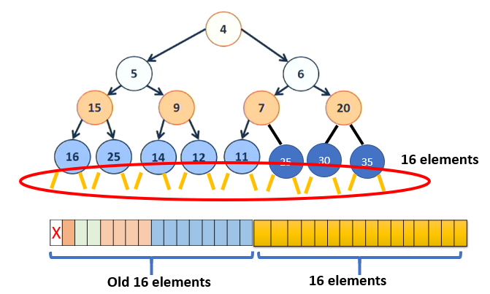

* + This is just adding a new layer to the tree



* Insert the element at the end of the array
* Make sure the result is still a heap (heapify-up)

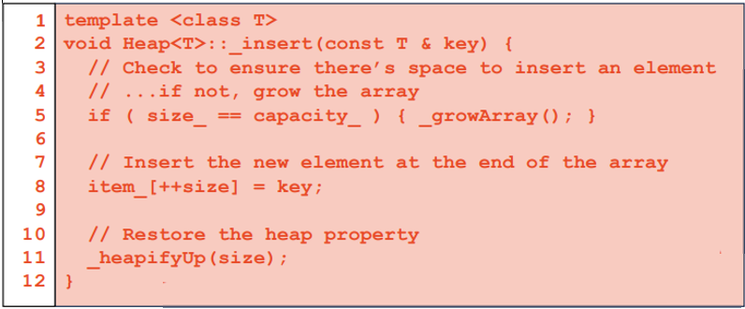

#### Heapify-Up

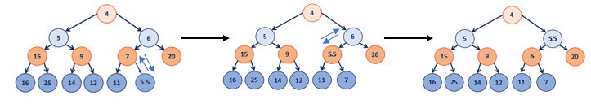

* Starts from the inserted node, assumes the heap is valid everywhere below that node
* If the current element is not the root and smaller than its parent
  + Swap the current element and its parent
  + Continue on the parent

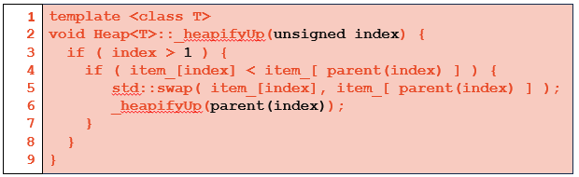

* Runtime of Insertion
  + growArray() takes O(1) amortized
  + insertion takes O(1)
  + heapify-up takes O(h) = O(lg n) since the tree is complete
  + **Total runtime: O(lg n)**

#### **Remove**

* Swap the root with the last element
* Remove the last element
* Heapify-Down to ensure the heap property

