**Create – Applications From Ideas  
Written Response Submission Template**

Please see [Assessment Overview and Performance Task Directions for Student](https://apcentral.collegeboard.org/pdf/ap-csp-student-task-directions.pdf?course=ap-computer-science-principles) for the task directions and recommended word counts.

**Program Purpose and Development**

2a)

|  |
| --- |
|  |

2b)

|  |
| --- |
|  |

2c)

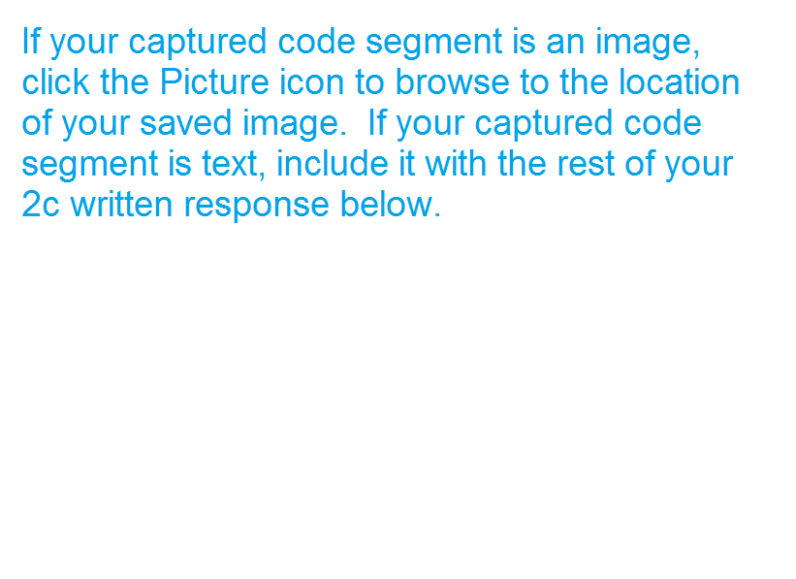

|  |
| --- |
|  |

2d)



  
  
  