PeerLend Whitepaper (Summary)

PeerLend: Set Your Own Interest – Manage Your Own Risk  
  
🔹 Summary  
  
PeerLend is a peer-to-peer lending protocol where users set their own interest rates to lend funds, while borrowers can take loans by depositing 150% collateral. There is no fixed loan duration. If the debt-to-collateral ratio drops below a threshold, the loan is automatically opened to the public rescue market. The protocol works without any oracle dependency and supports ETH, USDC, and WBTC.  
  
🔹 Core Features  
  
✅ Set Your Own Interest  
- Lenders submit loan offers with their desired interest rate.  
- Borrowers browse available offers and choose the one they like.  
  
✅ Fixed Collateral Ratio  
- Borrowers must deposit 150% collateral (e.g., 15,000 USD for a 10,000 USDC loan).  
- If the ratio falls below 135%, the debt becomes eligible for rescue.  
  
✅ No Fixed Duration  
- Borrowers can repay at any time and retrieve their collateral.  
- Over time, the loan grows with interest.  
  
🔹 Rescue Market  
  
- If the collateral ratio falls below 135%, the system flags the debt for rescue.  
- Borrowers may add a reward (e.g., 1%) to encourage repayment by others.  
- Third-party rescuers pay off the loan and receive:  
 - The full loan amount + accrued interest + reward.  
 - This amount is directly transferred to the rescuer.  
- Remaining collateral is returned to the borrower.  
- The protocol takes a small cut from the reward (e.g., 10%).  
  
🔹 Protocol Revenue  
  
- A small fee is taken from both lenders and borrowers during match (e.g., 0.5%).  
- The protocol also earns a cut from the rescue market (e.g., from the reward).  
- This ensures sustainability without relying on token inflation.  
  
🔹 Security & Oracle Independence  
  
- No price feeds or external oracles are used.  
- Collateral ratio is based only on the fixed collateral value and growing debt.  
- This makes PeerLend resistant to oracle exploits or manipulation.  
  
🔹 Supported Assets  
  
- ETH (native)  
- USDC (borrowable)  
- WBTC (collateral or borrowable)  
- Future assets can be added via governance.  
  
🔹 Use Cases  
  
- Passive income seekers: choose your interest rate, no lock-ups.  
- Borrowers with idle assets: get liquidity, repay whenever.  
- Traders: unlock stablecoins while holding your spot positions.  
- Bots and rescuers: profit by saving undercollateralized loans.  
  
🔹 Roadmap  
  
- ✅ MVP contract development (in progress)  
- 🔄 Launch on testnet  
- 🔒 Security audit  
- 🌐 Web interface integration  
- 🧪 Rescue market testing  
- 📣 Community launch & liquidity incentives  
- 🗳 Governance & DAO launch

# 📊 PeerLend Collateral Ratio Over Time (Oracle-Free Model)

PeerLend does not rely on price oracles. Therefore, it does not track the market value of collateral. Instead, it observes the growth of debt over time through accumulated interest. The chart below shows how a loan of 10,000 USDC grows over time, reducing the collateral ratio even though the collateral remains fixed at 15,000 USDC. Once the ratio drops below 135%, the loan is opened to the rescue market.

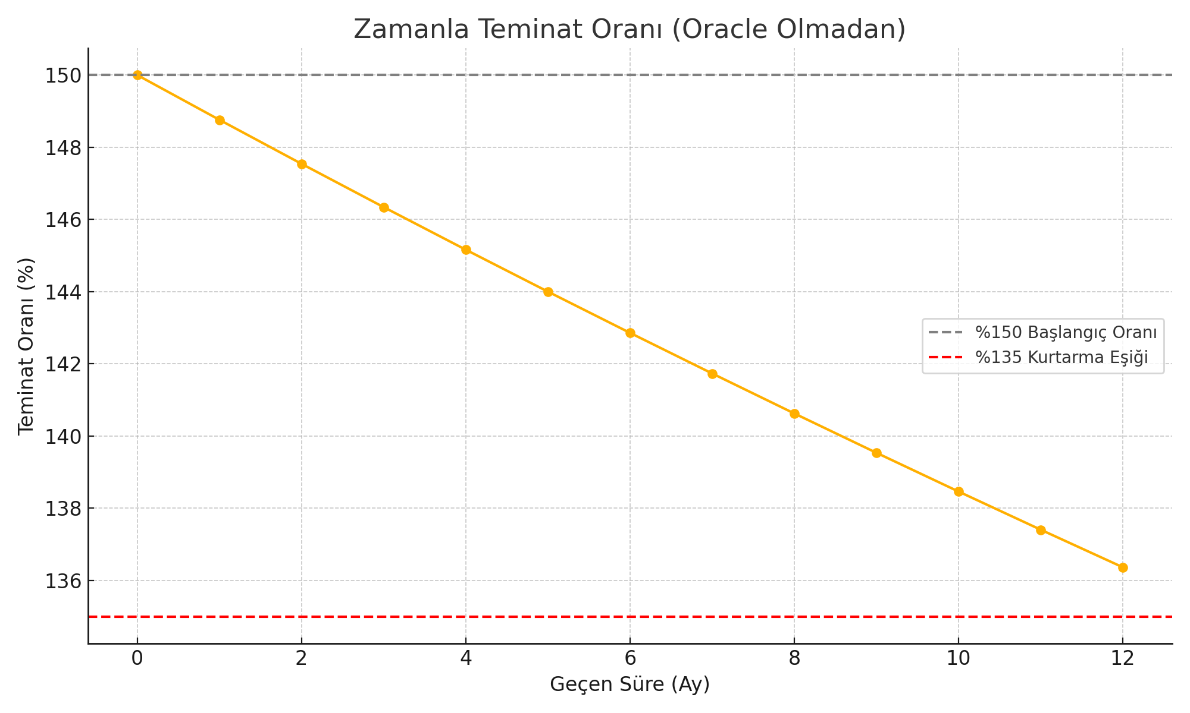

Note: The loan begins with a 150% collateral ratio. As interest accumulates, the debt grows, and the ratio drops, even though the collateral amount remains unchanged. This graph visualizes how PeerLend secures loans without using oracles.