Data Science Book
Spis treści
Pandas 1
Matplotlib 1
Plot 1
hist 1
scatter 1

Numpy
np.median

Pandas

DataFrame

df.sample(5) #random sample of 5 elements

CSV
df = pd.read_csv("data.csv")

Missing Values

missing_values_count_per_column = df.isnull().sum()
missing_values_total = df.isnull().sum().sum()

Matplotlib
import matplotlib.pyplot as plt

plt.plot(x,y)
plt.scatter(x = gdp_cap, y = life_exp, s = np.array(pop) * 2, c=col, alpha=0.8)
plt.hist()
plt.xlabel(“labelx”)
plt.title(“tutul wykresu)
plt.yticks([0,2,4],[“0”,”2B”,”4B”)#ticki i labele dla osi y
plt.xscale('log') #zmiana x na scale logarytmiczną
plt.clf()

fig, ax=plt.subplots(1,2)
sns.distplot(original_data, ax=ax[0])
ax[0].set_title("Original Data")
sns.distplot(normalized_data[0], ax=ax[1])
ax[1].set_title("Normalized data")

Plot

hist

scatter

TKINTER
import tkinter as tk  root = tk.Tk()  logo = tk.PhotoImage(file="python_logo_small.gif")  w1 = tk.Label(root, image=logo).pack(side="right")  explanation = """At present, only GIF and PPM/PGM (...)be added easily."""  w2 = tk.Label(root, justify=tk.LEFT, padx = 10, text=explanation).pack(side="left")  tk.Label(root, text="Blue Text(...)", fg = "blue", bg = "yellow", font = "Verdana 10 bold").pack()  root.mainloop()  w2.pack(fill=X, padx=10, ipadx=10) | 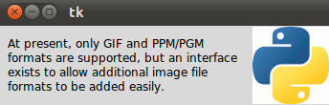  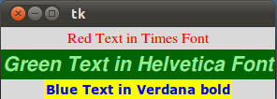  fill=X - tak szeroki jak parent  padx, pady, ipadx #i-internal
w = tk.Label(root, compound = tk.CENTER, text=explanation,image=logo).pack(side="right") | 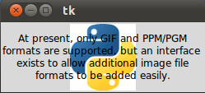
def counter_label(label):  def count():  global counter  counter += 1  label.config(text=str(counter))  label.after(1000, count)  count()  root.title("Counting Seconds")  label = tk.Label(root, fg="green")  counter_label(label)  button=tk.Button(root, text='Stop',width=25,command=root.destroy)  root.mainloop() | 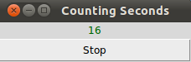
whatever_you_do = "Whatever you do(...)\t will.\n(Mahatma Gandhi)"  msg = tk.Message(root, text = whatever_you_do)  msg.config(bg='lightgreen', font=('times', 24, 'italic')) | 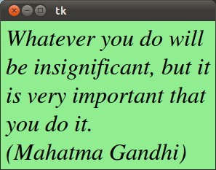
def write_slogan():  print("Tkinter is easy to use!")  root = tk.Tk()  frame = tk.Frame(root)  frame.pack()  button = tk.Button(frame, text="QUIT", fg="red",command=quit)  button.pack(side=tk.LEFT)  slogan = tk.Button(frame, text="Hello",command=write_slogan)  slogan.pack(side=tk.LEFT)  root.mainloop() | 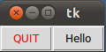
x = StringVar() # IntVar() # DoubleVar() # BooleanVar() #### x.get()
v = tk.IntVar()  tk.Label(root, text="""Choose a programming language:""", justify = tk.LEFT, padx = 20).pack()  tk.Radiobutton(root, text="Python",padx = 20, variable=v, value=1).pack(anchor=tk.W)  tk.Radiobutton(root, text="Perl", padx = 20, variable=v, value=2).pack(anchor=tk.W)  root.mainloop() | 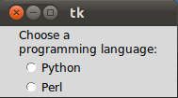
v = tk.IntVar()  v.set(1) # initializing the choice, i.e. Python  def ShC():  print(v.get())  langs = [ ("Python",1), ("Perl",2), ("Java",3), ("C++",4), ("C",5) ]  for val, lang in enumerate(langs):  tk.Radiobutton(root, text=lang,padx = 20, variable=v, command=ShC, indicatoron=0, value=val) | #.pack(anchor=tk.W)  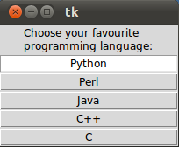!!!enumerate robi teź indeks, zamiast “Python” lang ma “Python 1”
var1 = IntVar()  Checkbutton(root, text="male", variable=var1).grid(row=0, sticky=W) #wyrownanie do lewej  var2 = IntVar()  Checkbutton(root, text="female", variable=var2).grid(row=1, sticky=W) | 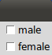
def var_states():  print("male: %d,\nfemale: %d" % (var1.get(), var2.get()))  Button(master, text='Show', command=var_states).grid(row=4, sticky=W, pady=4) | pady- “colspan/ pad y”
from tkinter import *  class Checkbar(Frame):  def __init__(self, parent=None, picks=[], side=LEFT, anchor=W):  Frame.__init__(self, parent)  self.vars = []  for pick in picks:  var = IntVar()  chk = Checkbutton(self, text=pick, variable=var)  chk.pack(side=side, anchor=anchor, expand=YES)  self.vars.append(var)  def state(self):  return map((lambda var: var.get()), self.vars)  if __name__ == '__main__':  root = Tk()  lng = Checkbar(root, ['Python', 'Ruby', 'Perl', 'C++'])  tgl = Checkbar(root, ['English','German'])  lng.pack(side=TOP, fill=X)  tgl.pack(side=LEFT)  lng.config(relief=GROOVE, bd=2)  def allstates():  print(list(lng.state()), list(tgl.state()))  Button(root, text='Quit', command=root.quit).pack(side=RIGHT)  Button(root, text='Peek', command=allstates).pack(side=RIGHT)  root.mainloop() | 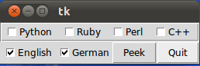  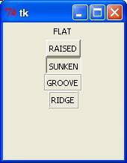relief=
e1 = Entry(root) # e1.insert(10,"Miller") # e1.delete(0,END)
from tkinter import *
fields = 'Last Name', 'First Name', 'Job', 'Country'
def fetch(entries):
for entry in entries:
field = entry[0]
text = entry[1].get()
print('%s: "%s"' % (field, text))
def makeform(root, fields):
entries = []
for field in fields:
row = Frame(root)
lab = Label(row, width=15, text=field, anchor='w')
ent = Entry(row)
row.pack(side=TOP, fill=X, padx=5, pady=5)
lab.pack(side=LEFT)
ent.pack(side=RIGHT, expand=YES, fill=X)
entries.append((field, ent))
return entries
iif __name__ == '__main__':
root = Tk()
ents = makeform(root, fields)
root.bind('<Return>', (lambda event, e=ents: fetch(e)))
b1 = Button(root, text='Show',
command=(lambda e=ents: fetch(e)))
b1.pack(side=LEFT, padx=5, pady=5)
b2 = Button(root, text='Quit', command=root.quit)
b2.pack(side=LEFT, padx=5, pady=5)
root.mainloop()

canvas_width = 200  canvas_height =200  w = Canvas(root, width=200, height=100)  w.pack()  w.create_oval ( x0, y0, x1, y1, option, ... )  points = [0,0,canvas_width,canvas_height/2, 0, canvas_height]  w.create_polygon(points, outline=python_green, fill='yellow', width=3)  #create_polygon(x0,y0, x1,y1, x2,y2, ...) | 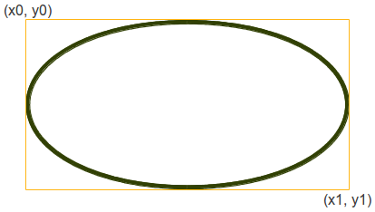  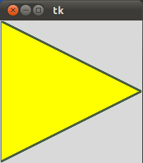
  w.create_rectangle(50, 20, 150, 80, fill="#476042")  w.create_line(0, 0, 50, 20, fill="#476042", width=3)  w.create_text(canvas_width / 2, canvas_height / 2, text="Python") | 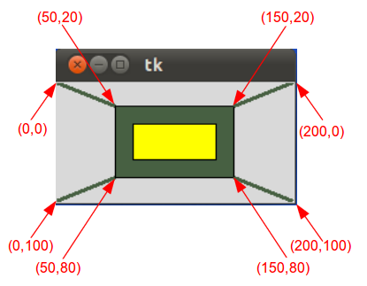
from tkinter import *  canvas_width = 500  canvas_height = 150  def paint( event ):  python_green = "#476042"  x1, y1 = ( event.x - 1 ), ( event.y - 1 )  x2, y2 = ( event.x + 1 ), ( event.y + 1 )  w.create_oval( x1, y1, x2, y2, fill = python_green )  master = Tk()  master.title( "Painting using Ovals" )  w = Canvas(master,  width=canvas_width,  height=canvas_height)  w.pack(expand = YES, fill = BOTH)  w.bind( "<B1-Motion>", paint )  message = Label( master, text = "Press and Drag the mouse to draw" )  message.pack( side = BOTTOM )  mainloop() | 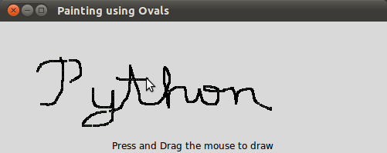  ___________________________  img=PhotoImage(file="ks.ppm")  #ppm, gif  canvas.create_image(20,20, anchor=NW, image=img)  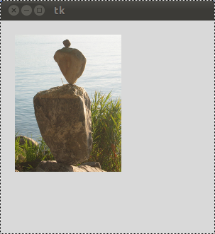
bitmaps = ["error", "gray75", "gray50", "gray25", "gray12", "hourglass", "info", "questhead", "question", "warning"]  nsteps = len(bitmaps)  step_x = int(canvas_width / nsteps)  for i in range(0, nsteps):  canvas.create_bitmap((i+1)*step_x - step_x/2,50, bitmap=bitmaps[i]) | 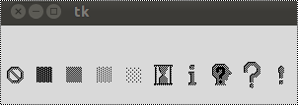
w = Scale(root, from_=0, to=200, tickinterval=8, orient=HORIZONTAL) | 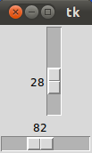
S = Scrollbar(root)  T = Text(root, height=4, width=50)  S.pack(side=RIGHT, fill=Y)  T.pack(side=LEFT, fill=Y)  S.config(command=T.yview)  T.config(yscrollcommand=S.set)  quote = """HAMLET(..bardzo dlugi tekst…..): Thed."""  T.insert(END, quote) | 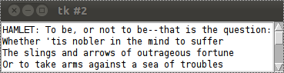
text1 = Text(root, height=20, width=30)  photo=PhotoImage(file='./William_Shakespeare.gif')  text1.insert(END,'\n')  text1.image_create(END, image=photo)  text1.pack(side=LEFT)  text2 = Text(root, height=20, width=50)  scroll = Scrollbar(root, command=text2.yview)  text2.configure(yscrollcommand=scroll.set)  text2.tag_configure('bold_italics', font=('Arial', 12, 'bold', 'italic'))  text2.tag_configure('big', font=('Verdana', 20, 'bold'))  text2.tag_configure('color', foreground='#476042', font=('Tempus Sans ITC', 12, 'bold'))  text2.tag_bind('follow', '<1>', lambda e, t=text2: t.insert(END, "Not now, maybe later!"))  text2.insert(END,'\nWilliam Shakespeare\n', 'big')  quote = """To be, (...długi tekst...)"""  text2.insert(END, quote, 'color')  text2.insert(END, 'follow-up\n', 'follow')  text2.pack(side=LEFT)  scroll.pack(side=RIGHT, fill=Y) | 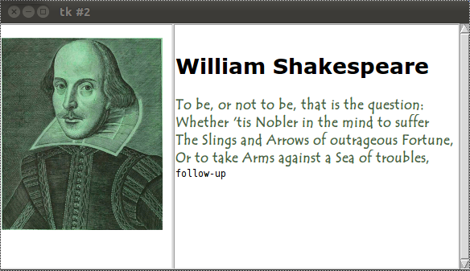
from Tkinter import *  from tkMessageBox import * #from tkinter.messagebox import showinfo  def answer():  showerror("Answer", "Sorry, no answer available")  def callback():  if askyesno('Verify', 'Really quit?'):  showwarning('Yes', 'Not yet implemented')  else:  showinfo('No', 'Quit has been cancelled')  Button(text='Quit', command=callback).pack(fill=X)  Button(text='Answer', command=answer).pack(fill=X)  mainloop()  #askquestion, askretrycancel, askyesnocancel... | askokcancel(title=None, message=None,**opts)
  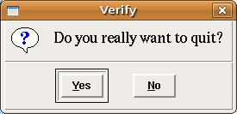 | 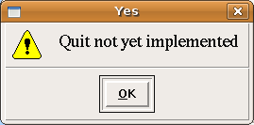
  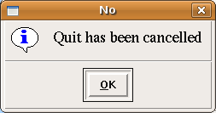 | 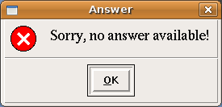
from tkFileDialog import askopenfilename ??tkinter.filedialog ??  def callback():  name= askopenfilename()  print name  Button(text='File Open', command=callback).pack(fill=X) | 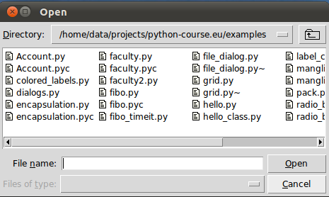
result = tkColorChooser.askcolor ( color, option=value, ...) | np.((106, 150, 98), '#6a9662')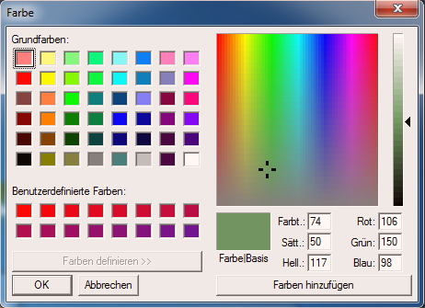
root.geometry("170x200+30+30")
colours = ['red','green','orange','white','yellow','blue']  r = 0  for c in colours:  Label(text=c, relief=RIDGE,width=15).grid(row=r,column=0)  Entry(bg=c, relief=SUNKEN,width=10).grid(row=r,column=1)  r = r + 1  mainloop() | 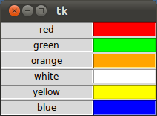
def About():  print "This is a simple example of a menu"  root = Tk()  menu = Menu(root)  root.config(menu=menu)  #(...)  helpmenu = Menu(menu)  menu.add_cascade(label="Help", menu=helpmenu)  helpmenu.add_command(label="About...", command=About)  filemenu.add_separator()  mainloop() | 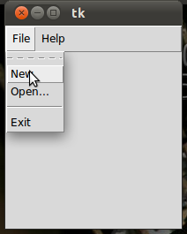
def hello(event):  print("Single Click, Button-l")  def quit(event):  print("Double Click, so let's stop")  import sys; sys.exit()  widget = Button(None, text='Mouse Clicks')  widget.pack()  widget.bind('<Button-1>', hello)  widget.bind('<Double-1>', quit)  widget.mainloop() | def motion(event):  print("pos(%s , %s)" %  (event.x, event.y))  return  msg.bind('<Motion>',motion)  #<Shift-Up>, <Return>  #<Key>  #<Configure>//”odmalowanie ekranu
GENERAL
from collections import deque  queue=deque([“a”,”b”,”c”])## ,maxlen=3) #maxlen zrobi “przesuwne okienko”(popleft)  queue.append(“d”)  queue.append(“e”) ### .appendleft()  queue.popleft()  queue.popleft()  print(queue) | #output  #deque([“c”,”d”,”e”])
from threading import Thread  from Queue import Queue  q = Queue()  num_threads=5  for i in range(num_threads):  worker = Thread(target=enki, args=(q,))  worker.setDaemon(True)  worker.start()  for x in range(50): #make threads work on the same queue  q.put(x)  #q.put(x, block=True, timeout=None) | ##definicje  def enki(q):# q to Queue  while True:  print(q.get())  q.task_done()  #if q.empty() q.full()  # queue.PriorityQueue()
class Meta(type): #metaclassa do klasy jak klasa do instancji  pass #odziedziczenie po klasie “type” robi z tego metaklase;  class Enki(metaclass=Meta):  pass #keyword “metaclass” zmienia domyślną | type(coś) ## isinstance(obiekt, klasa)
class Funky:  def __call__(self):  print("Look at me, I work like a function!")  >>> f = Funky()  >>> f()  Look at me, I.. | “magic methods”
 | my_dict=“first”:’a’, “second”:’b’ }  my_list=[‘a’,’b’]  second_list=[‘1’,’2’]  my_list2=[‘b’,’c’,’a’]  ________  x = {‘a’:1, ‘b’:2}  y={‘b’:3, ‘c’:4}}
  for k,v in my_dict.items():  print(k,v) | #first a  #second b
  for i,v in enumerate(my_list):  print(i,v) | #0 a  #1 b
  for f,s in zip(my_list,second_list):  print(f,s) | #a 1  #b 2
  #loop in reverse:  for f in reversed(sorted(set(my_list2))):  print(f) | #c  #b  #a
  z={**x,**y} # | # {‘c’:4. ‘a’:1,’b’:3 } #nadpisuje klucze
with open(‘a.txt’,’w’) as f: #’r’)  f.write(“a line”)  l= f.read() | f.closed #True or False
with my_context_manager as custom_name:  #do whatever | class my_context_manager:  def__enter__(self):  #set up  return thing  def __exit__(self, type, value, traceback):  #deal with unmanaged resources
class Enki:  def__init__(self):  self.__prywatna = 3.14  print(self.__prywatna)  enki=Enki() #wyprintuje prywatna  print(enki.__prywatna) #wywali AttributeErrror, ze nie ma takiej zmiennej  #print(enki._Enki__prywatna) #zadziala, ale tak nie rob | private var in class
print(time.time()) #sekundy od unix epoch  print(t_struct)  print(time.asctime(t_struct))  time.sleep(5) # 5 sekund  print(datetime.datetime.today() | import time  cur_time = time.time()  t_struct= time.localtime(cur_time)  import datetime
plus2 = functools.partial(b=2)  map(plus2,[1,2,3]  #3,4,5 | def plus(a,b):  return a+b  ##?? functools.cmt_to_key
list=[] # :))  for line in file:  line.append(str(line))  “”.join(list) | string=”” #:((  for line in file:  string+=str(line)
def generate_ints(N):
for i in range(N):
yield i
coll=[ el if cond1(el) and cond2(el) else modify(el) for el in list]  ##  squares= [x**2 for x in range(20) if x%5==0] | for el in list:  if cond1(el) and cond2(el:  coll.append(el)  else:  new=mutate(el)  coll.append(el)
if x == 1 or y == 1 or z == 1  if 1 in (x, y, z)  if x or y or z:  if any((x, y, z)): | # Different ways to test multiple  # flags at once in Python  x, y, z = 0, 1, 0
>>> sorted(xs.items(), key=lambda x: x[1])  [('d', 1), ('c', 2), ('b', 3), ('a', 4)]  >>> import operator  >>> sorted(xs.items(), key=operator.itemgetter(1))  [('d', 1), ('c', 2), ('b', 3), ('a', 4)] | # How to sort a Python dict by value  # (== get a representation sorted by value)  xs = {'a': 4, 'b': 3, 'c': 2, 'd': 1}
def greeting(userid):  return "Hi %s!" % name_for_userid.get(userid, "there")  >>> greeting(382)  "Hi Alice!"  >>> greeting(333333)  "Hi there!" | # The get() method on dicts  # and its "default" argument  name_for_userid = {  382: "Alice",  590: "Bob",  951: "Dilbert",}
dict_vec = {'x': 1, 'y': 0, 'z': 1}  >>> myfunc(*tup_vec)  1, 0, 1  >>> myfunc(**dict_vec)  1, 0, 1 | # Function argument unpacking  def myfunc(x, y, z):  print(x, y, z)  tup_vec = (1, 0, 1)
>>> def myfunc(a, b):  ... return a + b  >>> funcs = [myfunc]  >>> funcs[0]  >>> funcs[0](2, 3) | #  #  <function myfunc at 0x107012230>  5
>>> dispatch_if('mul', 2, 8) #16  >>> dispatch_dict('mul', 2, 8) #16  >>> dispatch_if('unknown', 2, 8) #None  >>> dispatch_dict('unknown', 2, 8) #None | # Because Python has first-class functions they can  # be used to emulate switch/case statements
  def dispatch_if(operator, x, y):  if operator == 'add':  return x + y  elif operator == 'sub':  return x - y  elif operator == 'mul':  return x * y  elif operator == 'div':  return x / y  else:  return None | def dispatch_dict(operator, x, y):  return {  'add': lambda: x + y,  'sub': lambda: x - y,  'mul': lambda: x * y,  'div': lambda: x / y,  }.get(operator, lambda: None)()
nfl_data = list(csv.reader(open("nfl.csv")))
sqlite> .output c:/sqlite/chinook.sql
sqlite> .dump
sqlite> .exit

# The standard string repr for dicts is hard to read:  >>> my_mapping  {'b': 42, 'c': 12648430. 'a': 23} # 😞  >>> print(json.dumps(my_mapping, indent=4, sort_keys=True))  {  "a": 23,  "b": 42,  "c": 12648430  } | >>> my_mapping = {'a': 23, 'b': 42, 'c': 0xc0ffee}  # The "json" module can do a much better job:  >>> import json  # Note this only works with dicts containing primitive types (check out the "pprint" module):  >>> json.dumps({all: 'yup'}) TypeError: keys must be a string
$ python3 -m http.server  # Python 2.x  $ python -m SimpleHTTPServer 8000 | # (This will serve the current directory at  # http://localhost:8000)
data science
np.array(<list>)  np.mean(<list>)  np.median(<list>)  np.corrcoef(x,y) //macierz korelacji?kowariancji | import numpy as np
# Convert positions and heights to numpy arrays: np_positions, np_heights  np_positions = np.array(positions)  np_heights = np.array(heights)  gk_heights = np_heights[np_positions=='GK']  # Print out the median height of goalkeepers i other.  print("Median height of goalkeepers: " + str(np.median(gk_heights))) | import numpy as np  # heights and positions are available as lists  # Heights of the goalkeepers: gk_heights
matplotlib
plt.scatter(x = gdp_cap, y = life_exp, s = np.array(pop) * 2, c=col, alpha=0.8)  plt.xlabel(“labelx”)  plt.title(“tutul wykresu)  plt.yticks([0,2,4],[“0”,”2B”,”4B”) #ticki i labele dla osi y  plt.xscale('log') #zmiana x na scale logarytmiczną  fig, ax=plt.subplots(1,2)  sns.distplot(original_data, ax=ax[0])  ax[0].set_title("Original Data")  sns.distplot(normalized_data[0], ax=ax[1])  ax[1].set_title("Normalized data") | import matplotlib.pyplot as plt  plt.plot(x,y)  plt.hist()  plt.text(x,y,”text”)  plt.clf() #clean  import seaborn as sns
pandas
nfl_data = pd.read_csv("NFL Play by Play 2009-2017 (v4).csv")  nfl_data.sample(5)  # get the number of missing data points per column  missing_values_count = nfl_data.isnull().sum()  # how many total missing values do we have?  total_cells = np.product(nfl_data.shape)  total_missing = missing_values_count.sum()  # percent of data that is missing  (total_missing/total_cells) * 100  nfl_data.dropna() # remove all the rows that contain a missing value  columns_with_na_dropped = nfl_data.dropna(axis=1) # remove all columns with at least one missing value  # just how much data did we lose?  print("Columns in original dataset: %d \n" % nfl_data.shape[1])  print("Columns with na's dropped: %d" % columns_with_na_dropped.shape[1])  # replace all NA's the value that comes directly after it in the same column,  # then replace all the reamining na's with 0  subset_nfl_data.fillna(method = 'bfill', axis=0).fillna(0)  landslides['date_parsed'] = pd.to_datetime(landslides['date'], format = "%m/%d/%y")  day_of_month_earthquakes= earthquakes['date_parsed'].dt.day  suicide_attacks['City'].unique()  suicide_attacks['City'].str.lower().str.strip().unique() #lower, strip whitespaces | import pandas as pd  import numpy as np  //”Handling missing values”
# scale the goals from 0 to 1  scaled_data = minmax_scaling(usd_goal, columns = [0])  normalize the exponential data with boxcox  normalized_data = stats.boxcox(original_data)  # plot both together to compare  fig, ax=plt.subplots(1,2)  sns.distplot(original_data, ax=ax[0])  ax[0].set_title("Original Data")  sns.distplot(normalized_data[0], ax=ax[1])  ax[1].set_title("Normalized data") | “”Scale and Normalize Data”  # for Box-Cox Transformation  from scipy import stats  from mlxtend.preprocessing import minmax_scaling  # plotting modules  import seaborn as sns  import matplotlib.pyplot as plt
# get the index of all positive pledges (Box-Cox only takes postive values)
index_of_positive_pledges = kickstarters_2017.usd_pledged_real > 0

# get only positive pledges (using their indexes)
positive_pledges = kickstarters_2017.usd_pledged_real.loc[index_of_positive_pledges]

# get the top 10 closest matches to "d.i khan"  matches = fuzzywuzzy.process.extract("d.i khan", cities, limit=10, scorer=fuzzywuzzy.fuzz.token_sort_ratio)  # function to replace rows in the provided column of the provided dataframe  # that match the provided string above the provided ratio with the provided string  def replace_matches_in_column(df, column, string_to_match, min_ratio = 90):  strings = df[column].unique() # get a list of unique strings  # get the top 10 closest matches to our input string  matches = fuzzywuzzy.process.extract(string_to_match, strings,  limit=10, scorer=fuzzywuzzy.fuzz.token_sort_ratio)  close_matches = [matches[0] for matches in matches if matches[1] >= min_ratio] # only get matches with a ratio > 90  # get the rows of all the close matches in our dataframe  rows_with_matches = df[column].isin(close_matches)  # replace all rows with close matches with the input matches  df.loc[rows_with_matches, column] = string_to_match  # let us know the function's done  print("All done!") | “Character encodings”  # helpful character encoding module  import chardet  # helpful modules  import fuzzywuzzy  from fuzzywuzzy import process
GIT
git status --global color.status.changed # (ui, branch, diff... | zmiana kolorów
git config --global help.autocorrect 30 | autokorekta po x sekundach

_________________________________SNMP
from pysnmp.hlapi import *

errorIndication, errorStatus, errorIndex, varBinds = next(
getCmd(SnmpEngine(),
CommunityData('public', mpModel=0),
UdpTransportTarget(('10.36.0.91', 161)),
ContextData(),
ObjectType(ObjectIdentity('43.11.1.1.6.1', 'sysDescr', 0)))
)

if errorIndication:
print(errorIndication)
elif errorStatus:
print('%s at %s' % (errorStatus.prettyPrint(),
errorIndex and varBinds[int(errorIndex) - 1][0] or '?'))
else:
for varBind in varBinds:
print(' = '.join([x.prettyPrint() for x in varBind]))
___________________________________
https://www.datacamp.com/statement-of-accomplishment/course/bc24f4f845092dde5818deb40d0a0cc0c6f8431b

yourVectorSource.forEachFeature( function(feature){ if (feature.get('CODEIF')==yourDesiredValue){ // add it on a temporary layer // and display it // while hiding yourVectorLayer } });

