

**Operating System**

**Assignment**

**On**

**Shortest Job**

**First**

**Submitted By: -**

**Name: Pyla Pavan**

**Durga Prasad**

**Reg. No: 11702481**

**Section: K17GB**

**Roll No: 26**

**Submitted To: -**

**Code**:

#include<stdio.h>

struct data

{

int et;

int bt;

int at;

int status;

};

int lwbt(int time,int np,struct data *processes)

{

int i,lbt,lbti=-1,onlyonce=0;

for(i=0;i<np;i++)

{

if((processes+i)->at<=time)

{

if((processes+i)->status==0 & onlyonce==0)

{

lbt=(processes+i)->bt;

lbti=i;

onlyonce=1;

}

else

{

if((processes+i)->status==0)

{

if (((processes+i)->bt) > lbt)

{

lbt=(processes+i)->bt;

lbti=i;

}

}

}

}

}

return lbti;

}

void main()

{

int np,i,npd=0,lbti;

printf("Enter the number of process :");

scanf("%d",&np);

struct data processes[np];

for(i=0;i<np;i++)

{

printf("Enter the arrival time :");

scanf("%d",&processes[i].at);

printf("Enter the burst time :");

scanf("%d",&processes[i].bt);

if(processes[i].at<1)

{

processes[i].status=1;

processes[i].et=-1;

npd++;

}

else

processes[i].status=0;

}

int time=1;

while(npd<np)

{

lbti=lwbt(time,np,&processes[0]);

if(lbti==-1)

time=time+1;

else

{

processes[lbti].et=time;

processes[lbti].status=1;

time=time+processes[lbti].bt+2;

npd=npd+1;

}

}

double avg_wt=0,avg_tat=0;

printf("~~~~~~~~~~~~~~~~~~~~~~~Processing the waiting time and the turnaround time~~~~~~~~~~~~~~~~~~~~~~~~~~~\n");

for(i=0;i<np;i++)

{

if (processes[i].et!=-1)

{

printf("%d \t\t\t%d\t\t\t%d\n",i,(processes[i].et-processes[i].at),(processes[i].et-processes[i].at+processes[i].bt));

avg_wt=avg_wt+(processes[i].et-processes[i].at);

avg_tat=avg_tat+(processes[i].et-processes[i].at+processes[i].bt);

}

else

printf("For process %d it is an error\n",i);

}

printf("Average turn around time is %lf\n",avg_tat/np);

printf("Average waiting time is %lf\n",avg_wt/np);

}

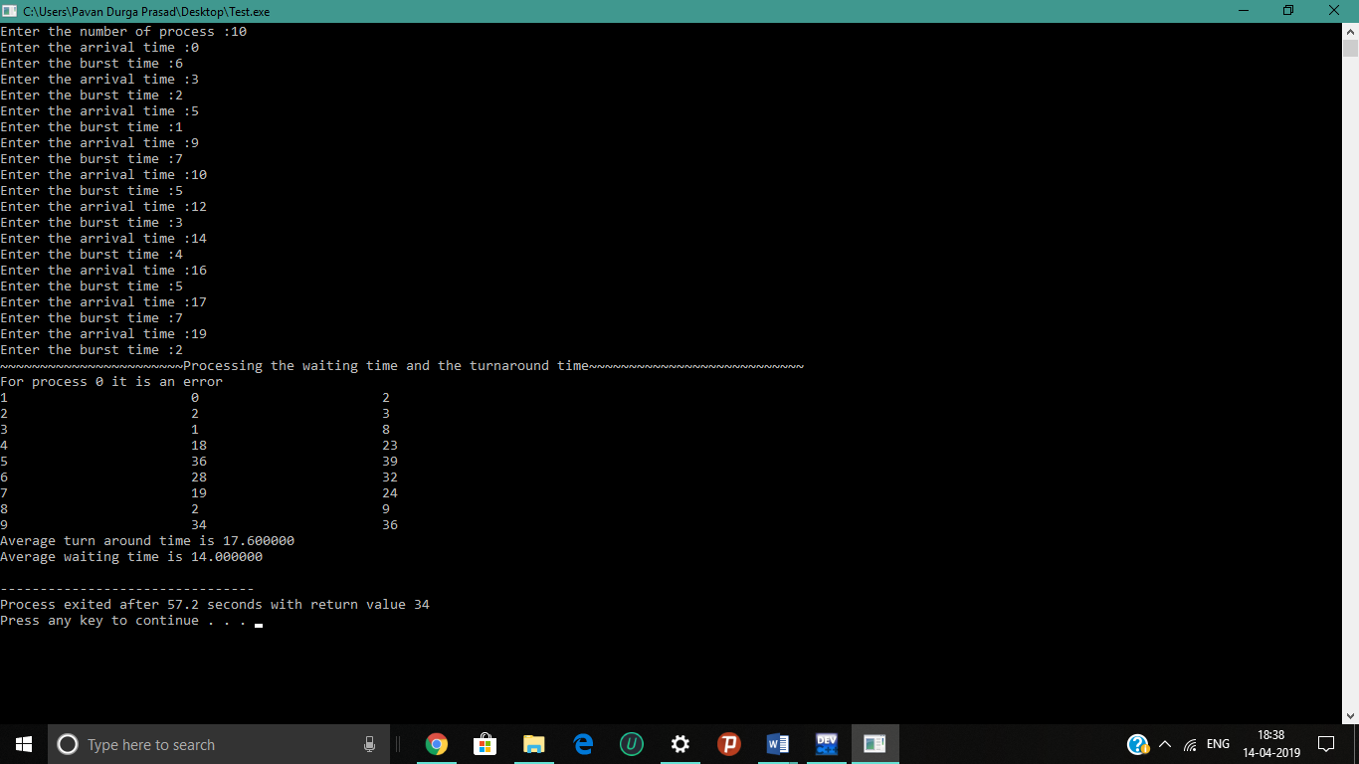

Test Cases:

