TrafficTelligence:  
Smart Traffic Volume Estimation using Machine Learning

**Submitted by:**  
PYLA TANUJA  
**Roll No:** 22Q71A0233  
Department of EEE  
Avanthi Institute of Engineering and Technology

**Team ID :**LTVIP2025TMID37717

**Introduction**

This project focuses on developing an TrafficTelligence assistant using IBM Granite, TrafficTelligence is a system that uses machine learning to predict traffic volume. It takes information like weather, temperature, date, and time to estimate how much traffic might be on the roads. This helps reduce traffic jams and supports smart city planning.

**Overview**

TrafficTelligence is a machine learning-based system designed to estimate and predict traffic volume with high accuracy. It analyzes historical traffic data along with environmental and temporal factors (like weather, holidays, and time) to produce intelligent forecasts. This system supports traffic authorities, urban planners, and daily commuters in making smarter decisions.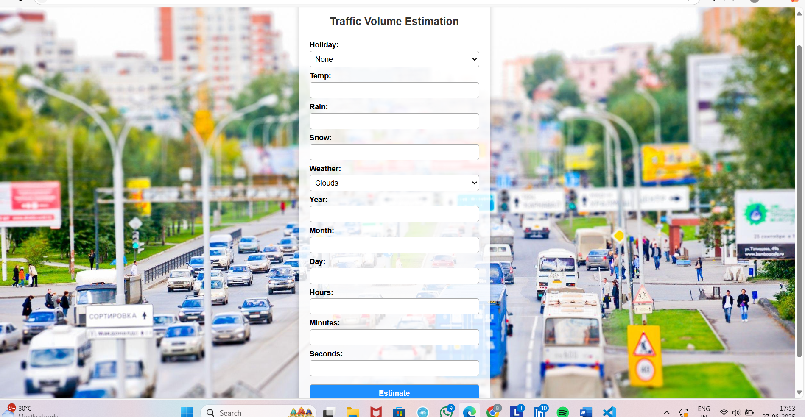

**Pre-requisites**

To build and run this project, basic understanding of the following is required:

* Python programming
* Machine Learning concepts (regression, feature scaling, etc.)
* Flask web framework
* HTML/CSS basics

**Required Python Packages**

Install these packages using Anaconda Prompt or terminal:

pip install numpy

pip install pandas

pip install matplotlib

pip install scikit-learn

pip install Flask

pip install xgboost

**Project Objectives**

* Identify if the problem is regression or classification.
* Clean and pre-process traffic datasets.
* Visualize data and extract insights.
* Apply and train suitable machine learning algorithms.
* Evaluate model accuracy.
* Integrate model with a web application using Flask.

**Project Flow**

1. User Input via Web Form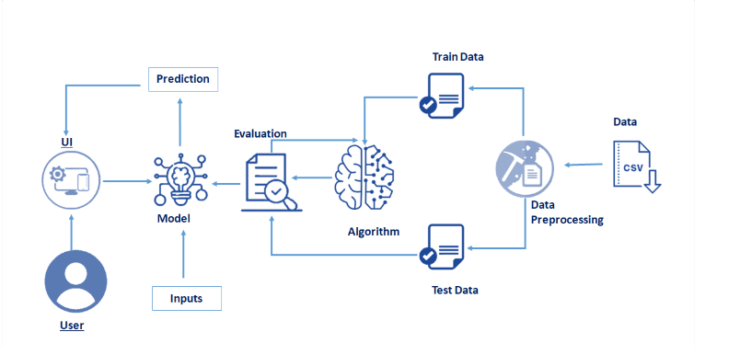

2. Input Processed by Machine Learning Model

3. Prediction Displayed on Web Interface

**Project Structure**

traffic_volume_app/

- app.py - model.pkl

- static/

- 3994546.jpg

- templates/

- index.html

**Data Collection and Pre-processing**

1. Collect Dataset: -

Use traffic data from public datasets (e.g., UCI, Kaggle).

1. Preprocessing Steps: -

**Import libraries**

- Load dataset using pandas

- Handle missing/null values

- Analyze data trends

- Normalize features with scaling

- Split data into training and testing sets

**Model Building**

- Use algorithms like Linear Regression or XGBoost

- Train model on historical traffic patterns

**Application Building**

- Frontend: Simple HTML form (index.html)

- Backend: Flask script (app.py)

- Output: Predicted traffic volume shown on screen

**Example Scenarios**

**Scenario1**: Dynamic Traffic Management Authorities use real-time predictions to optimize signal timings, reduce congestion, and manage lane control dynamically.

**Scenario 2**: Urban Planning Planners design road networks and public transport systems based on long-term traffic forecasts.

**Scenario 3**: Commuter Navigation Apps and drivers receive real-time predictions and reroute to avoid congested areas.

**Technical Architecture**

- Data Pipeline: Load and clean data

- Model: ML trained on historic + environmental features

- Web App: Flask handles requests and renders results

- UI: HTML + CSS with transparent design

**Conclusion and Future Work**

This project shows that we can use AI to predict traffic. In the future, we can use real-time data, show graphs, use a real model, and even create a mobile version.