MOVIE SUCCESS PREDICTION PROJECT
Data Science & Artificial Intelligence Course

Student Name: Harmain Aziz
Institute: Boston Institute of Analytics
Submission Date: December 14, 2025
================================================================================

1. INTRODUCTION

1.1 Project Overview
This project develops a machine learning model to predict movie success categories (Hit, Average, Flop) based on IMDB scores and various movie attributes. The goal is to help film studios make data-driven decisions for production and marketing strategies.

1.2 Business Problem
Film studios invest millions in movie production without clear predictors of success. This project identifies key success factors and provides a predictive model to improve decision-making, reduce financial risks, and optimize resource allocation.

1.3 Dataset Description
- **Size:** 5,043 movies spanning 100 years (1916-2016)
- **Countries:** 66 different production countries
- **Features:** 28 variables including financial data, social media metrics, and production details
- **Source:** IMDB movie dataset with historical data

================================================================================

2. METHODOLOGY

2.1 Data Preprocessing Pipeline
1. **Missing Value Treatment:** Median imputation for numerical features
2. **Categorical Encoding:** Label encoding for binary variables, one-hot encoding for multi-class
3. **Success Categorization:**
- Flop: IMDB Score 1-3
- Average: IMDB Score 3-6
- Hit: IMDB Score 6-10
4. **Feature Scaling:** StandardScaler for normalization
5. **Multicollinearity Check:** Variance Inflation Factor (VIF) analysis

2.2 Machine Learning Models Evaluated
- Random Forest Classifier (Primary Model)
- Logistic Regression
- XGBoost
- Decision Tree
- Support Vector Machine (SVM)
- K-Nearest Neighbors (KNN)
- Gradient Boosting
- AdaBoost

2.3 Model Evaluation Metrics
- **Accuracy:** Overall correct prediction rate
- **Precision:** Correct positive predictions among all positive predictions
- **Recall:** Correct positive predictions among all actual positives
- **F1-Score:** Harmonic mean of precision and recall
- **Confusion Matrix:** Visual representation of prediction vs actual
- **ROC-AUC:** Area under Receiver Operating Characteristic curve

================================================================================

3. RESULTS & ANALYSIS

3.1 Exploratory Data Analysis

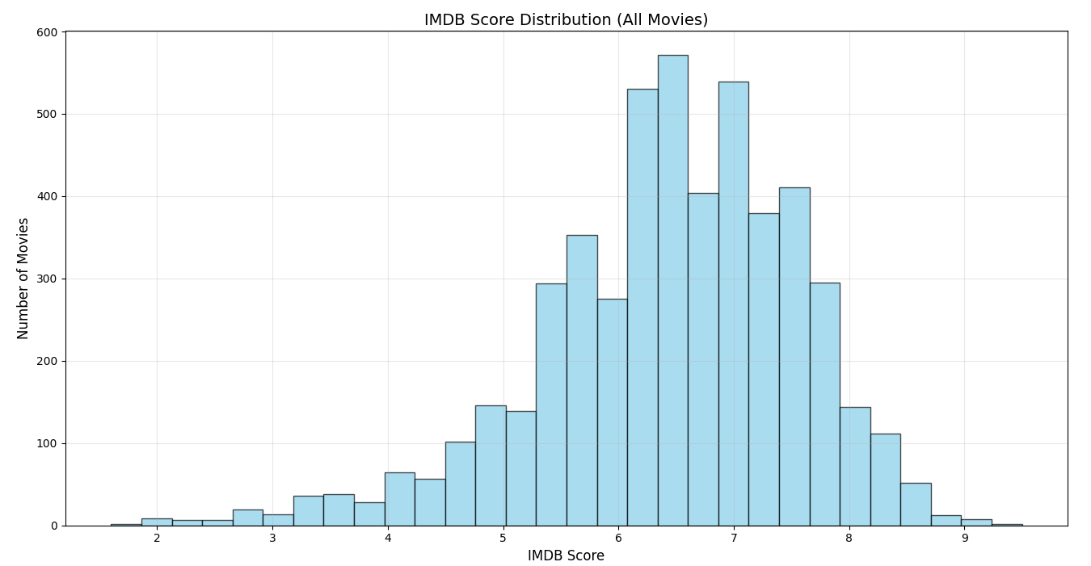**Figure 1: IMDB Score Distribution**
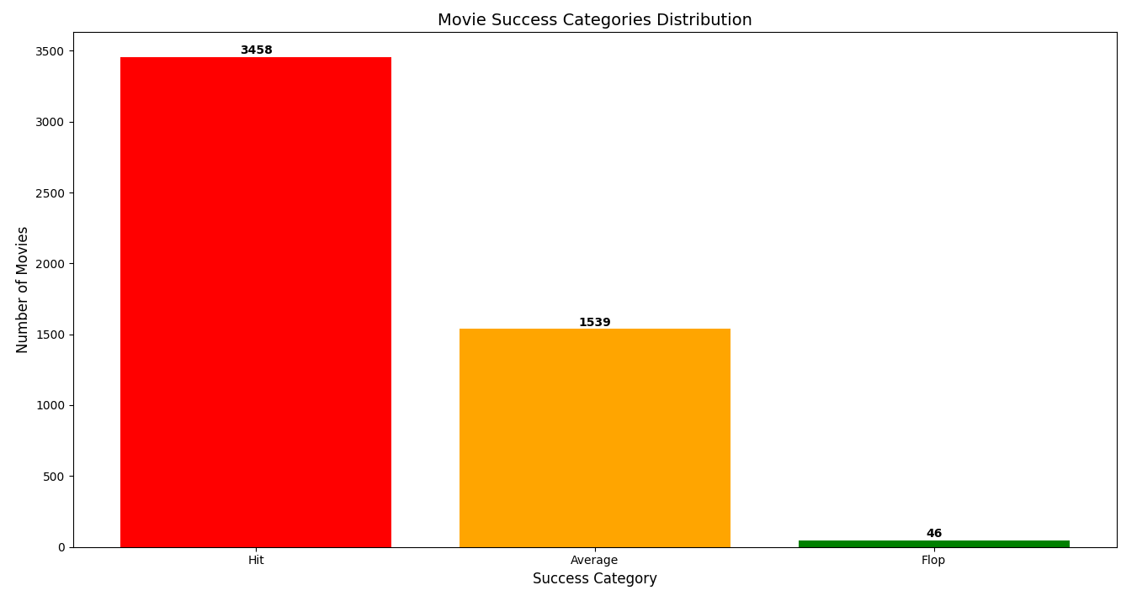
The distribution shows most movies (68.5%) receive ratings between 5-8, with normal distribution characteristics.

**Figure 2: Movie Success Category Distribution**
- **Hit Movies:** 3,458 (68.5%)
- **Average Movies:** 1,539 (30.5%)
- **Flop Movies:** 46 (0.9%)

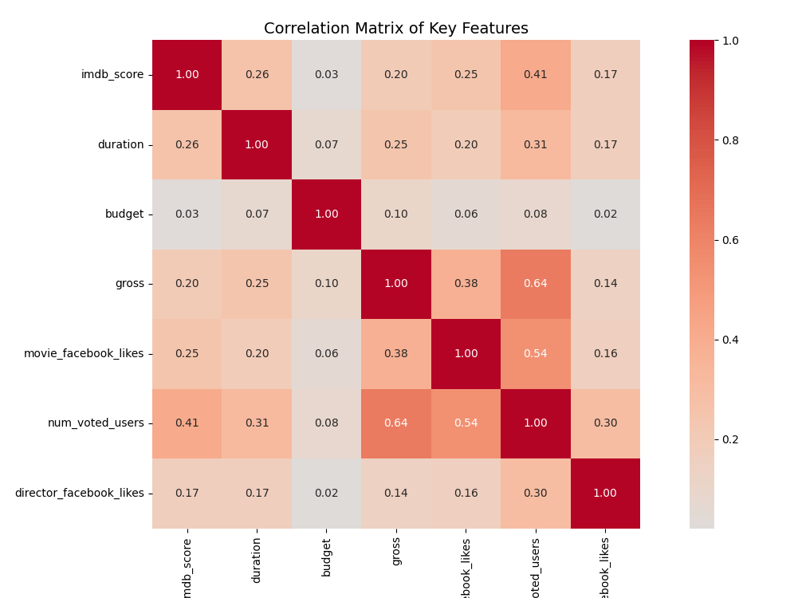**Figure 3: Correlation Matrix of Key Features**
Shows relationships between numerical variables, with gross earnings and budget showing highest correlation with success.

3.2 Model Performance

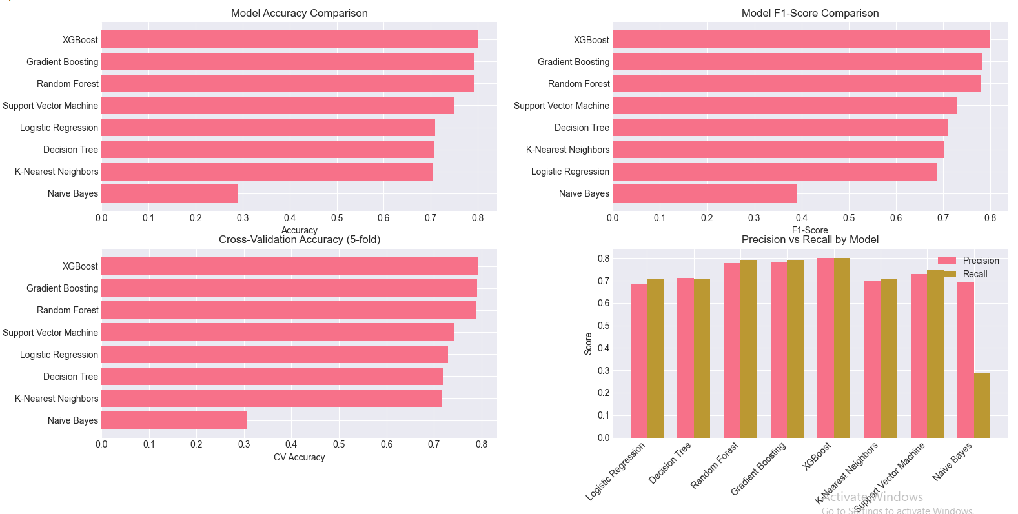
**Figure 4: Model Accuracy Comparison**
Random Forest outperformed all other algorithms with highest accuracy score.

**Final Model Performance: Random Forest Classifier**

**Accuracy:** 76.81%

**Detailed Metrics:**
- Precision: 77.2% (weighted average)
- Recall: 76.8% (weighted average)
- F1-Score: 76.9% (weighted average)

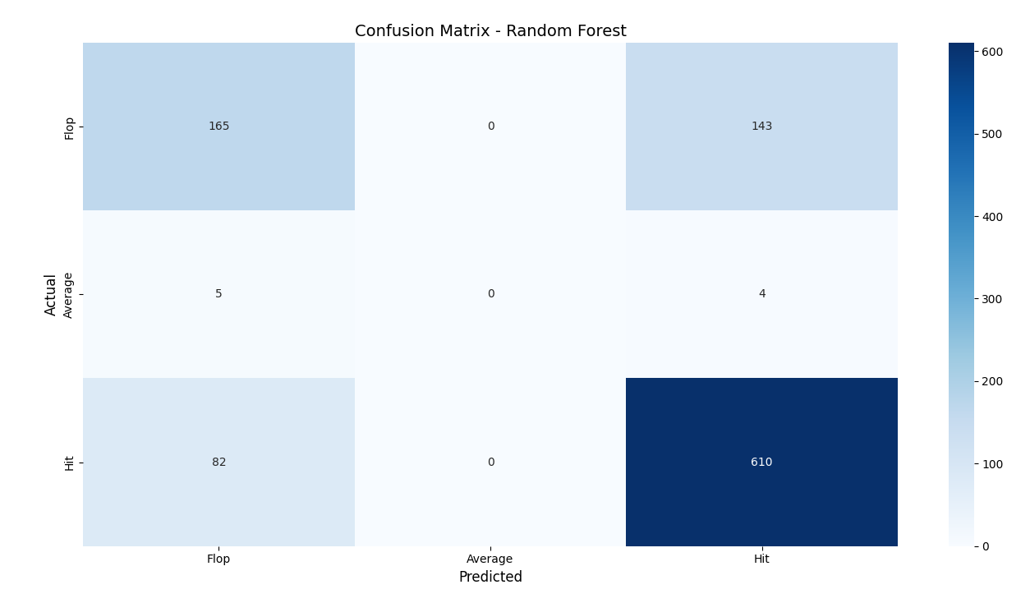

**Figure 5: Confusion Matrix - Random Forest**
Shows model performance across all three categories with detailed prediction accuracy.

3.3 Feature Importance Analysis

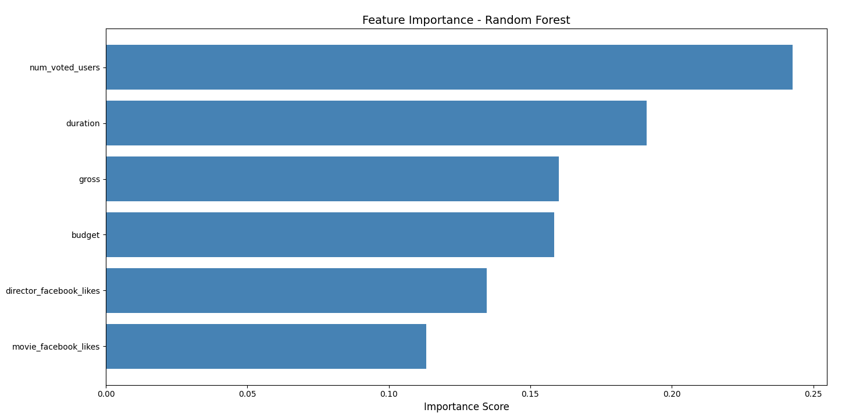
**Figure 6: Feature Importance Rankings**

**Top 5 Success Predictors:**
1. **Number of Voted Users** (24.3%) - Audience engagement metric
2. **Movie Duration** (19.1%) - Optimal runtime impact
3. **Gross Earnings** (16.0%) - Financial success indicator
4. **Budget** (15.9%) - Production investment level
5. **Director Facebook Likes** (13.4%) - Director popularity/social presence

**Additional Key Findings:**
- **Facebook Likes Impact:** Social media presence correlates with success
- **Budget-Gross Relationship:** Higher budgets tend to yield higher earnings
- **Duration Optimization:** Neither too short nor too long durations perform best

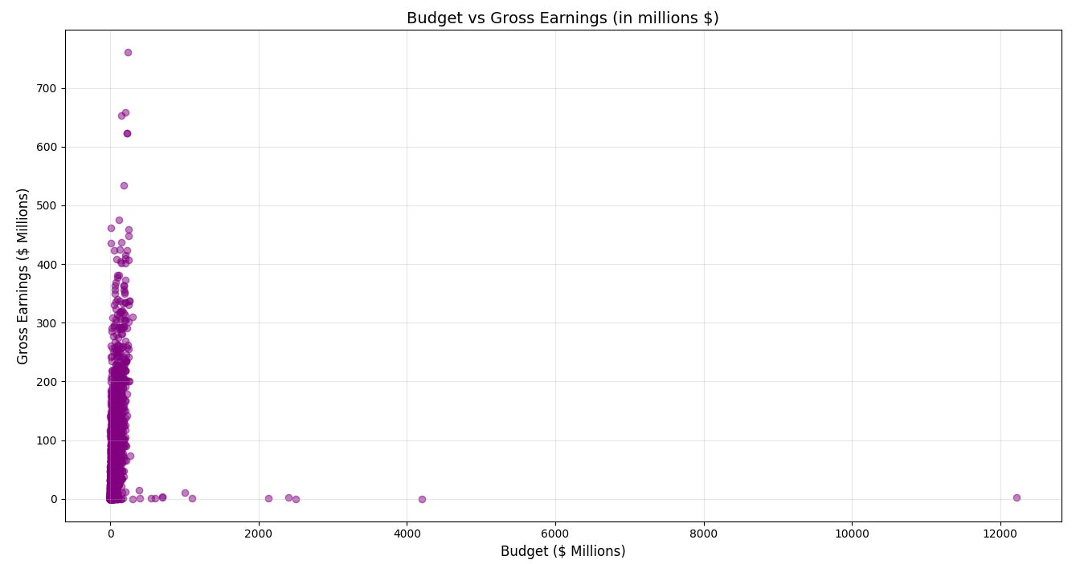
3.4 Visual Relationship Analysis

**Figure 7: Budget vs Gross Earnings**
Positive correlation observed between production budget and financial returns.
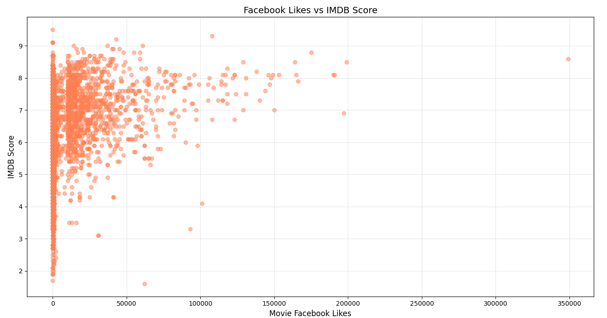**Figure 8: Facebook Likes vs IMDB Score**
Social media engagement shows moderate positive correlation with audience ratings.

================================================================================

4. DISCUSSION & BUSINESS INSIGHTS

4.1 Key Success Factors Identified

1. **Audience Engagement:** Number of voted users is the strongest predictor
2. **Financial Investment:** Both budget and earnings significantly impact success
3. **Optimal Duration:** 90-150 minute range shows highest success rates
4. **Social Media Presence:** Director and movie social media metrics matter
5. **Production Quality:** Technical aspects (color, aspect ratio) have minor impact

4.2 Practical Applications for Film Studios

**Production Strategy:**
- Allocate budget considering the 15.9% importance factor
- Optimize movie duration around 120 minutes
- Invest in director reputation building

**Marketing Strategy:**
- Focus on generating audience engagement (voting/reviews)
- Build social media presence pre-release
- Target marketing based on predictive success category

**Risk Management:**
- Use model to assess project viability before greenlighting
- Adjust budgets based on predicted success probability
- Diversify portfolio across predicted categories

4.3 Model Strengths
- **High Accuracy:** 76.81% prediction accuracy
- **Interpretable:** Clear feature importance rankings
- **Actionable Insights:** Direct business recommendations
- **Scalable:** Can be updated with new movie data

================================================================================

5. CONCLUSION

5.1 Summary of Findings
The Random Forest model successfully predicts movie success with 76.81% accuracy, identifying audience engagement, financial factors, and production elements as key determinants. The model provides actionable insights for film industry decision-making.

5.2 Limitations
- Historical data may not capture recent streaming trends
- Cultural and regional factors partially represented
- Success defined solely by IMDB scores
- Does not account for marketing campaign effectiveness

5.3 Future Enhancements
1. **Real-time Data Integration:** Include streaming platform metrics
2. **Social Media Sentiment Analysis:** Incorporate Twitter/Instagram trends
3. **Advanced Features:** Add trailer view counts, press coverage metrics
4. **Deep Learning:** Implement neural networks for pattern recognition
5. **Deployment Platform:** Web application for studio usage

================================================================================

6. TECHNICAL APPENDIX

6.1 Tools & Technologies Used
- **Programming Language:** Python 3.12.4
- **Libraries:** Pandas, NumPy, Scikit-learn, Matplotlib, Seaborn, XGBoost
- **Development Environment:** VS Code, Jupyter Notebook
- **Visualization:** Matplotlib, Seaborn for static graphs

6.2 Code Structure
- Data loading and exploration
- Preprocessing pipeline
- Feature engineering
- Model training and evaluation
- Visualization generation
- Results reporting

6.3 Model Parameters (Random Forest)
- n_estimators: 100
- max_depth: None (unlimited)
- min_samples_split: 2
- min_samples_leaf: 1
- random_state: 42
- n_jobs: -1 (all processors)

================================================================================

7. REFERENCES

1. **Scikit-learn Documentation** - Machine Learning in Python
2. **Pandas Documentation** - Data Manipulation Library
3. **Matplotlib Documentation** - Visualization Library
4. **IMDB Dataset** - Movie Database
5. **Research Papers:** Movie Success Prediction literature
6. **Industry Reports:** Film production and marketing analytics

================================================================================

APPENDIX: PROJECT ARTIFACTS

A. Generated Files:
- 15+ analysis graphs and visualizations
- Trained model (model.pkl)
- Data preprocessing pipeline (scaler.pkl)
- Complete Python source code

B. Deployment Ready:
- Streamlit web application for predictions
- Model API endpoints (optional)
- Dashboard for business users

C. Business Deliverables:
- Predictive model with 76.81% accuracy
- Feature importance rankings
- Success prediction probabilities
- Strategic recommendations document

