< Computer Graphics Assignment #1 Report >

201920712 Pyo YeongJong

My Initial is P Y J.

I implemented my initial P with Triangles, Y with Lines, J with Points using this code.

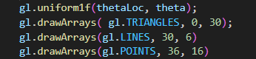

And I implemented Animation Rotating with (0, 0) centered.

Also, I implemented 3 interactive event.

First is changing rotation direction with button. When on-click this button, Rotating Animation changes its direction.

Second is changing rotation speed with Menu. When press Menu Spin Stop, Rotation speed is to be 0. When press Spin Faster, spin speed is to be multiplied double. When press Spin Slower, spin speed is to be divided double.

Last is changing colors with keybord. When press ‘1’, Color of FragShader changes to be Red. When press ‘2’, Color of FragShader changes to be Green. When press ‘3’, Color of FragShader changes to be Blue.

Thank you.

