Sales and Distribution (SD)Case Study

标题/题目：销售模块 实战模拟/情景练习
- 门/姓名：第 01组；潘羽&郭超政/
- 日期/联系方式：2018-06-01 panyuyuyu@outlook.com gchaozheng@163.com

提醒：使用GBI2.4实验手册！
注：要将报告三要素：①②③改为自己的相关信息

- 个人代码###:( 032 )
重要提示: 1, MM/SD/PP 使用同一“个人代码”； 2，抄袭/拷贝实验报告，没有成绩

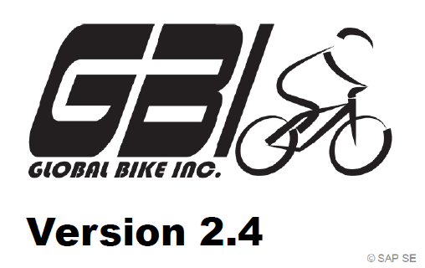
After you have successfully worked through the SD CASE STUDY,
you should be able to solve the following task on your own.

Scenario/ 销售业务“实战模拟”案例背景
Scenario Your customer The Bike Zone wishes to profit/受益 from your new initiative/促销/新举措, which promises one free off-road helmet for each mountain bike ordered. Please note that off-road helmets belong to a different division/产品系列. Notice that you thus ① need to expand the rights of your customer The Bike Zone to the effect (需要扩展客户的采购权限) that the company can release cross-division orders (使公司可以处理跨产品系列订单) for the division’ accessories and cross division. Subsequently, please ② order five mountain bikes for men， and five mountain bikes for women ，and ten off-road helmets in the role of The Bike Zone (以客户的身份). Please change the order probabilities for both mountain bikes to 70% (from 30%), and the order probability for the off-road helmets to 100% (from 30%), since they are added to the order for free.
Since The Bike Zone is a long-term customer, ③ the company gets/quotes 50$ discount on each ordered mountain bike， and an additional discount of 3% of the gross price for the complete or entire purchase order.

注：请选择“相应模块”，记录业务过程。如有“适当调整”，请做出相应文字说明。

SD实战模拟/情景模拟，评价参考：
（1）主要步骤“截屏”；（2）记录模块“执行结果”系统信息；（3）适当“文字说明”
以小组为单位（2-3人/不接受个人提交），下课前完成

采用“扣分制”，缺失“扣分点截屏”，扣5分；缺失主要步骤，“酌情扣减”

1，要求：截屏“销售范围定义”(关键环节)，70
2，要求：截屏调整转换概率后的“Create Inquiry: Overview”，75
3，要求：截屏/打印“报价单Quotation” ★，80，With Logo 
4，要求：截屏/打印“销售订单Order Confirmation”★，85，With Logo
5，要求：截屏/打印“销售发票Invoice”★, 90，With Logo
6，要求：截屏“凭证流Document Flow”，95
注：介于知识点70，80，90之间，酌情扣减

特别提醒/要求：
1，以“报告三要素”为准；
2，以“原文件名”为准（不要重命名）
3，“截屏”要求使用“局部截屏，全屏截屏扣减
4，在模板相应模块下编辑实验报告（以指定模块为准）

V2.4P142.
Step1,V2.1P108,SD 9: Create New Customer 0创建客户
Logistics ► Sales and Distribution ► Master Data ► Business
Partner ► Customer ► Create ► Complete
Trans Code/交易码：…VD02….…；部门：…各部门.……；身份：管理人员….……
新建客户信息改为cross division(00)
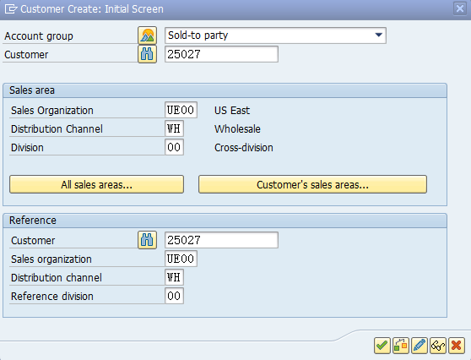

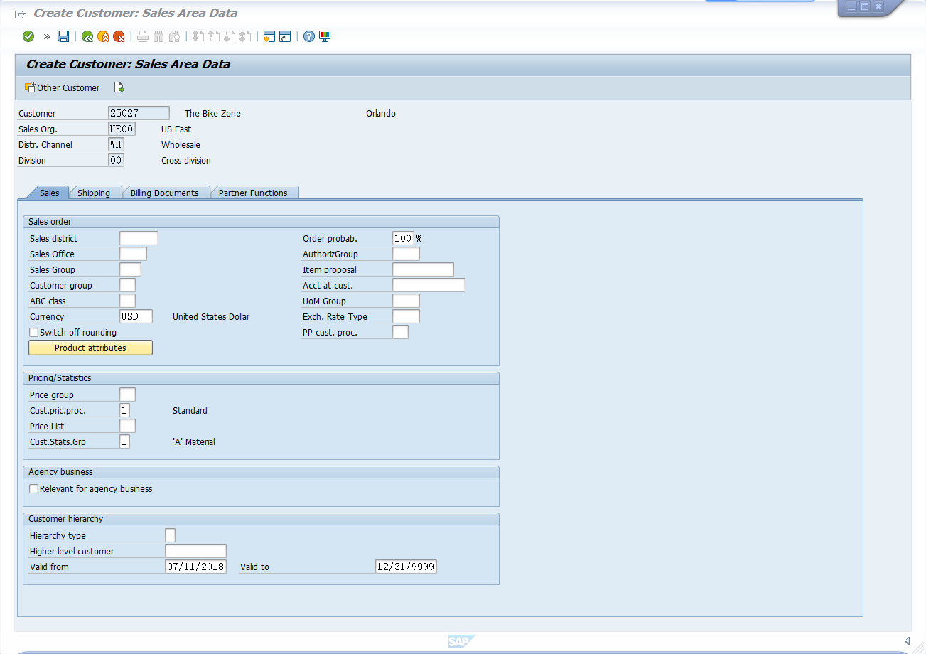

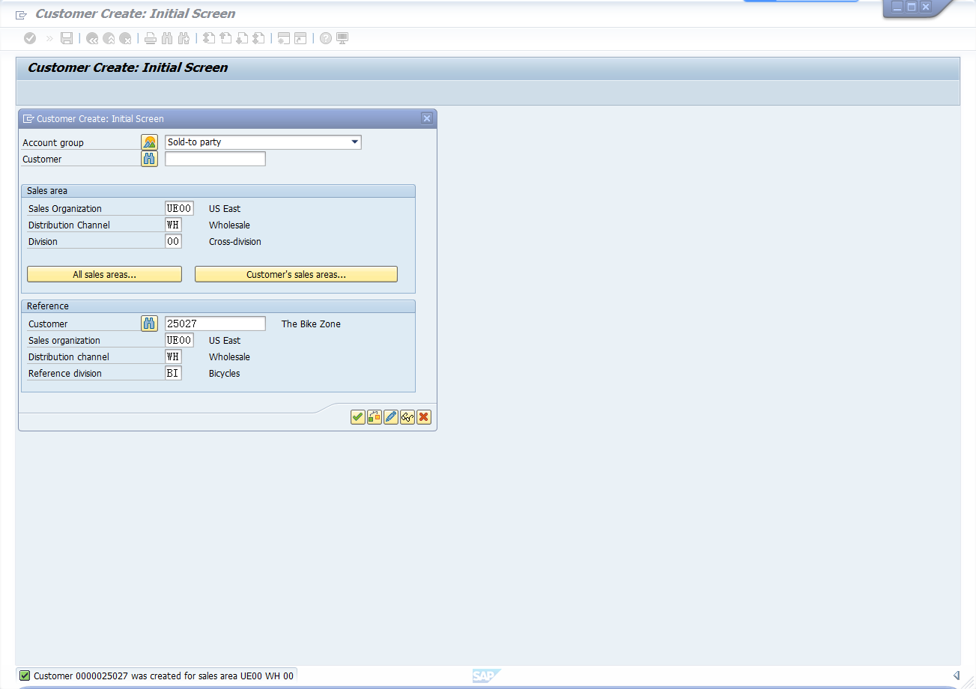

★补充介绍：“销售实战模拟”关键步骤一：
参考已经创建“销售范围”：UE00 + WH + BI
补充创建新的“销售范围”：UE00 + WH + 00, cross division (00) 定义“跨销售范围”
1，要求：截屏“销售范围定义”(关键环节)，70

方法：参考销售范围UE00 + WH + BI：创建销售范围UE00 + WH + 00, cross division (00)
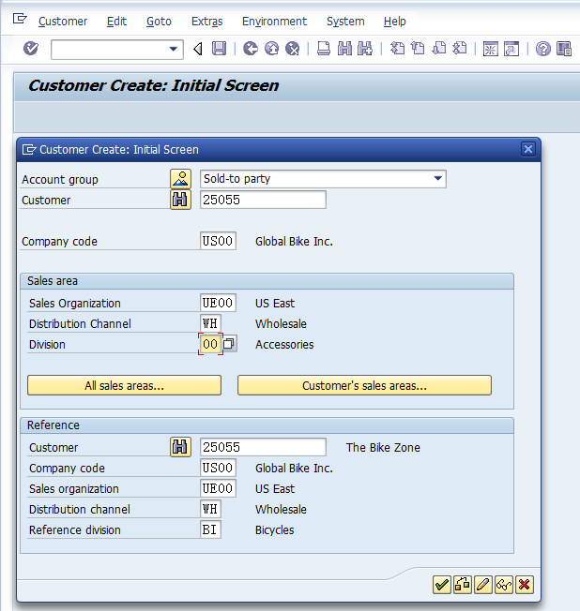
Save

注：参考/Reference, The Bike Zone （ 比如客户代码为：25055 ）数据，
补充创建新的“销售范围”：UE00 + WH + 00, cross division (00)

销售范围★： UE00 + WH + 00; cross division (00)，已创建

V2.4P146.
Step2,P111,SD 10: Create Contact Person for Customer
Logistics ► Sales and Distribution ► Master Data ► Business
Partner ► Contact Person ► Create
Trans Code/交易码：…….…；部门：….……；身份：….……

使用原有不需要操作

V2.4P148.
Step3,P113,SD 11: Change Customer
Logistics ► Sales and Distribution ► Master Data ► Business
Partner ► Customer ► Change ► Sales and Distribution
Trans Code/交易码：…….…；部门：….……；身份：….……

使用原有不需要操作

V2.4P150.
Step4,P115,SD 12: Create Customer Inquiry 0创建询价请求
Logistics ► Sales and Distribution ► Sales ► Inquiry ► Create
Trans Code/交易码：…….…；部门：….……；身份：….……
2，要求：截屏调整转换概率后的“Create Inquiry: Overview”，75（预期价值17650）

显示为00，跨域
调整70，70，100显示17，650
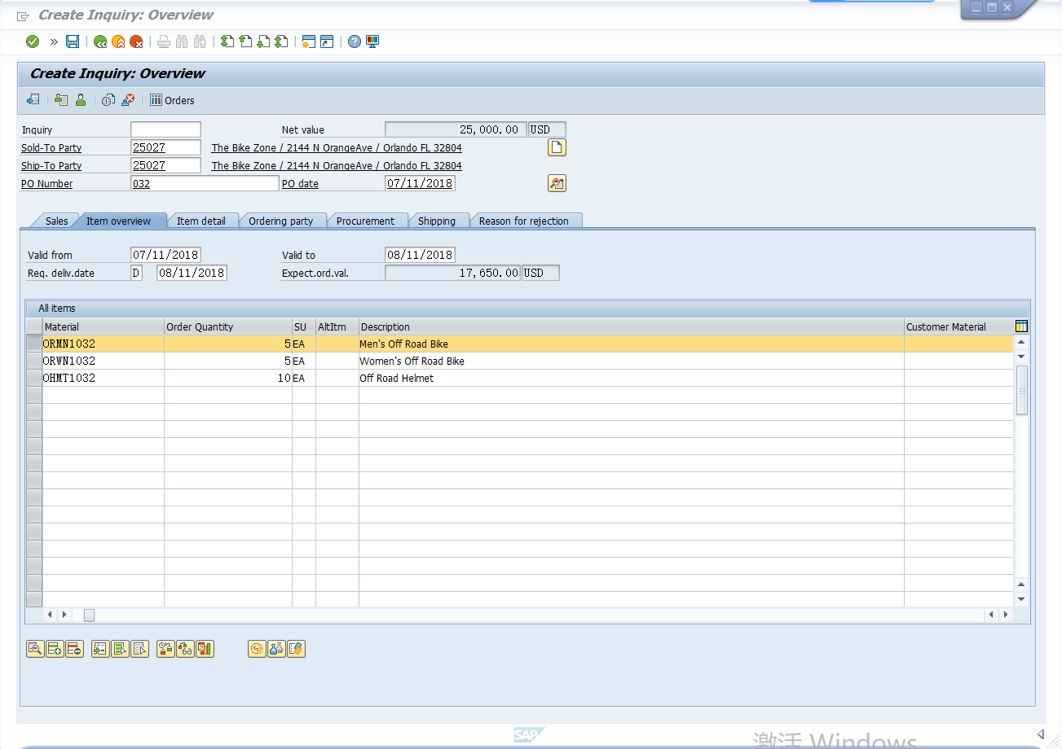
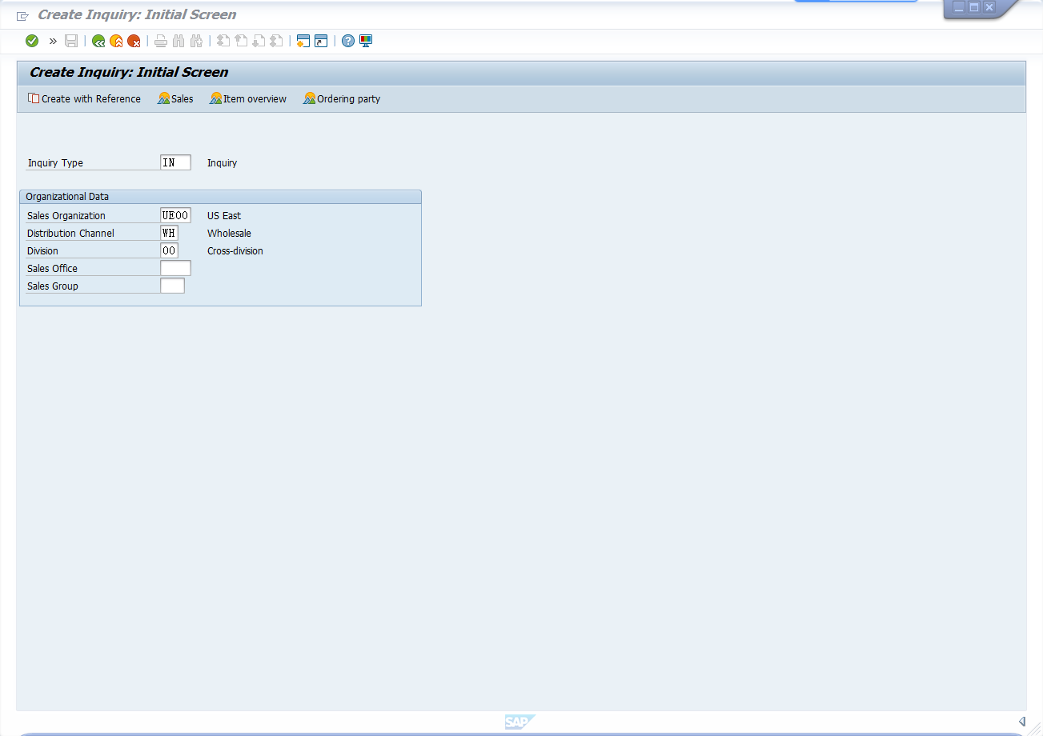

V2.4P154.
Step5,P119,SD 13: Create Customer Quotation 0创建报价 ★
Logistics ► Sales and Distribution ► Sales ► Quotation ► Create
This will
Trans Code/交易码：…….…；部门：….……；身份：….……
- 要求：截屏/打印“报价单Quotation” ★，80，With Logo

创建报价单

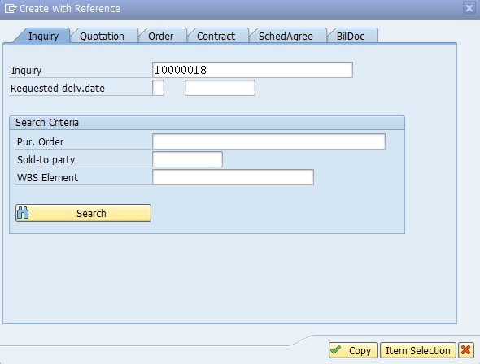

设置免费
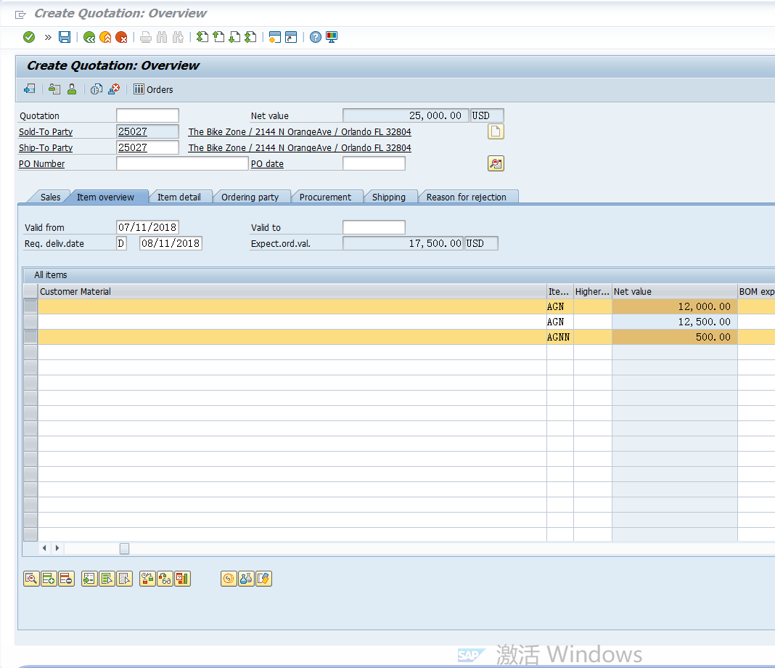

价格24000
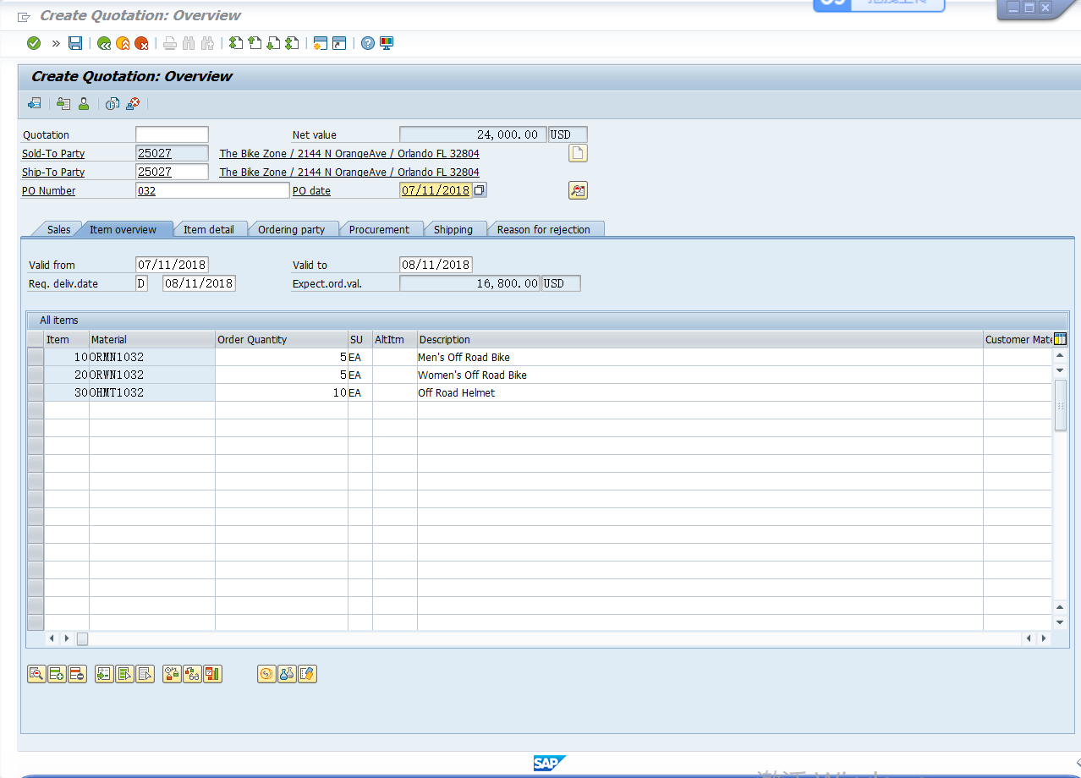

调整3%，符合23,280
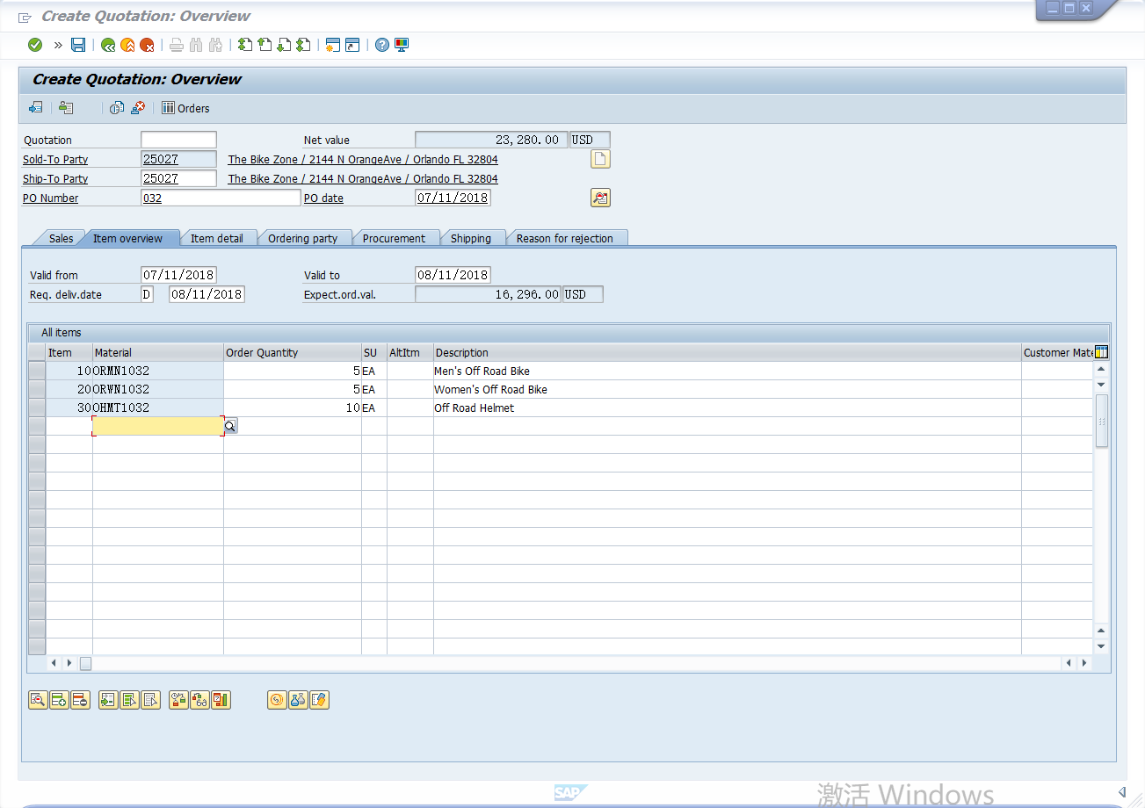

Print preview
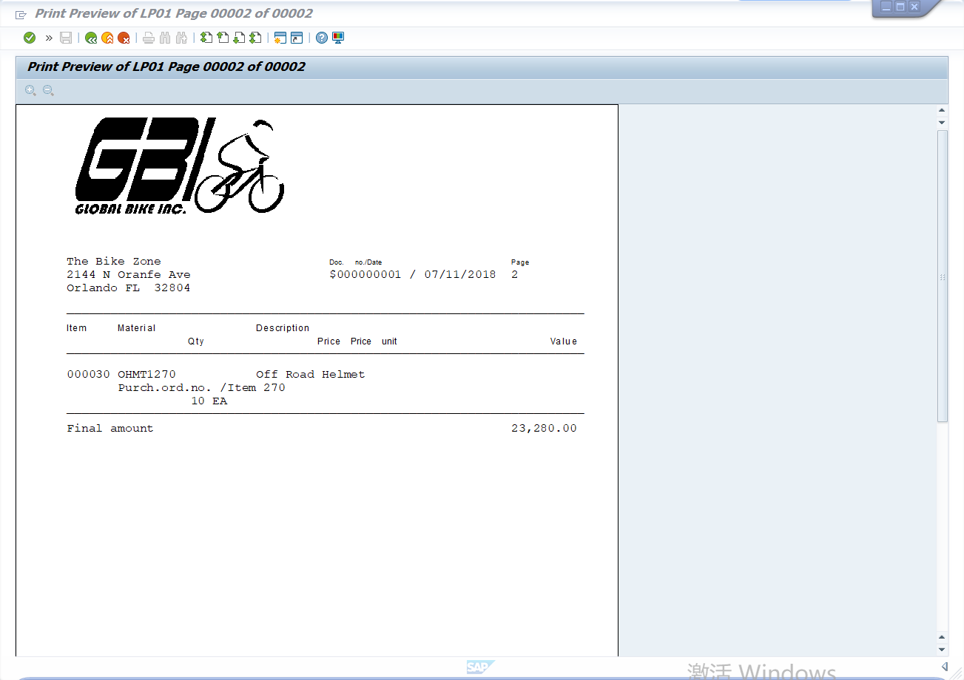

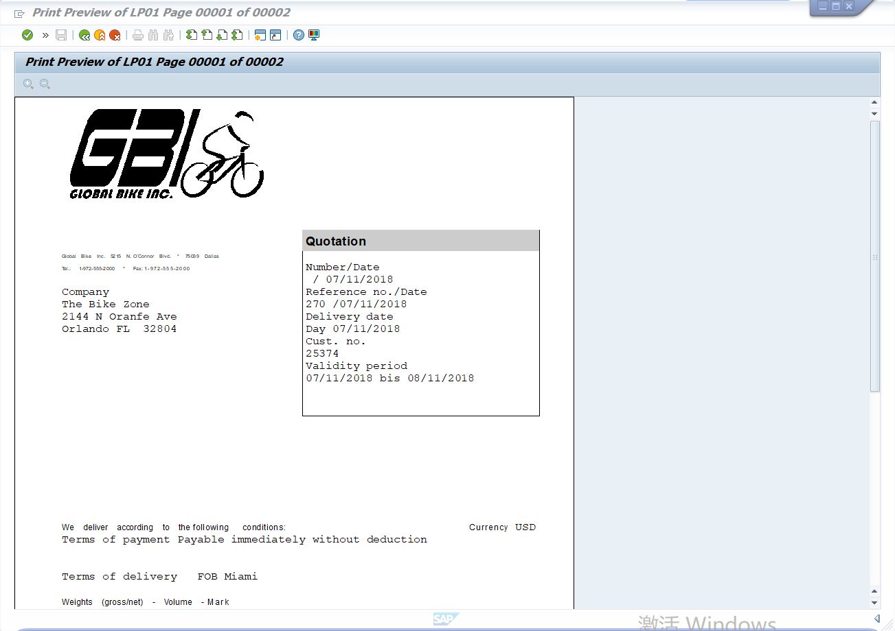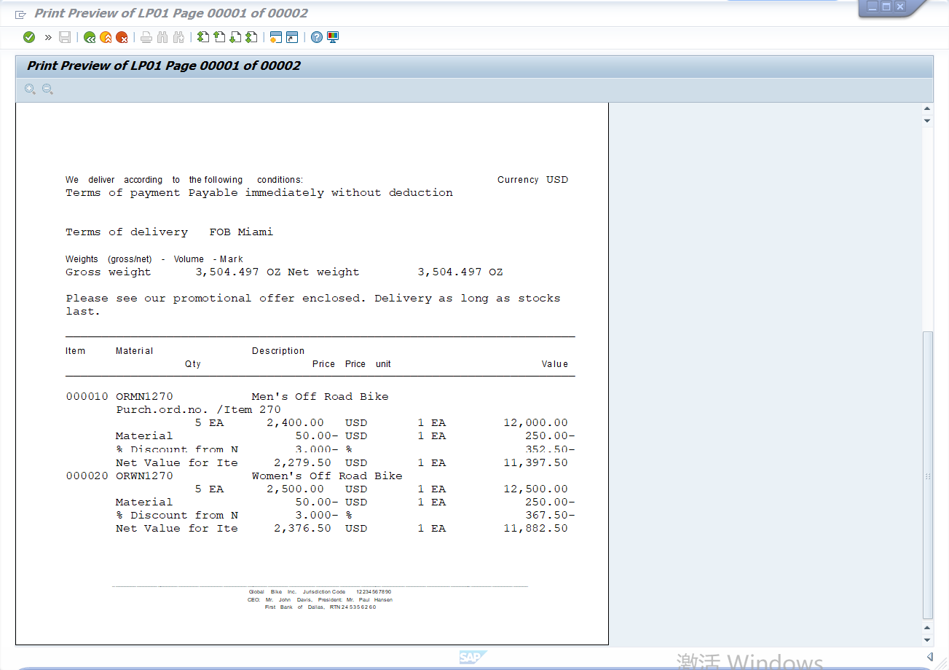

★补充介绍：“销售实战模拟”关键步骤二：
设置促销“免费”物料（赠品）；

报价操作一：设置10个 “免费” 头盔(“免费”物料)
要求：截屏设置：Item Category= AGNN （物料类型为“免费”）

报价操作二：设置ORMN1###, 和ORWN1###, 每个降价50
To grant $50.00 discount for each ordered mountain bike
要求：截屏“价格生效”

- ORMN1###: (单价2400 – 50) x 5 = 11,750
2，ORWN1###: (单价2500 – 50) x 5 = 12,250

报价操作三：设置整个订单优惠3%
To apply the 3% discount on the complete purchase order
Follow the menu path: Go To -> Header -> Conditions
要求：截屏“价格生效”

订单总价24000*（1-3%）=23,280

★ 特别提醒：
Quotation保存前，先Print Preview, 检查“报价单”总价，是否 =23,280 ？
如果总价不是23,280，说明“报价过程”存在错误！应放弃此次报价，重新报价！

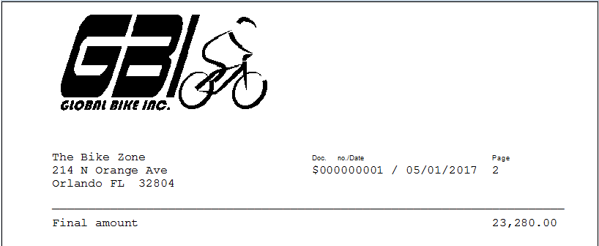
注：Quotation如果有多页的话，应该翻“下一页”

V2.4P159.
Step6,P124,SD 14: Create Sales Order Referencing a Quotation ①创建销售订单
Logistics ► Sales and Distribution ► Sales ► Order ► Create
Trans Code/交易码：…….…；部门：….……；身份：….……
4，要求：截屏/打印“销售订单Order Confirmation”★，85，With Logo

V2.4P161.
Step7,P126,SD 15: Check Stock Status
Logistics ► Materials Management ► Inventory Management ►
Environment ► Stock ► Stock Overview
Trans Code/交易码：…….…；部门：….……；身份：….……

V2.4P164.
Step8,P129,SD 16: Display Sales Order
Logistics ► Sales and Distribution ► Sales ► Order ► Display
Trans Code/交易码：…….…；部门：….……；身份：….……

V2.4P167.
Step9,P132,SD 17: Start Delivery Process ③创建发货通知
Logistics ► Sales and Distribution ► Shipping and Transportation
► Outbound Delivery ► Create ► Single Document ► With
Reference to Sales Order
Trans Code/交易码：…….…；部门：….……；身份：….……

V2.4P169.
Step10,P134,SD 18: Check Stock Status
Logistics ► Materials Management ► Inventory Management ►
Environment ► Stock ► Stock Overview
Trans Code/交易码：…….…；部门：….……；身份：….……

V2.4P171.
Step11,P136,SD 19: Pick Materials on Delivery Note ⑤分拣物料
Logistics ► Sales and Distribution ► Shipping and Transportation
► Outbound Delivery ► Change ► Single Document
Trans Code/交易码：…….…；部门：….……；身份：….……
Enter FG00 as Storage Location for the mountain bikes and TG00 as Storage Location for the off-road helmets. Furthermore, please enter the corresponding amounts for Picked Quantity (5 for ORWN1###, ORMN1### and 10 for OHMT1###).

V2.4P172.
Step12,P137,SD 20: Post Goods Issue ⑥销售发货GI
Logistics ► Sales and Distribution ► Shipping and Transportation
► Outbound Delivery ► Change ► Single Document
Trans Code/交易码：…….…；部门：….……；身份：….……

V2.4P173.
Step13,P138,SD 21: Check Stock Status
Logistics ► Materials Management ►Inventory Management ►
Environment ► Stock ► Stock Overview
Trans Code/交易码：…….…；部门：….……；身份：….……

V2.4P175.
Step14,P140,SD 22: Create Invoice for Customer ⑦创建发票
Logistics ► Sales and Distribution ► Billing ► Billing Document ►
Process Billing Due List
Trans Code/交易码：…….…；部门：….……；身份：….……
5，要求：截屏/打印“销售发票Invoice”★, 90，With Logo

V2.4P178.
Step15,P143,SD 23: Display Billing Document and Customer Invoice
Logistics ► Sales and Distribution ► Billing ► Billing Document ►
Display
Trans Code/交易码：…….…；部门：….……；身份：….……

V2.4P181.
Step16,P146,SD 24: Post Receipt of Customer Payment ⑧结算应收帐款
Accounting ► Financial Accounting ►Accounts Receivable ►
Document Entry ► Incoming Payments
Trans Code/交易码：…….…；部门：….……；身份：….……
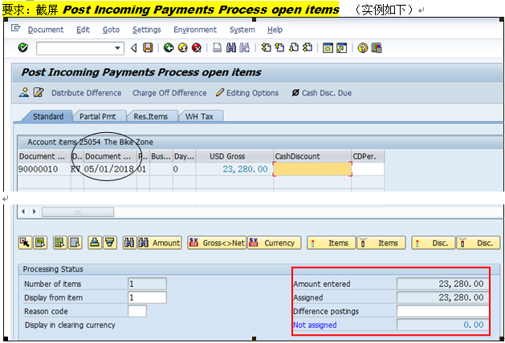
注：此截屏的Document Date应该为“情景练习”时间

V2.4P184.
Step17,P149,SD 25: Review Document Flow 凭证流/业务流概览
Logistics ► Sales and Distribution ► Sales ► Order ► Display
Trans Code/交易码：…….…；部门：….……；身份：….……
6，要求：截屏“凭证流Document Flow”，95

Document Flow “客户”凭证流/业务流概览 (Customer 25068事例)
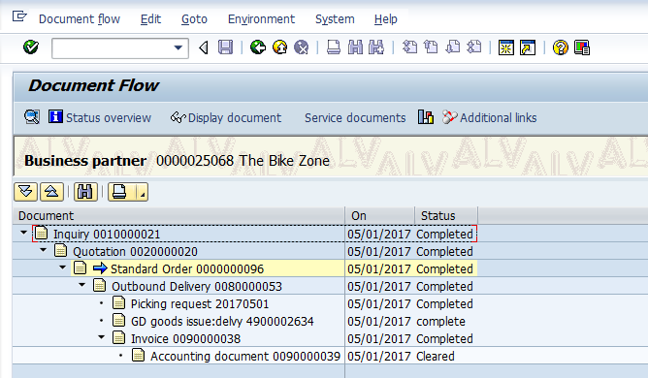
注：按客户显示的“凭证流”，其日期应该为05/28/2018

销售模块实验总结/感受：
1、

2、

3、

。。。。。。

