  - CS6208 Homework 2

1. Introduction
We study one round of tiny_hana, a two-player zero-sum game in which players make decisions without knowing all the cards held by their opponent. A win gives a payoff of +1, a loss gives −1, and an unresolved round gives 0. In the default game, each player has an equal chance of starting, with 2,757 information sets and 3,672 sequences per player. Our goal is to find strategies that are close to a Nash equilibrium and compare how much computation different methods require.
We investigate two approaches to solving the game. First, we compare counterfactual regret minimization (CFR), Fictitious Play (FP), and Double Oracle (DO), using sequence-form linear programming (LP) as a numerical reference. This allows us to compare their convergence, equilibrium accuracy, and computation time. Second, we test whether changes to regret matching, strategy averaging, and player update order improve CFR's convergence.

2. Game Representation and Equilibrium Measurement
Our implementation computes posterior probabilities over hidden game states that are consistent with a player's observations. These probabilities account for chance events and the opponent's actions. This allows us to reason about the hidden information available during play.
We represent each player's strategy using a realization plan, which specifies the probability of reaching each sequence of that player's own actions. The probabilities must satisfy the sequence-form flow constraints at every information set. Let (x) and (y) denote the two players' realization plans and let (A) be the chance-weighted payoff matrix for Player 1. The expected payoff is xᵀAy. We compute best responses using the sequence-form representation.
We measure equilibrium accuracy using the saddle-point residual (SPR).
$$\text{SPR}(x,y) = {\text{max}}_{x'} x'ᵀAy - {\text{min}}_{y'} xᵀAy'$$
Here, (X) and (Y) are the sets of valid realization plans. The first term is the highest payoff Player 1 can obtain against Player 2's strategy. The second term is the lowest payoff Player 2 can force against Player 1's strategy. Their difference measures the total possible improvement from unilateral deviations. A small SPR means neither player can gain much by changing their strategy alone. We use the full residual without dividing it by two.
We implement CFR to compute averaged strategies and use LP to compute the submitted Nash strategies. The saved policies in nash_p1.npz and nash_p2.npz are obtained from LP and have a measured SPR of 6.94 × 10⁻¹⁸. The CFR+ strategies evaluated later are separate experimental outputs.

3. Methods and experimental setup
CFR [1] uses regret matching at each information set. At each iteration, it compares the value of each available action with the expected value of the current strategy and accumulates the differences as regrets. Actions with positive cumulative regret receive higher probabilities. If no action has positive regret, CFR assigns equal probabilities. We average the resulting sequence-form realization plans across iterations to obtain the strategy used for equilibrium evaluation.
Fictitious Play [2] repeatedly computes a best response to the opponent's average strategy and updates its own average strategy. Our implementation starts with a uniform strategy as the initial observation. Double Oracle [3] maintains a smaller set of candidate strategies for each player. It solves the restricted game using LP, finds best responses in the full game, and adds them to the candidate sets. These methods allow us to compare local regret updates with repeated full-game best responses.
We also solve each game setup using sequence-form LP [4]. LP directly finds equilibrium strategies by optimizing over realization plans that satisfy the sequence-form constraints. We check that the two players' optimization results agree on the game value and that the resulting strategies have low SPR. This provides a numerical reference for evaluating CFR, FP, and DO. LP uses the same game representation and payoff matrix. We separately compare sequence-form payoffs with payoffs calculated by the game engine to check the underlying payoff calculations.
We test five CFR configurations to examine the effects of regret clipping, strategy averaging, and alternating updates.
Method | Regrets | Average | Updates
CFR | Signed | Uniform | Simultaneous
CFR-linear | Signed | Linear | Simultaneous
RM+ | Nonnegative | Uniform | Simultaneous
RM+-linear | Nonnegative | Linear | Simultaneous
CFR+ | Nonnegative | Linear | Alternating
Table 1. The five CFR configurations used in the experiments.
With RM+, negative cumulative regrets are replaced by zero after each update, following R ← max(R + r, 0) where (r) is the new regret. Linear averaging gives greater weight to strategies from later iterations, using iteration number (t) as the weight. The regret updates themselves are not linearly weighted. In the alternating CFR+ configuration [5], Player 1 updates first and Player 2 then updates against Player 1's refreshed strategy. All five configurations average the realization plans formed before the iteration's regret updates. The first four configurations compare clipping and averaging, while the fifth examines the additional effect of alternating updates.
We run each iterative method for 20,000 iterations with three repetitions. For the Nash solver comparison, we use four game setups. These are a random starting player with neutral favors, Player 1 starting, Player 2 starting, and Player 1 starting with G3 favor. This produces 36 complete runs. For the CFR configurations, we use three game setups, each with a random starting player. The neutral setup has no favors. The advantage setup gives Player 1 the G1 favor. The contested setup gives Player 1 G1 and Player 2 G3. This produces 45 complete runs with 14 recorded checkpoints per run.
We compare methods using SPR and elapsed computation time because different algorithms perform different amounts of work per iteration. In the Nash solver experiments, time includes solver updates, SPR evaluation, and recording the intermediate results. In the CFR configuration experiments, time is accumulated across the solver calls used to reach the checkpoints. Initial game-tree construction and file exports are excluded. LP is timed separately. Because the two experiments use different timing procedures, we compare runtimes within each experiment rather than directly across them.

4. Correctness verification
All 60-unit tests pass, and all four task notebooks execute successfully. We check posterior probabilities against known hidden-state probabilities, compare best-response and payoff calculations with exhaustive small-game calculations, and test solver behavior on games with known equilibria. We also test regret updates, strategy averaging, alternating updates, and the validity of realization plans.
To check the payoff representation, we compare expected payoffs computed from the game engine and from sequence form. The maximum recorded difference is 2.78 × 10⁻¹⁷. We also verify the submitted Nash strategies through best-response SPR calculations and confirm that all 36 Nash solver histories and 630 CFR checkpoint observations follow the experimental settings. Together, these checks support the correctness of the implementations and the recorded results.

5. Comparing Nash Solvers
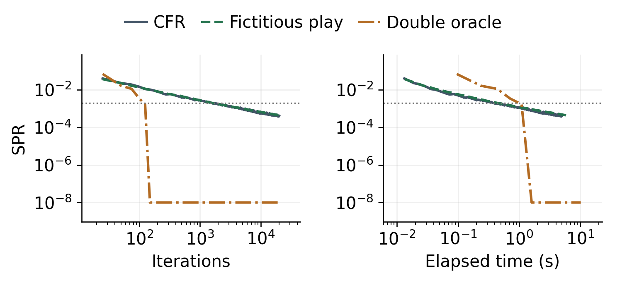
Figure 1. SPR against iterations and elapsed time in the neutral game. Each line represents the repetition with the median full runtime for that method. The dotted line marks the target SPR of 0.002. Values below 10⁻⁸ are displayed at 10⁻⁸, while the measured values remain unchanged in the saved results.
Scenario | CFR | FP | DO
Random start | 1,550 / 0.388 | 1,576 / 0.439 | 123 / 1.089
P1 starts | 1,550 / 0.238 | 1,576 / 0.306 | 57 / 0.223
P2 starts | 1,550 / 0.233 | 1,576 / 0.279 | 53 / 0.200
P1 + G3 | 675 / 0.196 | 1,386 / 0.287 | 65 / 0.309
Table 2. First recorded iteration reaching SPR ≤ 0.002 and median elapsed time in seconds. Each entry shows iteration / time. All runs continue to 20,000 iterations.
Figure 1 shows that CFR and FP reduce SPR gradually, while DO reaches a much lower residual in fewer iterations. After 20,000 iterations in the neutral game, CFR achieves an SPR of 4.16 × 10⁻⁴ in 4.990, and FP achieves 4.39 × 10⁻⁴ and 5.845 s. DO reaches 2.35 × 10⁻¹⁵ in 10.204 s. The separate LP reference reaches 6.94 × 10⁻¹⁸ in 0.069 seconds in the reference calculation.
Although DO needs only 123 iterations to reach SPR ≤ 0.002 in the neutral game, it takes 1.089 seconds to reach this target, compared with 0.388 seconds for CFR and 0.439 seconds for FP. DO solves a restricted LP as new candidate strategies are introduced, so each iteration can require more computation. In a separate run using the stricter target SPR ≤ 10⁻⁹, DO reaches the target after 134 iterations, with 80.9% of the runtime spent solving restricted LPs. Its total runtime over 20,000 iterations therefore does not represent the time needed to first reach a low SPR.
The neutral game randomly selects the starting player, so it consists of two equally weighted game branches in which either Player 1 or Player 2 starts. Their LP game values are +0.019048 and −0.019048. CFR and FP reach the target after the same number of iterations in the neutral and fixed-starter setups. DO reaches the target in 57 and 53 iterations in the two fixed-starter setups, compared with 123 in the neutral game. This difference is consistent with CFR and FP updating strategies locally at information sets, while DO expands candidate strategies for the full game.
The LP results also show that equilibrium strategies need not be unique. In the Player 1 starting setup, at an information set where Player 1 holds Geishas 1 and 3, the probability of reserving G3 can range from 0 to 0.417 while maintaining numerical optimality. This means different strategies can achieve the same equilibrium value.

6. CFR improvement results
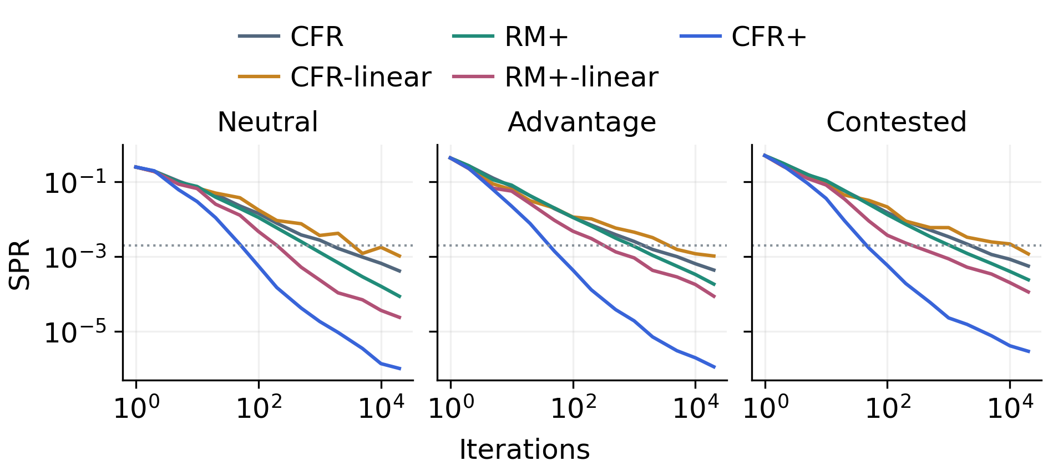
Figure 2. Averaged-strategy SPR across the neutral, advantage, and contested game setups. Each curve shows the median SPR at each checkpoint across three repetitions. The dotted line marks SPR = 0.002.
Method | Neutral | Advantage | Contested | Time (s)
CFR | 4.16e-04 | 4.39e-04 | 5.63e-04 | 5.017
CFR-linear | 1.05e-03 | 1.04e-03 | 1.19e-03 | 4.881
RM+ | 8.69e-05 | 1.84e-04 | 2.41e-04 | 5.040
RM+-linear | 2.38e-05 | 8.72e-05 | 1.14e-04 | 5.028
CFR+ | 1.02e-06 | 1.12e-06 | 2.93e-06 | 5.780
Table 3. Final SPR after 20,000 iterations. Time is neutral median solve seconds; exact values and all timing repetitions accompany the report.
Linear averaging alone does not improve CFR in these experiments. In the neutral game, CFR-linear has an SPR 2.52 times larger than ordinary CFR, and its final SPR is also higher in the other two setups. Giving more weight to recent strategies does not necessarily help when those strategies continue to change across iterations.
Regret clipping improves convergence in all three setups. In the neutral game, RM+ reduces SPR by a factor of 4.78 compared with CFR. Combining clipping with linear averaging reduces SPR by another factor of 3.66 compared with RM+ alone. These results suggest that the effect of linear averaging depends on whether negative cumulative regrets are retained.
Alternating updates provide a further improvement. With the same regret clipping and linear averaging, CFR+ reduces neutral SPR by a factor of 23.42 compared with RM+-linear. Across the three setups, CFR+ reduces final SPR by factors ranging from 192 to 409 compared with ordinary CFR. This improvement reflects the combined changes to regret treatment, averaging, and update order rather than alternating updates alone.
The lower SPR also comes with additional computation. In the neutral game, CFR+ takes a median of 5.780 seconds compared with 5.017 seconds for ordinary CFR, an increase of approximately 15%. We also find that the averaged strategy is much closer to equilibrium than the current strategy. At the final neutral checkpoint, ordinary CFR has a current-strategy SPR of 0.08659, compared with (4.16\times10^{-4}) for its averaged strategy. This illustrates why we evaluate CFR using averaged realization plans rather than only the latest strategy.

7. Discussion and limitations
The results show that the number of iterations alone is not enough to compare equilibrium solvers. DO reaches low SPR in fewer iterations than CFR and FP, but its restricted LP calculations make those iterations more expensive. Sequence-form LP provides an accurate numerical reference and solves the small game directly. The CFR experiments show that regret clipping, linear averaging, and alternating updates can substantially change convergence. Their effects are clearer when these changes are compared separately.
Our results apply to a single round of tiny_hana. We have not evaluated the complete multi-round game or larger game instances such as medium_hana. The two investigations also use different scenarios and timing procedures, so their runtime measurements should not be combined into one overall ranking. Each method has only three timing repetitions, which limits conclusions about small runtime differences. LP and best-response calculations also use numerical tolerances, so very small SPR values should be interpreted as approximate numerical equilibrium rather than exact arithmetic solutions.

8. Conclusion
We compared different methods for solving the single-round Tiny Hanamikoji game and tested improvements to CFR. LP provided a numerical equilibrium reference with very low SPR. DO reach low SPR in fewer iterations than CFR and FP but required more computation per iteration. The CFR experiments showed that regret clipping, linear averaging with clipping, and alternating updates improved convergence under the tested conditions. These findings explain the accuracy and computational trade-offs of the methods on this game.

References
[1] M. Zinkevich, M. Johanson, M. Bowling, and C. Piccione (2007). Regret Minimization in Games with Incomplete Information. Advances in Neural Information Processing Systems 20.
[2] J. Robinson (1951). An Iterative Method of Solving a Game. Annals of Mathematics, 54(2), 296–301.
[3] H. B. McMahan, G. J. Gordon, and A. Blum (2003). Planning in the Presence of Cost Functions Controlled by an Adversary. Proceedings of ICML.
[4] B. von Stengel (1996). Efficient Computation of Behavior Strategies. Games and Economic Behavior, 14(2), 220–246.
[5] O. Tammelin (2014). Solving Large Imperfect Information Games Using CFR+. arXiv:1407.5042.

