1. **Dashboard**

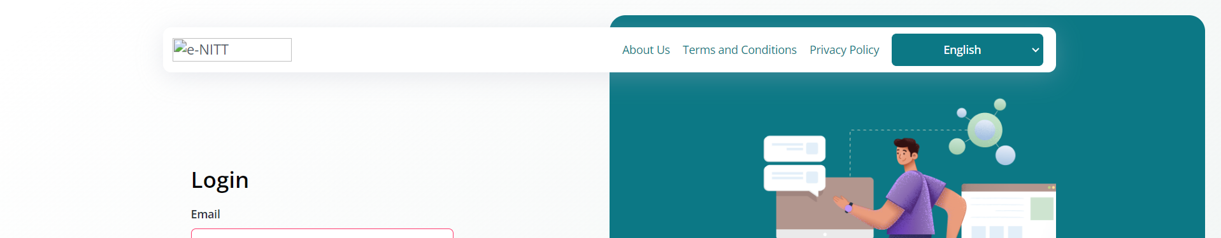

* Remove the top bar and adjust the logo to nitt one
* **Dashboard**



* Remove the top bar and adjust the logo to nitt one