**27th September, 2024.**

The management,

AYU & Company NIGERIA LTD.

Opp LISA Suites, by Abuja Water-board,

Along Maraba Yanya RD

AYA, FCT Abuja.

Abuja.

**Dear Sir,**

**COMMISSIONING REPORT FOR THE** INSTALLATION OF 5-KVA INVERTER WITH ONE-PIECE OF 5-KWH LITHIUM BATTERY AND 8-PIECES OF SOLAR PANNELS

Thias is to accertain that we have successfully  **SUPPLY AND INSTALLED AND COMMISSIONED the 5-KVA INVERTER WITH 5-KWH lithium battery together with 8-pieces of 300watts solar panel at Yauri,**

In accordance with the term of reference in the contract, dated 17th July, 2024. We are here by notifying you that the project has been executed successfully. FIND BELLOW THE COUNTERSTAFF SIGNATURE FROM YOUR COMPANY

Thanks for your patronage,

We remain,

Yours sincerely,

**KAMALDEEN ISIAQ (GMD/Project Manager) (MNSE, MIEE, B.Eng Elect/Elect.)**

**REPRESENTATIVE of AYU & Company NIGERIA LTD**

|  |  |  |  |
| --- | --- | --- | --- |
| S/N | Staff Name | Designation/Rank | Signature And Date |
| 1 |  |  |  |
| 2 |  |  |  |

**Kamzone Integrated Technologies LTD**

|  |  |  |  |
| --- | --- | --- | --- |
| S/N | Staff Name | Designation/Rank | Signature And Date |
| 1 | Engr. ABDULYEKEEN AHMAD | Technical Team Lead/Site engineer |  |
| 2 | Engr. Mudasir A. | Site engineer |  |

**CONSTRUCTION OF SOLAR ARRAY ROOF STAND**

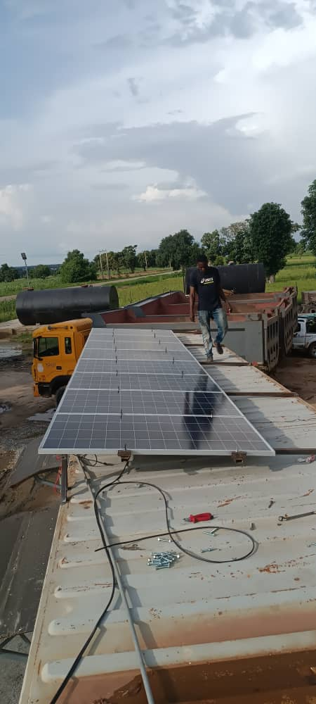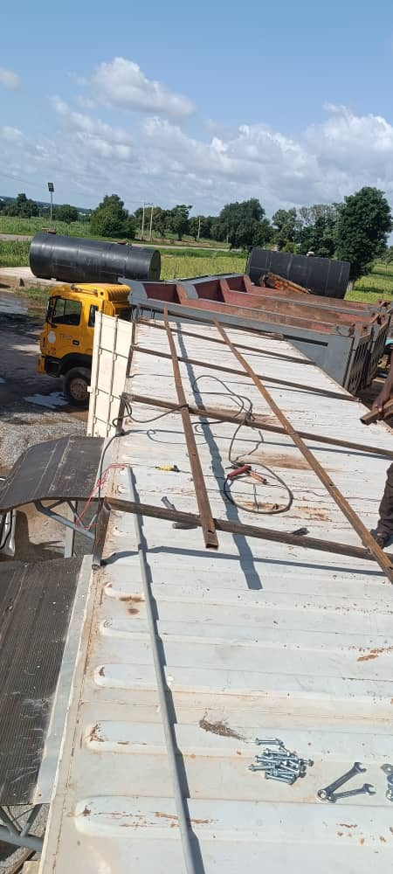



ARIAL VIEW OF THE SOLAR PANNELS ARIAL VIEW OF THE SOLAR PANNELS

