Kidnapped by a U.F.O.

Fill in the gaps with the correct form of the past tense (prétérit / prétérit+ING)

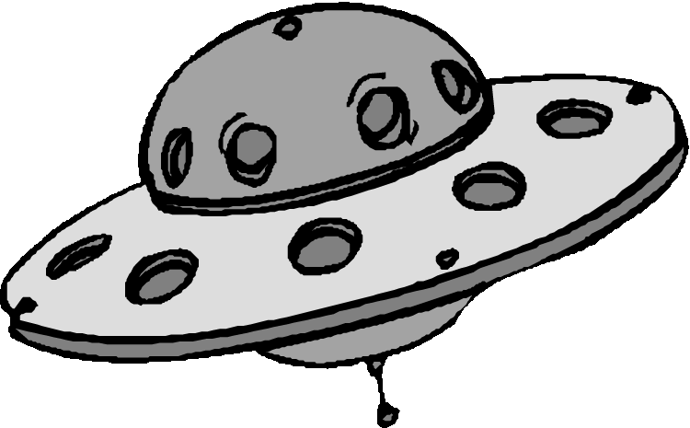Everyone **though** (**THINK**) that Gulf Breeze in the USA was an ordinary, quiet little town until 11 November 1977. Two friends, Ed Walters and Charlie Bennett, reported (**REPORT**)a very strange incident. At first nobody **belived** (**BELIEVE**) their story, but even today, both Charlie and Ed claim that the incident really **happened** (**HAPPEN**).

Here is part of the interview.

It **was** (**BE**) seven o'clock in the evening. My friend Charlie and I **walked**(**WALK**) through the park. We were on our way home . We **talked** (**TALK**) and  **laughed** (**LAUGH**). Suddenly the sky **went** (**GO**)very dark. Charlie **looked** (**LOOK**) up and said, 'It's going to rain'.

Then I **heared** (**HEAR**)a loud bang and the sky went(**GO**)bright green. I thought I  (**DREAM**). There was a huge, shiny spaceship just above our heads. It **didn't move** (**NOT MOVE**).**PULLpulled** (**PULL**) us off the ground. Seconds later we were inside it. Twenty strange creatures **looked** (**LOOK**) at us. They all **had** (**HAVE**) wrinkled skin and hands like pincers. They **didn’t hurt** (**NOT HURT**) us. They **smiled** (**SMILE**) and they seemed very friendly. I don't know how long we **were** (**BE**) in space, but I think the spaceship **moved**(**MOVE**).   
  
Suddenly the door **opened** (**OPEN**)underneath us. We **fall** (**FALL**)out of the spaceship onto the ground. We were back in the park again. Charlie and I just stared(**STARE**) at each other. We **shaked** (**SHAKE**) because we were so scared. Then we **ran** (**RUN**) home as fast as we could.

That's all Charlie and I can remember. I know it sounds crazy but it's the truth. On 11 November 1982, exactly five years after the kidnapping, more strange things**_happened** (**HAPPEN**) in Gulf Breeze. Cars **disapeared** (**DISAPPEAR**), cats started to fly and several people **saw** (**SEE**) spaceships in the sky.