





Round 1: Idea Submission

**Team Name:** Moisture Bois

**Team Leader:** Shourya De

**Problem Statement ID:** PS01

**Problem Statement:** Traffic Management in WCE using Video Surveillance: Alert owner and authorities if parked vehicle is not in authorized area. Processing of video feed to be done using CNN.

**Track:** Expert

(This document should not exceed given pages. Keep the abstract short and precise.)

 \*\***( This page is applicable only for Open innovation)\*\***

**Problem identified:**

( Describe the problem you have selected for which you are developing a solution. )

**Market Research:**

(Try answering these questions in this section:

Who are your customers and end-users?

What are the solutions already available in market for your problem? How is your solution better than existing solutions?

What impact will your project make on the current market? )

**Project Name:** parkIn

**Describe your solution:**

Our initiative, parkIn aims to combine video surveillance and efficient parking using CNN (Convolutional Neural Network) through YOLOv4.

Using the concept of distributed systems, we aim to channel the live feed from the CCTV cameras to a processing server where our algorithm will detect if the vehicle is parked correctly or not in the right area.

The processing server will relay feedback and will alert the authorities and the owner using SMS/email.

A web-app is designed where the vehicle owners can check their fines and dues for wrong/unauthorised parking. A functionality to raise a request for adding/removing vehicle from the database would be provided in case of buying/selling the vehicle.



**Technology Stack:**

(Technologies used for developing the project.)

Frontend- Jinja,HTML,CSS

Backend- Python (FastAPI)

Database- MongoDB

Deep Learning Architecture: YOLOv4

**Innovativeness:**

(Innovation aspect of the project and special features that it provides)

Quick and smart detection using state-of-the-art algorithm by YOLOv4

Scalability {Can used for multiple camera systems using a central processing server}

Frontend for easy management and payment of fines

**Show Stoppers:**

(Show stoppers are obstacles and risks that may arise in the future and which may come in the way of your solution)

Number plate recognition

Position of the camera

**Prototype:**

( You can add pictures of the prototype/wireframes/UI or provide a video link in which prototype is explained ) (This section has maximum weightage)

**Login Page**

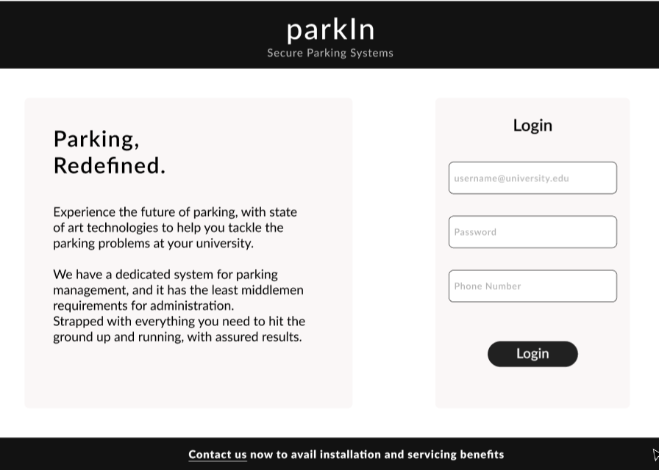

**User Page**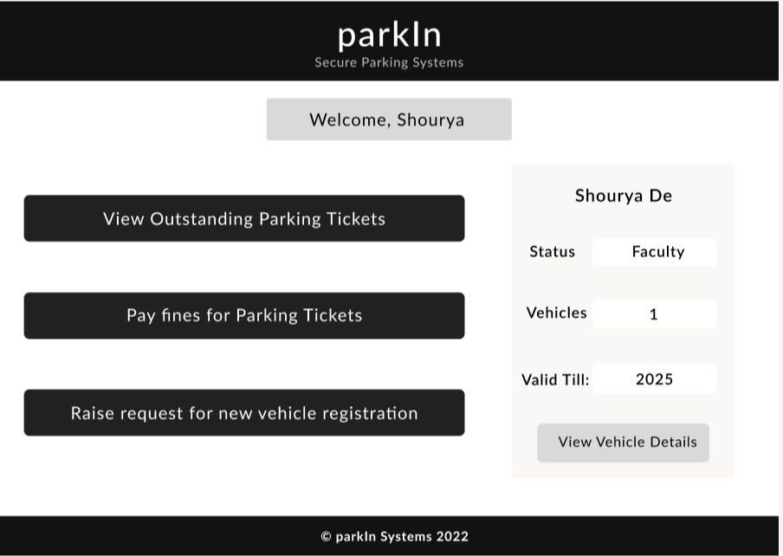

**Vehicle Details Page**

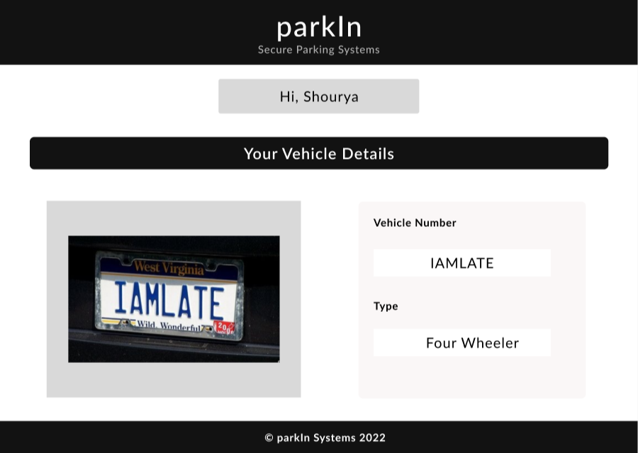

**View Outstanding Tickets**

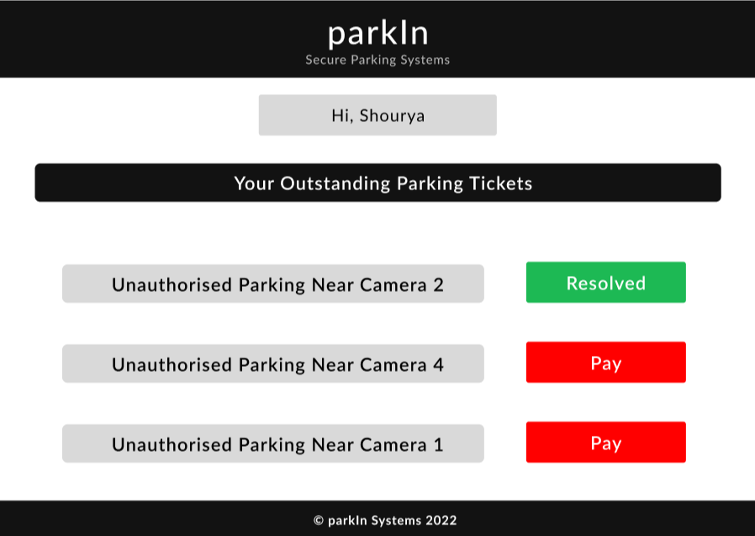

**Use Case Diagram/Flow Diagram:**

