

**Contents**

VERSION HISTORY 2

INTRODUCTION 2

Purpose 2

Scope 2

Overview 2

Reference Material 2

Definitions and Acronyms 2

SYSTEM OVERVIEW 2

SYSTEM ARCHITECTURE 2

Architectural Design 2

Decomposition Description 2

Design Rationale 2

SYSTEM REQUIREMENTS 2

DATA DESIGN 2

Data Description 2

COMPONENT DESIGN 2

GRAPHICAL USER INTERFACE DESIGN 2

Overview of User Interface 2

Screen Images 2

Screen Objects and Actions 2

DEBUGGING AND TESTING 2

# **VERSION HISTORY**

# **INTRODUCTION**

## **Purpose**

**Login System**

The purpose of the system is to allow the player to login. Each aspect of the menu system has its own purpose; for example, the Main Menu is where a user can login to their account or retrieve an account they have lost access to.

**Player Account**

It is the purpose of the player account to display unique character/account related information. This includes such things as a player’s username, statistics, avatars and other displayable features which set players apart.

**Character Creation**

The system dedicated to character creation allows the player to create, delete or edit their avatar. This better diversifies the game’s community and gives players the opportunity of individuality in the character customisation.

**HUD**

The goal of the HUD is to communicate information directly to the player when in-game to do with HP, Controls, Pause Option(s), etc.

**Lobby**

The main purpose of the lobby is to preoccupy players whilst in matchmaking and to make last game-affecting decisions and preparations such as changing an aspect of their character.

**Inventory**

The inventory system works to visually store all the player’s acquired items for later use.

## **Scope**

## **Overview**

Put simply, a team of survivors (the players) must scavenge for weapons and defend for as long as they can against the impending zombie horde. The game reflects the current contemporary survival-genre as team mates can be wounded or ‘downed’ and then rescued or ‘revived’ by remaining team members.

## **Reference Material**

CoD Zombies, Fortnite, Killing Floor, Left4Dead, etc.

## **Definitions and Acronyms**

**Login System**

# **SYSTEM OVERVIEW**

**Login System**

* Login menu
* Main Menu system (ie. play, quit, etc)
* Forgot password section
* Create account section

**Player Account**

* Username
* Health bar and stats
* Avatar/skin/accessories

**Character Creation**

* Basic avatar
* Accessories/clothing
* Weapon of choice
* In-game items accumulated

**HUD**

* HP bar
* Show ping and frames-per-second
* Abilities
* Hotbar

**Lobby**

* Equipped items
* Character display/preview
* Other player usernames and stats

**Inventory**

* Items
* Healthbar & other stats

# **SYSTEM ARCHITECTURE**

## 

## 

## 

## 

## **Architectural Design and Description**

**Login System**

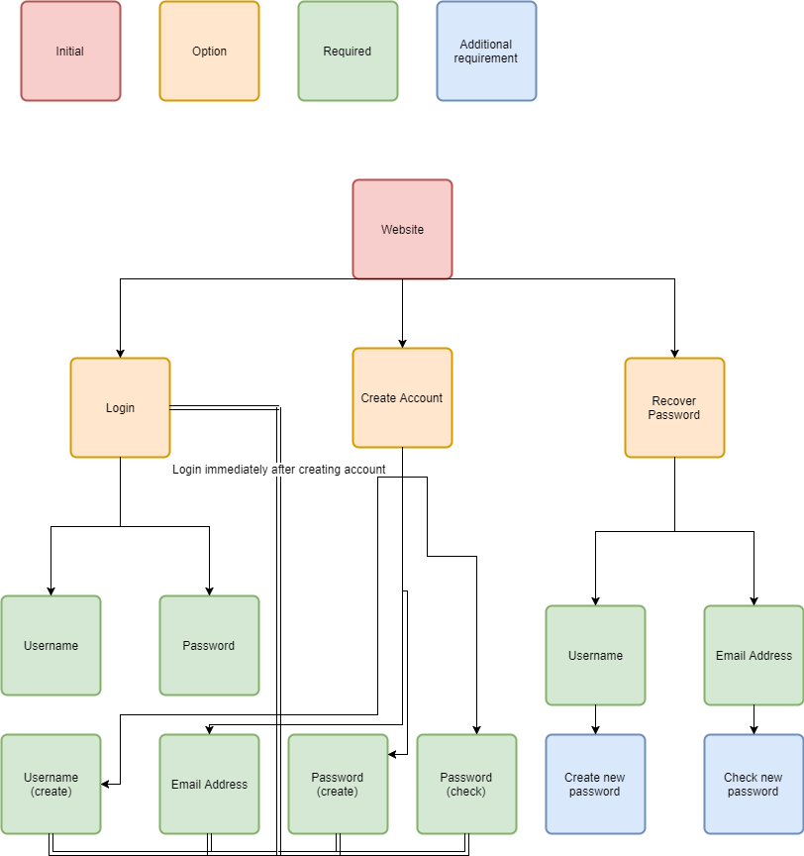

As portrayed by the above image, the login system follows that of a simple, easy and above all recognisable login menu screen; the user may choose to create a new account or login with an existing one - creating a new account will require an email address and the creation of a password.

The system works through the transferring of strings. Upon creating an account, that new set of strings (ie. username and password) are sent and set in the database, where they can be retrieved upon logging in.

**Player Account**

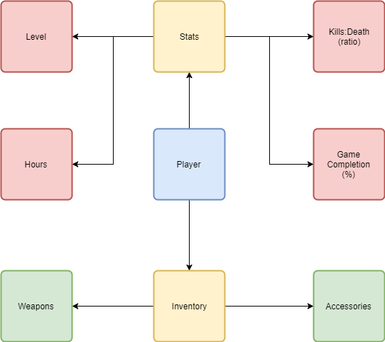

The player account system works similarly to that of the login system as it is based upon the transferral of strings and integers; upon logging in, the game checks the database and fetches for the player’s associated character and features as depicted by strings. The individual ints within each string may resemble such things as weapons, clothing/armour, character level, win percentage, et cetera.

**Character Creation**

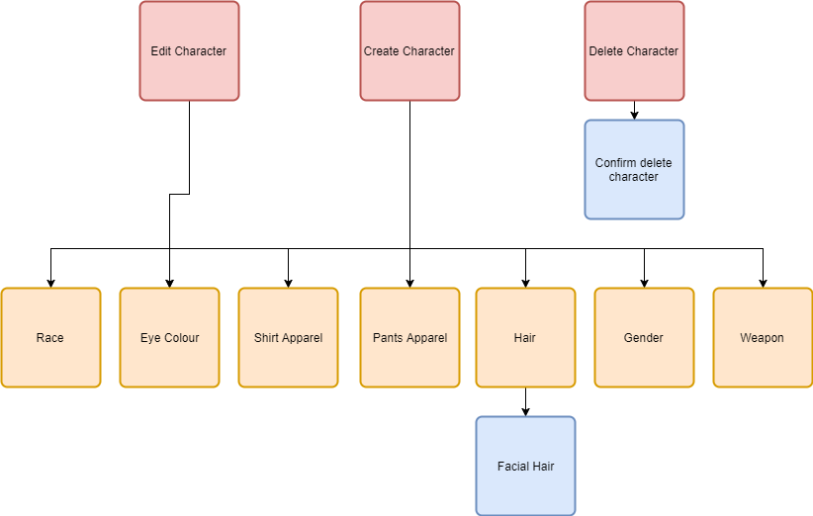

As demonstrated by the flowchart above, the character edit and creation sections of the GUI both involve editing a character. When doing either, the newly changed or created features are saved to the database via their individual ints. For example, in the situation where a player edits their character and changes the character’s pants from blue to red, the int regarding ‘pant’ is changed from ‘2’ to ‘5’, and this information is secured in the database.

**HUD**

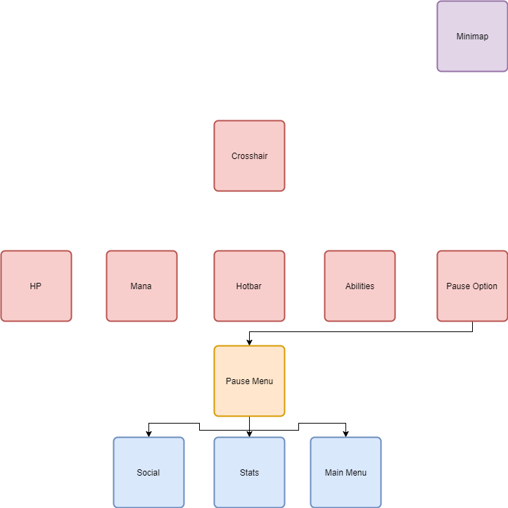

The HUD focuses more on ‘display’ rather than ‘function’, though this does not nullify its purpose entirely: for example, when a certain ability is used as marked in the Abilities bar, that function is called in the script and the ability activates. The HUD is also a device from which the player can access the options menu, so they can check stats, socialise or leave the game.

**Lobby**

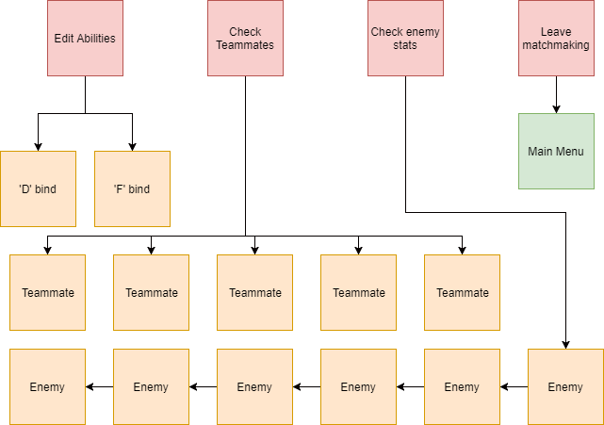

The lobby system is simple as it has few complicated buttons and features. Firstly, there is an option to leave the matchmaking and return to main menu, which is necessary in case the player no longer wishes to play. As well as this, players have the option to select other players in the lobby and preview their game history, character display and stats.

**Inventory**

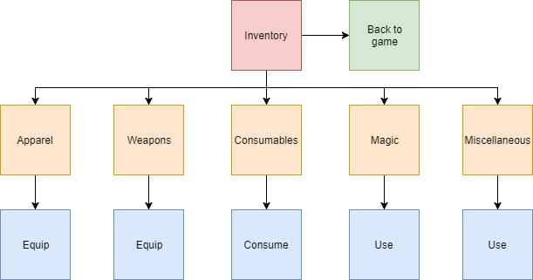

The inventory system holds a bunch of strings and follows, for the most part, a set of booleans. For example, if the player chooses the ‘weapons’ category in the inventory, then they are taken to the weapons category, and if they choose to equip or use a weapon, then that weapon is used or equipped. Other options may include; selling items, removing items, checking item info, etc.

## **Design Rationale**

**Login System**

The aim of the GUI is a mix of practicality, usability and security. The section regarding retrieving a lost or forgotten password is both secure as it stops accounts from being stolen, and user friendly as it allows users to continue with their original account rather than create a new one. The system is practical in the it flows like most other login systems, making it recognisable by users and therefore easy to use.

**Player Account**

The design rationale of the player account is set up in this way to assure that the correct information is displayed for each individual player and so that each player can experience unique character customisation.

**Character Creation**

The player account GUI is visually designed so that each player can set apart their characters. The design rationale emphasizes how the player’s character is one of many online avatars occupied within the game.

**HUD**

The design rationale for the HUD is crucial for the enjoyment and immersion of players in the game. The HUD must have an appealing design which flows with the style of the game, as well as the genre; for example, in an MMO, the widely accepted format for the design rationale of the

Abilities is that they are set up in a row on the bottom of the screen, with key-bindings set up alongside them.

**Lobby**

The lobby design is key for keeping players occupied and interested while they wait for a match to start. This is achieved through a variety of visual and interactive features. Such features can include: minor character customisation, player profile(s), chat system, character perview(s), etc.

**Inventory**

While the inventory can have more practical implications than design ones, the design rationale of the inventory system remains necessary for the utmost experience of the player. This can include simpler navigation through the inventory and more appealing menus and titles, so as to fully immerse and inspire the player.

# **SYSTEM REQUIREMENTS**

**Login System**

# **DATA DESIGN**

**Login System**

This system consists of a selection of strings. A string is a collection of various integers or characters (ie. A, 3, c, etc) often used in a certain combination. If a string combination is entered, the database checks for a match, resulting either in a successful or unsuccessful login.

**Player Account**

The player account extracts information from the database dealing with the player’s stats and experiences in the game. This information is stored and gathered in the form of a string, such as the player’s level (ie. Lv 34).

**Character Creation**

The character creation system accesses information in the database specific to a user’s account in the form of a string. That string is then translated into certain information in the game. For example, a player may have customised orange hair, which may be referred to in the game as “17”. If this number is detected in the database and recognised in the game as ‘orange hair’.

**HUD**

The data for the HUD is programmed locally in Visual Studio and, for the most part, does not require a database. However, a database may be necessary when grabbing information to do with the Player Account; for example, the HUD may display player stats such as Health, and so a database is required here.

**Lobby**

There is much data needed for the lobby system as it grabs and displays information about multiple other players. Due to this, multiple databases are needed (one for each player) in order to display the right information. This data is retrieved in the form of a string representing each player’s database and relevant information.

**Inventory**

The inventory requires heavy use of the database, as each individual aspect lies within the database. Each item is represented in the database by an int (eg. Health Potion = 36), or possibly a string (eg. “GOLDEN_SWORD”).

## **Data Description**

**Login System**

* Strings from 30 to 100 characters, including Username, Password, Email Address, etc

**Player Account**

* Strings of specific ints representing features or aspects of the player, including Health Points, Damage Output

**Character Creation**

* Strings of specific ints representing features or aspects of the player, including Facial Hair

**HUD**

* Strings of specific ints representing things such as abilities and Health Points

**Lobby**

* Strings representing entire databases (players) with additional strings and ints

**Inventory**

* Ints referring to different items inside the inventory such as Shields and Gloves

# **COMPONENT DESIGN**

# 

# **GRAPHICAL USER INTERFACE DESIGN**

**Login System**

The GUI is a modest, adequate design primarily to avoid confusion among users.

**Player Account**

The player account demonstrates a simple overview of the character and character info for the character that the user has signed into. If the user has just created a character, then the player account will show the default character loadout(s).

**Character Creation**

The GUI for the character creation section allows the player to scroll and choose between different assets and features outlined as options for their character. For example, the player, when creating a character, can choose between long hair, short hair, red shirt, blue eyes, etc, as opposed to any of the other options.

**HUD**

The GUI for the HUD is possibly the most important GUI system as it is what the players will be seeing and experiencing throughout their playthrough of the game - it must be practical, attractive and fit with the overall style of the game.

**Lobby**

**Inventory**

## **Overview of User Interface**

The GUI is easy to understand and easy to navigate, yet superbly decorated and designed.

## **Screen Images**

## **Screen Objects and Actions**

# **DEBUGGING AND TESTING**