Schedule for Senior Project

Week 1 (1/13-1/17)

* + Class Sign up and setting up adviser

Week 2 (1/20- 1/24)

* + Talk with Advisor and make sure that everything is all good and if need to make changes do so this week.
  + Make up for Project implementation (497), redo that.

Week 3(1/27 – 1/31)

* + Talk to the networking people at csu to see how it would work to implement a RFID reader onto campus
  + Look at what data they are looking to read (names, times, dates, what other things do I need for a test environment)
  + Start making prototype RFID reader to get a working model and start messing around.
  + Think if you want a throwaway design or spiral prototype design

Week 4(2/3- 2/7)

* + Make sure that you have everything you need for the back end of things from the networking people. (database information, API’S)
  + Continue to test and learn how RFID and how it read/writes
  + Begin design documentation

Week 5 (2/10-2/14)

* + Acquire rfid tags as test to see how the prototype program does with any kind of RFID tags
  + Start looking into how to make a web page to test services.
  + continue design documentation

Week 6 (2/17- 2/21)

* + Continue to tinker with RFID cards and building tests (Not close to the final product)
  + Think of how to make the RFID system compact and into a handheld system.
  + Design complete ()
  + Design review.

Week 7 (2/24-2/28)

* + If design is done: make a schedule for coding (**milestone**)
  + Design review

Week 8 ()

* + TBD based on week 6-8:

Week 9

* + Testing
  + TBD

Week 10

* + Coding and testing
  + TBD

Week 11

* + Coding and testing
  + TBD

Week12

* + Coding and testing
  + TBD

Week 13

* + Coding and testing
  + Documentation prep

Week 14

* + Coding and testing
  + Documentation

Week 15

* + Coding and testing
  + TBD
  + Documentation

|  |  |  |  |
| --- | --- | --- | --- |
|  |  |  |  |
|  | Sep 1-8 |  | Sep 9 - 16 |

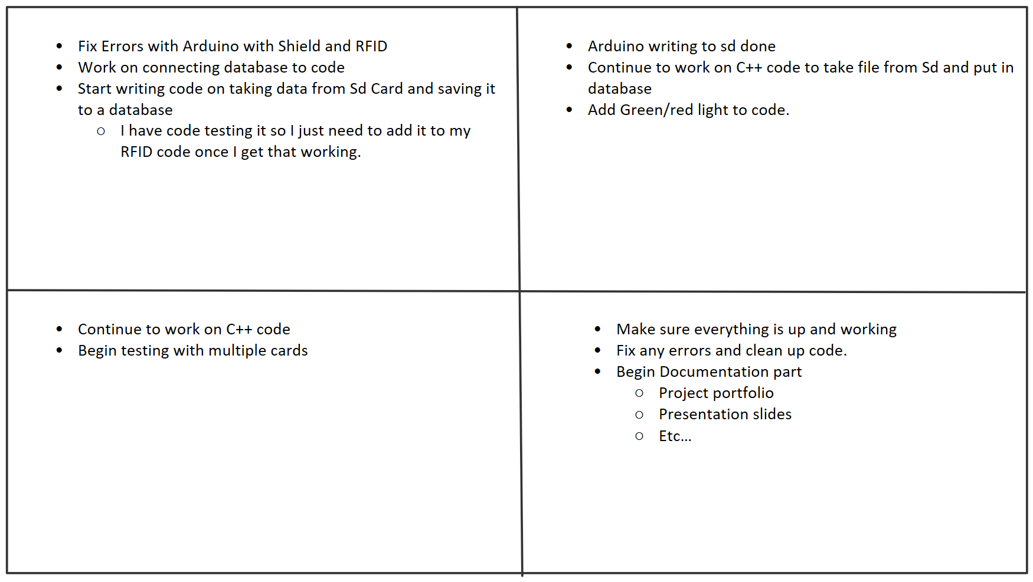

|  |  |  |  |
| --- | --- | --- | --- |
|  |  |  |  |
|  | Sep 17 - 24 |  | Sep 24- Oct 2 |