MS3 Individual Report – Security Testing
Low Wei Sheng | A0259272X | CS4218 AY2025/26 Sem 2
Non-Functional Test Type: Security Testing
I chose security testing because prior milestones had already surfaced security-adjacent defects — a bcrypt password hash returned in an API response (BUG-01, MS2) and enum validation bypassed on database updates (BUG-02, MS2) — indicating the codebase was worth probing more systematically for vulnerability classes beyond those discovered incidentally.
OWASP Top 10 as a Testing Framework
Rather than testing for vulnerabilities ad hoc, I structured the entire test suite around the OWASP Top 10 2021 — a standard published by the Open Worldwide Application Security Project at owasp.org that ranks the ten most critical web application security risk categories. Using it as a framework ensures coverage is risk-driven rather than arbitrary: each of the 14 security user stories I wrote maps to one or more of these categories.
The ten categories are: A01 Broken Access Control (users accessing resources beyond their permissions); A02 Cryptographic Failures (sensitive data exposed due to weak or absent encryption); A03 Injection (attacker-controlled input interpreted as commands, e.g. SQL/NoSQL injection); A04 Insecure Design (architectural flaws that no control can fully mitigate); A05 Security Misconfiguration (insecure defaults, missing hardening, overly permissive settings); A06 Vulnerable and Outdated Components (using libraries with known CVEs); A07 Identification and Authentication Failures (broken login, session management, or credential controls); A08 Software and Data Integrity Failures (insecure deserialization or CI/CD pipeline compromise); A09 Security Logging and Monitoring Failures (insufficient logging to detect or respond to attacks); A10 Server-Side Request Forgery (server fetching attacker-supplied URLs).
I tested six of the ten categories. A01 was covered by three AUTHZ stories verifying admin endpoint isolation, IDOR prevention across user orders, and mass assignment resistance. A02 was covered by DATA-01, asserting that the password field never appears in any API response. A03 was covered by AUTH-03 injection payloads against the login endpoint and INJ-01 NoSQL operator injection against the product filter endpoint. A05 was covered by four CONFIG and DATA stories targeting CORS policy, security headers, and raw error serialisation. A06 was addressed by Semgrep SAST scanning controllers for known Mongoose anti-patterns. A07 was covered by four AUTH stories testing JWT expiry enforcement, signature validation, authentication hardening, and brute-force rate limiting. A04, A08, A09, and A10 were out of scope: A04 requires architectural review beyond automated tests; A08/A09/A10 have no applicable attack surface in this Express + Mongoose stack.
Security Test Metrics
I tracked six metrics suited to security testing. Test pass/fail rate distinguishes verified controls (pass) from confirmed findings (fail) — in this suite a failing test is the result, not an error. Remediation rate measures how many findings were fixed versus documented, capturing the team's response to the results. OWASP category coverage quantifies breadth — what proportion of the Top 10 risk categories the suite addresses. CVSS severity distribution (Common Vulnerability Scoring System) classifies each finding by exploitability and impact, allowing prioritisation. Semgrep defect density counts static analysis hits per codebase, measuring how pervasively a pattern class appears across all controllers — not just the ones covered by dynamic tests. ZAP passive alert count provides independent corroboration from a black-box perspective, validating findings that the automated tests also detected.
Three-Layer Methodology
Automated Tests (Jest + Supertest + mongodb-memory-server) - I extended the same supertest infrastructure from MS2 into a dedicated tests/security/ directory. Each test file spins up the full Express app against an in-memory MongoDB instance, exercising real middleware chains and real Mongoose queries — no mocks. For example, in inj.query.security.test.js I sent { "pricegte": { "$gt": 0 } } as a query parameter and asserted the response count did not exceed the seeded product count, verifying that the operator was not interpreted by Mongoose. Tests are written so that a failing test confirms a vulnerability and a passing test confirms the control works.
SAST (Semgrep with custom rules) - I wrote two custom YAML rules targeting Mongoose-specific anti-patterns: findByIdAndUpdate without runValidators: true (the root cause of BUG-02 from MS2) and raw error objects passed directly to res.send() (CWE-209). Running these against all three controllers found 3 real findByIdAndUpdate hits and 38 raw-error instances — a pattern class that would be impractical to enumerate by hand.
DAST (OWASP ZAP Baseline Scan) - I ran a passive ZAP scan against the live server using the ghcr.io/zaproxy/zaproxy:stable Docker image. Passive scanning observes HTTP traffic without sending attack payloads, making it safe to run locally. The scan produced 8 WARN alerts — missing X-Content-Type-Options, exposed X-Powered-By, and CORS wildcard — all three corroborating findings already confirmed by the automated tests, providing independent cross-layer validation.
Low Wei Sheng · A0259272X · CS4218 AY2025/26 Sem 2

MS3 Test Statistics and Combined Results (MS1–MS3)
Low Wei Sheng | A0259272X | CS4218 AY2025/26 Sem 2
MS3 Security Test Metrics
77 security tests automated across 12 files covering 5 epics (AUTH, AUTHZ, INJ, DATA, CONFIG). 66 tests pass, confirming security controls are in place; 11 fail, confirming findings. 4 of 5 findings were remediated in the same commit.
Metric | Value
Total tests | 77 across 12 test suites
Pass rate (controls verified) | 85.7% (66 / 77)
Fail rate (findings confirmed) | 14.3% (11 / 77)
Vulnerabilities found | 5 (4 confirmed · 1 risk documented)
Remediation rate | 80% (4 of 5 findings fixed)
OWASP category coverage | 60% (6 of 10 categories tested)
CVSS severity distribution | 0 High · 3 Medium · 2 Low
Semgrep defect density | 41 hits (38 raw-error · 3 missing runValidators)
ZAP passive scan alerts | 8 WARN · 0 FAIL
Combined Test Statistics (MS1–MS3)
Across all three milestones I automated 343 tests spanning unit (MS1), integration and E2E (MS2), and security non-functional (MS3) tiers. 20 bugs and security findings were identified in total; 17 were fixed.
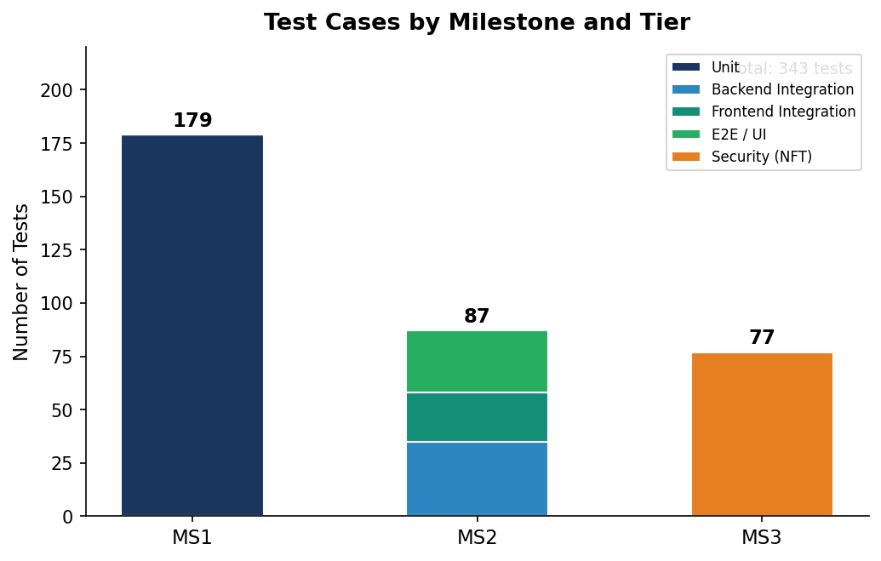
Figure 1 – Test cases by milestone and tier: MS1 (179 unit), MS2 (87 integration + E2E), MS3 (77 security) — 343 total
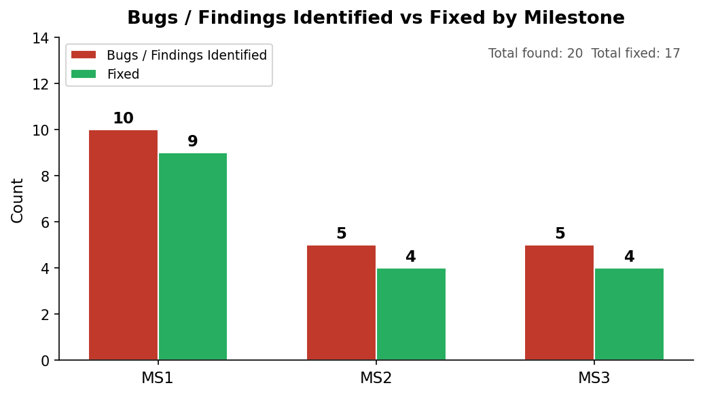  Figure 2 – Bugs/findings identified vs fixed per milestone (total: 20 found · 17 fixed) | 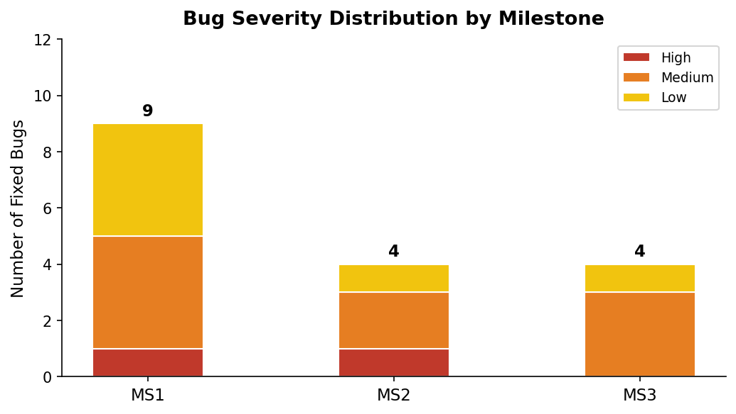  Figure 3 – Severity distribution of fixed bugs across milestones (High · Medium · Low)
Low Wei Sheng · A0259272X · CS4218 AY2025/26 Sem 2

Most Significant Bugs and Lessons Learned
Low Wei Sheng | A0259272X | CS4218 AY2025/26 Sem 2
Bug 1 (Most Significant) — BUG-01: Hashed Password Returned in Profile Update Response
Discovered in MS2 via auth.profile.test.js. When a user called PUT /api/v1/auth/profile, the JSON response body included updatedUser.password — the bcrypt hash of the user's current password. The bug was found during test design: writing the assertion expect(res.body.updatedUser.password).toBeUndefined() immediately prompted checking whether updateProfileController called .select("-password") — it did not, unlike every other write controller in the same file.
Fix: Added .select("-password") to the findByIdAndUpdate call, consistent with getAllUsersController and getOrdersController in the same file.
Risk if unresolved: Any client-side monitoring or logging tool — Sentry, Datadog, browser devtools network tab — that captures API responses would silently store every user's bcrypt hash. Bcrypt hashes are offline-attackable: a leaked hash combined with a common-password wordlist via hashcat or john-the-ripper can recover weak passwords without any server interaction. Users who just changed their password are most exposed — the new hash is returned in the same response confirming the password change, immediately after the plaintext was processed.
Bug 2 — AUTH-04: No Rate Limiting on Login Endpoint (CWE-307)
Discovered in MS3 via auth.ratelimit.security.test.js. I sent 20 concurrent POST /api/v1/auth/login requests and asserted that at least one received a 429 Too Many Requests response. Every request returned 401 — confirming that the server applied no throttling whatsoever. The login route had no rate-limit middleware, making it trivially automatable.
Fix: Added express-rate-limit with a window of 15 minutes and a maximum of 10 attempts before returning 429. The limiter is applied specifically to POST /api/v1/auth/login before the auth routes mount, so it does not affect registration or password reset.
Risk if unresolved: An e-commerce platform accumulates user accounts over time, each associated with a payment method and order history. Without rate limiting, an attacker with a breached email list can run automated credential stuffing — trying thousands of commonly reused passwords per account — with no server-side friction. A successful login grants full access to saved addresses, order history, and any stored payment tokens. Unlike BUG-01 which required a leaked hash, this attack requires only a valid email address, which is often publicly inferable or available from prior data breaches.
Lessons Learned
- Test design is code review. BUG-01 and BUG-02 (MS2) were both found while writing assertions, before any test ran. Structuring the expected output of an API call forces you to confront what the implementation actually returns versus what it should — making test design itself a defect-detection activity.
- Mock at the right level. MS1 unit tests mocked Mongoose entirely, which hid the runValidators bug. MS2 integration tests using a real mongodb-memory-server instance caught it immediately. Mocking the DB layer trades coverage for speed; the right choice depends on what you are trying to verify.
- Non-functional testing requires a framework. Without OWASP Top 10 as a structure, security testing devolves into checking whatever comes to mind. The framework forced me to consider A07 authentication failures (finding AUTH-04) and A05 misconfiguration (finding CONFIG-01/02) that I might never have tested ad hoc.
- AI is most valuable as a validator, not just a generator. The most impactful AI interactions across all three milestones were not test generation but assumption checking: verifying whether BUG-05's || vs ?? change was actually a bug (it was not), and catching the tautological assertion in DATA-01 that superficially passed but verified nothing. Both required reading code that the task description did not mention — the kind of lateral check that prevents shipping incorrect fixes.
- Security and correctness overlap more than expected. Every MS3 security finding had a correctness dimension: AUTH-03e was also a wrong HTTP status code (404 vs 401); CONFIG-01 was also a missing configuration option; AUTH-04 was also an absent middleware. Security vulnerabilities are often just correctness bugs in a threat model — the same discipline of writing precise assertions catches both.
Low Wei Sheng · A0259272X · CS4218 AY2025/26 Sem 2

